**IEEEDuino Student Contest 2024**

**Design Stage**

Team Name: Arduscope

IEEE Section: Egypt

Team Members:

1. Youssef Khaled Omar ([youefkh05@ieee.org](mailto:youefkh05@ieee.org)) (99175764)
2. Khaled Mohamed Sarhan ([khaledsarhaan@ieee.org](mailto:khaledsarhaan@ieee.org)) (100104283)
3. Ameer Ashraf Louly ([loulyameer@ieee.org](mailto:loulyameer@ieee.org))( 100076577)

University or Student Branch Name: IEEE Cairo University Student Branch (IEEE CUSB)

Project Title: Arduino Multimeter & Oscilloscope



# Project Scope, Purpose and Background

The purpose of this project is to address the empowerment of young people from lower-income backgrounds by providing them with affordable electronics kits that inspire future Electrical Engineers and pave the way for their success.

Our goal is simple: we want to get more young people excited about electronics. By putting together these kits, we're making it cheaper and simpler for beginners to get started with electronics which is shown in Additional Material sector. We believe that by breaking down these barriers, we can inspire a new generation of inventors and makers who can use electronics to change the world.

Our project is all about making electronic tools more affordable and easier to use. We're creating a Kit that includes important electronic tools like a Multimeter, oscilloscope, function generator, etc. These tools are usually pricey, especially for beginners.

Design Criteria

We plan to use the Arduino Microcontroller to build our Kit which includes:

1. Oscilloscope

Oscilloscope is decided to be built to help users see their Signals in Time Domain which has proven to be an instrumental tool in the Electronics Lab.

1. Spectrum Analyzer

Spectrum Analyzer is decided to be built to help users work with Frequency Domain which helps them in Analyzing their circuit behavior

1. Signal Generator

A Signal Generator is decided to be built to help users test their Circuits with various Signals.

1. Multimeter

A multimeter which consists of an Ohmmeter, Voltmeter and Ammeter is considered to be a fundamental tool in measuring currents and Voltages in test circuits and checking on Resistors

We Believe that This Kit will be Sufficient in most of Simple Lab Projects.

…

Detailed Design

## Block Diagram:

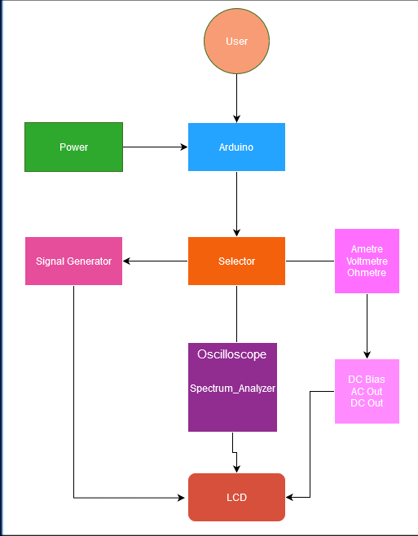

Figure 1 Block Diagram

## Circuit Layout:

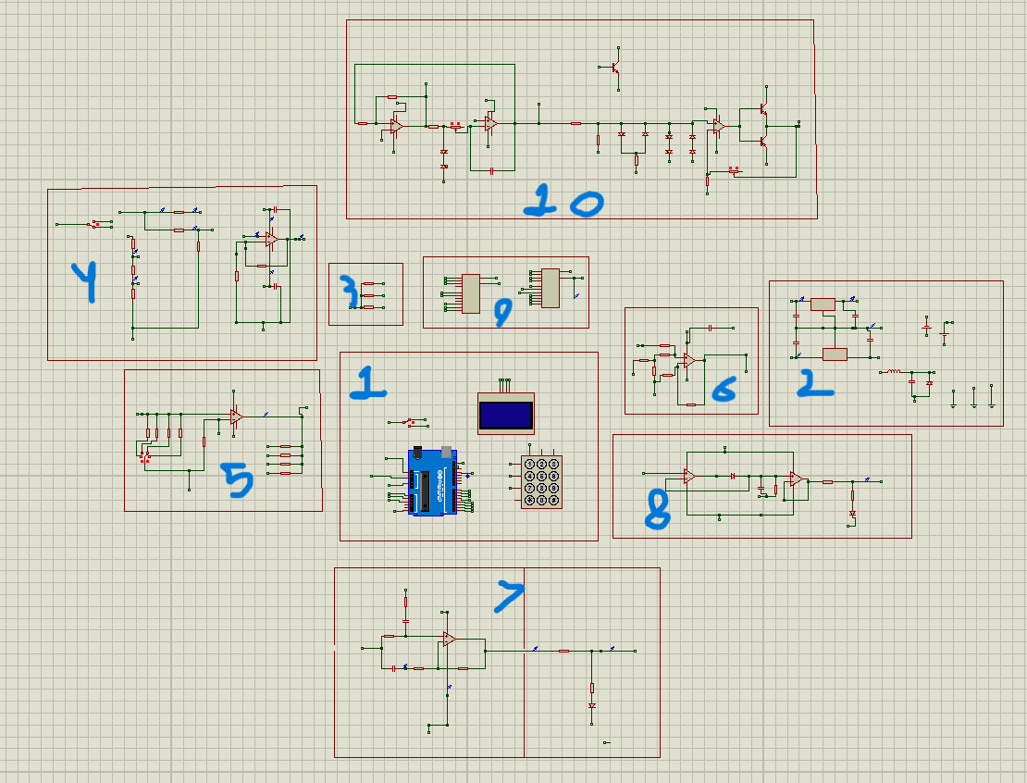

Figure 2 Overall Circuit Layout

## 1) Arduino Block:

Figure 3 Arduino Block

*note: We are using 1*3 Keybad Not 4*3

## 2) Power Block:

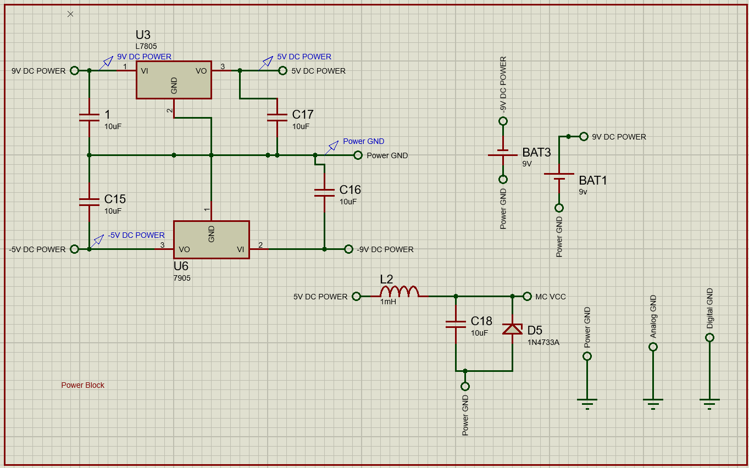

Figure 4 Power Block

## 3) Ohmetre Block:

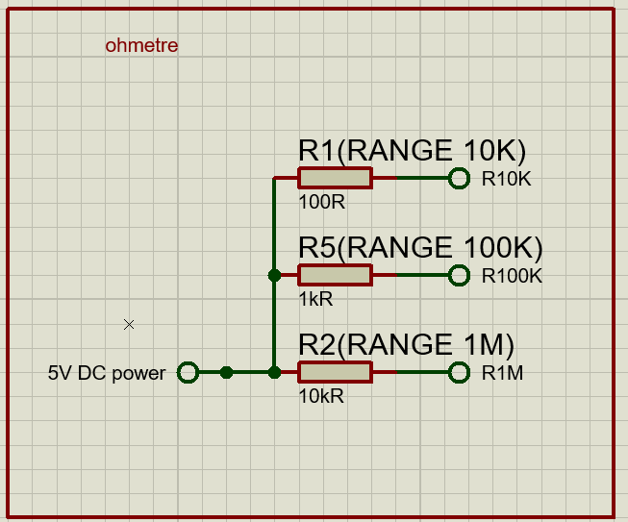

Figure 5 Ohmetre Block

## 4) Voltmetre Block:

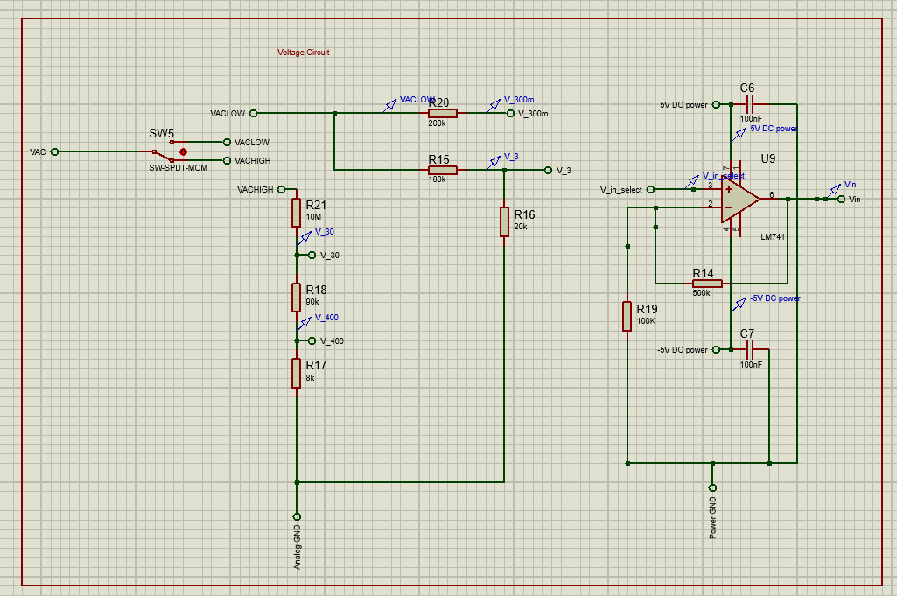

Figure 6 Voltmetre Block

## 5) Ametre Block:

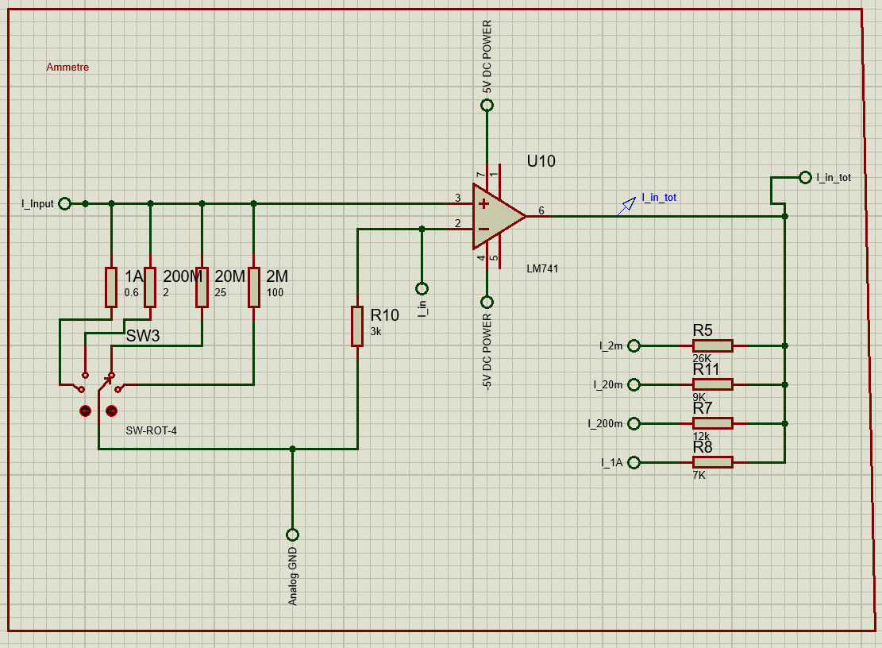

Figure 7 Ametre

## 6) Dc Bias Block:

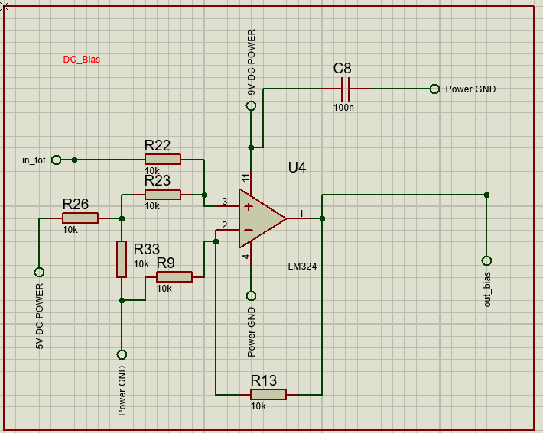

Figure 8 Dc Bias Block

## 7) Dc out Block:

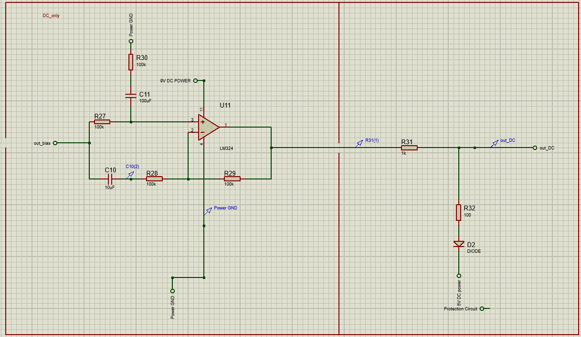

Figure 9 DC out Block

## 8) Ac Bias Block:

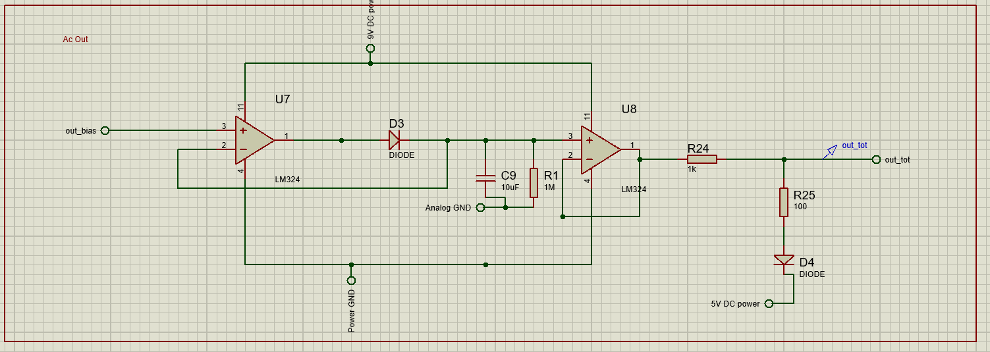

Figure 10 AC Out Block

## 9) Selector Block:

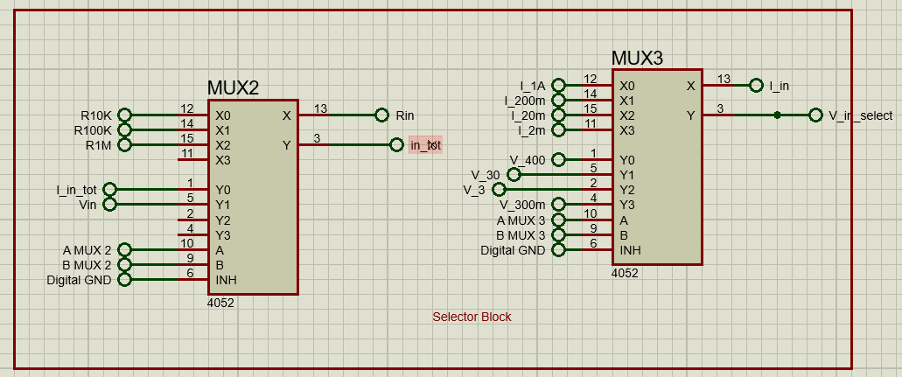

Figure 11 Selector Block

## 10) Signal Generator Block:

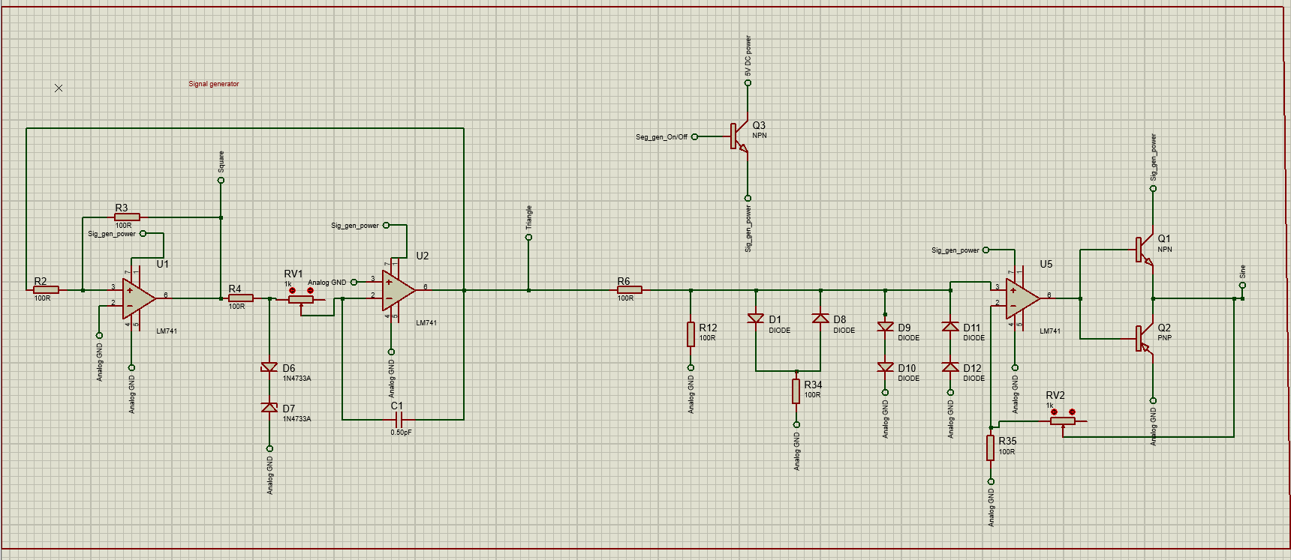

Figure 12 Signal Generator

## Additional Materials

The components used were Price

1. Arduino 10$
2. 3*1 Keypad 0.5$
3. LCD OLED 3.75$
4. DC Power Supply 4.25$
5. Resistors 1$
6. Capacitors 1$
7. Inductors 0.5$
8. Switches 0.5$
9. Transistors 0.5$
10. Diodes 1.5$
11. OP Amp LM741 1$
12. OP Amp LM324 1$
13. Negative Voltage Regulator 7805 0.5$
14. Positive Voltage Regulator 7905 0.5$
15. Analog Mux CD4052 0.5$

As shown, The total price is 27$ which is far cheaper than the real Oscilloscope which is 385$.

Making us reach the required goal!

## Extracts of Pseudocode:

Display “the devices” //the user will one

Select_device() //A function that reads the keypad

IF Ohmetre:

Close_all_working_device() //to make sure that this only working device now

Select_range() //Using Mux Ohmetre Range (100: 1M) Ohm

Capture_input_signal() //from our analog pin

Show_Value() // Showing the value on the Screen

IF Ametre:

Close_all_working_device() //to make sure that this only working device now

Select_range() //Using Mux Ametre Range (0.01: 1) Amp

Capture_input_signal() // from prespective input analog pin

Show_Value() // Showing the value on the Screen

IF Voltametre

Close_all_working_device() //to make sure that this only working device now

Select_range() //Using Mux Voltametre Range (0.01: 400) Volt

Capture_input_signal() // from prespective input analog pin

Show_Value() // Showing the value on the Screen

IF Signal Generator:

Select_Signal() // Sin, Triangular, Sawtooth and Square

Save_State() // To run in the background by Keeping power pin high

IF Oscilloscope:

Close_all_working_device() //to make sure that this only working device now

Capture_input_singal() //from prespective input analog pin

Draw_In() //Draw the input on Screen

IFSpectrum_Analyzer

Close_all_working_device() //to make sure that this only working device now

Capture_input_singal() //from prespective input analog pin

Apply_FFT() //to Transfrom the signal from Time Domain into

Frequency Domain

Draw_In() //Draw the input on Screen

# Forward Plan:

If selected, during the ‘Build Phase’, we will spend the week as follows…

We will test the proposed design by

1. Putting the last touches on the code in Arduino IDE (Day 1 &2)
2. Simulating the full circuit in proteus (Day 2)
3. Using the Arduino IDE Code on the Simulation to make sure that the code is correct and gives the expected output (Day 2)
4. Getting the hardware components to test them making sure they function as planned (Day 3)
5. Assemble the full circuit making sure the connections are right so it generates the expected output (Day 3& 4)
6. Testing the code by uploading it on the Arduino (Day 4)
7. Test the project in the university laboratory with all possible inputs (Day 5)
8. Checking that everything is ok. If a problem appeared, we would debug the circuit using the laboratory tools to find the problem and fix it (Day 6 &7)