Part 1

Q1)

Code

%--------Q1--------

% Define the open-loop transfer function G(s)

num_G = 1;

den_G = [1 1 0]; % s(s+1) = s^2 + s

G_S = tf(num_G, den_G)

% Define the feedback transfer function H(s)

num_H = [1];

den_H = [1]; % Unity Feedback

H_S = tf(num_H, den_H)

Output:  
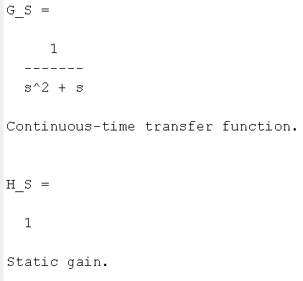

Q2) the 𝑠𝑡𝑒𝑝() command to plot the output of 𝐺(𝑆)

Code: We made a function that plots step time response and checks stability

%--------Q2-------- Step Response of G(s) (Open-Loop)

% Plot step response of G(s)

draw_step(G_S, 'Open-Loop System G(s)');  
  
  
function draw_step(sys, sys_name)

% Create figure

figure;

% Plot step response

step(sys);

title(['Step Response of ', sys_name]);

grid on;

% Display poles

poles = pole(sys);

disp(['Poles of ', sys_name, ':']);

disp(poles);

% Check stability

if all(real(poles) < 0)

disp('System is stable (all poles in LHP)');

elseif any(real(poles) > 0)

disp('System is unstable (at least one pole in RHP)');

else

disp('System is marginally stable (poles on imaginary axis)');

end

end

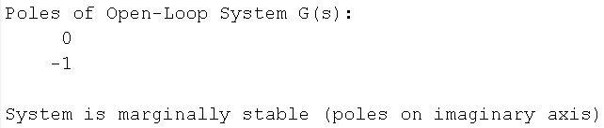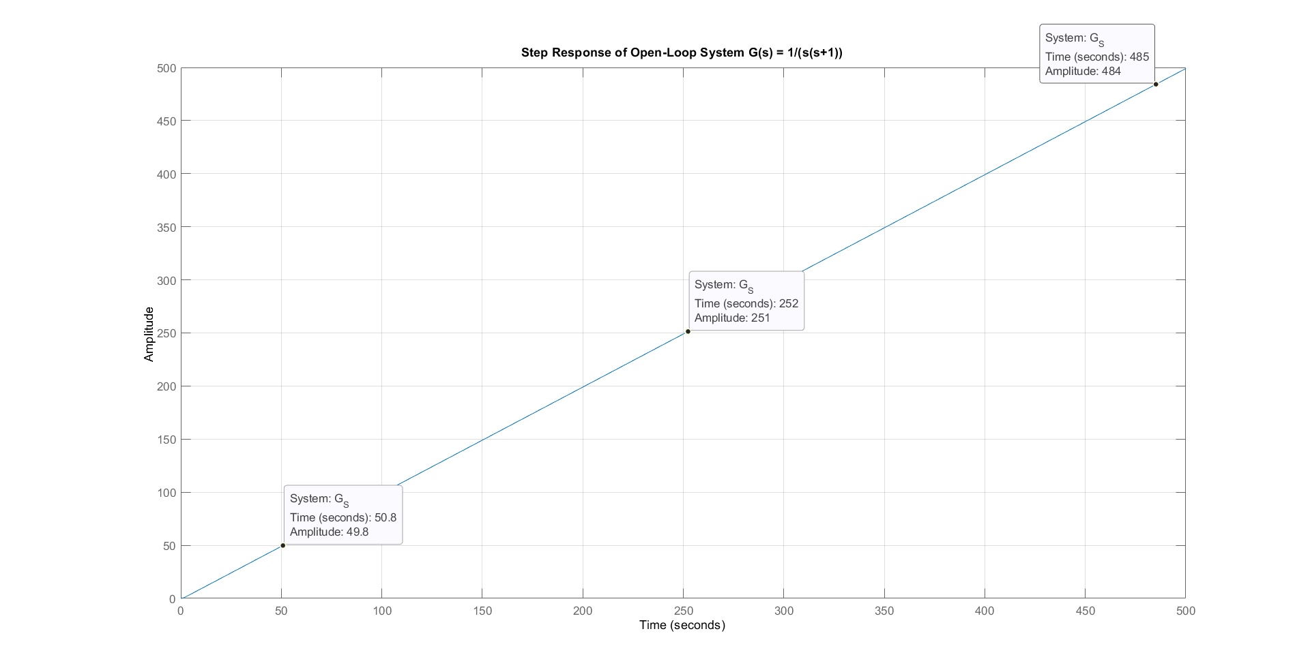Output:

Q3)

Code:

%--------Q3-------- Closed-Loop Analysis

disp('Closed-Loop TF using feedback():');

T_feedback = feedback(G_S, H_S)

disp('Closed-Loop TF using manual formula (G/(1+GH)):');

T_manual = (1 / (1 + G_S * H_S)) * G_S; % Equivalent to T(s) = G/(1+GH)

T_manual = minreal(T_manual) % Cancel common terms

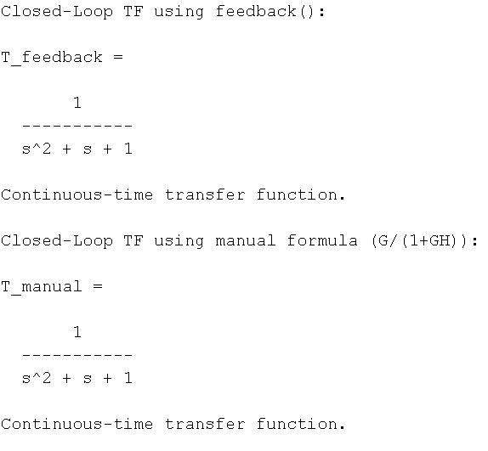Output:

Q4)

Code:

%--------Q4-------- Step Response of T(s) (Closed-Loop)

% Plot step response of T(s)

draw_step(T_feedback, 'Closed-Loop System T(s)');

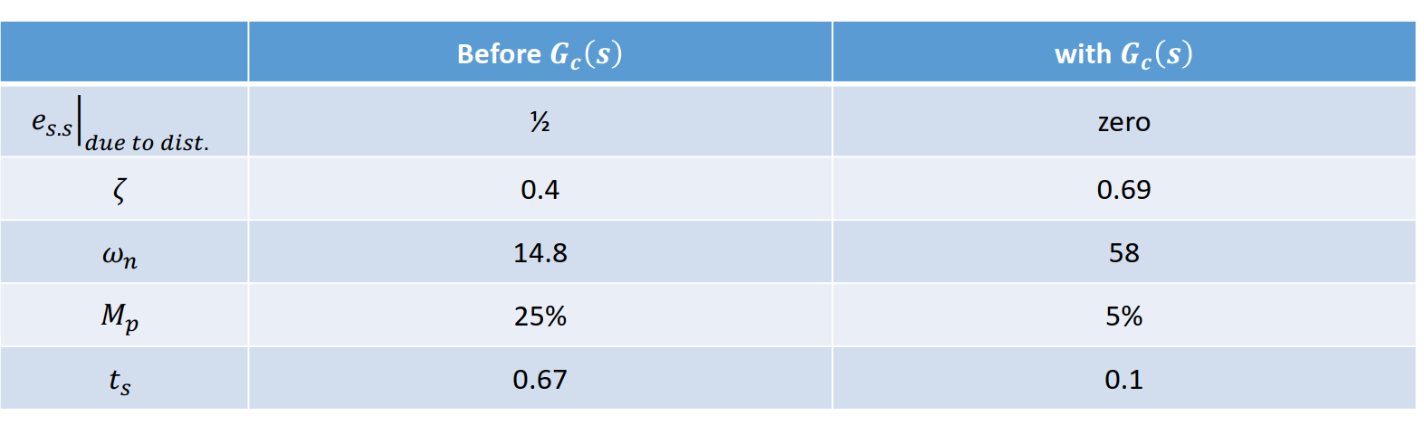Output:

Ouput:

System: Closed-Loop System T(s)

Poles: -0.5-0.86603i -0.5+0.86603i

Stability: stable (all poles in LHP)

Over shoot MP: 16.2929% at t = 3.592 sec

Damping ratio (ζ): 0.500

Natural frequency (ωn): 1.000 rad/s

Settling time (2%): 8.1051 sec

Rise time (10-90%): 1.6579 sec

Steady-state value: 1.0014

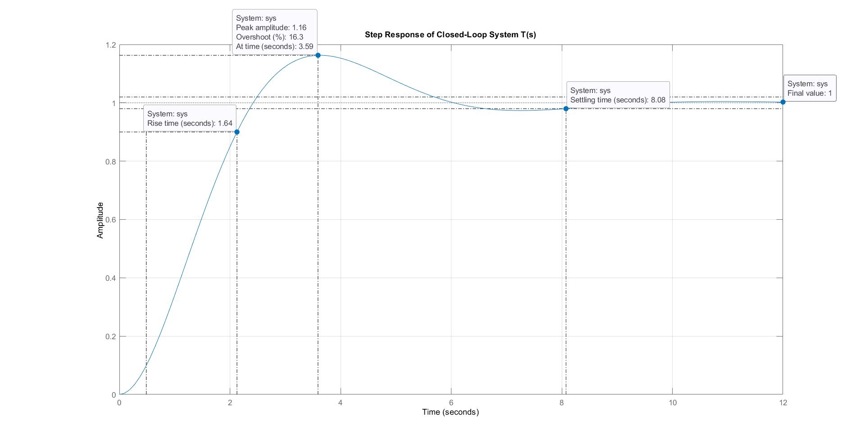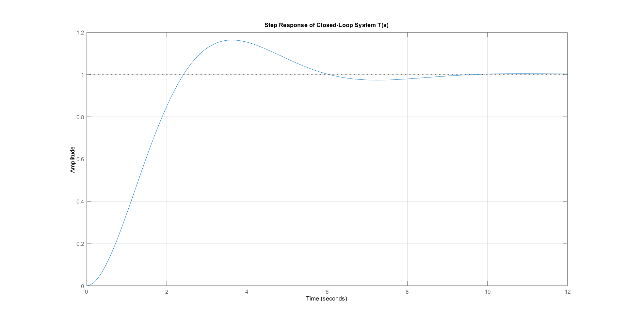

Q5)

Code:

function [poles] = draw_poles(sys)

% Create figure

figure;

% Plot pole-zero map

pzmap(sys);

title(['Pole-Zero Map of: ' inputname(1)]);

grid on;

% Get poles

poles = pole(sys);

% Display poles

disp(['Poles of ' inputname(1) ':']);

disp(poles);

% Damping characteristics (for complex poles)

if ~isreal(poles)

[wn, zeta] = damp(sys);

fprintf('Damping ratio (?): %.3f\n', zeta(1));

fprintf('Natural frequency (?n): %.3f rad/s\n', wn(1));

end

end

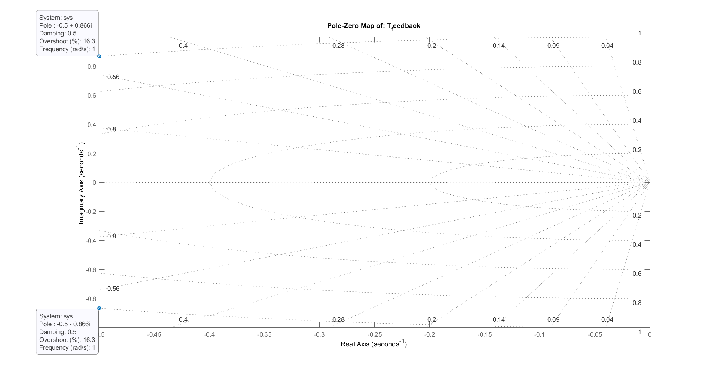Output:

Poles of T_feedback:

-0.5000 + 0.8660i

-0.5000 - 0.8660i

Damping ratio (ζ): 0.500

Natural frequency (ωn): 1.000 rad/s

Q6,Q7 is done