
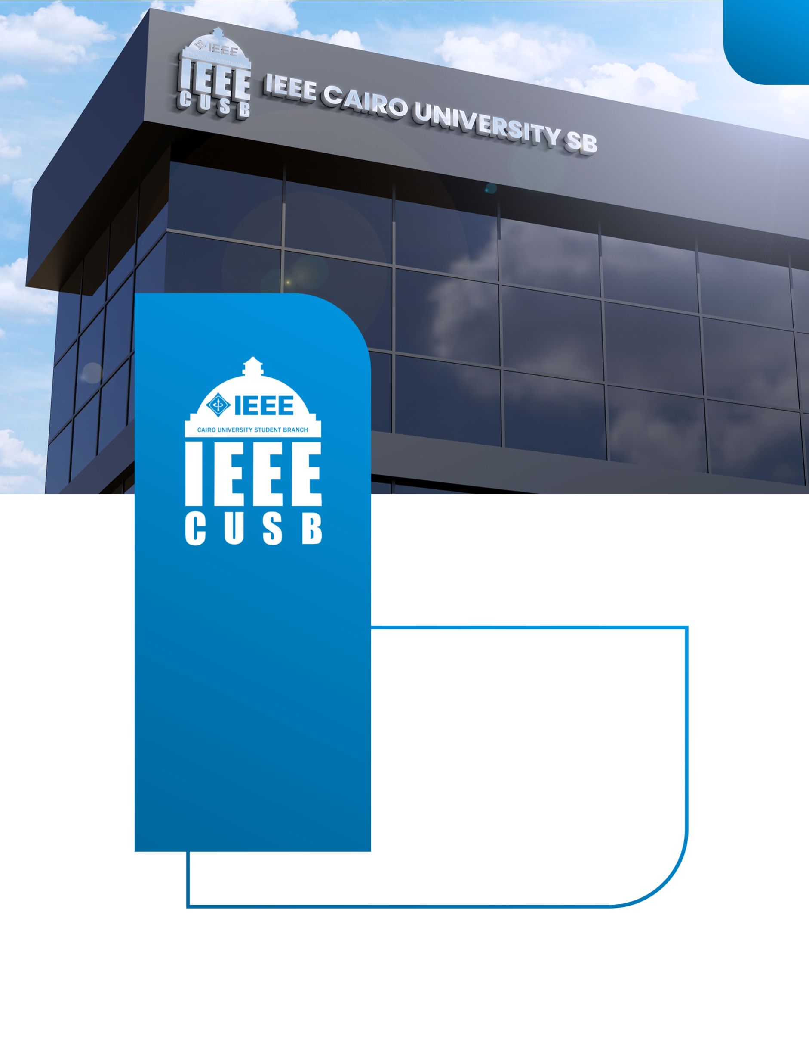
Content
Embedded AVR Work
2025-2026
ieeecusb
IEEE CAIRO UNIVERSITY
STUDENT BRANCH



IEEE CUSB – AVR Workshop

Detailed Session Guide (Instructor Version)
- For every session, we define three things:
- Session Content (what is taught)
- In-Session Assignment (done live with instructor)
- Pre-Session Task (home task before next session)
- The students will deliver their task in their own repo

Detailed Continuous Session Plan (Final Version)

Session 1 – Embedded Systems Concepts

Session Content
- What is Embedded Systems?
- Microcontroller vs Microprocessor
- AVR family overview
- Memory map (Flash / SRAM / EEPROM)
- Registers
- Datasheet reading
- Clock system
- Polling vs Interrupt

In-Session Assignment
- Read ATmega32 datasheet:
  - Identify GPIO registers
  - Identify ADC block

Pre-Session Task
- Short technical report:
  - Where is DDR register located?
  - Difference between SRAM and Flash

Session 2

Session 2 – C Programming (Part 1)

Session Content
- GitHub Intro
- Data types
- Operators
- if / switch
- for / while loops
- Bitwise operations

In-Session Assignment
- Implement basic bit manipulation functions:
  - SetBit()
  - ClearBit()

Pre-Session Task
- Implement:
  - ToggleBit()
(Using only bitwise operations)

Session 3

Session 3 – C Programming (Part 2)

Session Content
- Functions
- Arrays
- Pointers
- Structs
- Macros (#define, #if)
- Header files
- Header guards

In-Session Assignment
- Build reusable Calculator Driver:
  - Add()
  - Sub()
  - Mul()
  - Div()

Pre-Session Task
- Create a Mini Matrix Library:
  - matrix.c / matrix.h
  - Support:
    - Matrix addition
    - Matrix subtraction
(Using structs + pointers only)

Session 4

Session 4 – GPIO + Layered Architecture

Session Content
- MCAL vs HAL vs APP
- GPIO registers
- Input vs Output
- Pull-up vs Pull-down

In-Session Assignment
- Build:
  - Button → LED system
  - Using layered architecture

Pre-Session Task
- Design:
  - Traffic light system with ON/OFF button

Session 5

Session 5 – LCD & Keypad

Session Content
- LCD interfacing
- Keypad scanning

In-Session Assignment
- Display:
  - Keypad value on LCD

Pre-Session Task
- Extend Traffic Project:
  - Add LCD
  - Add keypad password system

Session 6

Session 6 – Interrupts

Session Content
- ISR concept
- External interrupts
- Global interrupt enable

In-Session Assignment
- External interrupt:
  - Button → Toggle LED

Pre-Session Task
- Extend Traffic Project:
  - Add emergency interrupt button

Session 7

Session 7 – Timers & ICU

Session Content
- Timer modes
- Prescalers
- Input capture

In-Session Assignment
- Two LEDs:
  - One blinks fast
  - One blinks slow

Pre-Session Task
- Modify Traffic Project:
  - Replace delays with hardware timers

Session 8

Session 8 – PWM & ADC

Session Content
- Analog vs Digital
- PWM
- ADC

In-Session Assignment
- Potentiometer controls LED brightness

Pre-Session Task
- Extend Traffic Project:
  - Add motor
  - Potentiometer controls speed

Session 9

Session 9 – UART

Session Content
- Serial communication
- Baud rate
- TX / RX

In-Session Assignment
- Send:
  - Sensor data to PC

Pre-Session Task
- Extend Traffic Project:
  - Add second MCU
  - One sends data, one displays on LCD

Session 10

Session 10 – I2C & SPI

Session Content
- I2C vs SPI
- Master / Slave
- Real devices

In-Session Assignment
- Use:
  - LCD over I2C

Final Task
- Final Project:
  - Choose idea
  - Draw block diagram
  - Define peripherals
  - Prepare documentation

