
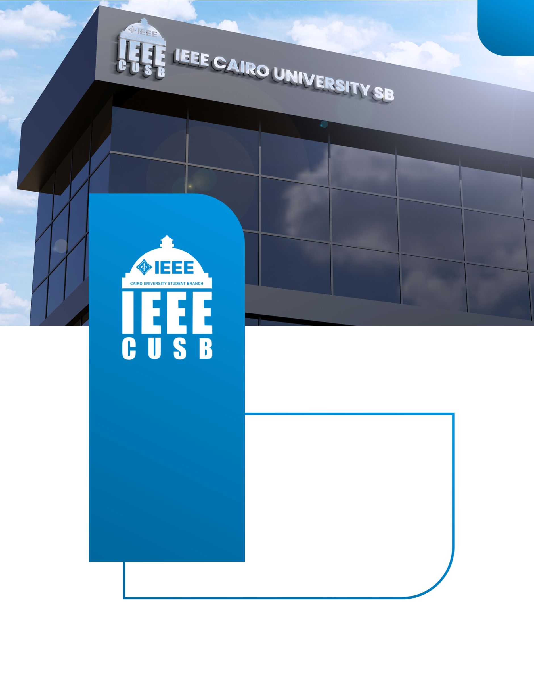
Embedded AVR Work
Plan
2025-2026
ieeecusb
IEEE CAIRO UNIVERSITY
STUDENT BRANCH


IEEE CUSB – AVR for Beginners Workshop

Workshop Overview
- Title: Embedded AVR for Beginners
- Track Type: Foundational
- Duration: 10 Sessions (2–3 hours each)
- Target Audience:
- First-year & second-year engineering students
- Anyone with zero background in embedded systems
- Workshop Goal:
To build strong fundamentals in C programming and bare-metal embedded systems and prepare students to develop a competition-ready mini project.

Hardware & Tools
- Required Hardware
- ATmega32 board
- Breadboard
- LEDs, resistors, buttons
- Potentiometer
- LCD
- Wires
- Software
- Atmel Studio
- Proteus (for simulation)
- GitHub (for code templates)

Session Plan
Session | Content
0 | Intro + Environment Setup
1 | C Programming – Part 1
2 | C Programming – Part 2
3 | Embedded Systems Concepts
4 | GPIO + Layered Architecture
5 | Interrupts
6 | Timers & ICU
7 | PWM & ADC
8 | LCD & Keypad
9 | UART
10 | I2C & SPI

Instructor Guidelines
For each instructor Must submit:
- Session slides
- Lab code
- Protous Simulation
- Feedback report

Final Project

Final Project Rules:
- Must use at least 4 peripherals
- Must have:
  - Sensors
  - User interface
  - Real logic (not blinking LEDs)
- Must include:
  - README
  - Block diagram
  - Flowchart

Examples:
- Smart fan controller
- Digital thermostat
- Access control system
- Mini weather station

