

Cairo University

Facility of Engineering

Electrical, Electronics and Communication Engineering

Third Year

First Term

**Thermostatic control of temperature Using On/Off switch  
Control Assignment 2**

|  |  |  |
| --- | --- | --- |
| Student Name | Section | B.N. |
| يوسف اشرف محمد ابوطالب | 4 | 9220972 |
| يوسف خالد عمر محمود | 4 | 9220984 |

Presented by

**Instructors: Dr.** Ahmed Ismail

**Eng.** Ahmed Amr

# Simulation:

## System Description:

We need to implement a model of the thermostatic control of a water tank that is heated electrically. The thermostat switches the heater **ON** when the temperature falls below the setpoint minus a differential gap (±2) and **OFF** when the temperature exceeds the setpoint plus the gap.

The water tank dynamics include:

1. A steady-state rise of **8°C per amp** of heater current.
2. A **first-order lag** with a time constant (τ) of **9 minutes**.
3. A **dead time** (θ) of **0 minutes,** **0.5 minutes**, extended to **4.5 minutes** for the third simulation.

The system starts at an initial temperature of **25°C** with the heater OFF, and the setpoint temperature is **50°C** with a differential gap of **2°C**. The heater supplies **10 amps** when ON.

We will the simulation for **30** minutes.

## Matlab Simulink Simulation:

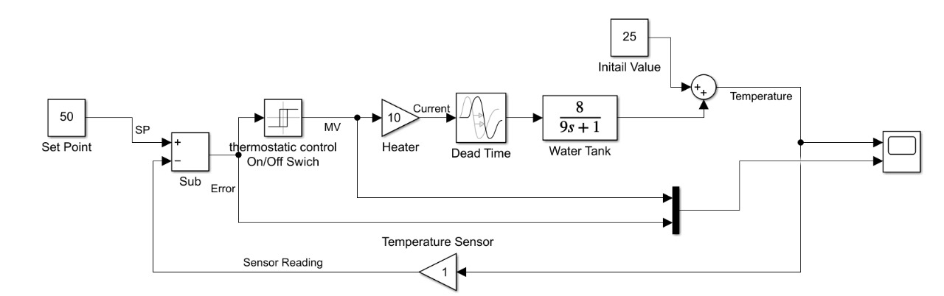

Figure 1 Simulink System Simulation

As shown in *Fig[1]*,The system is implemented using the following Simulink blocks:[1]

### Constant Blocks:

Figure 2 Constant Blocks

As shown in *Fig[2]*, We use them to define fixed values in the system, including:

* **Initial temperature** of 25 °C.
* **Setpoint temperature** of 50 °C.

#### 2. Subtractor Block:

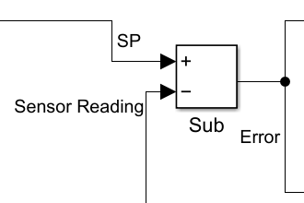

Figure 3 Subtractor Block

As shown in *Fig[3]*, We use it to calculate the error between the current temperature and the setpoint.

#### 3. Relay Block:

Figure 4 Relay Block

As shown in *Fig[4]*, We use it to serve as an ON/OFF controller with hysteresis (differential gap of ±2°C):

* **Switch ON:** 48°C.
* **Switch OFF:** 52°C.

#### 4. Gain Block:

Figure 5 Gain Block

As shown in *Fig[5]*, We use it to simulate the heater's effect, where the heater’s current is 10 Amp.

*Figure 10.the magnitude spectrum of the first signal @20000 Hz.(input and output) in frequency response*

#### 5. Transport Delay Block:

Figure 6 Transport Delay Block

As shown in *Fig[6]*, We use it to account for the dead time in the system.

* **Dead Time**:0 minutes for the first simulation, 0.5 and 4.5 minutes for the second and third simulations.

#### 6. Transfer Function Block:

Figure 7 Transfer Function Block

As shown in *Fig[7]*, We use it to represent the water tank's first-order lag with the transfer function:

Equation 1 Water tank transfer function

$$T\left(S\right)=\frac{8}{9s+1}$$

As shown in *Equ[1]*, The first order lag has:

* **Static Gain (K) = 8** (8°C rise for every amp)
* **Time Constant (τ)= 9** minutes.

The simulation successfully models the thermostatic control of the water tank. The first-order lag and dead time significantly influence the system's behavior, with longer dead times increasing temperature variations.

*Figure 11 the magnitude spectrum of the first sgnal @20000 Hz.(input and output) (Hz)*

# Results:

# The graphs show the yellow is the PV, the red line is the error and the blue is the MV.

## 1) No Dead Time:

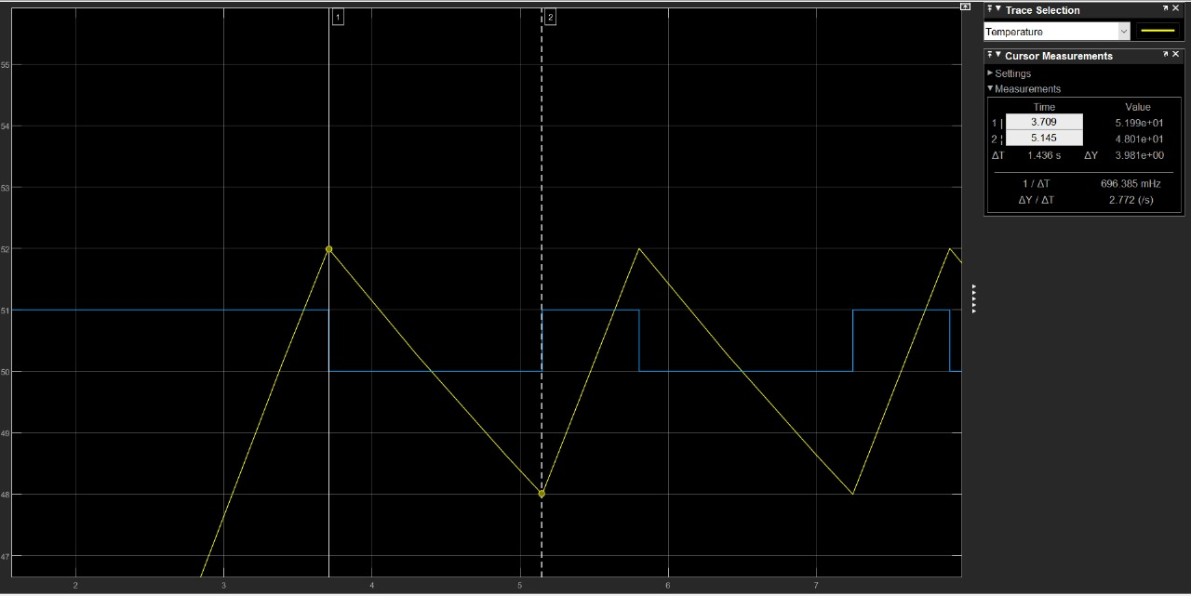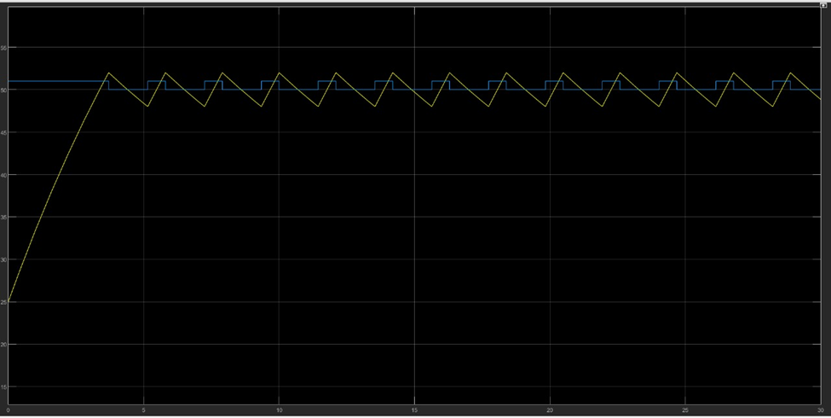

Figure 9 PV peak to peak without any dead time

Figure 8 PV graph without any dead time

As shown in *Fig[8]* and *Fig[9]*, The controller works as intended with

Peak-to-Peak value = 52-48 = 4°C

## 2) Dead Time (0.5 min):

*Figure 31 Transmitter and Receiver design*

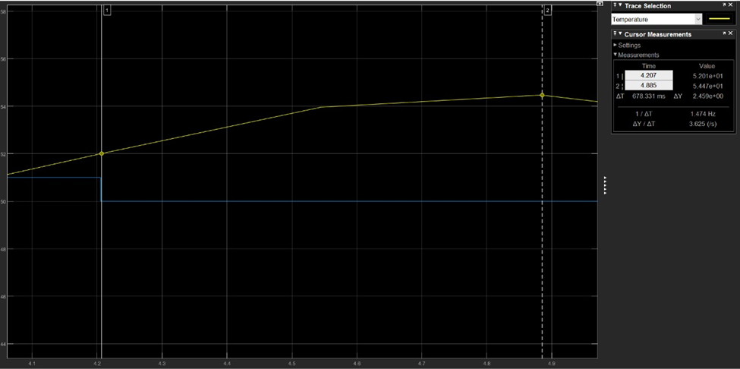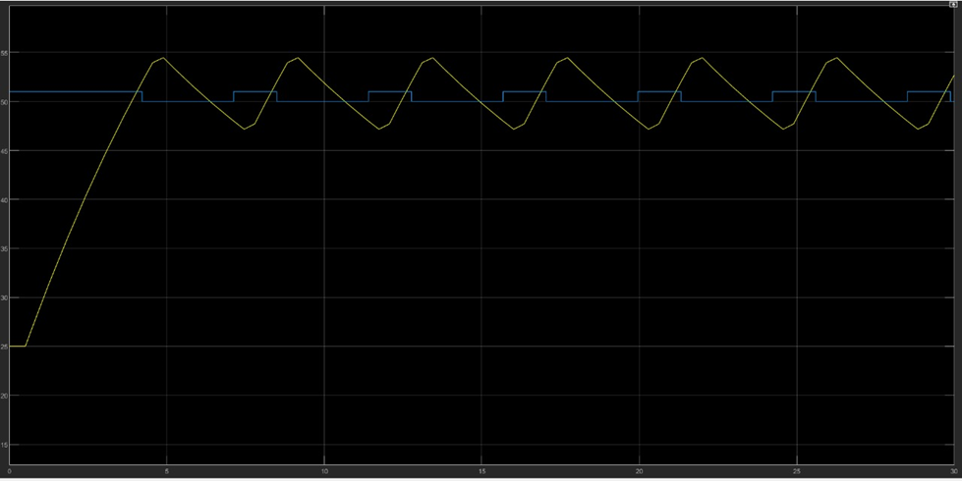

Figure 11 effect of the dead tme”0.5 min” on PV

Figure 10 first order lag with delay 0.5 min

As shown in *Fig[10]* and *Fig[11]*, The PV is getting out of its boundary (±2°C) due to the delay.

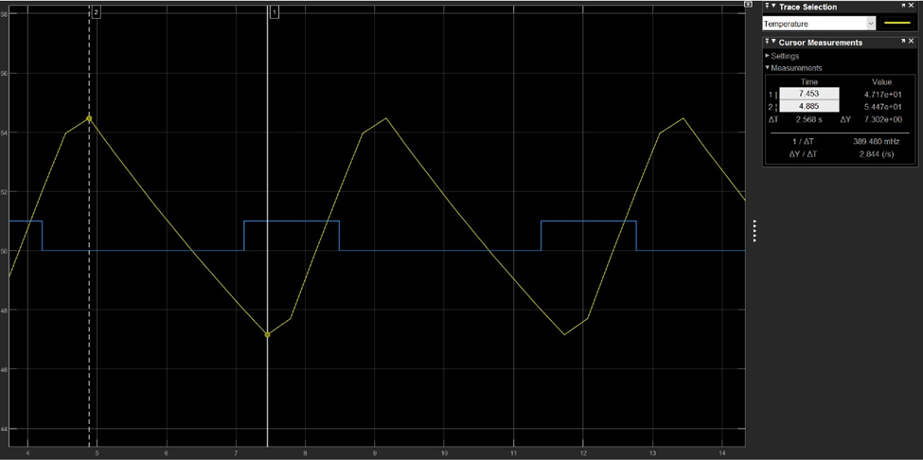

Figure 12 PV peak to peak with dead time “0.5 min”

As shown in *Fig[12]*, The PV peak-to peak value increased, but it is acceptable.

Peak-to-Peak value = 54-47 = 7°C

## 3) Dead Time (4.5 min):

*Figure 31 Transmitter and Receiver design*

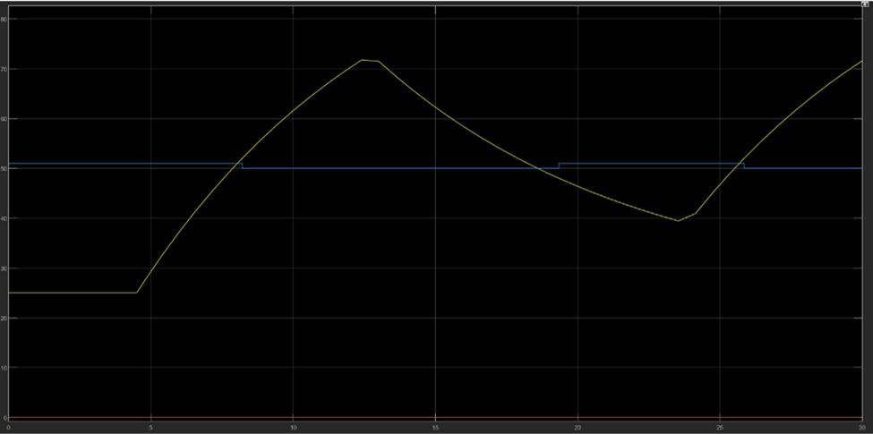

Figure 14 effect of the dead tme”4.5 min” on PV

Figure 13 first order lag with delay 4.5 min

As shown in *Fig[13]* and *Fig[14]*, The PV isn’t restricted with its boundary (±2°C) anymore due to the delay.

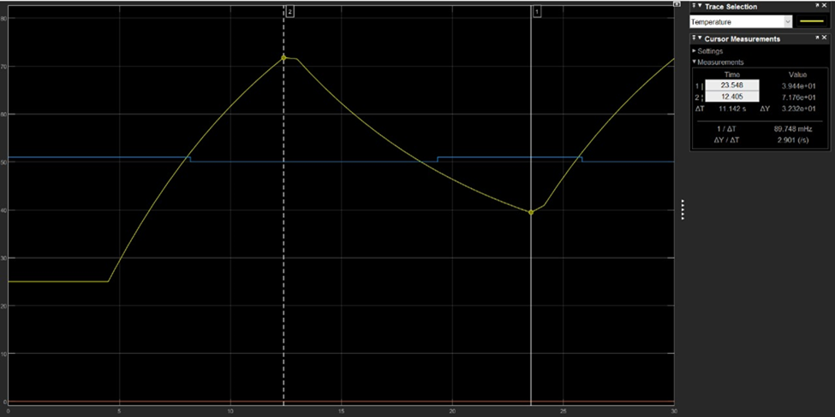

Figure 15 PV peak to peak with dead time “4.5 min”

As shown in *Fig[15]*, The PV peak-to peak value has significantly increased, indicating that the system is now out of control.

Peak-to-Peak value = 71-39 = 32°C

# Conclusion:

As the dead time increases, controlling the system becomes harder.

The results highlight the failure of the controller to maintain stability and regulate the system effectively.

We can notice that the dead time causes issues. When the controller is off the temp is still rising for the dead time period so it does not achieve the specification with large dead times.

# References:

[1] <https://github.com/youefkh05/ON-OFF_Switch_Thermostate->