 

**Electronics and Electrical Communications Engineering  
Department**

**Faculty of Engineering**

**Cairo University**

**Streetlight Monitoring System**

**Submitted to**: Dr. Mahmoud El-Hadidi

**Analysis of the Merbok Estuary Oyster Farm IoT Deployment**

**Initial Report submitted for course ELC4015 “Selected Topics in Communications: Internet of Things“**

**4th Year**

**1st Semester - Academic Year 2025/2026**

**Prepared by:**

|  |  |  |
| --- | --- | --- |
| **NAME** | **SECTION** | **ID** |
| **Youssef Khaled Omar Mahmoud** | **4** | **9220984** |

**Submission Date:** 21 October 2025

# Table of Contents

1- Table of Contents 2

2- Table of Figures 2

3- List of tables 2

4- Summary 3

5- Research Limitations and Author Outreach 3

5.1 Formal Correspondence and Author Acknowledgement 3

5.2 Summary of Key Correspondence Points 4

5.3 Critical Research Limitations 5

6- Detailed Analysis of the 12 Required Points **Error! Bookmark not defined.**

6.1 Specific Name of IoT Application 5

6.2 Specific Date for Case-Study Implementation 6

6.3 Name of IoT Vertical Application 6

7- Specific Functions Performed by IoT in the Case Study 6

7.1 Functions Performed by the Sensing Devices 6

7.2 Functions Performed by the LoRaWAN Gateway 7

7.3 Functions Performed by the Cloud and Application Layer (AWS) 8

8- References: 13

# Table of Figures

Figure 1 Screenshot of Sent Email 4

Figure 2 Dr. Tatsuya Yurimoto Response 4

Figure 3 WS-2902 Home Wi-Fi Weather Station 6

Figure 4 Buoy Node Developed circuit board **Error! Bookmark not defined.**

Figure 5 AWS services diagram **Error! Bookmark not defined.**

# List of tables

Table 1 Dr. Tatsuya Yurimoto Response Summary 4

Table 2 Follow-Up Inquiry 5

Table 3 WS-2902 functions 7

Table 4 LoRaWAN Gateway Functions 7

Table 5 AWS Functions 8

# Summary

This report analyzes the IoT deployment detailed in the publication, **“Observation of the Freshwater Inflow Event Using IoT Devices at an Oyster Farm in the Merbok Estuary During Monsoon”** (Yurimoto et al., 2025)[1]

The system represents an "actually implemented" solution utilizing **commercially available observation devices** (specifically the Ambient Weather WS-2902 series). The application focuses on establishing a real-time monitoring system within the oyster farm environment, primarily observing changes in water temperature and salinity during the monsoon season.

This report evaluates the project according to the **12 analytical** points required for **ELC4015**, confirming its implementation status and identifying specific research limitations.

# Research Limitations and Author Outreach

While the environmental observations and results are **fully documented** in the publication, specific details regarding the communication architecture, hardware specifications, and formal performance metrics were **not provided** in the original paper.

This section acknowledges the successful outreach to the authors, integrates their clarifying information, and addresses the remaining knowledge gaps.

## Formal Correspondence and Author Acknowledgement

The primary goal of the inquiry was to gather undocumented technical details necessary to analyze the Merbok Estuary IoT deployment for this academic coursework. The kind and prompt response from **Dr. Tatsuya Yurimoto** and his co-authors successfully clarified the system's architecture while simultaneously defining the limitations of the available engineering data. We formally acknowledge their support.

As shown in figure 1, A formal email was sent on **October 17, 2025 (7:25 PM)** to the project’s lead author — via yurimoto@outlook.com

As shown in figure 1, the message, titled “Inquiry Regarding Deployment and Network Details of Your Open-Source Fish-Farming IoT Buoy System”.

The message, titled “**Inquiry Regarding Deployment and Network Details of Your Open-Source Fish-Farming IoT Buoy System**,” requested clarification on key technical points **missing** from the publication. These inquiries included the deployment scale and duration, the specific communication architecture (such as topology, protocols, and backhaul type), power supply, and confirmation of any recorded performance metrics or available schematics.

It emphasized the academic purpose of the request—to ensure accurate documentation of the system within this research report.

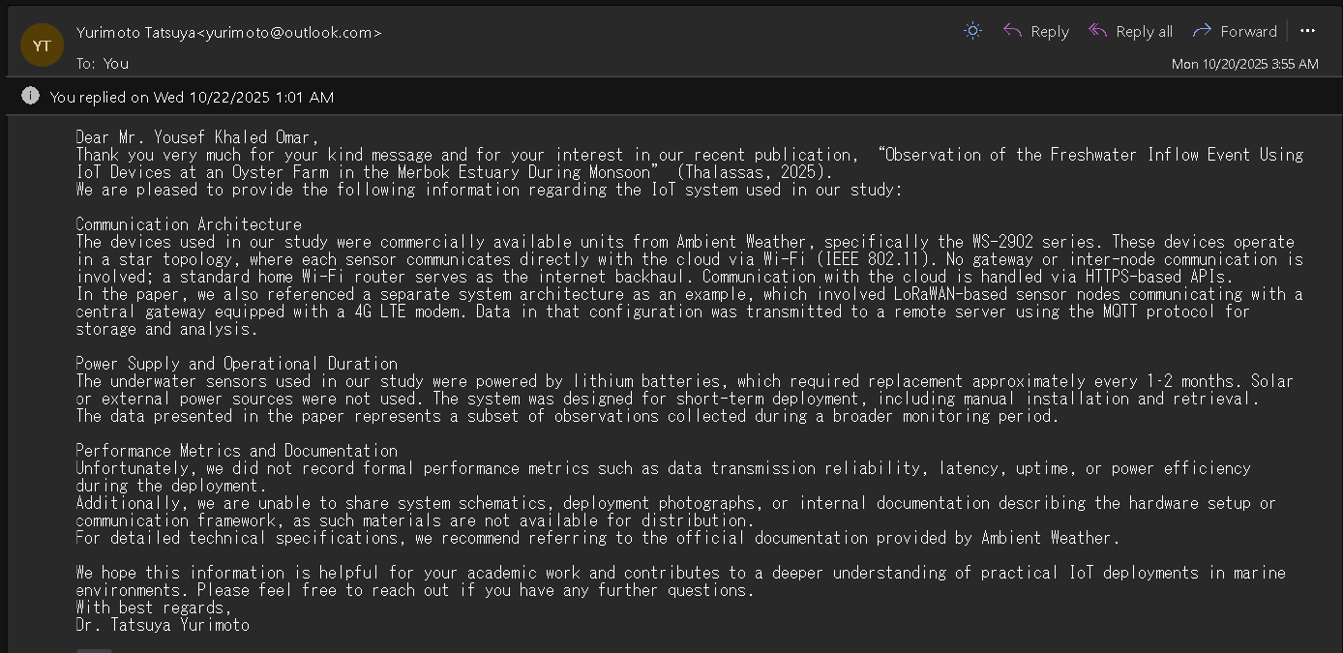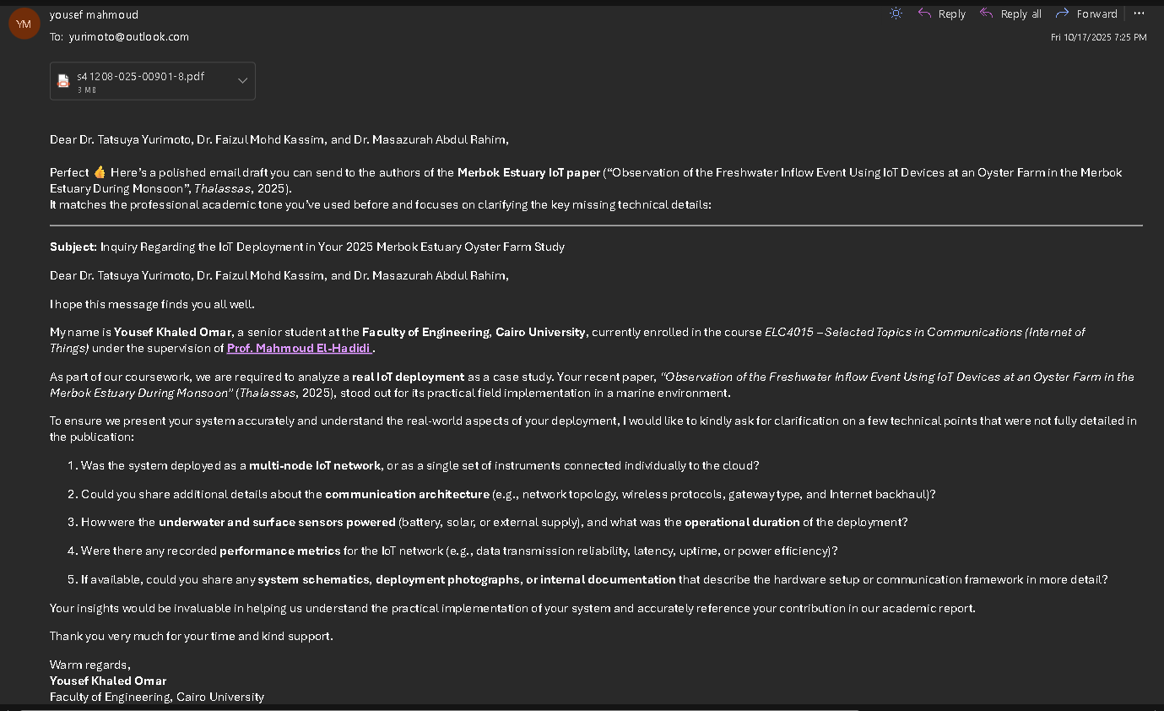

Figure 1 Dr. Tatsuya Yurimoto Response

Figure 2 Screenshot of Sent Email

As shown in figure 2, **Dr. Yurimoto responded promptly to these inquiries, providing the essential technical clarifications summarized below.**

## Summary of Key Correspondence Points

Table 1 Dr. Tatsuya Yurimoto Response Summary

|  |  |  |
| --- | --- | --- |
| Query Topic | Author Confirmation / Clarification | Implication for Analysis |
| System Identity | Confirmed to be commercial **Ambient Weather WS-2902 series** devices. | Analysis must rely on publicly available technical specifications. |
| Network Architecture | **Star topology** using **Wi-Fi (IEEE 802.11)** with a standard home Wi-Fi router as the backhaul. **No gateway** or inter-node communication. | Defines the system as a high-bandwidth, short-range COTS solution. |
| Power & Duration | Powered by **lithium batteries** requiring replacement every **1–2 months**. No solar or external supply. | Confirms high power consumption typical of continuous Wi-Fi transmission. |
| Performance Metrics | **None recorded** (No data on reliability, latency, uptime, or power efficiency). | These metrics constitute the **critical research limitations** of this report. |
| Documentation | **Unavailable.** (No schematics, photos, or internal documentation can be shared). | Prevents detailed component-level or installation analysis. |

after reading table 1, To enrich our analysis by comparing a commercial (Wi-Fi) and a custom **LPWAN** deployment, we intend to contact the authors again to clarify a few points regarding the **LoRaWAN** system they referenced in their response. We fully understand that this system was not the primary focus of the published paper.

Table 2 Follow-Up Inquiry

|  |  |
| --- | --- |
| Purpose | Detail |
| Deployment Location | Was this LoRaWAN system also deployed at the Merbok Estuary, or was it a separate project used for comparative research? |
| Hardware (MCU) | What was the primary **microcontroller/MCU** used for the custom LoRaWAN sensor nodes? (e.g., ESP32, STM32, or a similar board). |
| Gateway Model | Could you mention the general model or brand of the **LoRaWAN gateway** that was paired with the 4G LTE modem? |
| Code Repository | Since technical documentation cannot be shared, we wanted to ask if the source code for the LoRaWAN system (or any other custom code related to your research) is available on a public repository, such as **GitHub**? |

## Critical Research Limitations

Despite the authors' helpful clarification, several critical parameters required for a detailed engineering analysis are confirmed to be unavailable or unrecorded, leading to necessary limitations in this report's scope:

* **Deployment Documentation:** System schematics, deployment photographs, or internal documentation are not available for distribution.
* **Performance Metrics:** The authors confirmed they **did not record formal performance metrics** such as data transmission reliability, latency, uptime, or power efficiency during the deployment.
* **Specifics:** Technical specifications beyond the general model must be inferred from the **official documentation provided by Ambient Weather**, as detailed documentation of any custom modifications is unavailable.

# Specific Name of IoT Application

The application is **Real-Time Environmental Monitoring of an Oyster Farm during Monsoon**. Its objective is to observe the impact of freshwater inflow events on water quality parameters critical for aquaculture health.[1]

# Specific Date for Case-Study Implementation

The paper documenting the project was published in **2025**. The data presented was collected during the **2024 monsoon season (October–November)**, representing a short-term, specific-event monitoring period.[1]

# Name of IoT Vertical Application

The system operates within the vertical of **Smart Agriculture**, specifically **Precision Aquaculture / Water-Quality Monitoring in Marine Environments**. The key focus is on rapid data collection to understand environmental stressors (like salinity changes) during transient weather events.[1].

# Specific Functions Performed by IoT in the Case Study

The system's operation is divided into three functional layers: **Sensing Devices** (data acquisition), **Wi-Fi Router** (network bridge), and the **Cloud Services** (data processing and storage).[1, 3].

## Functions Performed by the Sensing Devices

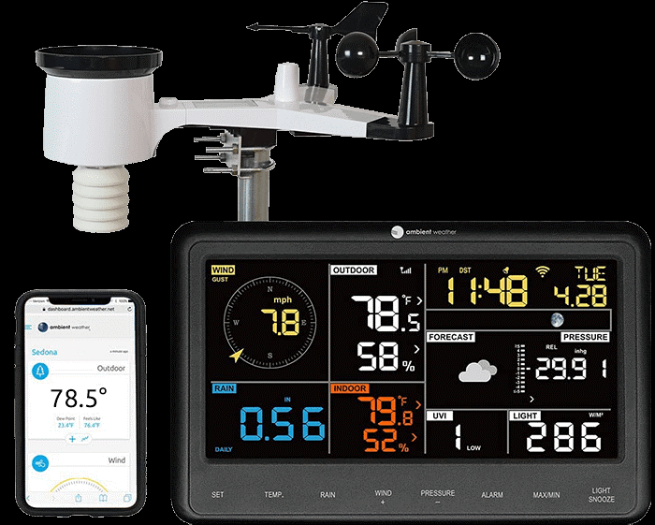The COTS sensing devices (buoys) such as Ambient Weather WS-2902 are responsible for interacting directly with the physical environment, acquiring data, and preparing it for network transmission.[1].

Figure 3 WS-2902 Home Wi-Fi Weather Station

Figure 4 WS-2902 Home Wi-Fi Weather Station

As shown in figure 3[3],We can some of the **Sensing Devices functions**:

Table 3 Sensing Devices functions

|  |  |  |
| --- | --- | --- |
| Function | Detail | Technical Implication |
| Sensing/Acquisition | Devices read water temperature and salinity via specialized probes. | Sensors are integrated into a self-recording unit with built-in Analog-to-Digital Conversion (ADC). |
| Local Data Processing | The internal microcontroller formats, calibrates, and time-stamps the sensor readings into a structured data packet. | This processing is handled internally by proprietary firmware. |
| Wireless Transmission | Utilizes the integrated **Wi-Fi (IEEE 802.11)** module to connect to the local router and initiate data packet transmission. | Requires significant power draw, leading to limited battery life (1–2 months). |
| Cloud Ingestion | The device establishes a secure **HTTPS** connection to the proprietary Ambient Weather Cloud API to upload data. | Ensures data integrity and security during the transport layer. |

## Functions Performed by the WI-FI Router

The **Wi-Fi Router (network bridge)** is the central component in the star topology, handling all local network and routing functions, acting as the critical link between the local sensors and the global Internet[2]

We can see the **Functions Performed by the Wi-Fi Router**

Table 4 Wi-Fi Router Functions

|  |  |  |
| --- | --- | --- |
| Function | Detail | Technical Implication |
| Network Access Point (AP) | Provides the **IEEE 802.11** wireless access point that the sensor nodes use to join the local network. | Enables the high-speed, short-range connectivity required by the COTS devices. |
| Local Security (L2) | Implements **WPA2/WPA3** encryption to secure the wireless link between the sensors and the router. | Protects the raw sensor data packets from eavesdropping on the local network. |
| Network Address Translation (NAT) | Translates the private IP addresses of the sensor nodes into the single public IP address needed to communicate with the Cloud Services over the Internet. | Facilitates access to the wide area network (WAN) from the local network (LAN). |
| Routing/Backhaul | Forwards the sensor data packets (tunneled via HTTPS) from the local network to the public Internet, and ultimately to the Ambient Weather Cloud server. | Provides the necessary uplink capacity to the Internet Service Provider (ISP). |

## Functions Performed by the Cloud Services

The **Cloud Services** layer (proprietary **Ambient Weather** Cloud Platform) performs all the application-level tasks, including secure data handling, long-term storage, and providing the user interface.[1, 3]

We can see the **Cloud Services Functions:**

Table 5 Cloud Services Functions

|  |  |  |
| --- | --- | --- |
| Function | Detail | Technical Implication |
| Secure Ingestion Endpoint | Provides a highly available, secure **HTTPS** server endpoint that receives the authenticated and encrypted data stream from the field devices. | Guarantees the security and authenticity of the data source before processing. |
| Data Parsing and Processing | Decodes the proprietary data payload received from the COTS devices, validates timestamps, and performs any necessary unit conversions or checks. | Prepares the raw data for storage and analysis. |
| Data Storage (Database) | Stores the validated time-series sensor data in a persistent, scalable cloud database solution. | Enables historical trend analysis and long-term research based on the collected environmental parameters. |
| Data Visualization & Access | Provides the user interface (web dashboard) that allows researchers to view real-time data, download historical records, and manage the devices. | Fulfills the final goal of the system: providing actionable insights to the researcher. |

# More Details for the IoT Application

## Location and Topology of IoT Nodes

as shown in figure 4, the **IoT Nodes** are commercially available devices adapted for the water environment (buoys). They are deployed within the oyster farm area in the **Merbok River Estuary**. The system employs a **Star Topology** as the author told from table 1, where each node communicates directly with the central Gateway.

Figure 4 illustrates the location of the farm and deployed equipment:[1]

**(a) the location of the Merbok Estuary in the Malay Peninsula (red frame)**

**(b) the location of the oyster farm at the mouth of the Merbok (star)**

**(c) an aerial photograph of the oyster farm (arrow)**

**(d) the location of the various equipment installed at the oyster farm: (C) weather camera, (D) depth sensor, (W) weather instrument, and (WS) suspension position of the water quality sensor**. This geographical context establishes the physical boundary for the deployment.

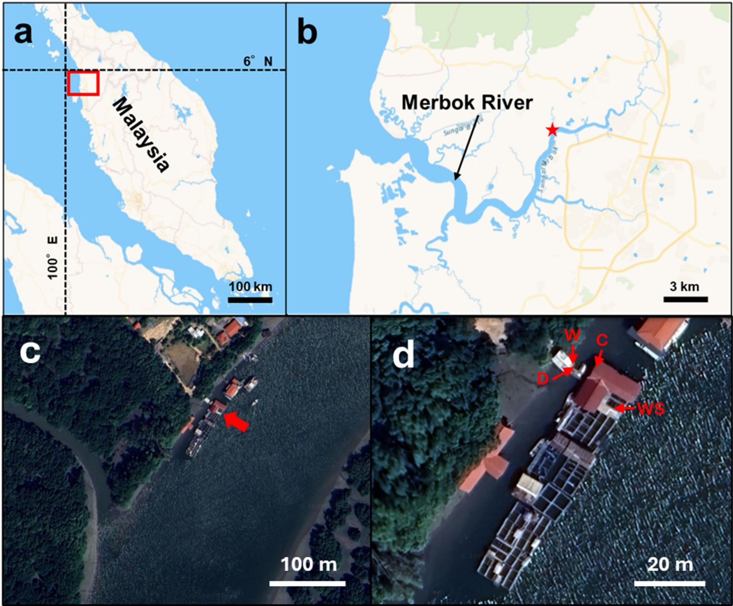

Figure 5 Observation of the Freshwater Inflow Event Using IoT Devices at an Oyster Farm in the Merbok Estuary During Monsoon

## Type/Model of IoT Nodes

The end devices are based on the **Ambient Weather WS-2902 Series** (console/sensor array), adapted into waterproof buoys with water temperature and salinity sensors. Figure 5 provides an overview of the installed devices, **which include (a) a weather meter, (b) a weather camera, and (c) a water temperature buoy, with (d) showing the home page screen displaying live data.[1]**

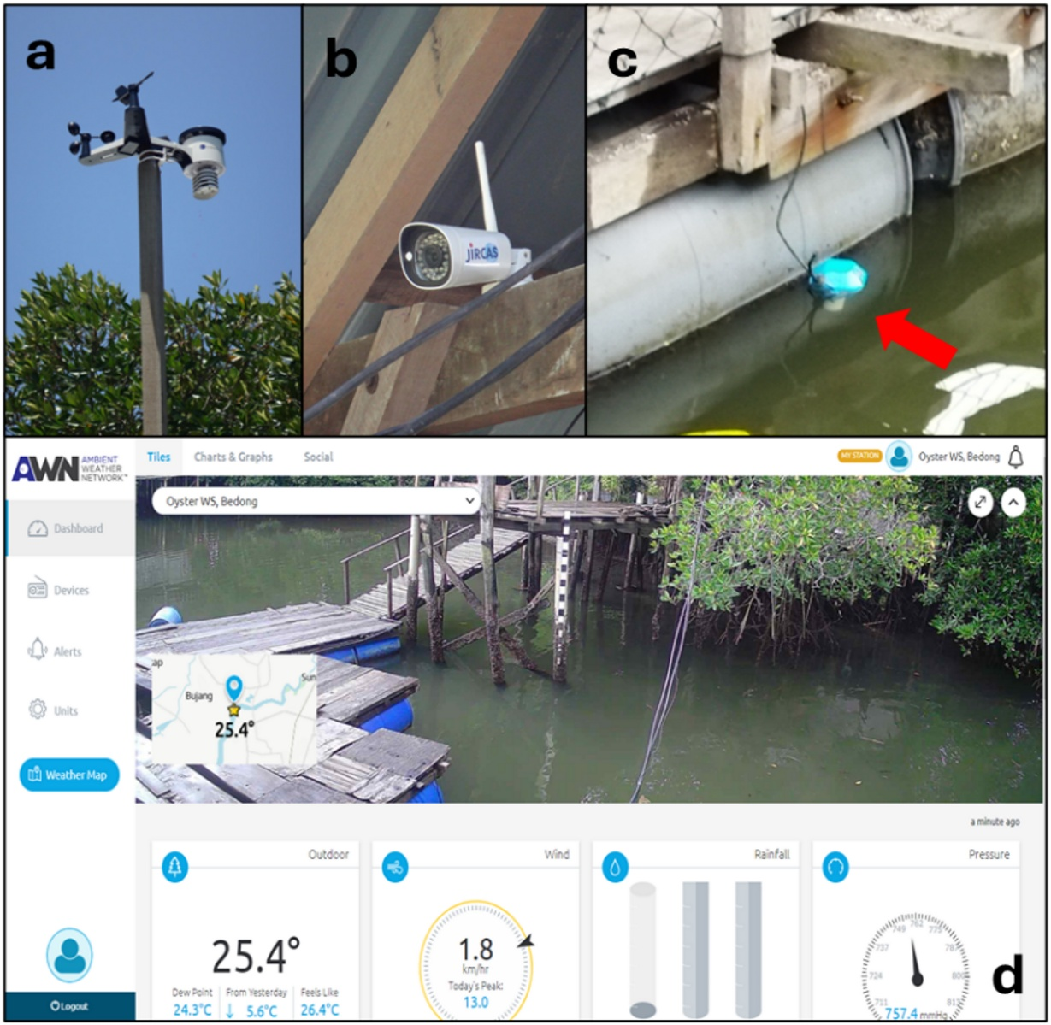

Figure 6 Observation of the Freshwater Inflow Event Using IoT Devices at an Oyster Farm in the Merbok Estuary During Monsoon

Figure 7 Observation of the Freshwater Inflow Event Using IoT Devices at an Oyster Farm in the Merbok Estuary During Monsoon

## Location and Type/Model of Gateway

The Gateway is a standard **Home Wi-Fi Router**, likely located onshore or on a moored structure near the sensor cluster due to Wi-Fi's limited range. It acts as the backhaul bridge. **Each sensor communicates directly with the cloud via Wi-Fi (IEEE 802.11). No specialized gateway logic or inter-node communication is involved; the standard home Wi-Fi router serves strictly as the internet backhaul. Communication with the cloud is handled via HTTPS-based APIs.[2]**

## Internet Connectivity

This connectivity detail is a **logical and necessary conclusion** derived from the known facts about the system's architecture (Node => Router => Cloud), as it was not explicitly stated in the paper or correspondence. Since the local Wi-Fi network must eventually reach the public cloud, the router must be connected to the Wide Area Network (WAN) using a standard ISP technology (like Fiber, DSL, or 4G/LTE) and operate using the universal **TCP/IP protocols**.

The connection from the Gateway to the wider area network is therefore via a standard **ISP link** (e.g., Fiber, DSL, or 4G modem) operating over **TCP/IP**.[1, 2]

## Cloud Connectivity

Data is transmitted over the Internet to the proprietary **Ambient Weather Cloud Platform** (Ambient Weather Network).[3]

## Location of IoT Application Software

The primary IoT application software (data processing, storage, visualization) resides on the proprietary **Ambient Weather Cloud Platform**.[3]

## Man-Machine Interface (MMI)

Researchers access the data and dashboards remotely via a standard **web browser interface** provided by the cloud platform, as shown in Figure 5(d) home page screen displaying live data.[1]

# Details of Wireless Communication Protocol/Standard used for Communication between IoT Nodes

The protocol is **Wi-Fi (IEEE 802.11)**.[2]

Table 6 IEEE 802.11 WIFI Characteristic

|  |  |
| --- | --- |
| Protocol Characteristic | Detail |
| Standard | **IEEE 802.11** (likely a mix of b/g/n standards for COTS devices). |
| Frequency Band | Typically **2.4 GHz ISM** band. |
| Data Rate | High (tens of Mbps), providing high-speed but continuous data upload. |
| Topology | Star topology, requiring direct line-of-sight or coverage from the central router. |

# Details of Wireless Communication Protocol/Standard used for Interconnecting IoT Nodes to the Internet

The interconnection is handled by standard networking protocols:[1 ,2]

1. **Local Link:** **Wi-Fi (IEEE 802.11)** for the local wireless connection.
2. **Transport/Application:** **HTTPS (Hypertext Transfer Protocol Secure)** over **TCP/IP** is used to tunnel the data securely from the local Wi-Fi router, across the public Internet, to the specific cloud ingestion API.

# Routing Protocol Deployed

There are **no specialized routing protocols** deployed within the IoT segment (Node to Router)[1, 2]

* **Node-to-Router:** Standard **Layer 2 (MAC)** addressing and Layer 3 (IP) resolution within the local Wi-Fi segment.
* **Router-to-Cloud:** Standard **IP Routing** is used across the wide area network (Internet).

# IoT Architecture

The architecture is a simplified, vendor-locked, **three-layer model**: [1, 3]

1. **Sensing Layer:** The COTS buoys and weather stations provide data acquisition and local processing.
2. **Network Layer:** The local **Wi-Fi Router** acts as the singular network bridge and backhaul medium.
3. **Application Layer:** The proprietary **Ambient Weather Cloud Platform** handles data storage, security, and visualization.

# Power Requirements for the Transmitters & Receivers of the IoT Nodes

From figure 2, The system exhibits **high power requirements** characteristic of Wi-Fi technology.

* **Power Source:** Lithium batteries (likely AA or similar form factor).
* **Operating Current:** The transceiver draws substantial current (typically ≈100 mA to 300 mA) during transmission bursts.
* **Endurance:** The battery life is critically short, confirmed by the authors as requiring replacement every **1–2 months** due to the continuous high-power consumption associated with maintaining a persistent Wi-Fi connection and high-frequency data uploads.

# Maximum Distance Coverage

The distance coverage is severely limited by the COTS Wi-Fi protocol:[1. 2]

* **Coverage:** Typically 10m to 100m in an outdoor, semi-obstructed environment like an estuary farm.
* **Limitation:** The deployment is highly restricted by the range of the central Wi-Fi Router, forcing a centralized sensor cluster close to the anchor point of the router.

# Security Features/Capabilities Built

Security is reliant on established industry standards for commercial products:[1, 2]

1. **Local Network Security:** **WPA2 or WPA3** encryption is used to secure the wireless link between the sensor devices and the local Wi-Fi router.
2. **Transport Security:** **TLS/SSL (HTTPS)** encryption is used for end-to-end security when transmitting data over the Internet to the proprietary cloud server.

# References:

[1] Yurimoto, T., Kassim, F.M., & Rahim, M.A. (2025). Observation of the Freshwater Inflow Event Using IoT Devices at an Oyster Farm in the Merbok Estuary During Monsoon. Thalassas: An International Journal of Marine Sciences 41(143). <https://doi.org/10.1007/s41208-025-00901-8>

[2] IEEE Standards Association (2020). IEEE 802.11: Wireless LAN Medium Access Control (MAC) and Physical Layer (PHY) Specifications

[3] Ambient Weather (n.d.). WS-2902 Smart Weather Station. Retrieved from <https://ambientweather.com/ws-2902-smart-weather-station>