Introduction
The TMS is a production-ready system designed to streamline the lifecycle of training programs. It integrates program creation, session scheduling, student tracking, and performance analytics into a single interface.

Trainer Management System (TMS) - User Manual

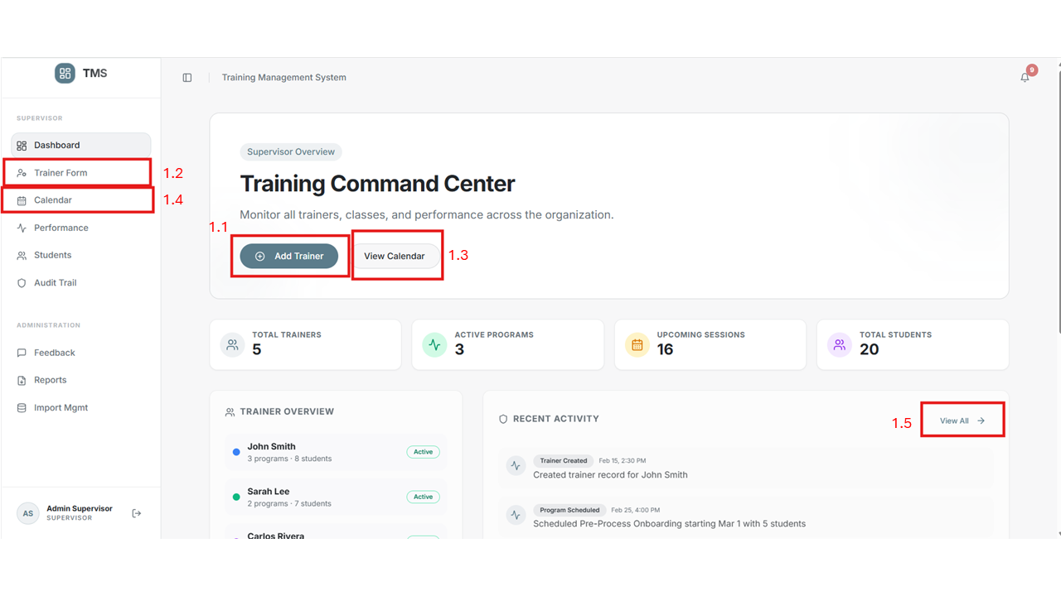
  - – The User (Admin) would click and would take to a trainer form
• This action opens the Trainer Registration Form. Administrators can add new trainers by filling in details like Portal ID, Email, and Trainer Type.
• Key Fields: Portal ID, First Name, Last Name, Email, Role (Lead/Senior), and Status.
  - The Trainer form would contain details to enter
  - View calender would take to the calender page
• The Calendar provides a centralized view of all scheduled sessions. You can filter by trainer or program to see specific timelines.
• Tip: You can drag and drop sessions to reschedule them instantly.
  - Calender page has the information of the Scheduled session created
  - View all would take to the Audit trail which will show the recent activities taken on the app
• The Audit Trail logs every major action in the system, including attendance submissions, program scheduling, and student assignments.
• This ensures accountability and transparency across all user roles.

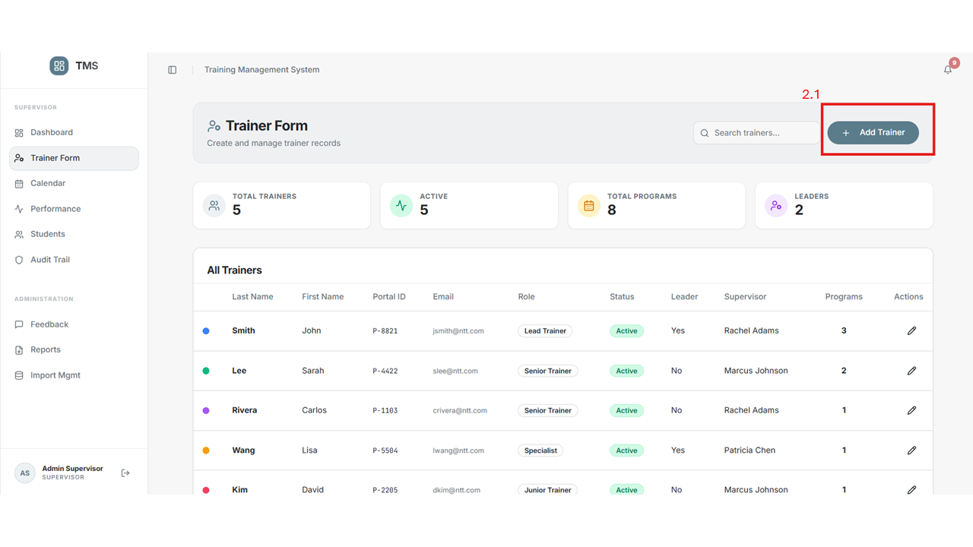
2.1 Admin will click the Add trainer and add the trainer with the information
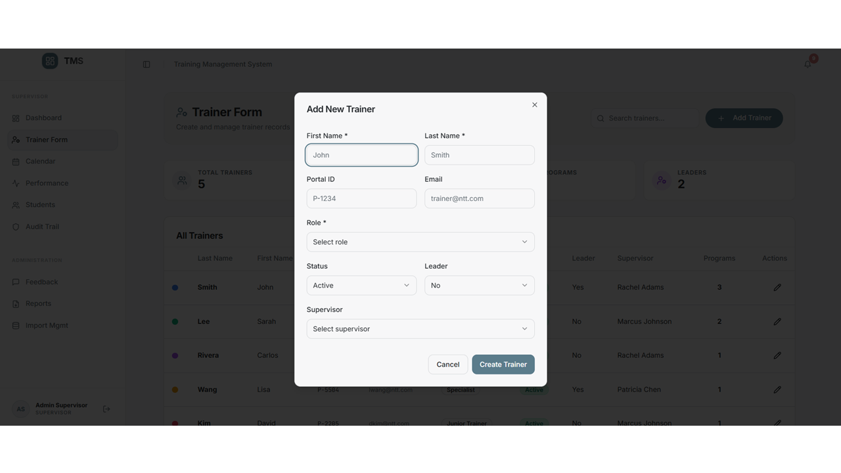

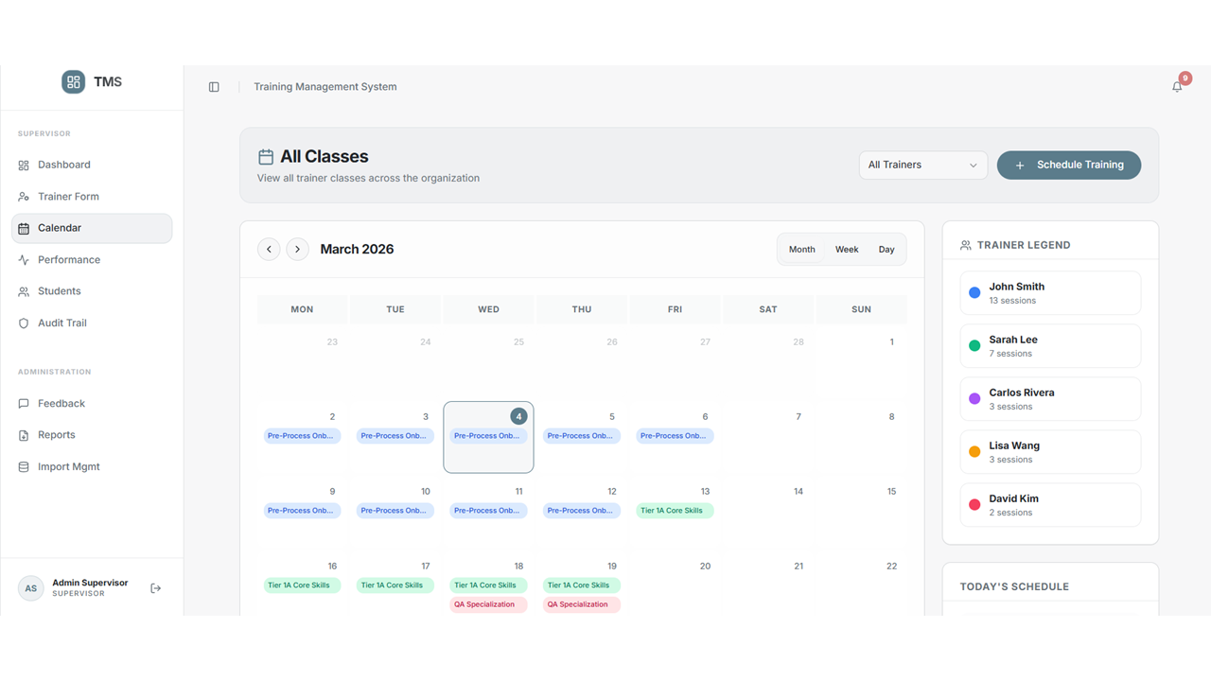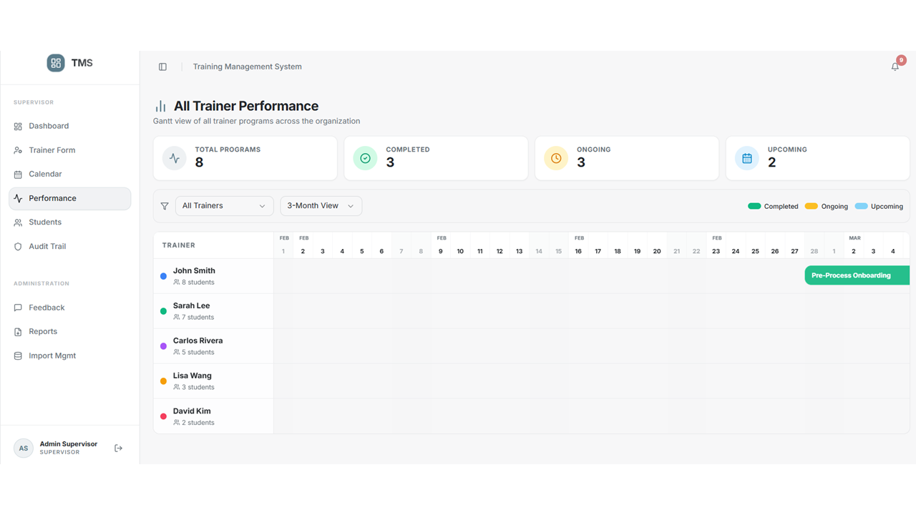
Performance Page would show the admin the Completed Ongoing and Upcoming event for all the trainers
• The Performance tab features a Gantt Timeline showing 'Completed', 'Ongoing', and 'Upcoming' sessions.
• Each trainer is color-coded for easy identification (e.g., John Smith is Blue, Sarah Lee is Emerald).
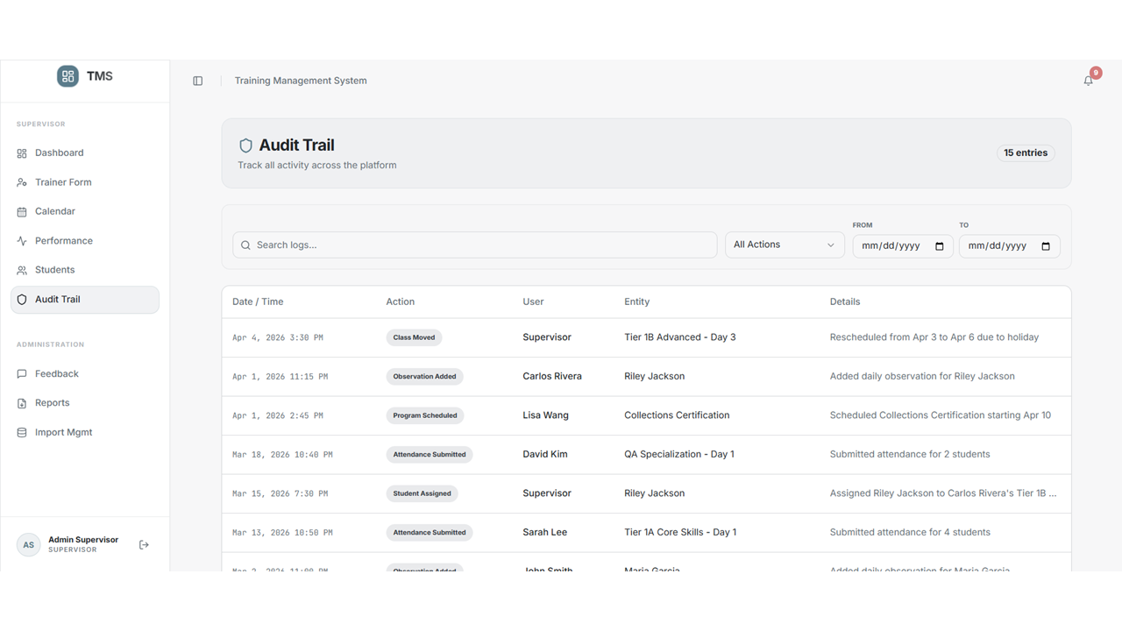

Audit Trail will show all the recent activities done from the Trainer side

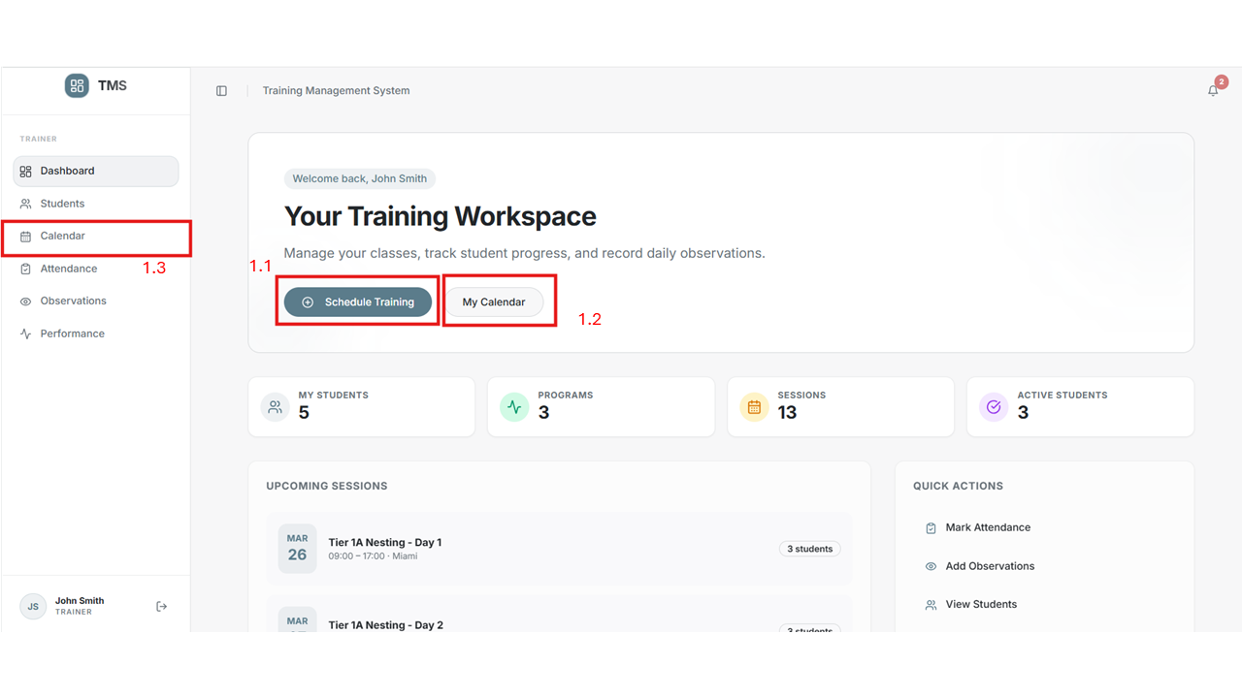
  - The User(Trainer) will the schedule training and add the session details
• Trainers can create new training programs. The system automatically allocates sessions based on the start date and business rules.
• Once scheduled, these sessions appear immediately in the Trainer's and the global Calendar.
  - My Calender would take to the Calender page
  - Calender page would show the scheduled session

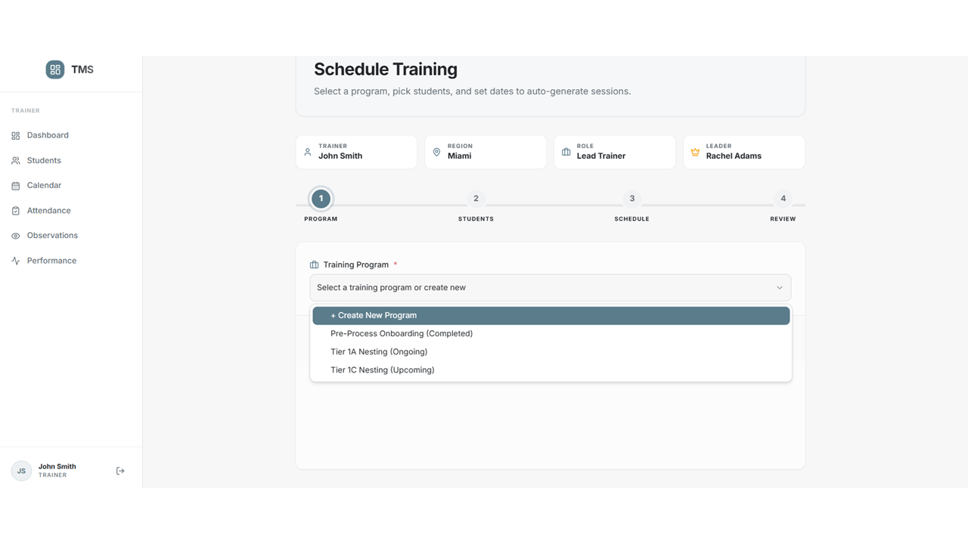

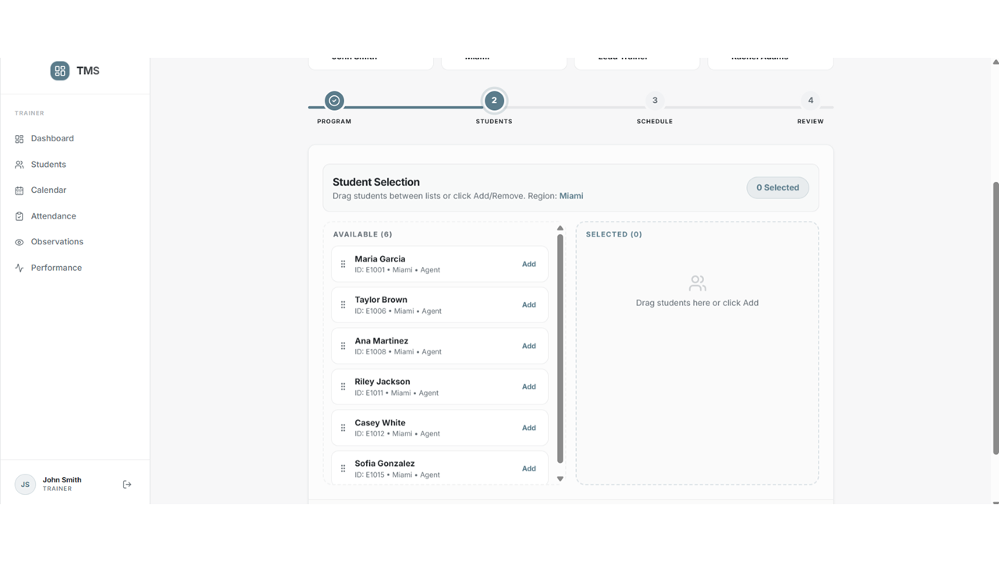

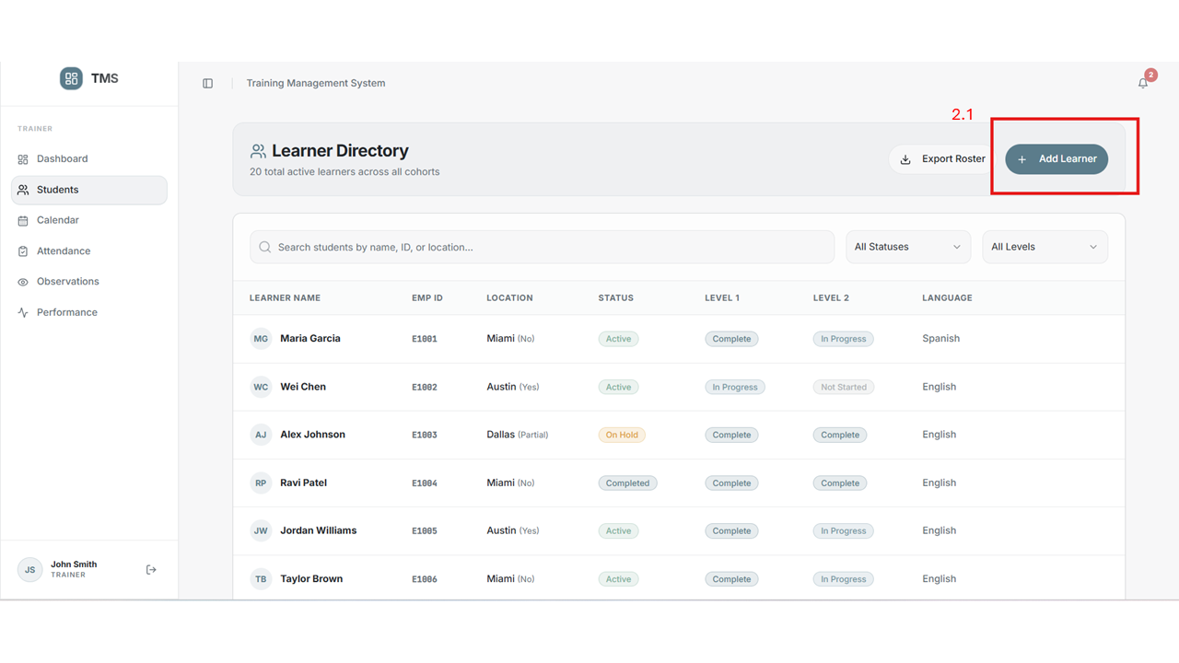
2.1 Add leaner would let the User(Trainer) add students into the system
• Register new students into the system. Capturing detailed information like Emp ID, WFH status, and Language helps in better tracking.
• Student records are persistent and linked to their training history.

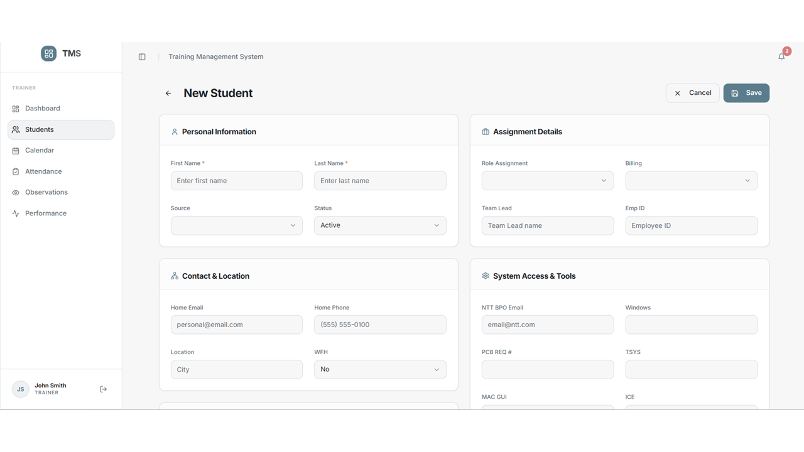

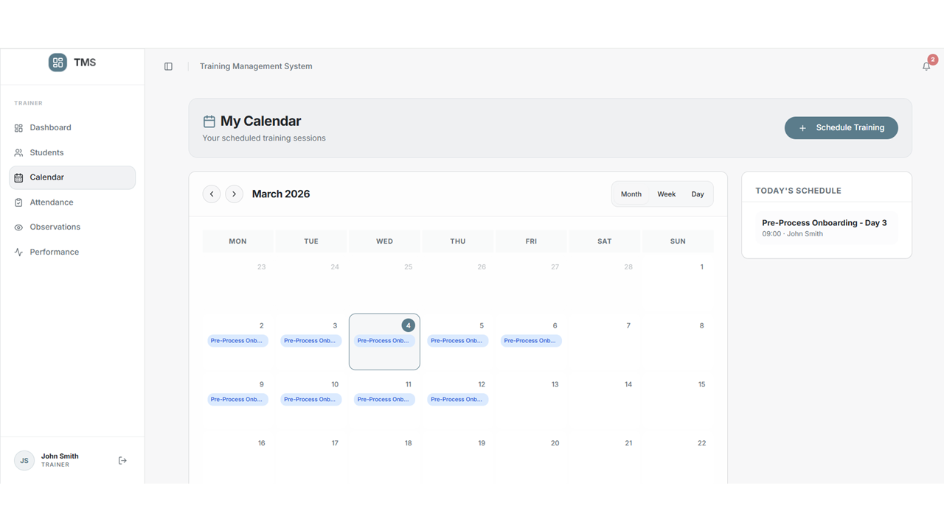
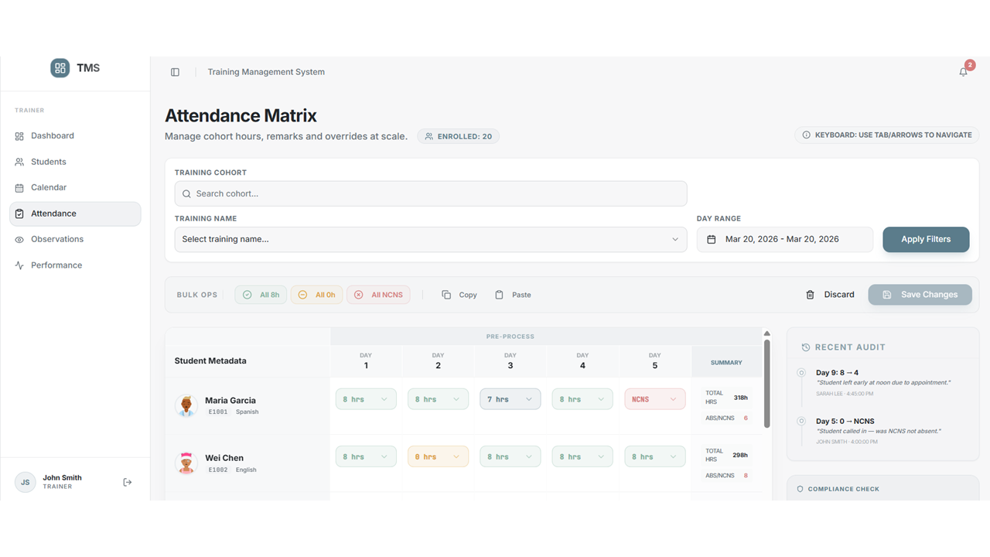

Attendance Matrix would allow the User(Trainer) mark the attendance for the Students
• The Attendance Matrix is a high-speed tool for marking attendance. You can status multiple students as 'Present', 'Late', or 'Absent' in one click.
• Attendance data directly impacts the student's overall progress summary.

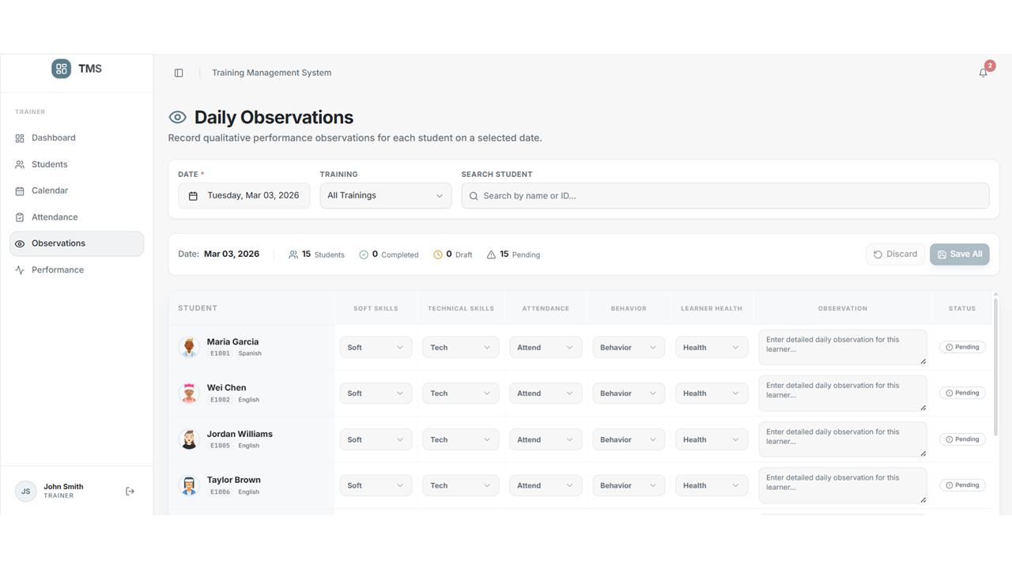
Daily Observation where the User(Trainer) would be able to mark the performance of the students on a regular basis
• Record performance scores (1-5) for Behavior, Knowledge, and Engagement.
• Detailed notes can be added to capture specific strengths or areas for improvement.

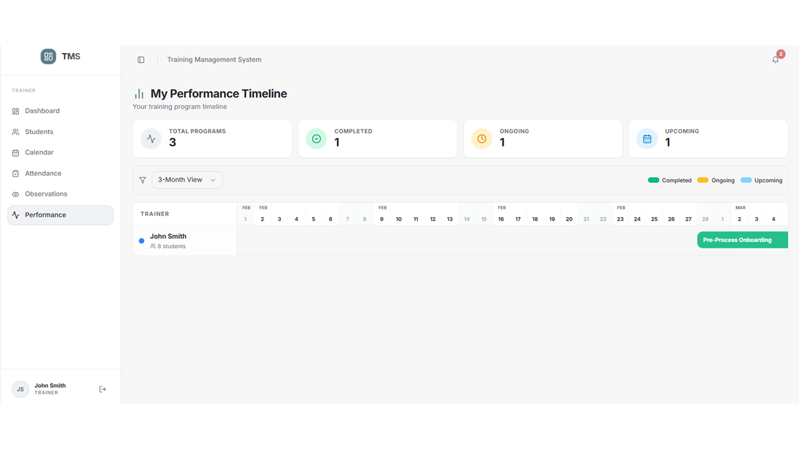

My performance Timeline would show the Sessions completed ongoing and upcoming for the User(Trainer)
• This view helps Trainers manage their specific workload, showing upcoming classes and historical performance metrics.

Troubleshooting & FAQ
• Q: Why can't I see the 'Add Trainer' button?
A: This feature is exclusive to Supervisor and Admin roles.
• Q: How do I reschedule a session?
A: Navigate to the Calendar and drag the session to a new date.
• Q: What do the colors represent?
A: Each trainer has a unique color brand for easy visual tracking.
Last Updated: March 2026

