

CSE302: Database Systems (Section 2)
[SPRING 2023]

Project Report

Faculty Advising

https://apex.oracle.com/pls/apex/r/mim_cse302_sp21/faculty-advising/

182039

Submitted by:

Student ID | Student Name | Contribution Percentage
2020-3-60-073 | Md. Iftekhar Hossain Khan | 28%
2020-3-60-064 | Arun Jyoti Mondal | 26%
2021-1-60-091 | Nur Nahar Mim | 23%
2021-1-60-127 | Yougshree Saha Urmy | 23%

Final version of the E-R Model of the Project:

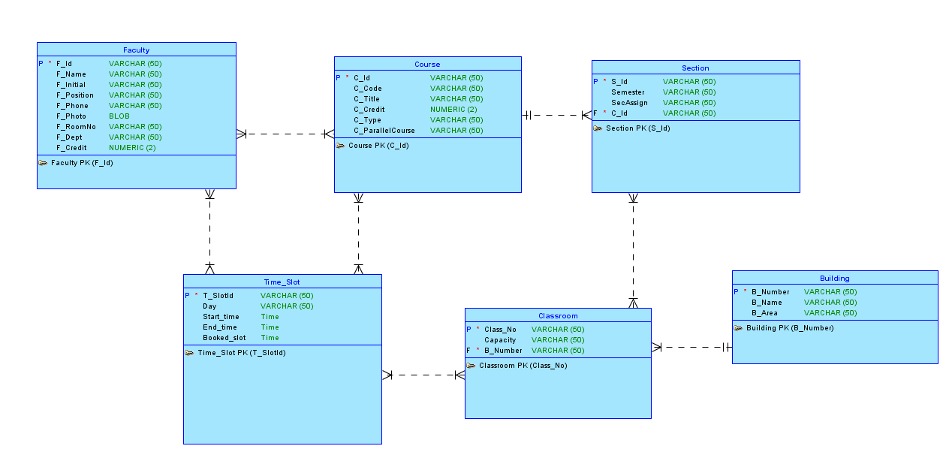

Final Version of the Relational Data Model of the Project

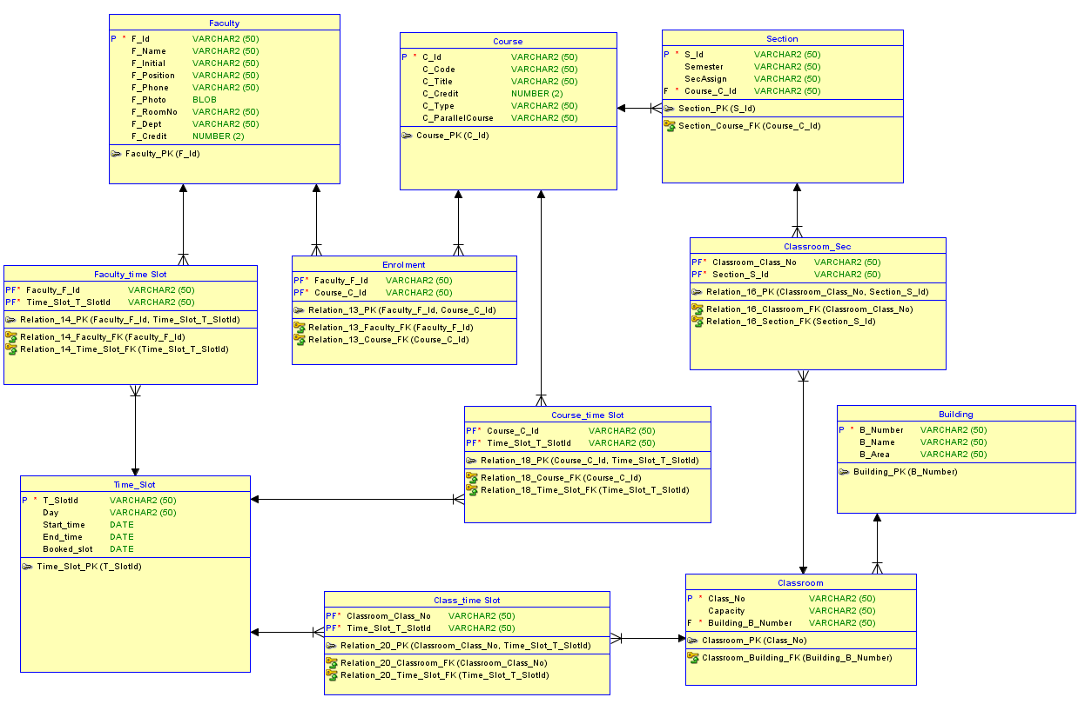

Implementation Checklist

Description | Remarks
Project ID | 182039
Workspace Name | MIM_CSE302_SP2
Workspace Email | 2021-1-60-092@std.ewubd.edu
Workspace Password | 12345678
Authentication Type | Admin
Username and Password to Login
User 1: | admin
Password : | admin123
User 2: | reader
Password : | reader123
Uploaded and Displayed Images in Reports | YES
Implemented Page-wise Authorization | YES
Number of Reports with Forms | 14
Number of Master-detail Forms | 1
Number of Reports based on Queries, Aggregate Queries | 2
Number of Parameterized Reports | 1
Number of Graphs/Charts | 1
Included any trigger/other feature which is not taught in class. If yes, please explain briefly. | YES. We have used a trigger for update credit in Faculty table and another trigger for section tracking in section table.
Write the most unique feature/functionality in your application or the page of your application that you are proud of. Explain briefly. | By using HTML, we have added background picture and, used triggers to update credits and keep track of section table, and from the little we have learned, adding these features kind of makes us feel proud.

Reports with Forms

Report Page Number and Name | Form Page Number and Name | Table
Page 2: Building Report | Page 3: Building Form | Building
Page 4: Classroom Report | Page 4: Classroom Form | Classroom
Page 7: Course Report | Page 6: Course Form | Course
Page 8: Faculty Report | Page 9: Faculty Form | Faculty
Page 10: Faculty Course | Page 26: Enrolments Form | Enrollment(Relation 13)
Page 12: Faculty time slot | Page 13: Faculty time slot Form | Faculty_time_slot  (Relation 14)
Page 14: Classroom section list | Page 15: Class_sec list | Classroom_sec(relation 16)
Page 16: Course time slot | Page 17: Course time slot Form | Course_time_slot(relation 18)
Page 18: Classroom time slot | Page 19: Classroom time slot Form | Classroom_time_slot(relation 20)
Page 20: Section report | Page 21: Section report Form | Section
Page 22: Time slot report | Page 23: time slot report Form | Time_slot

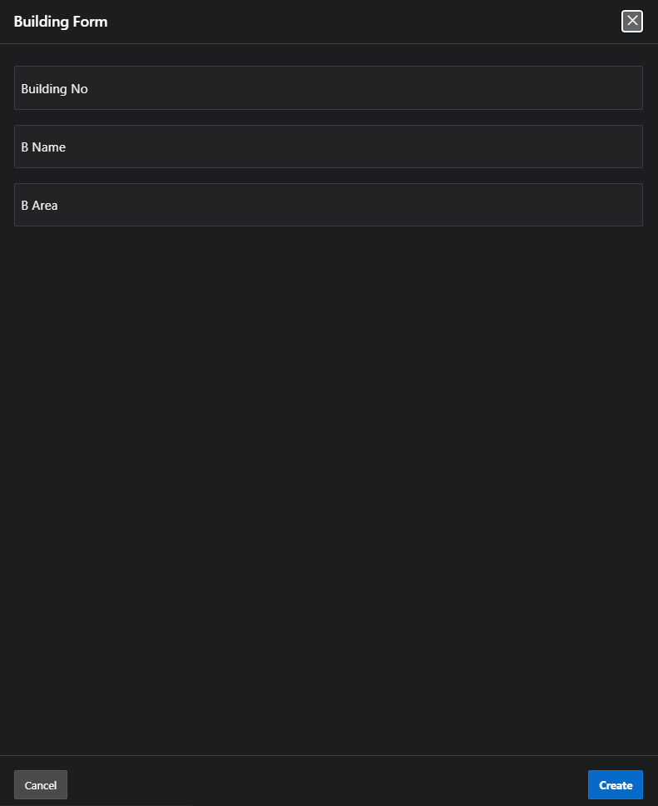

Figure 4.1 : Builing Form ( Building Table )
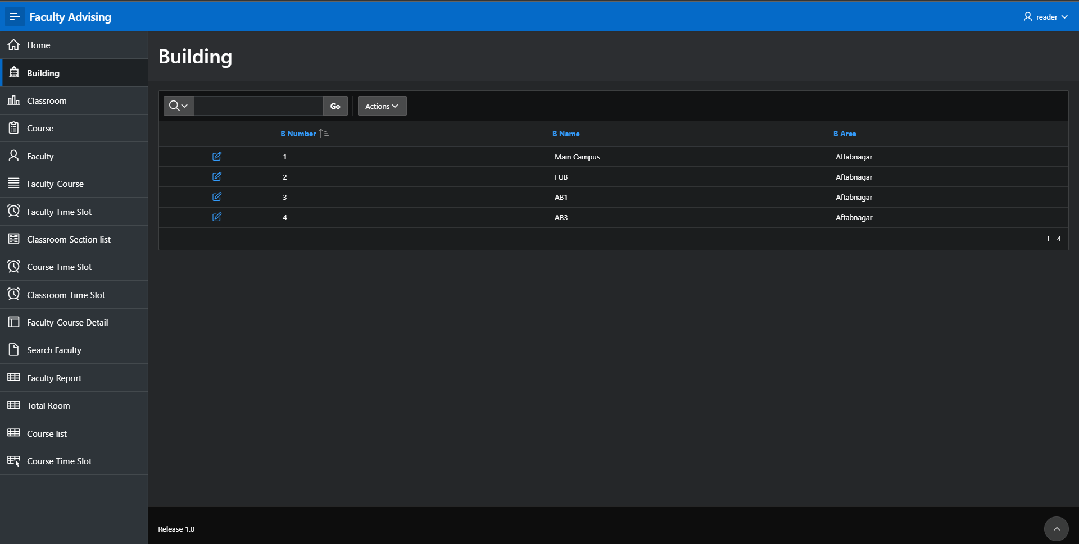

Figure 4.1: Building Report ( Building Table)

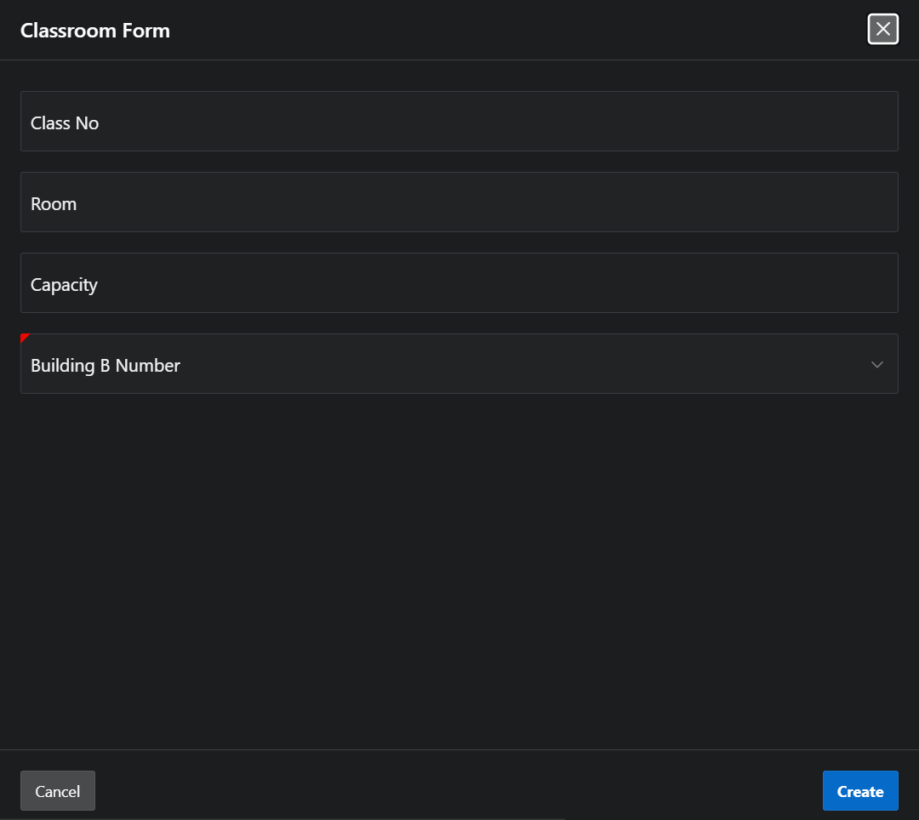

Figure 4.3: Classroom Form( Classroom Table)
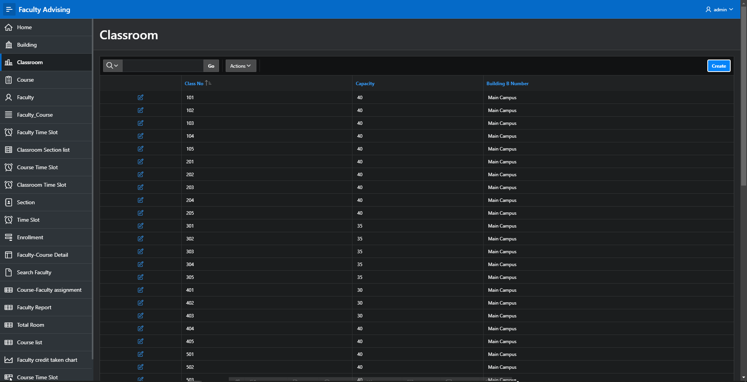

Figure 4.4 : Classroom Report (Classroom Table )

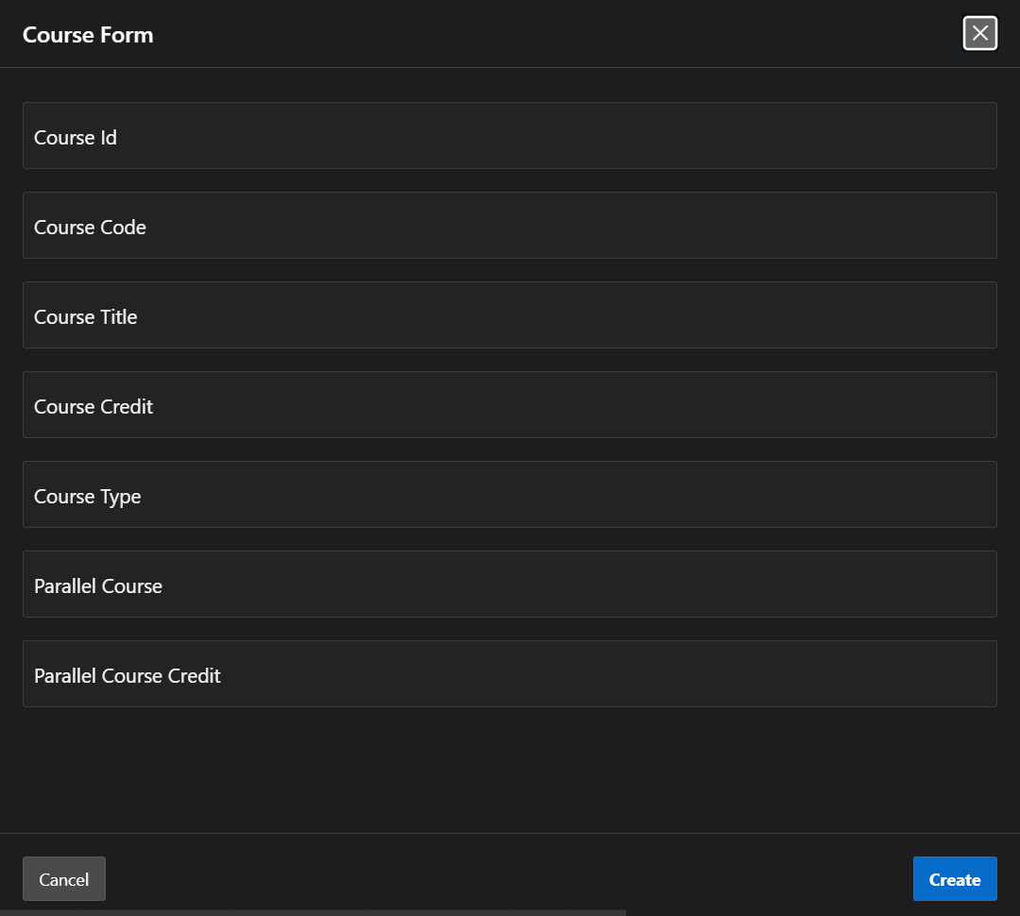

Figure : 4.5 Course Form (Course Table)

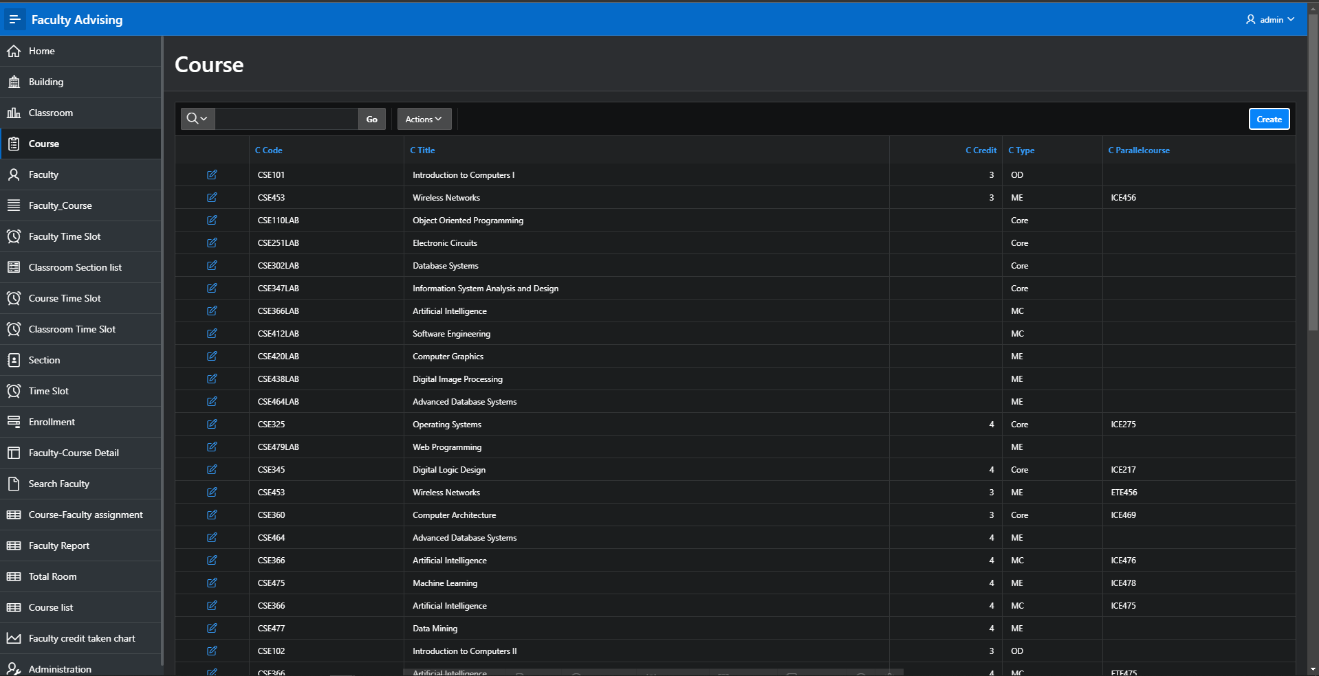

Figure 4.6 : Course Report (Course Table)

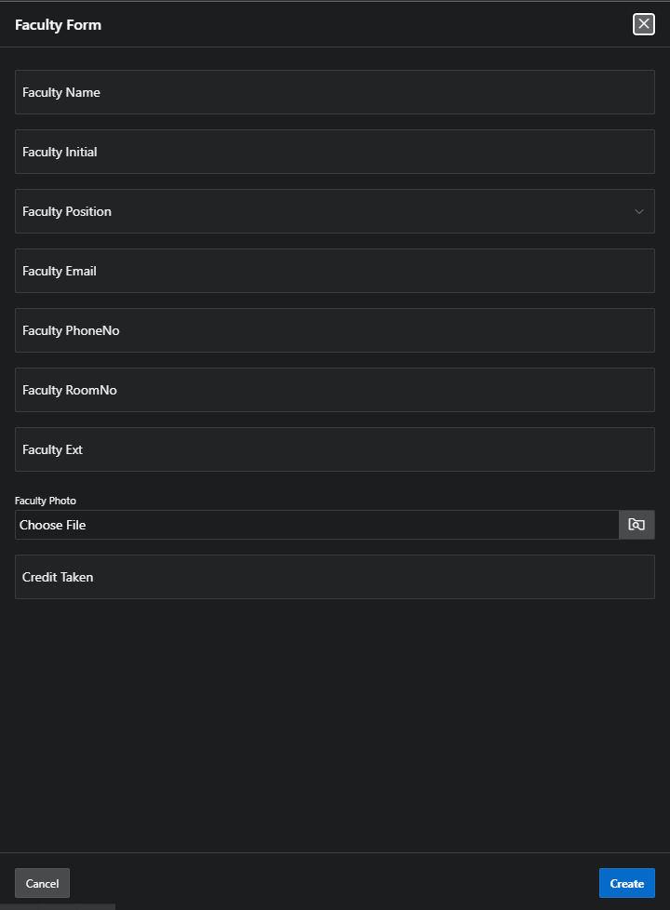

Figure 4.7 : Faculty Form (Faculty Table )

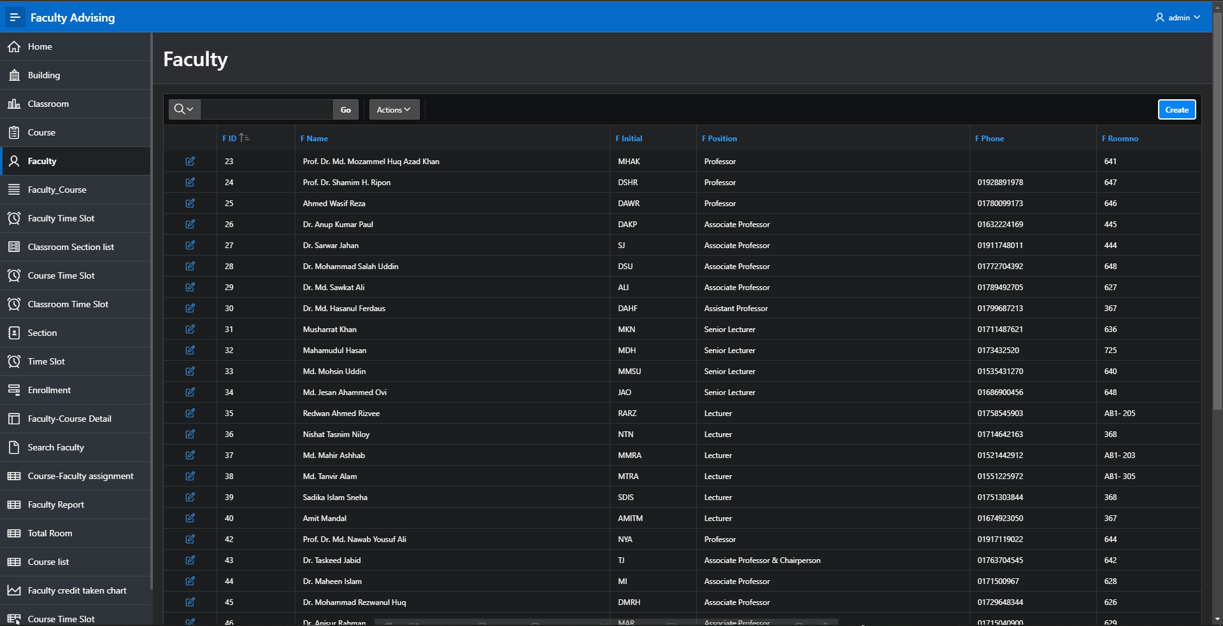

Figure 4.8: Faculty Report (Faculty Table )
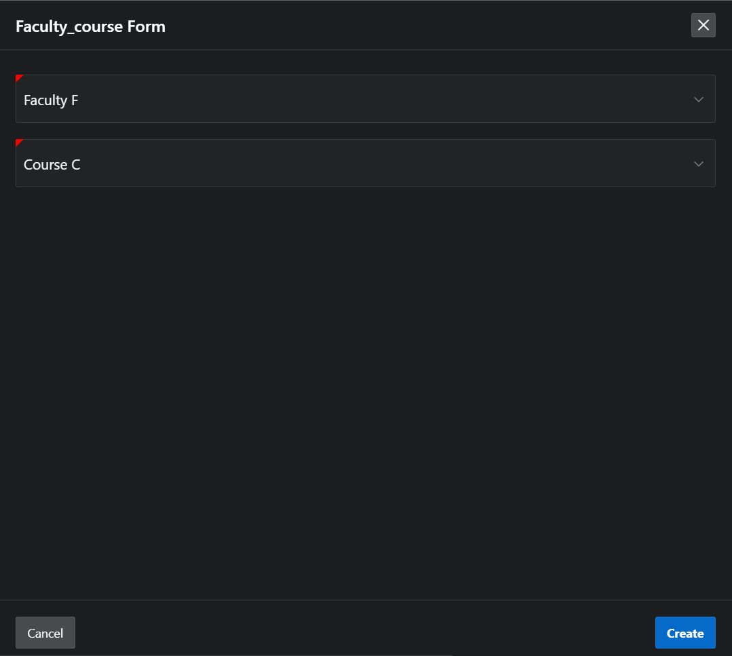

Figure 4.9 : Faculty Course Form ( Enrollment Relation 13)

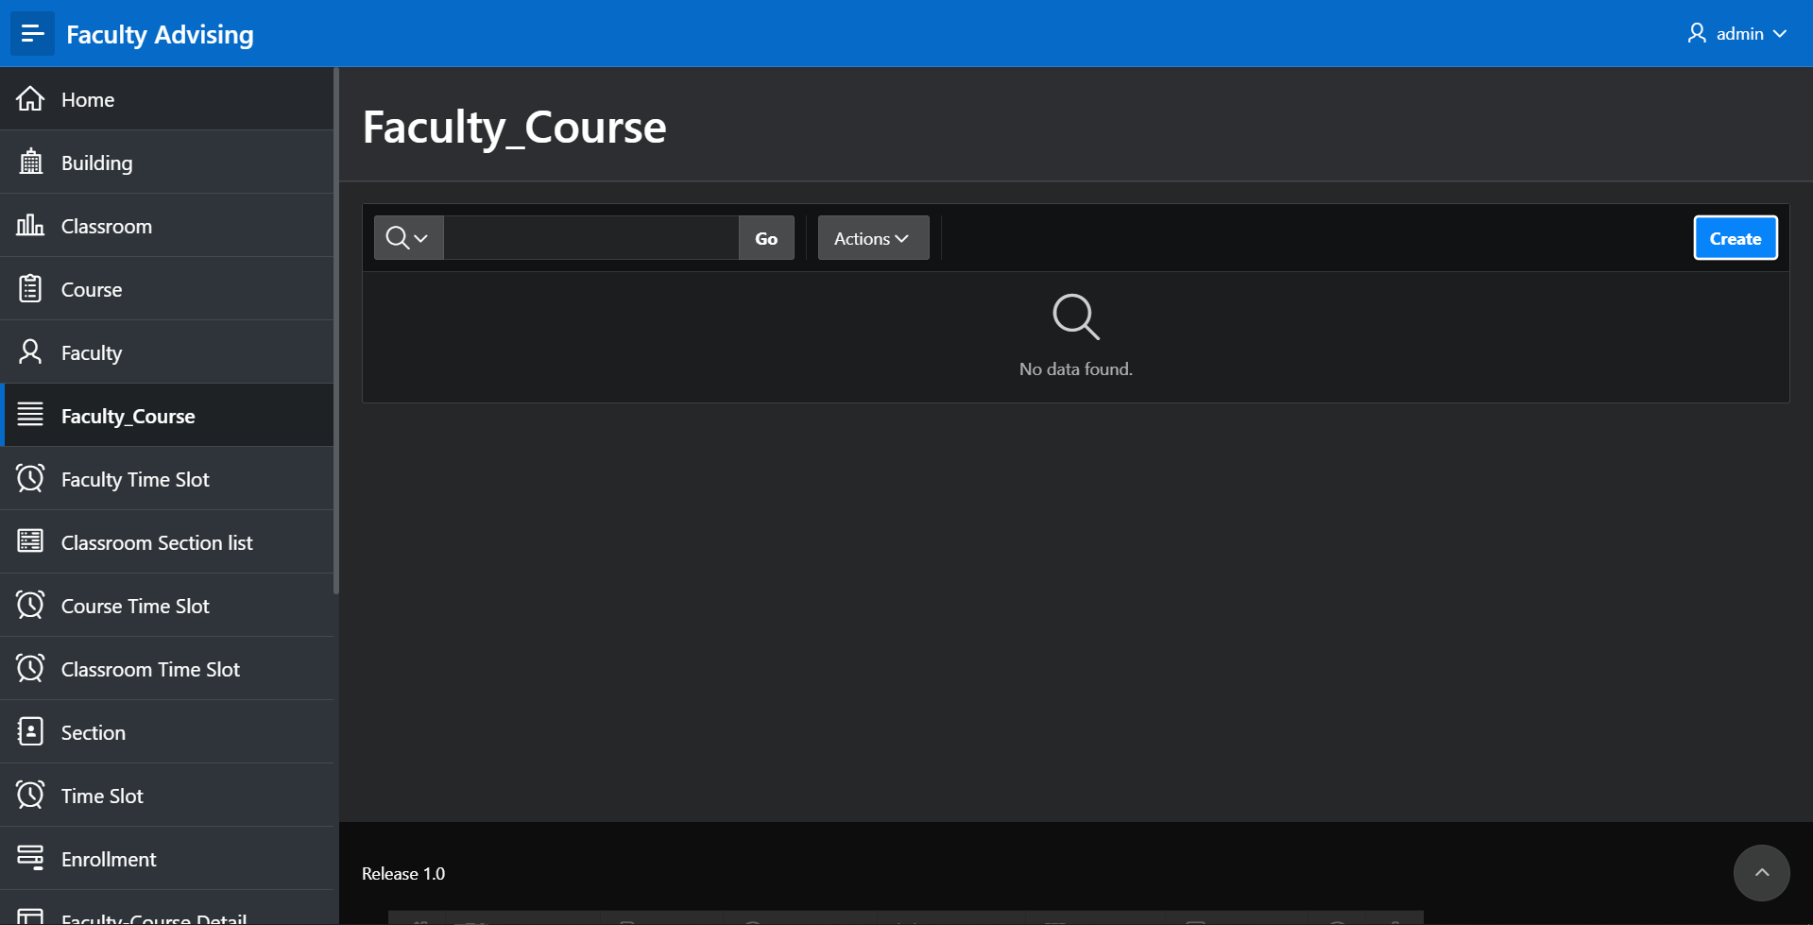

Figure 4.10 : Faculty Course Report
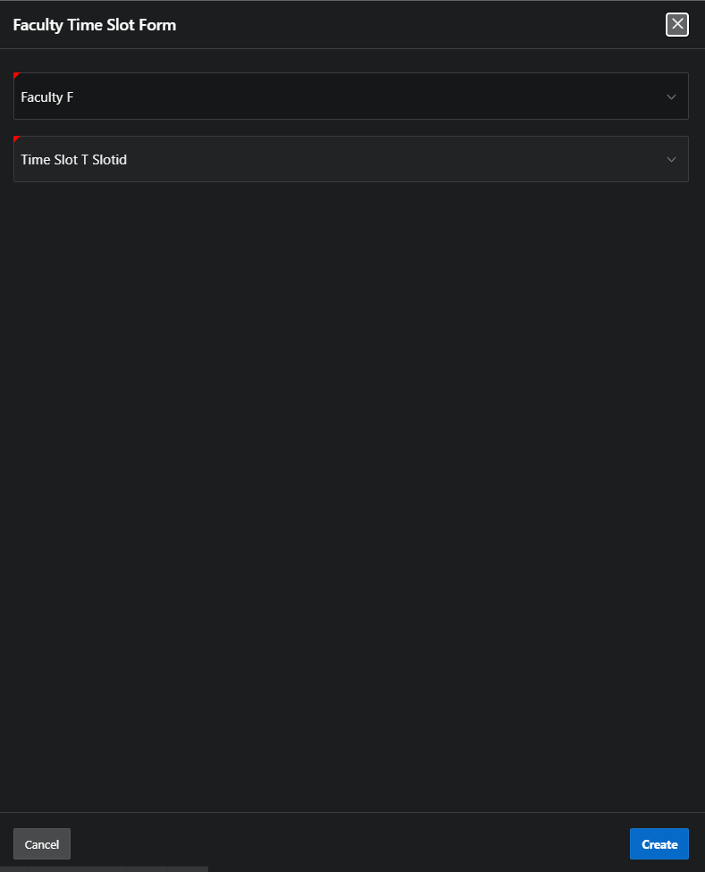
Figure 4.11: Faculty Time Slot Form

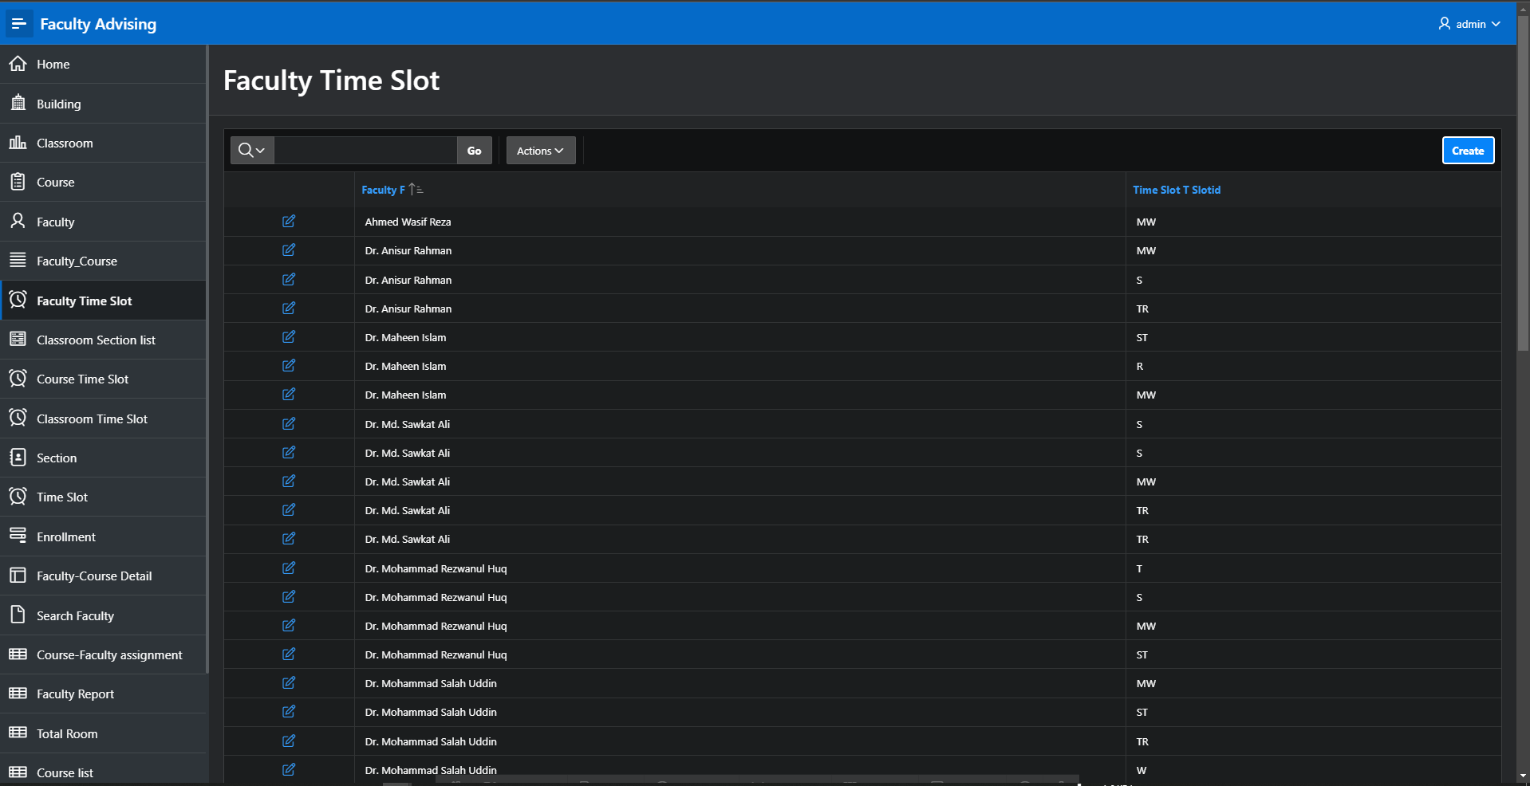

Figure 4.12 : Faculty Time Slot Report

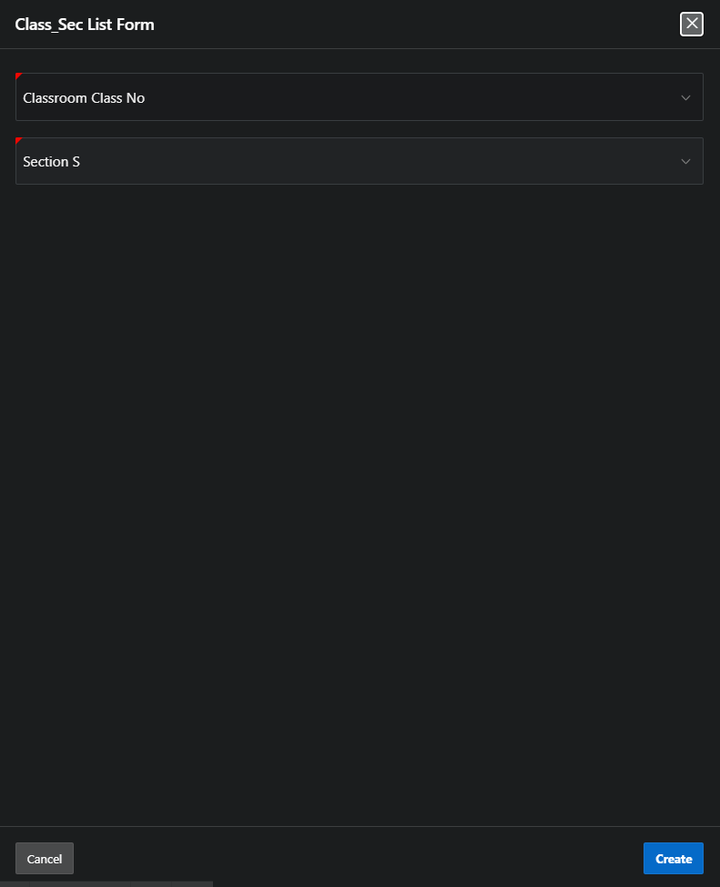

Figure 4.13 : Classroom Section List Form

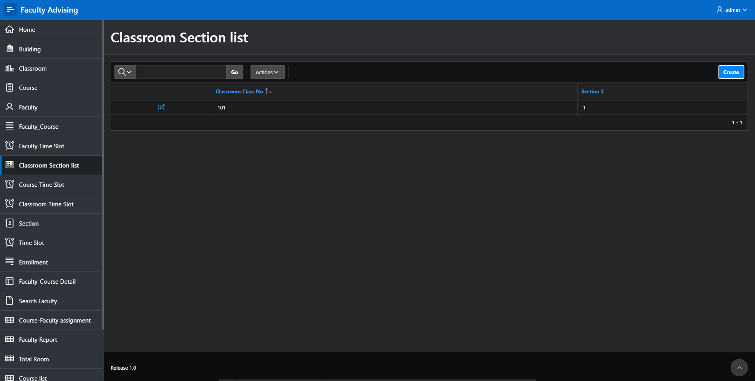

Figure 4.14 : Classroom Section List Report

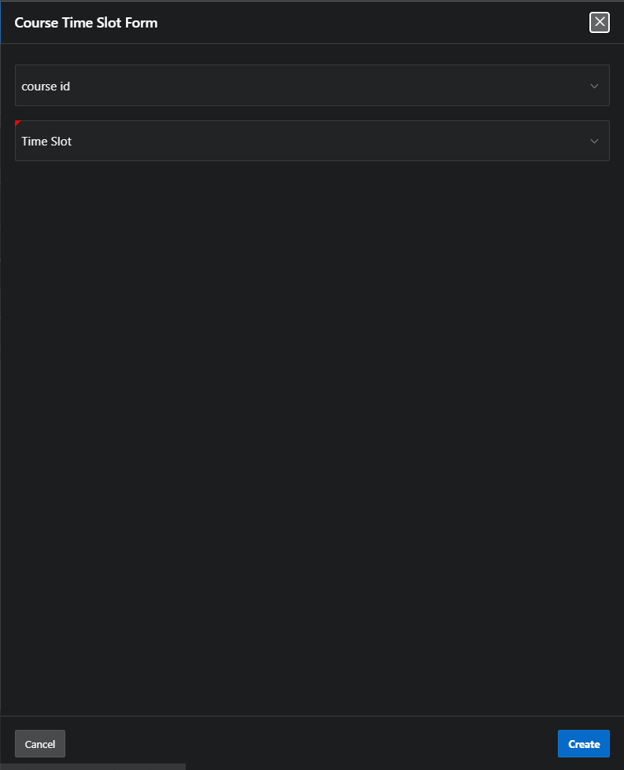

Figure 4.15: Course Time slot Form

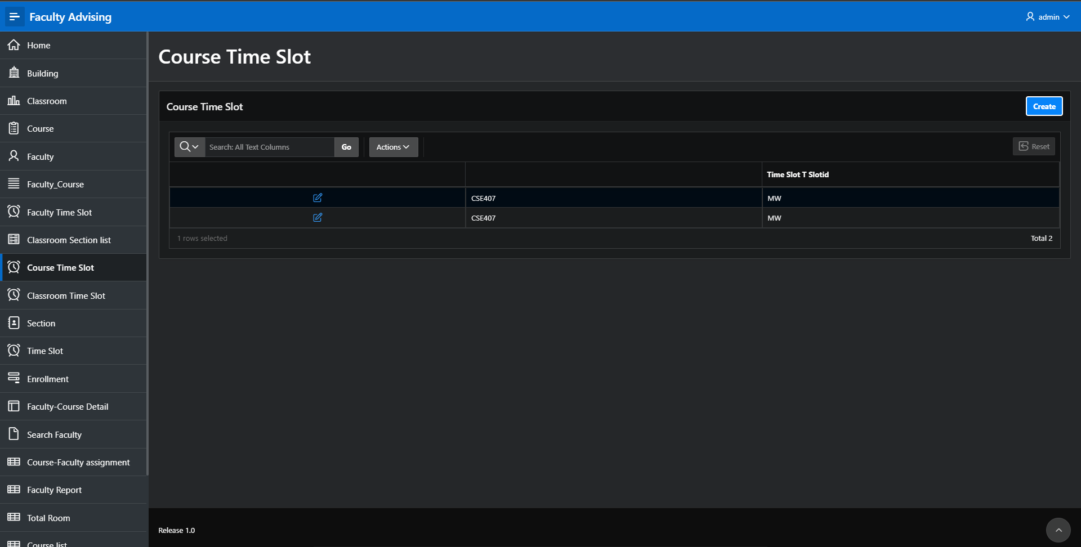

Figure 4.16: Course Time Slot Report

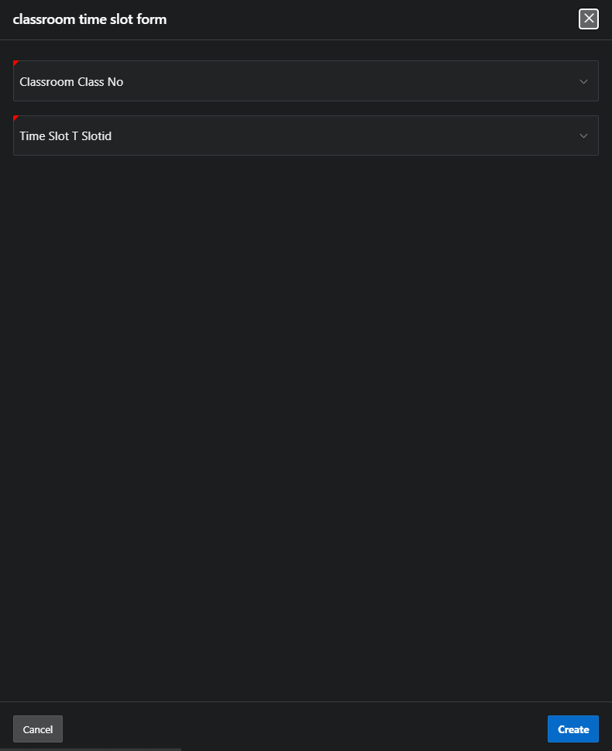

Figure 4.17 : Classroom Time Slot Form

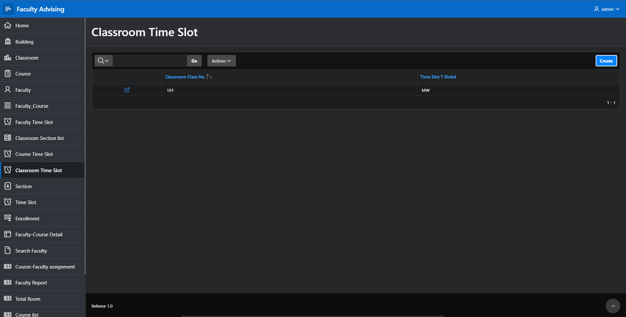

Figure 4.18: Classroom Time Slot Report

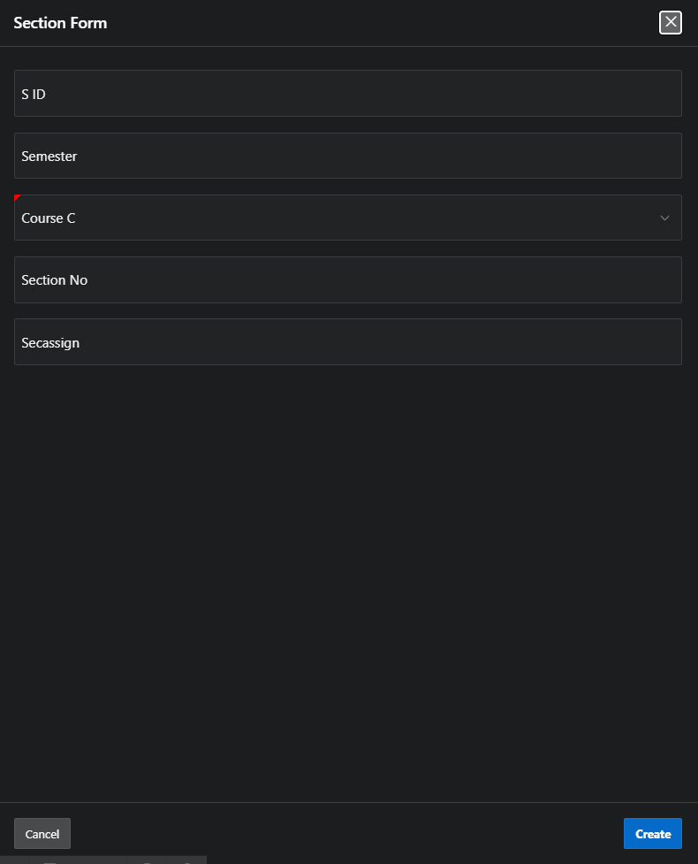

Figure 4.19: Section Form (Section table)

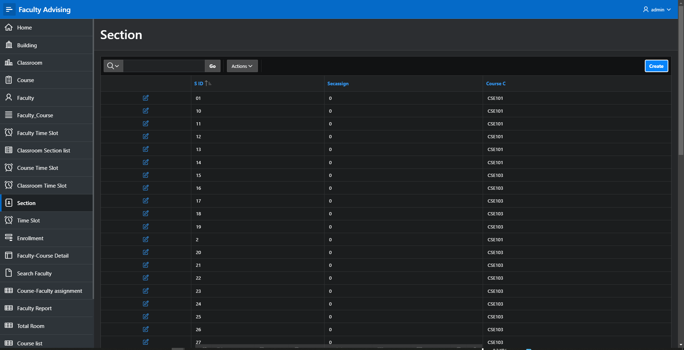

Figure 4.20: Section Report
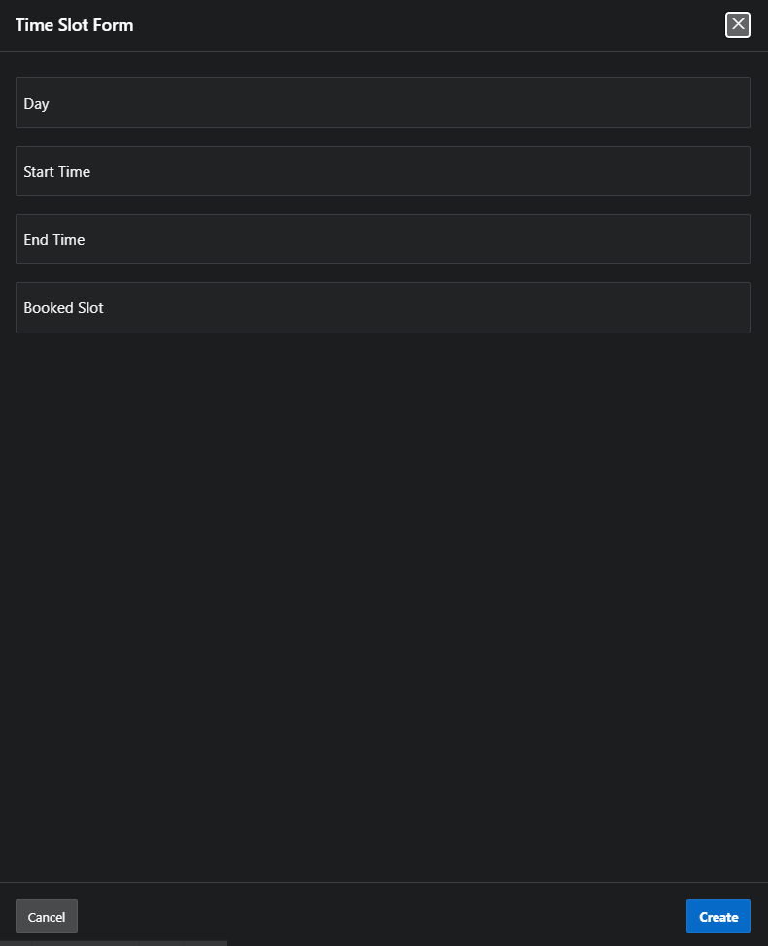

Figure 4.21: Time Slot Form

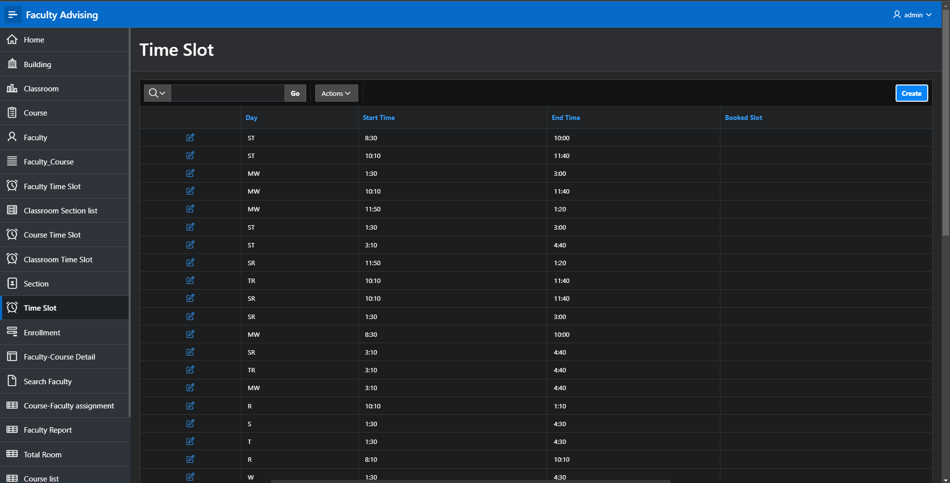

Figure 4.22: Time Slot Report

Master-Detail Form

Page Number and Name | Master Table (Parent) | Detail Table (Child)
Page 27: Faculty_Course Detail | Faculty | Faculty time slot

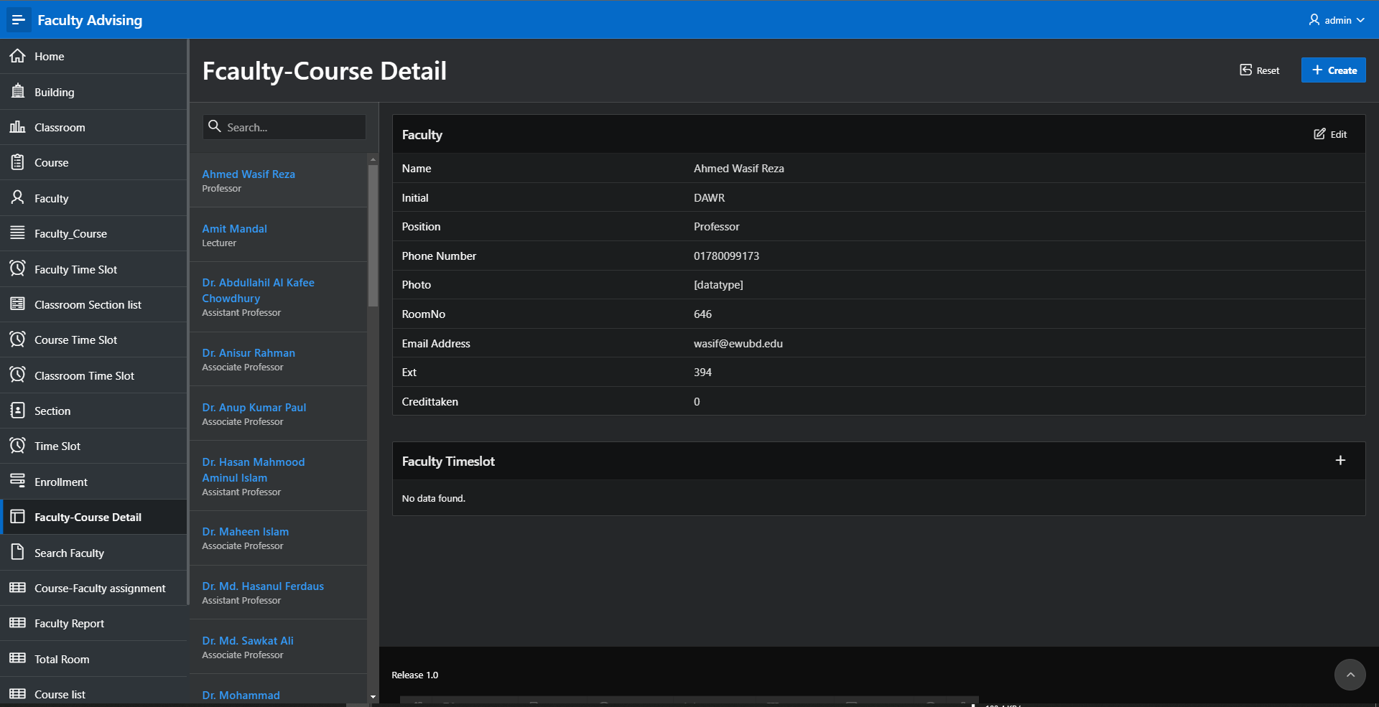

Figure 5.1 : Faculty Course Details ( Faculty )

Reports based on Multi-Table and Aggregate Queries

Page Number and Name | Query Type | Report description
Page 38: Total room | Aggregate query | This aggregate query report shows that.  The total number of rooms in a building
Page 40: Course list | Distinct | This keyword-based report shows that the unique courses and course code.
Page 55: Enrollment Information | Multitable query | This multitable query shows the course and section assigned to the faculty.

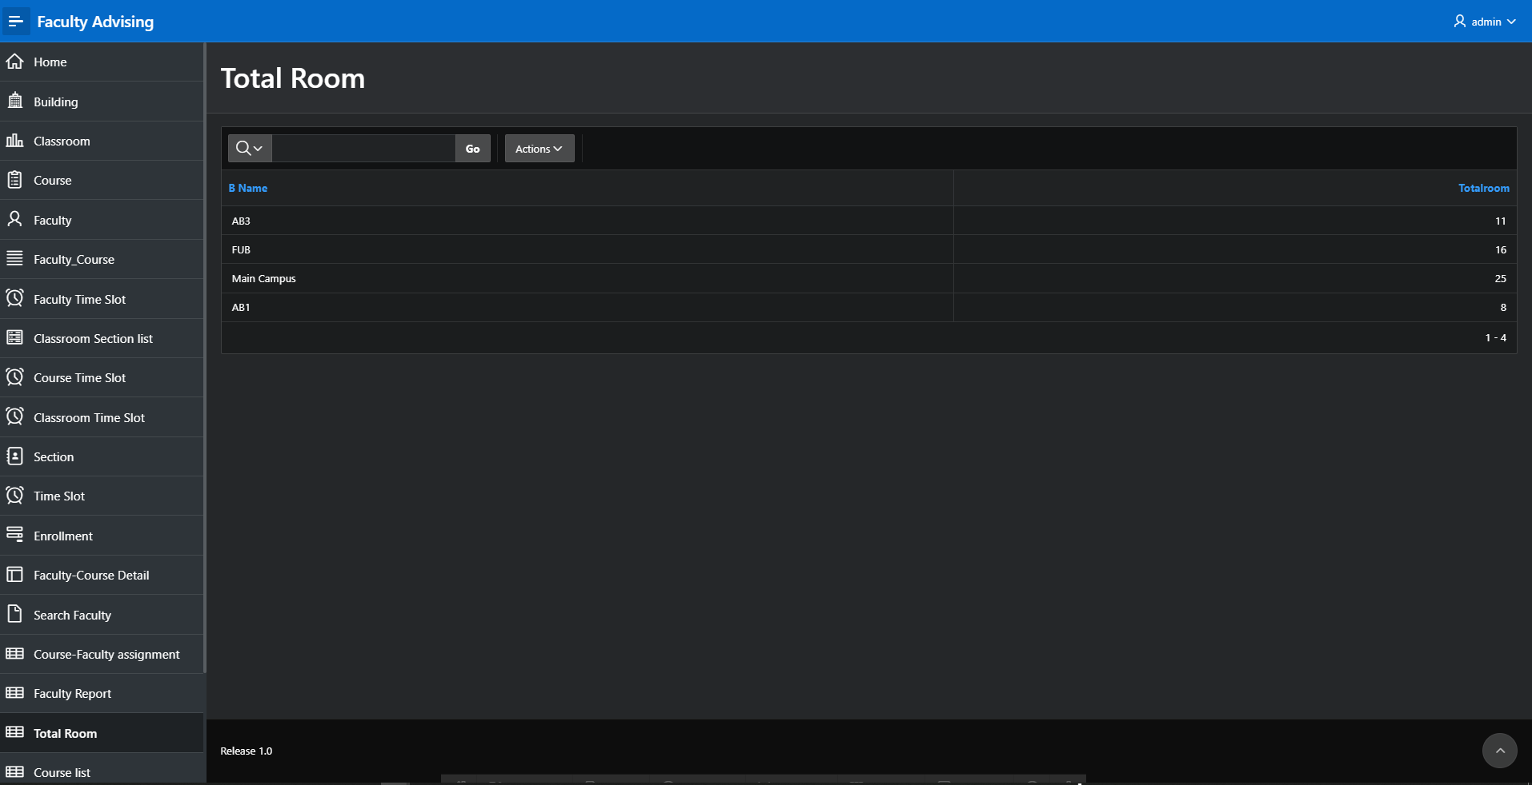

Figure 6.1 : Total Room

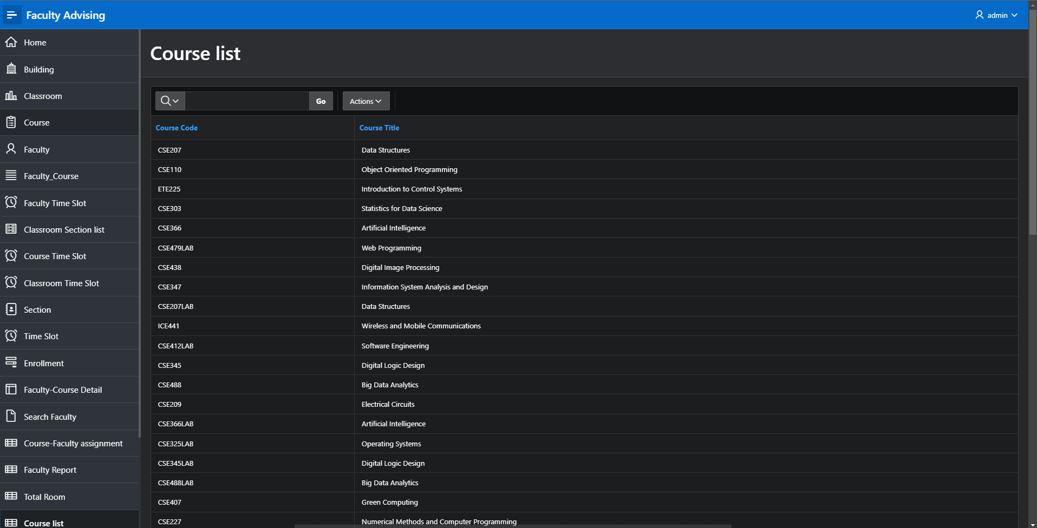

Figure 6.2 : Course List

Parameterized Reports

Page Number and Name | Given Input | Report description
Page 30: Search Faculty | Faculty Initial | User given the faculty initial and click on the search button then it will show the faculty ID, faculty initial, faculty name and faculty position.

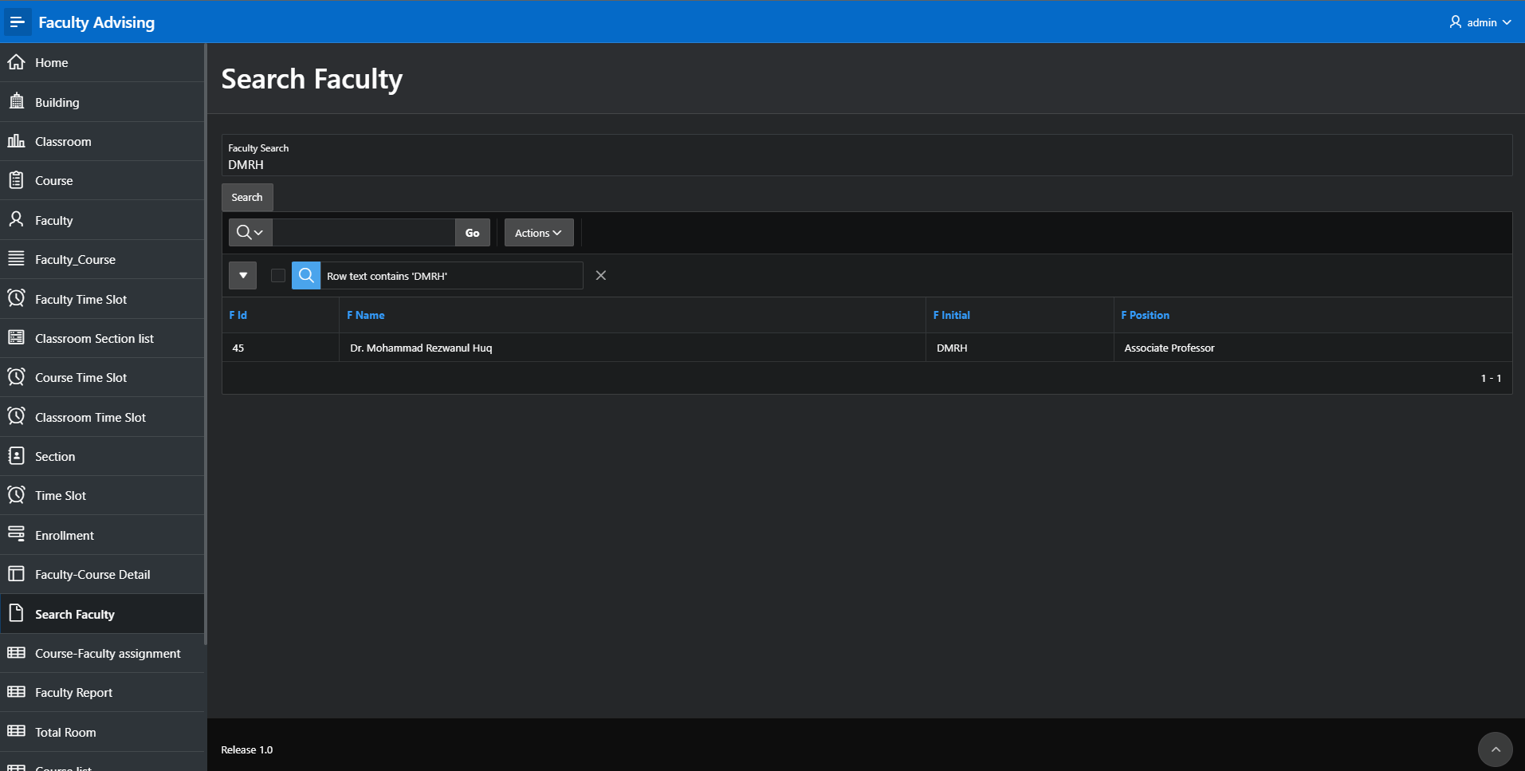

Figure 7.1 : Search Faculty

Charts and Other Pages

Page Number and Name | Chart description
Page 49:faculty credit taken chart | This chart will show the credit taken by each faculty not more than 11 credit in ascending order.

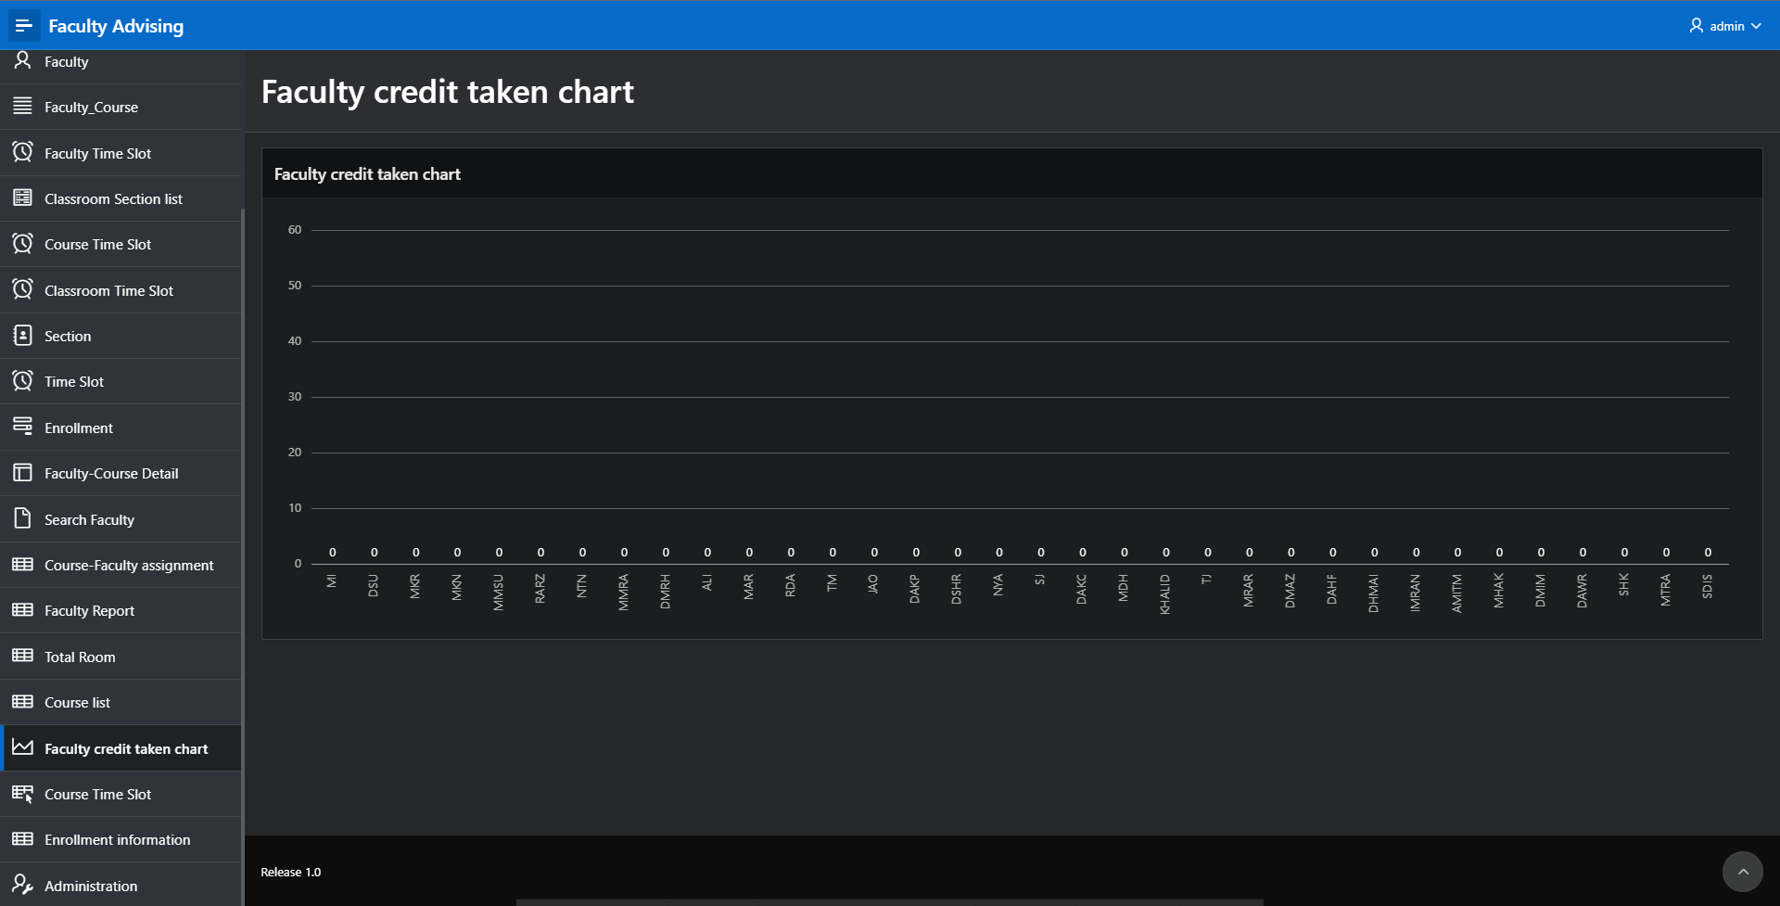

Figure 8. 1: Faculty Credit Taken Chart

Authorization and User Role Assignment

User Role Assignment

User name | Password | Role
admin | admin123 | Administrator
reader | reader123 | Viewer

Page-wise Authorization Information

Page number and name | Authorization Level
Example: P1. Home | Reader
Example: P10000: Administration | Administrator

Concluding Remarks

Here we used Oracle APEX to build an application “Faculty Advising”. We have learned how to build a different type pages and reports to make it useful and easy to understand. We have built single table query and multi table query. We have made the master detail report and parameterised report. Chart also included in this application. We have learned how to authorize the authentication. We create the multiple users for authentication. One user has the administrator right and another user has the right to reader administration right. We use the trigger in faculty table and section table. It was a group wise project. We all have done our work properly and test it after every update. And our work went more smoothly because of our honourable instructor’s excellent teaching method and guidance.

