Requirements

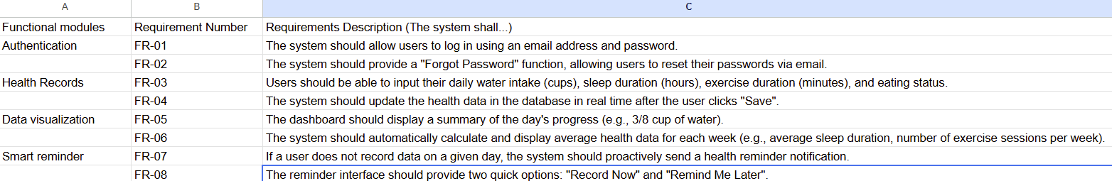
- Functional requirements

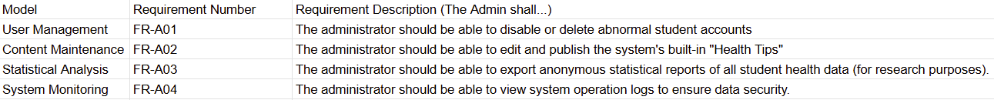

- Non-functional requirements

A. Usability:
Interface Simplicity: The interface design should be intuitive, ensuring new users can learn how to record data within 2 minutes.
Responsive Design: The system should adapt to various screen sizes (although the prototype is mobile, different phone models usually need to be considered).
B. Security:
Data Encryption: User health data and login credentials must be encrypted during transmission and storage (e.g., using AES-256).
Privacy Protection: The system must not share any personal health indicators with third parties without user authorization.
C. Performance:
Response Time: The system's response time should not exceed 2 seconds after a user clicks "Save" or "Login."
Concurrency Handling: The system should support at least 500 students operating online simultaneously without lag.
D. Reliability & Availability:
Uptime: The system should guarantee 99.9% uptime, ensuring students can record data at any time.
Data backup: The system should perform automatic data backups daily to prevent data loss due to server failure.

