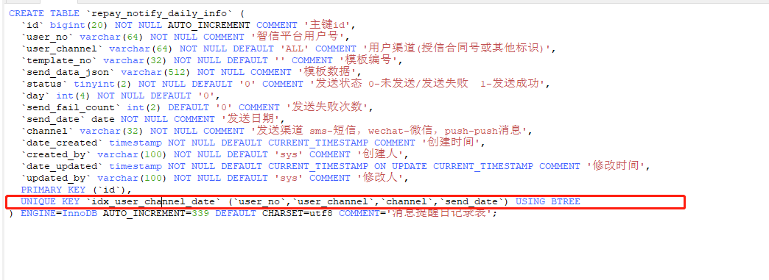

表有四个字段组成的联合索引

`idx_user_channel_date` (`user_no`,`user_channel`,`channel`,`send_date`)

1.# user_no字段索引

explain SELECT * FROM `repay_notify_daily_info` where user_no='UR5908827301608423424';



命中了user_no字段索引ref显示只有一个字段常量

2.#user_no，user_channel 字段

explain SELECT * FROM `repay_notify_daily_info` where user_no='UR5908827301608423424' and user_channel='RA5913726587567607808';

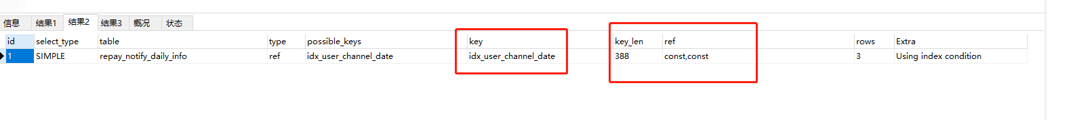

命中了user_no， user_channel字段索引 ref显示有两个字段常量

3.#user_no channel

explain SELECT * FROM `repay_notify_daily_info` where user_no='UR5908827301608423424' and channel='wechat';

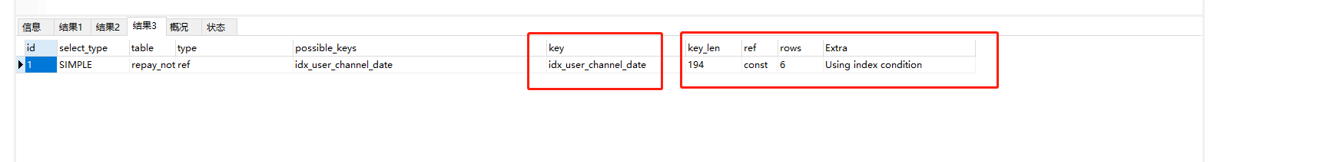

只命中了user_no字段索引ref显示只有一个字段常量

1. #user_channel channel

explain SELECT * FROM `repay_notify_daily_info` where user_channel='RA5913726587567607808' and channel='wechat';

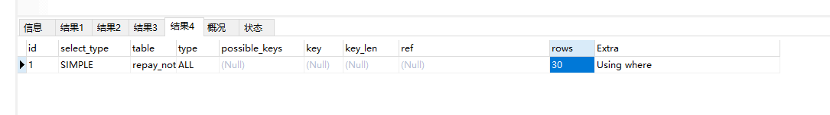

key没有显示命中了索引， type=ALL 没有走索引

5.user_channel channel user_no

explain SELECT * FROM `repay_notify_daily_info` where user_channel='RA5913726587567607808' and channel='wechat' and user_no='UR5908827301608423424'

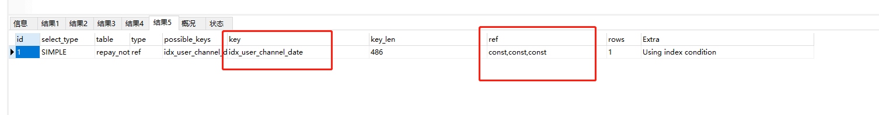

命中了索引，ref显示走了3个字段常量，因为mysql会自己优化where的顺序