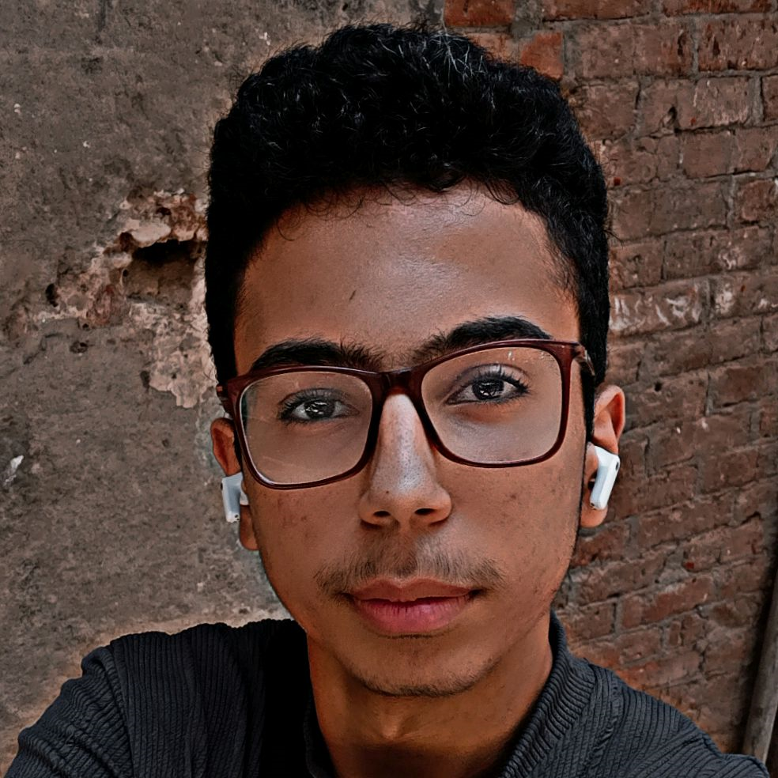**Mohamed Abdelfatah - CV**

# About Me

I'm Mohamed Abdelfatah, a passionate junior programmer who loves learning new technologies. I have a solid foundation in front-end development and am expanding my skills into back-end programming. My dream is to become a full-stack developer and contribute to real-world projects that make an impact.

# Skills

* HTML5, CSS3, JavaScript
* Python (Beginner – Intermediate)
* Responsive Web Design
* Basic Git & GitHub
* Problem Solving & Debugging

# Projects

* Personal Portfolio Website
* Interactive To-Do List (JavaScript)
* Basic Calculator (HTML, CSS, JS)
* Simple Python Data Analysis Script

# Education

* Bachelor's in Computer Science (Ongoing)
* Front-End Development Course – Udemy
* Python Basics – SoloLearn

# Languages

* Arabic – Native
* English – Intermediate

# Certificates & Achievements

* Certificate in Responsive Web Design – freeCodeCamp
* Python for Everybody – Coursera

# Interests

* Problem Solving & Coding Challenges
* UI/UX Design
* Reading Tech Blogs

# Contact

Email: mohamed.a.a.fatah2010@gmail.com

Phone: +20 128 553 6282

WhatsApp: https://wa.me/201285536282

Telegram: https://t.me/201285536282

Facebook: https://www.facebook.com/profile.php?id=61572685060484

Instagram: https://www.instagram.com/0mohamedabdelfatah0/