Deploy NGINX on EC2 with a Custom Domain
DevOps Bootcamp — Networking Assignment
Date: 7 April 2026

📋 Project Overview
This document outlines the step-by-step process of deploying an NGINX web server on an AWS EC2 instance and configuring a custom domain via Cloudflare DNS. This was completed as part of the networking module of a DevOps bootcamp.

Objectives
- Purchase a custom domain
- Launch and configure an EC2 instance on AWS
- Install and run NGINX on the server
- Configure DNS records in Cloudflare to point the domain to the EC2 instance
- Verify the website loads correctly on the custom domain

Assignment Checklist
Step | Task | Status
1 | Buy a domain | ✅ Done
2 | Launch EC2 instance on AWS | ✅ Done
3 | Connect to EC2 via SSH | ✅ Done
4 | Install NGINX on EC2 | ✅ Done
5 | Point Cloudflare domain to EC2 | ✅ Done
6 | Test site loads on domain | ✅ Done

Step 1 — Buy a Domain
The first step was to purchase a custom domain name. The domain was registered and managed through Cloudflare.

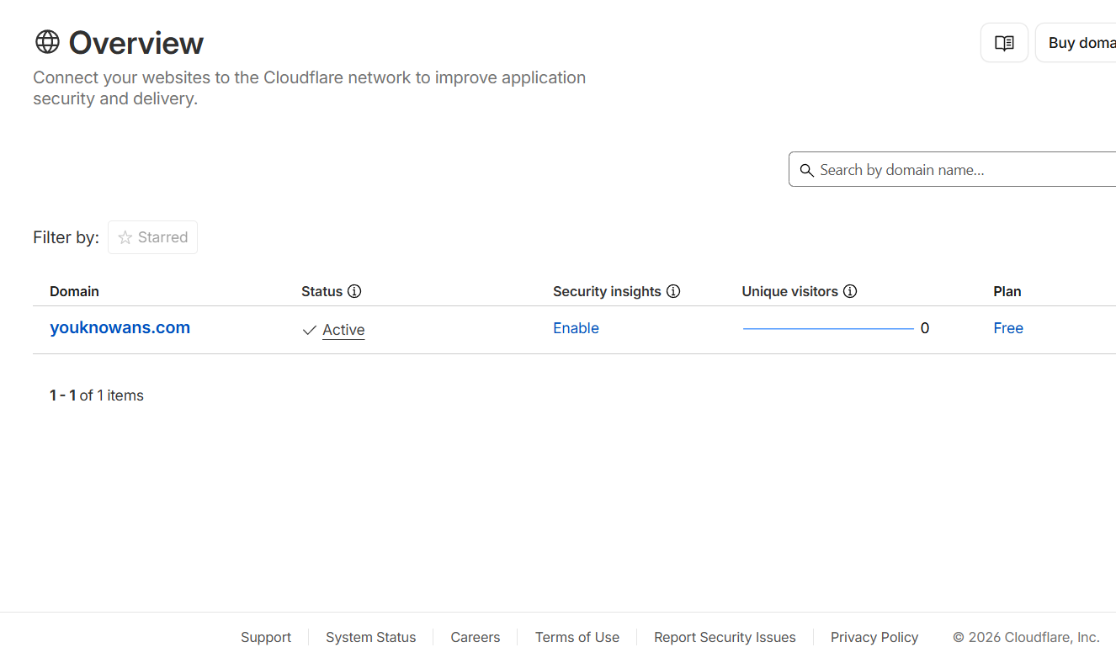

Step 2 — Launch an EC2 Instance on AWS
An EC2 (Elastic Compute Cloud) instance is a virtual server hosted on Amazon Web Services. Think of it as renting a computer in Amazon's data centre that is always on and accessible from anywhere in the world.

Steps Taken
- Logged into the AWS Console at aws.amazon.com
- Searched for EC2 and clicked Launch Instance
- Configured the instance with the following settings:

Setting | Value
Name | my-nginx-server
OS Image (AMI) | Ubuntu (Free Tier eligible)
Instance Type | t2.micro (Free Tier)
Key Pair | Created new .pem key pair for SSH access
SSH Traffic | Enabled
HTTP Traffic | Enabled
HTTPS Traffic | Enabled

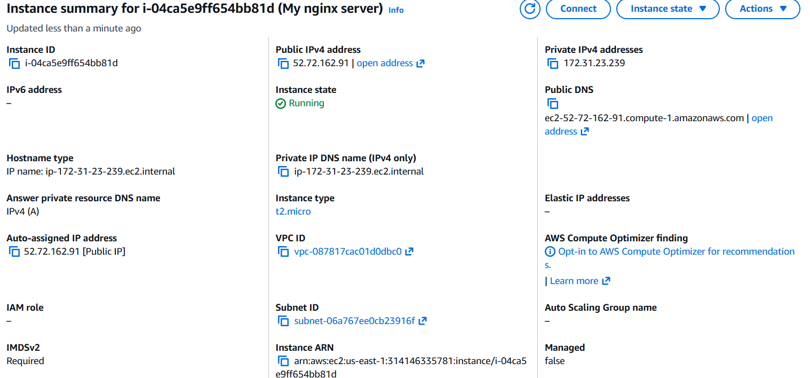

Step 3 — Connect to EC2 via SSH
SSH (Secure Shell) is a way to securely connect to and control a remote server from your computer. Think of it like having a remote keyboard and screen for a computer that lives in Amazon's data centre.

Connection Method
Connected to the EC2 instance using VS Code Remote SSH extension, using the .pem key pair downloaded during instance creation.

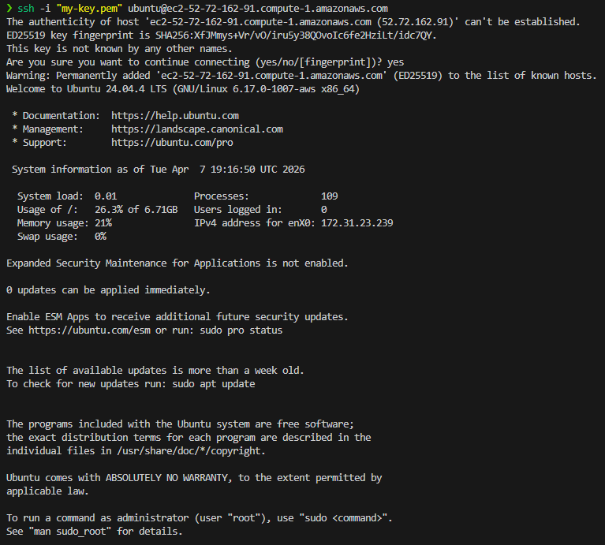

Step 4 — Install NGINX on EC2
NGINX is a web server — software that listens for requests from browsers and serves web pages back to them. It was installed directly on the EC2 instance using the following commands:

Commands Run
# Update the server's software list
sudo apt update

# Install NGINX
sudo apt install nginx -y

# Start NGINX and enable it on reboot
sudo systemctl start nginx
sudo systemctl enable nginx

# Verify NGINX is running
sudo systemctl status nginx

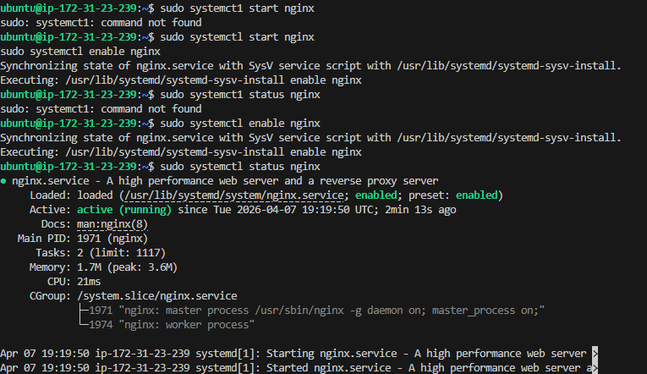

Step 5 — Configure DNS Records in Cloudflare
DNS (Domain Name System) acts like a phone book for the internet — it translates human-readable domain names into IP addresses that servers understand. Two A records were added in Cloudflare to point the domain to the EC2 instance.

What is an A Record?
An A record maps a domain name directly to an IPv4 address. Two records were created:

Both records point to the same EC2 public IP address (52.72.162.91), ensuring the site loads whether the user types the domain with or without 'www'.

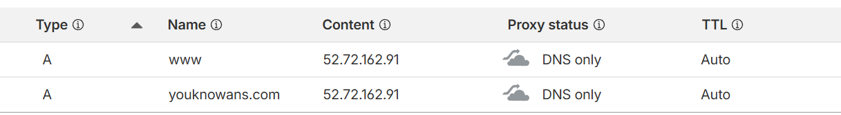

Step 6 — Verify Domain Loads Successfully
After allowing time for DNS propagation (the process by which DNS changes spread across the internet), both URLs were tested in a browser to confirm the NGINX welcome page loaded correctly.

URLs Tested
- http://youknowans.com
- http://www.youknowans.com

What is DNS Propagation?
When a DNS record is updated, the change does not happen instantly across the entire internet. DNS servers around the world need time to update — this can take anywhere from a few minutes to 48 hours. A useful tool to check propagation status is dnschecker.org.

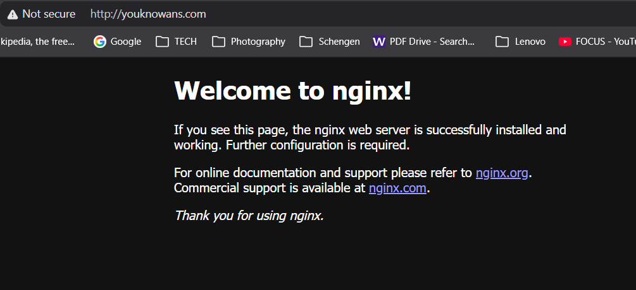

📚 Key Concepts Learned
- A virtual server hosted on AWS, accessible from anywhere with a public IP address.EC2 (Elastic Compute Cloud):
- A lightweight, high-performance web server used to serve web content.NGINX:
- Translates domain names into IP addresses so browsers can find the right server.DNS (Domain Name System):
- A DNS record that maps a domain name to an IPv4 address.A Record:
- The time it takes for DNS changes to spread across all servers on the internet.DNS Propagation:
- AWS firewall rules that control which traffic is allowed into and out of an EC2 instance.Security Groups:
- A secure protocol used to remotely connect to and control a server.SSH:

DevOps Bootcamp — Networking Module Assignment

