Problems | Task No. | β = 2 | NN | MO-MFEA
CIHS | T₁ | 3.54E-4 | 3.77E-4 | 3.99E-4
CIHS | T₂ | 2.36E-3 | 2.54E-3 | 2.65E-3

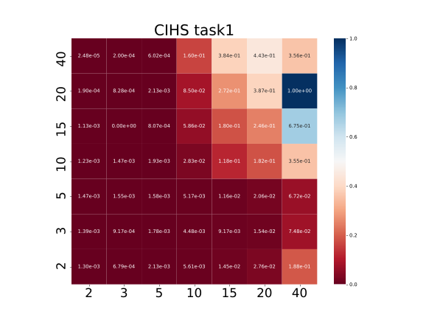 | 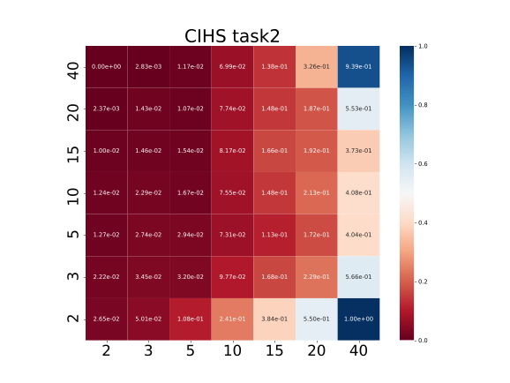

Problems | Task No. | β = 2 | NN | MO-MFEA
CIMS | T₁ | 1.15E-1 | 8.89E-2 | 4.57E-2
CIMS | T₂ | 6.41E-2 | 5.80E-2 | 8.77E-3

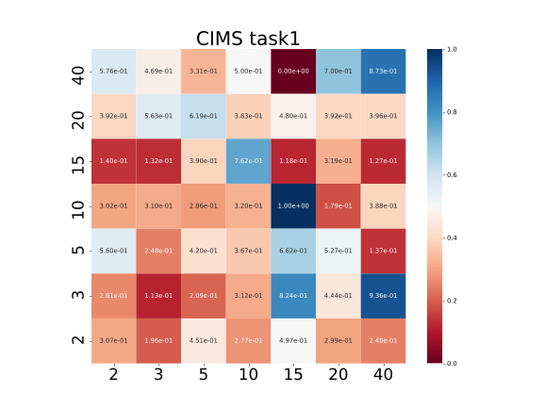 | 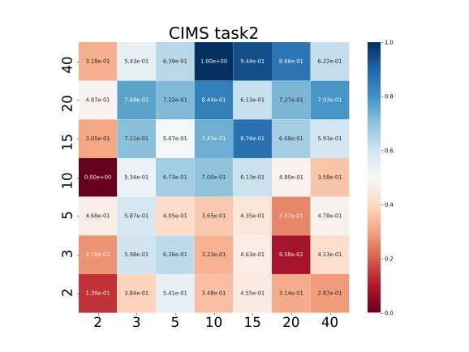

Problems | Task No. | β = 2 | NN | MO-MFEA
CILS | T₁ | 2.00E-4 | 1.94E-4 | 2.71E-4
CILS | T₂ | 1.82E-4 | 1.82E-4 | 1.90E-4

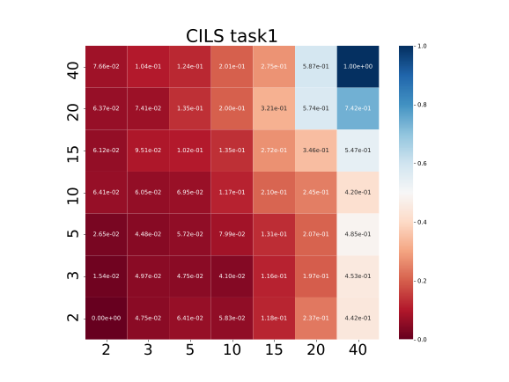 | 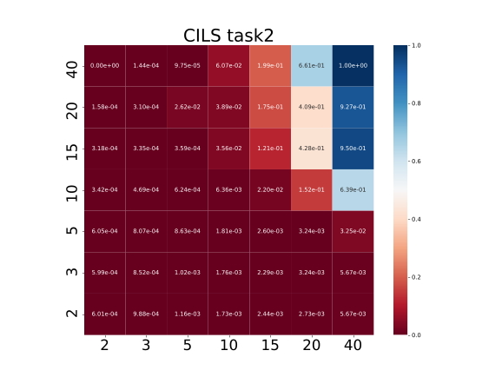

Problems | Task No. | β = 2 | NN | MO-MFEA
PIHS | T₁ | 3.64E-4 | 3.76E-4 | 1.10E-3
PIHS | T₂ | 2.54E-2 | 2.51E-2 | 3.04E-2

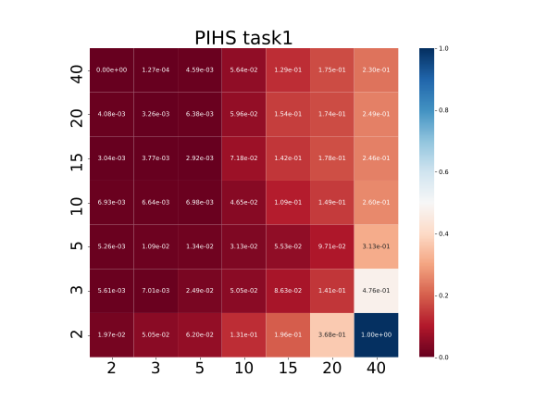 | 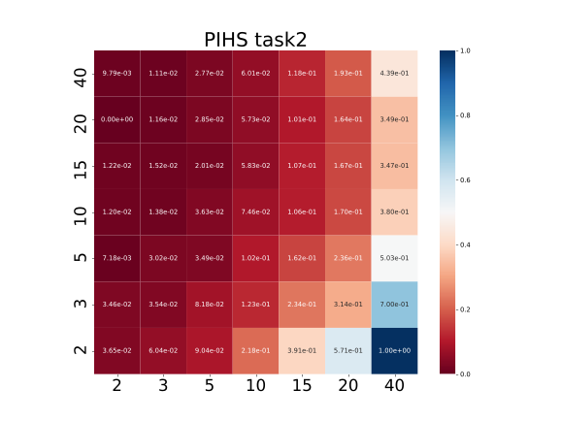

Problems | Task No. | β = 2 | NN | MO-MFEA
PIMS | T₁ | 4.13E-3 | 4.30E-3 | 2.62E-3
PIMS | T₂ | 1.72E+1 | 1.83E+1 | 1.09E+1

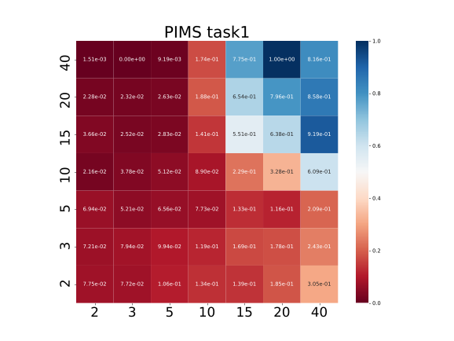 | 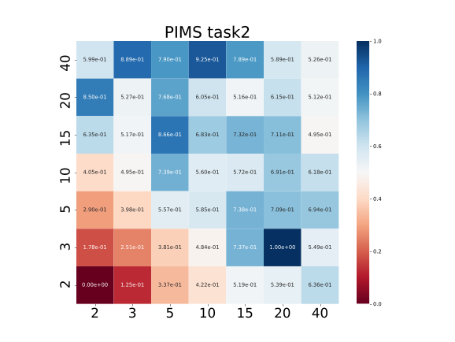

Problems | Task No. | β = 2 | NN | MO-MFEA
PILS | T₁ | 3.03E-4 | 2.25E-4 | 3.24E-4
PILS | T₂ | 6.33E-1 | 6.33E-1 | 1.10E-2

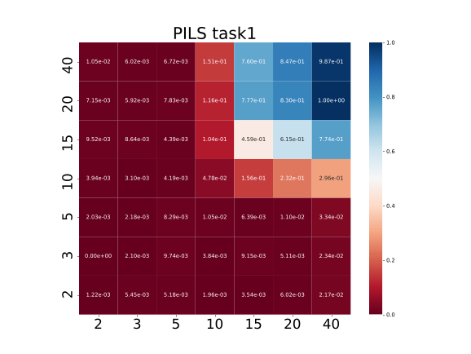 | 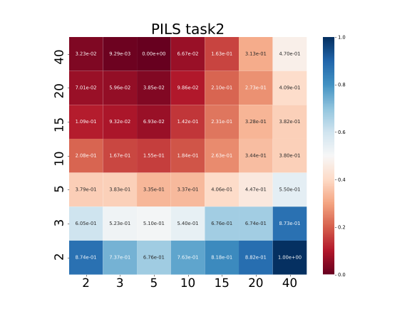

Problems | Task No. | β = 2 | NN | MO-MFEA
NIHS | T₁ | 5.35E+0 | 4.27E+0 | 1.55E+0
NIHS | T₂ | 7.67E-4 | 6.69E-4 | 5.02E-4

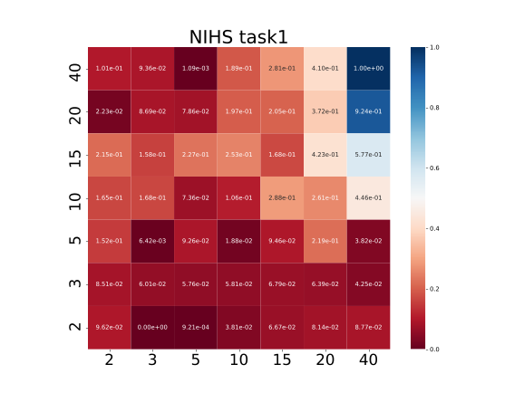 | 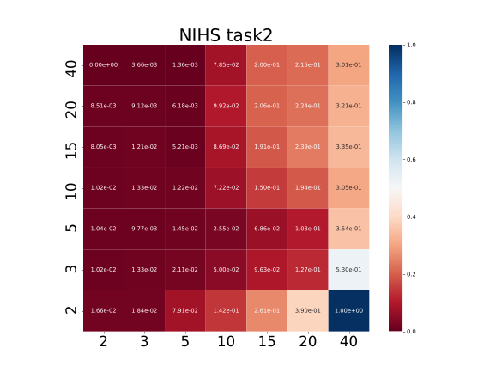

Problems | Task No. | β = 2 | NN | MO-MFEA
NIMS | T₁ | 4.21E-1 | 3.34E-1 | 2.79E-1
NIMS | T₂ | 5.62E-2 | 7.34E-2 | 2.86E-2

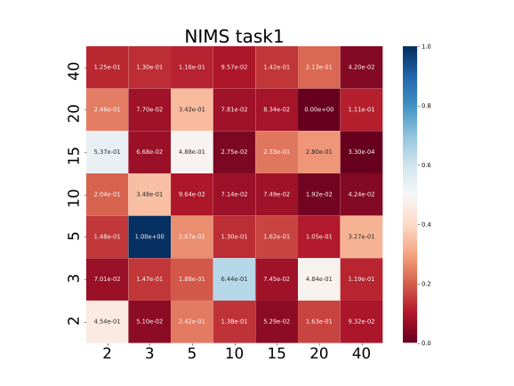 | 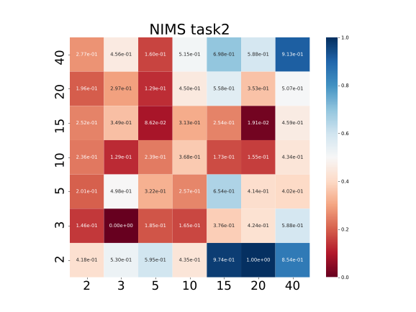

Problems | Task No. | β = 2 | NN | MO-MFEA
NILS | T₁ | 7.91E-4 | 8.05E-4 | 8.35E-4
NILS | T₂ | 6.42E-1 | 6.42E-1 | 6.43E-1

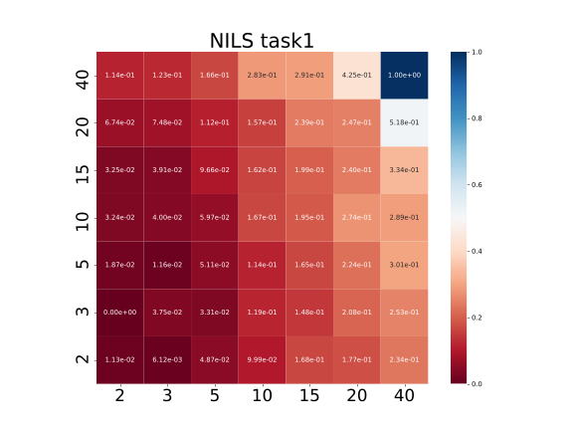 | 