COVER
(Print the corresponding contents on the cover printed by the college uniformly. Following is an example)

Title Instruction of Graduation Project (Thesis) Typesetting
――General Sample of Typesetting

Name Author’s name
College Software College
Software Engineering
Information Security
Digital Media
Specialty
Supervisor Supervisor Name and Associate Supervisor Name
For Internship outside Campus Only
Notes

June 10 20XX

Design and Implementation of the Base Service Subsystem of Custody Business System

Name： | You Xiao
Supervisor： | Jiang Linying | Title
Associate Supervisor： | Wei Jingqi | Title
College： | Northeastern University
Specialty： | Software Engineering

Northeastern University
June 2016

金融资产托管平台-基础服务子系统的设计与实现

作者姓名： | 游宵
校内指导教师： | 姜琳颖 | 副教授
校外指导教师： | 韦景琪 | 高级工程师
单位名称： | 北京浩桦科技有限公司
专业名称： | 软件工程

东 北 大 学
20016年6月
Project Plan for Graduation Project (Thesis)
Title of Graduation Project(Thesis)：
Design and Implementation of the Base Service Subsystem of Custody Business System
Basic Content：
I will investigate financial custody industry by looking up relevant references and learning relevant technologies and development progress of custody service. I will also learn some technologies about base infrastructure of IT system, analyze basic requirements of custody services, research design and implementation technologies of custody business system, besides, I will design and implement the base service subsystem of custody business system, including data management module, clearing reports module, session storage and asynchronous module, maybe also decompile technology. What’s more, I will test and evaluate about what i do in base service subsystem, and translate one English material about base service subsystem which have at least 4000 word.
Topic of Graduation Project(Thesis)：
Title：
Basic Content：

Receiving Date
Week 1
Signature：

2016Year 3 Month 11 Day

毕业设计（论文）任务书
毕业设计（论文）题目：
金融资产托管平台-基础服务子系统的设计与实现
基本内容：
调查资管行业，查阅相关参考资料并了解熟悉资产托管业务的相关技术及其发展现况，学习研究IT系统基础架构相关技术，分析资产托管基础服务需求，研究系统的设计及实现技术。完成资产托管基础服务子系统的总体设计和详细设计，完成数据管理、通用报表、服务端session、异步队列、代码反编译等功能。并对所实现的部分进行测试和评价。翻译一篇与毕设内容相关的外文资料，译文汉字字数不少于4000字。
毕业设计（论文）专题部分：
题目：
基本内容：
学生接受毕业设计（论文）题目日期
第 1 周
指导教师签字：

2016年 3 月 11 日

Design and Implementation of the Base Service Subsystem of Custody Business System
Abstract
Base service subsystem play an important role in a web-based finance hosting system, as it provide basic technical support for business system and make architecture more powerful and robust. My research is just a part of the base service system, In general, it contains four modules, they are Data Import and Management, SSO (Single Sign On), Asynchronous queue & Session Management, Data Report.
The Data Import & Management module import and prepares the basic data which will be used by business system, moreover, it provides a management system with UI to management the business data interface (source of data) and data import configuration & status and query of imported data.
The SSO module provides the basic and unified authentication of all subsystems, including subsystems written in java & python source code, so the SSO should be Compatible with several languages.
In some case, we need to use asynchronous queue to send message and handle some time-consuming task, and we need to manage user session in the server’s side, so we should create key-value cache system or specific queue system.
Data report module focus on some important data report of Fund Settlement subsystem.
This article focuses mainly on how to design and implement those modules of base service system mentioned above. The author uses spring+springmvc+mybatis to build data management and data report module, which is a popular and powerful way, as for SSO, the CAS server is used and the author re-build the python-cas library for python client, what’s more, we create a key-value system using leveldb for storage engine to satisfy the requirement of session storage, which also could be used for queue. At last, as all module test passed, the base service subsystem is implemented.
Keywords：Base Service, Data Import, Data Report, Asynchronous-Queue, Key-Value System
金融托管平台-基础服务子系统系统的设计与实现
摘 要
毕业设计（论文）是学生在校学习的最后阶段，是培养学生综合运用所学知识，发现、提出、分析和解决实际问题，锻炼实践能力的重要环节，是对学生实际工作能力的系统训练和考察过程。毕业设计（论文）是学生在教师指导下，对所从事工作和取得成果的完整表述，是学生毕业及学位资格认定的重要依据。论文的撰写是学生基本能力训练的过程，应当符合国家及有关行业（部门）指定的有关标准，符合汉语语言规范。为加强对此项工作的指导，严格把关，依据中华人民共和国《科学技术报告、学位论文和学术论文的编写格式》和东北大学论文格式制定此规范，本规范专为我院本科毕业设计（论文）撰写打印时使用。
本文主要介绍本科毕业设计（论文）的排版及打印规范，关于论文的撰写原则及内容指导请参考《本科毕业设计（论文）的撰写规范》一文。学位论文主要部分由前头部分、主体部分和结尾部分组成。前头部分主要包括：封面、中文题名页、英文题名页、任务书、中文摘要、英文摘要、目录。主体部分主要包括：绪论、正文、总结及展望。结尾部分包括：参考文献、致谢、附录（限必要时添加）。
希望通过本文的阐述，使同学们能够了解掌握东北大学软件学院本科毕业设计（论文）的排版及打印规范，并认真执行。

关键词：本科毕业设计，论文排版，论文打印，页面布局，段落格式
Content
Abstract I
Abstract(Chinese) II
Chapter 1 Introduction 1
1.1 General Requirements of Thesis Typesetting 1
1.1.1 Printing 1
1.1.2 Numbering 1
1.1.3 Header Setting 2
1.1.4 Binding 2
1.2 Main Part of Thesis 2
1.2.1 Head Part 2
1.2.2 Body Part 3
1.2.3 Ending Part 4
1.3 Structure 4
Chapter 2 Head Part of Thesis 6
2.1 Cover 6
2.1.1 Title of Thesis 6
2.1.2 Name 6
2.1.3 Date on Cover 7
2.2 Chinese and English Title Page 7
2.2.1 Title 7
2.2.2 Name 7
2.2.3 School and Date 7
2.3 Project plan for Graduation Project (Thesis) 7
2.3.1 Title 7
2.3.2 Basic Content 8
2.3.3 Topic of Graduation Project(Thesis) 8
2.3.4 Receiving Date 8
2.4 Chinese and English Abstract 8
2.4.1 Title 8
2.4.3 Content 8
2.4.4 Keywords 9
2.5 Content 9
2.5.1 Content 9
2.5.2 Index Entry 9
Chapter 3 Body Part 10
3.1 Titles at All Levels 10
3.2 Text 10
3.3 Figure 10
3.4 Table 11
3.5 ProgramCode 12
3.6 Formula 12
Chapter 4 Ending Part 14
4.1 References 14
4.2 Reference Format 14
4.3 Reference Example 15
References 16
Acknowledgment 17

Chapter 1 Introduction
It’s common to invest some funds or some other financial products, but without necessary supervision and constraints, these investments may be in high risk investment, the investment may be abused of by fund manager for high-risk or even invalid behavior. So it’s necessary to use custody services provided by bank or other valid custody institution to manage and supervise the investment behavior of institutional investors.

1.1.1 Introduction to Custody Business

1.2.1 History of Custody Business
In the 1920s, the America’s economy grew rapidly, and people have more enthusiasm for investment, US stock market have been an unprecedented golden year, the US stock market have been an unprecedented golden year, between 1924 and 1929, 56 closed-end trust product is established, to the 1929’s crisis coming, the total value of the assets held by the 89 closed-end investment trust product was about 3 million, while total stock value was $ 87 billion. Due to lack of necessary supervision and restraint, these closed-end investment was addicted with high-risk investments, and even abuse of rights investors given.
After 1932, Franklin Roosevelt became the president, then published several significant laws, specially “investment company act” said funds must be given to custodians including bank.
As the practice have proven, the custody services have protected the profit of investor and reduce the risk of investment, make the investment behavior more normative, after using custody services, the 2005’s total value of funds in America is 3000 times of 1929.
Custody services have been developed in china since 1990s, refer to America’s experience, custody play a important role in china’s securities investment funds.

1.2.2 Definition and Characteristics of Custody Business
Custody Business of Commercial banks is a kind of business which is responsible for safe-keeping assets of principal, paying according agreement based on laws and regulations, and most importantly, it should supervise the behavior of all participants in the process of custody business which should comply with the rules assigned by Regulators or principal.
In general, there are three parts participants in the process of custody business, one is investment manager who works for different kinds of investment organizations, who is the manger of delegated assets and decision-makes of investment behavior, while the principle is the true owner of the delegated assets who should also bear the risk of investment failure, the custodian is a specialized financial institution responsible for safeguarding a firm's or individual's financial assets, and supervise the investment behavior and fund flows.
The custody business of commercial banks can protect the security of assets, improve the confidence of principles and guarantee performing of contracts, in trading activities like investment, free trade, stock-trade, hence it’s be adopted widely in financial custody process. All in all, the core part is that principle should entrust the individual third party-commercial bank to keep the delegated assets, pay according to agreements and some specific laws and supervise the investment behavior, when principle contacts some institution for financial investment.
There are some characteristics of custody services:
- Keep the properties of trust assets, like different roles have different rights;
- Separate the right to process, the right to use, the right to earning
- Custodian supervise the assets independently;
- Bank is responsible for safekeeping, supervision, clearing, accounting.
- Combination of laws and conventions.

1.2 Introduction to Custody Business System
This section will present the introduction of custody business system and the base service subsystem.

1.2.1 Overview of Custody Business System
Custody Business System is IT infrastructure of Custody services of bank, so it will cover mainly these aspects: safekeeping, supervision, clearing, accounting and periodic reports. There is a CBS among china’s custodian bank, but it’s not user-friendly and not powerful, so it’s necessary to design and implement a new web-based CBS.
To deal with the challenge custodian bank have faced, we need to develop several subsystems, including Data Management, Algorithm Configuration, Clearing, Accounting, System Management, Periodic Report, and the basic architecture is showed as figure 1.1.
As the figure shows, the Data Management module import raw data from ftp site or local file system, and format the data into unified format we defined for our web system, and import the data into oracle database, while these data will be mainly used by clearing and accounting subsystems. The algorithm configuration module provides the interface to configure the clearing and accounting algorithms and many other algorithms.
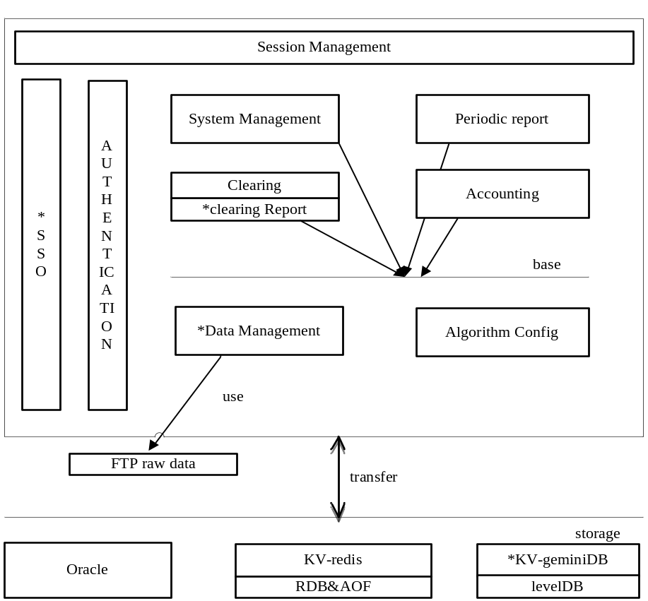
Figure 1.1 A Popular Architecture of SE
Clearing and Accounting module provide two main process of custody services. Clearing provides some operations like clearing data process, clearing data check, data split, clearing report, day-end business, while Accounting provides financial management, business data management, business processing, evaluation management, accounting data check.
System management module provide the interface to mange the whole CBS system status, including daemon task management, data interface configuration and import configuration which is management sub-module for managing the Data Management subsystem mentioned above, system performance monitor, system dictionary configuration. the last main business module is Periodic Report, which provide all kinds funds reports for custodians, fund manager, principles in different time dimensions.
Besides the business modules, we have some necessary basic modules, such as SSO module providing single sign on service to all modules and Authentication Management module giving the basic authentication support.
All the modules use the basic products like storage layer, which we use several infrastructures for different situations. Oracle provide stable support for relational data, while Redis is used as cache and some of asynchronous queue, and our key-value storage product based on levelDB is mainly for session storage and some other unstructured data.

1.2.2 Base Service Subsystem of CBS
As shown in 1.2.1, the applications signed with * are parts of BSS(Base Service System). BSS is not consisting of base products as the name implied, but it is described by the requirements of CBS, which including SSO, Data Importing, Asynchronous Queue, Session Storage, Clearing Reports.
All applications transfer data with storage layer which contains three infrastructures – oracle, Redis, geminiDB. In our system, oracle is used for relational data storage, and most of data is designed to obtain a data schema. What’s more, The Redis is well-known and widely used open source solutions for NoSQL because it optimize many data useful basic data structures like SDS(simple dynamic string), ziplist, skiplist, intset, map, not only can it be used as asynchronous queue but also it’s a good choice for key-value storage. With the properties that all data is storage in RAM memory, while the RAM memory is expensive, so Redis is not the best choice if you don’t have too much budget, you can find some alternatives to Redis, whose data is in disk. In our company, the geminiDB is developed by ourselves for key-value storage based on the levelDB which released by google team for local disk storage engine, and it save quite a lot memory.
Simply conclude: BSS is necessary because some basic issues need to solved so as to provide technical support for upper business systems, this article just talk about a part of BSS, and it’s my work for graduation project.

1.3 My Work
A whole service management subsystem consists of five main subsystems: base service subsystem, clearing subsystem, accounting subsystem, system management subsystem, periodic report subsystem. As time and other resources is limited, we can’t cover all these aspects, and the base service system contains several difficult modules that not appropriate for graduation project, so we focus mainly some separate but complete parts of Base Service subsystem.
In the rest of this article, we will introduce the architecture, detailed design and some core algorithms of base service subsystem, all modules are designed elegant, we developed data management and clearing report using common Java lightweight development way, and developed python-cas module in python language, and developed geminiDB using c because it’s quite efficient. So these parts of base service subsystem is funny and challenging.
This is how this article is organized. Chapter 2 presents a brief introduction to the techniques that were used in the process of implementation, it’s short but cover several popular aspects of software development. Chapter 3 is the system analysis of the base service subsystem we worked on. The architecture and detailed design of each module of base service subsystem is presented in chapter 4, while in chapter 5, the implementation detail is introduced, moreover, we give the test method have been used in the test process in chapter 6, at last we draw the conclusion and introduce some feasible directions for the future research.

Chapter 2 Core Technologies
In chapter 1, we introduce the simple requirements and implementation method of base service subsystem, but it’s not specific, so here we will talk about special key technology.

2.1 Web Development in Java

2.2.1 Java EE Specification
Web system is a big and comprehensive engineering, may include architecture, web design, web content development, security, there are many different method for web developing in high-level language.
Using Java, Java EE specification introduce the model for developing enterprise application, Java Platform, Enterprise Edition or Java EE is a widely used enterprise computing platform developed under the Java Community Process ^{[2]}, the platform provides an API and runtime environment for developing and running enterprise software, including network and web services, and other large-scale, multi-tiered, scalable, reliable, and secure network applications.
the Java EE specification is complete and powerful as shown in figure 2.1.
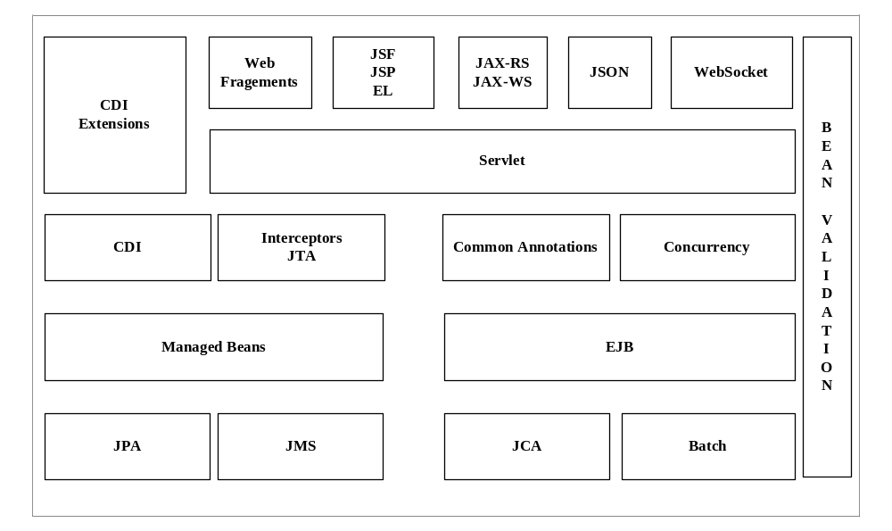
Figure2.2 Java EE7 architecture
Java EE is based on Java Platform but extends the Java SE(Java Standard Edition), providing an API for object-relational mapping, distributed and multi-tier architectures, and web services, it comprises several specification and is extending, for example, servlets specification is introduced to used as dynamic web content technology in Java compared with PHP and .NET, using with the JSP and EL and JSTL, you can develop a powerful dynamic web site efficiently, moreover, the JSF specification introduce the facet design pattern in MVC pattern, the EJB give a template using distributed application component, and JPA encapsulate unified model for operating persistence API, which may be very useful as you don’t need to care about which technology used as persistence layer, and it’s low coupling and robust, what’s more, the JTA provide the facet for transaction control.
The Java EE platform incorporates a design based largely on modular components running on an application server, beside, the platform emphasizes convention over configuration and annotations for configuration, optionally XML can be used to override annotations or to deviate from the platform defaults.
As we can see, the java EE application is too big and constraint, Compared with Java EE platform, a lightweight solution based on servlet API is introduced, in which Spring framework is most popular, next section we will introduce the basis and architecture of lightweight framework.

2.2.1 Lightweight solution
SSM(Spring+SpringMVC+Mybatis) is a typical combination of lightweight framework for web development, the architecture is shown in figure 2.2.
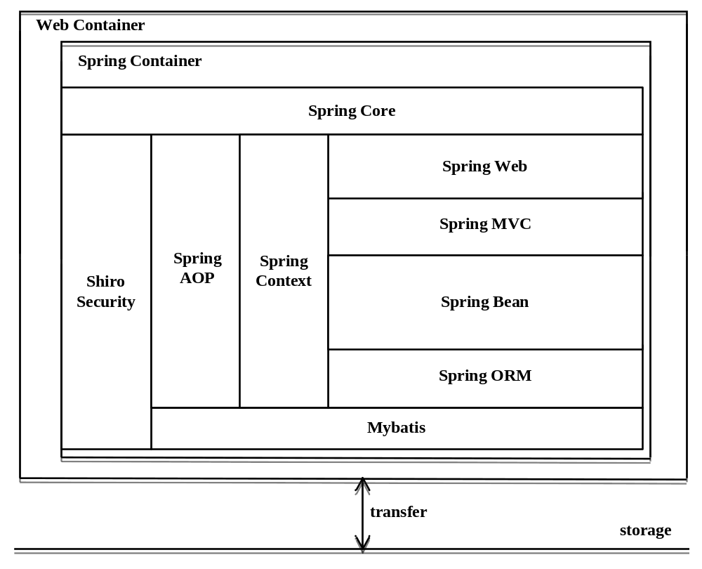
Figure2.3 lightweight web framework architecture
First of all, the Spring Framework is a Java platform that provides comprehensive infrastructure support for developing Java applications, Spring handles the infrastructure so you can focus on your application, Spring enables you to build applications from "plain old Java objects" (POJOs) and to apply enterprise services non-invasively to POJOs. This capability applies to the Java SE programming model and to full and partial Java EE.
The application is deployed in the web container, and all the beans is managed by spring container. The Spring Framework Inversion of Control (IoC) provide a formalized means of composing disparate components into a fully working application ready for use, which means the spring framework provide dependency injection and inversion of control, enabling you inject the components whenever you want and do not to care about the initialization of components.
AOP (Aspect Oriented Programming) enable you create a aspect or so called proxy of beans what you want to add functionality without changing the code, it provide efficient way for changing features and make the architecture low coupling. In spring way, you can just configure the AOP in the XML configuration file or Java annotation.
The SpringMVC is designed as a MVC web framework that dispatches requests to handlers that user user defined with configurable handler mappings, view resolution, locale, time zone and theme resolution as well as support for uploading files. The default handler is based on the @Controller and @RequestMapping annotations, offering a wide range of flexible handling methods. The controller also allows you to create RESTful Web sites and applications, through the @PathVariable annotation and other features, the diagram below show how it works.
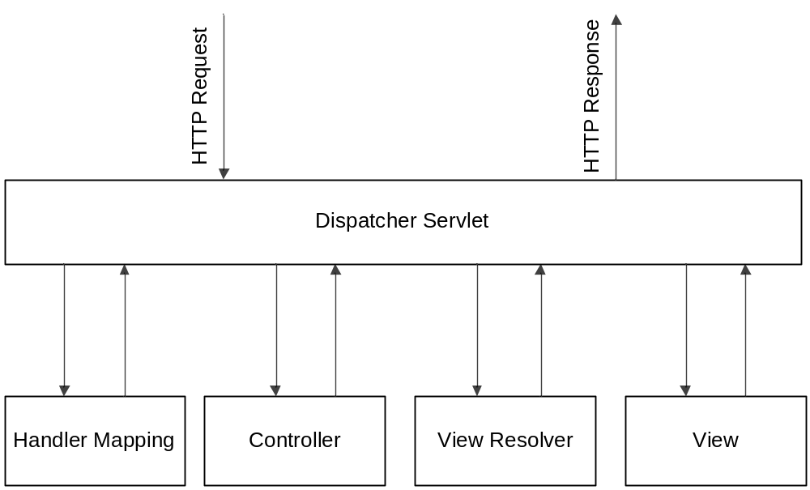
Figure2.4 SpringMVC architecture
Besides components handling web MVC process and bean management, we need framework do the object relation mapping work that transfer raw relational data info java object. Here we use mybatis as ORM components, which can be configured by XML or annotation, eliminating almost all of the JDBC code and manual setting of parameters and retrieval of results.
As shown in figure 2.4, mybatis parse the SqlMapConfig written by user into SqlMaps, input and output using all kinds of java data formats.
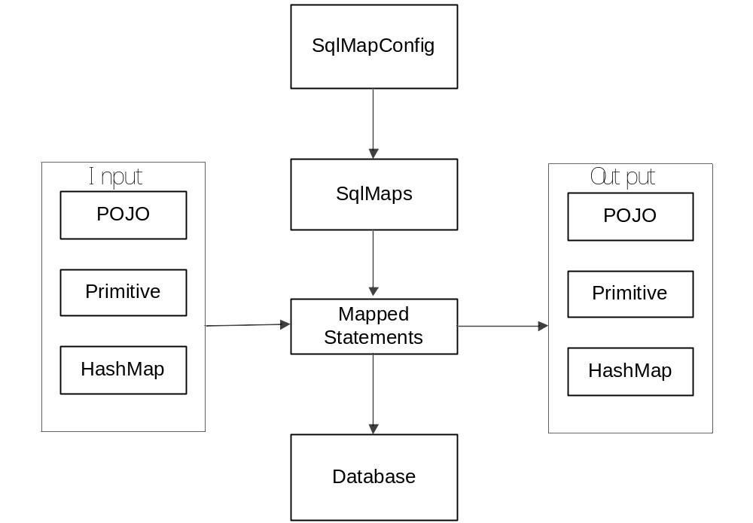
Figure2.5 Mybatis architecture

2.2 Web development in Python

2.2.1 Introduce to WSGI

In order to make frameworks can run anywhere, Python introduce a concept named WSGI, WSGI is not a server, a python module, a framework, an API or any kind of software. It is just an interface specification by which server and application communicate. You can choose any server based on WSGI specification like FastCGI, wsgiref or any framework have implemented the protocol.

2.2.1 Introduce to Flask
In this section, a micro python web app framework called Flask will be introduced.it dispatch the request routes like what SpringMVC did. Specially, Flask make response to clients use a template language called Jinja2, which is powerful by embedding to html file.
What’s more, the Flask is a micro-framework that aims to keep the core simple but extensible. Flask won’t make any decisions for you, such as what database to use, what template engine to use, are easy to change.
In Conclusion, we mainly used common web development technologies, comprising java and python, designed robust architecture based on some principles, besides, OOP also speeded up development process.

Chapter 3 System Analysis
In this chapter, we introduce the functional and non-functional analyze of base service subsystem. The base service subsystem contains several parts, it’s user oriented in some cases, while some of them is base product. We will analyze the modules next, respectively. At last the development environment will be presented.

3.1 Overview of requirements

3.1.1 Requirements of Custody Business System
All custodian bank wants to provide custody services to people, so they need IT system to manage the info and calculate the data, so as to make employees work more efficiently by focusing the core businesses like negotiations and decision making. The custody business system system aims to solve all problems caused by custodian services of commercial bank, such as the complexity of data management, the statistical analysis of trading data, it provides an abstract model of custodian trading process so that promote the sharing of investment info and efficiency of clearing and accounting operation.
After analyzing the custody services process, a whole architecture is introduced based on tier-principle as shown in figure 3.1.
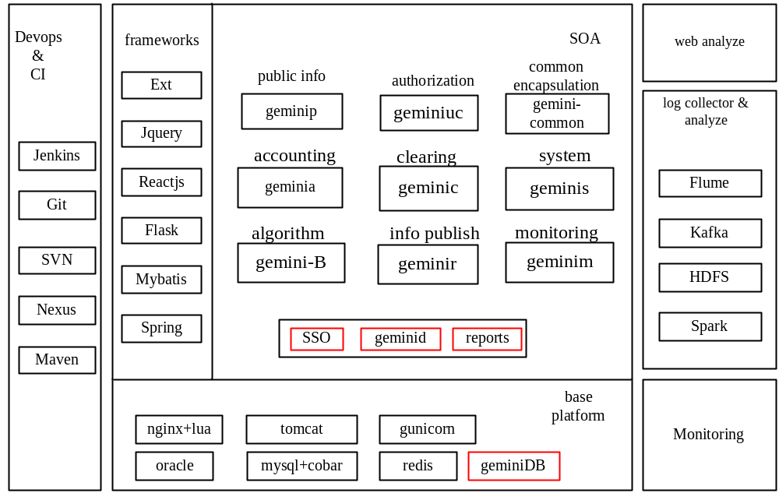
Figure3.6 architecture of custody service system
We tried to provide mainly clearing, accounting, algorithm configuration, info publishing systems, by analyzing the custody services processes. The clearing makes the clearing operation which involves the management of post-trading, pre-settlement credit exposures is possible, the accounting system make the sure the accounting operation which includes assets evaluation and accounting going smoothly, moreover, the algorithm configuration manage the financial calculation formulas of custody business systems, while the info publishing system maintain funds reports in all time dimensions. Besides, the source data is multi-format and coming from different place, the data management module aiming to manage data interface and data import process is needed. In order to guarantee the validation of investment behavior, the monitoring system is also introduced.
All the subsystems above are business oriented, but we need some other services so that the whole system is comprehensive and robust, the public info subsystem maintain the public parameters like holiday parameters, the authorization subsystem give the authorization lists in JSON format back after authenticated by SSO module when you invoke it, the common subsystem encapsulate many operations which is used frequently in Java development.

3.1.2 Requirements of Base Service Subsystem
As shown in figure 3.1, the red parts make up the base service subsystem, generally speaking, SSO module solve the authentication problem, the geminid solve the raw data importing and management, the reports module represent the clearing report in different query situations, the geminiDB provides strings and lists data structure. The figure below shows the base requirements of base service subsystem.
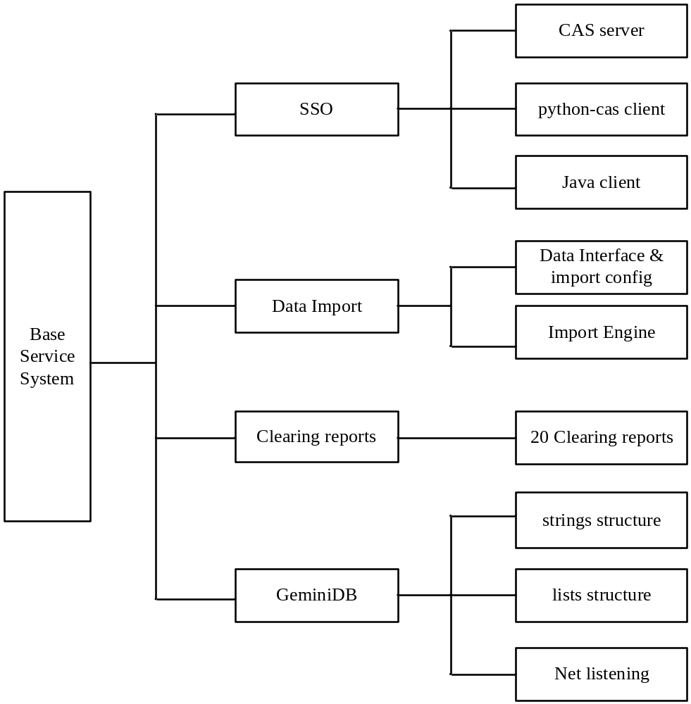
Figure 3.7 functional requirements of base service subsystem
The diagram above shows all the functional requirements we should implement in the base service subsystem. Next section we will explain the detailed requirements of four modules separately.

3.2 Detailed analysis of Base Service Subsystem

3.1.1 Functional Requirements
The use case of base service subsystem is shown in figure 3.3, there are mainly two actors, the operators in bank and the data manager, as we know, the operators will login those subsystems, of course logout is in need, both of is part of SSO. Besides, the operators also check the clearing reports at work, they have some behaviors that will cause the using of session storage and asynchronous queue, those use-cases are represented in this diagram. The data manager has the permission to manage the data interface and importing, so he has the use case data management which have several children, the interface configuration focus on configuring data interface like trading data, the importer configuration aims to configuring how and where to download and import raw data, once the import engine is started, the importing process run, which we will introduce system design chapter.
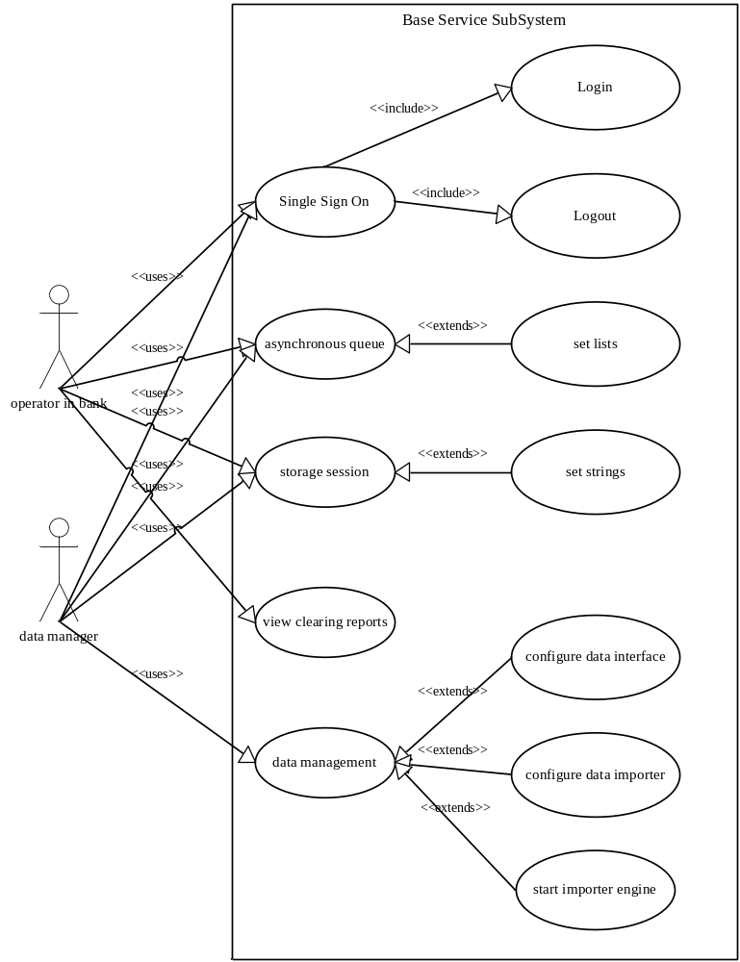
Figure3.8 use-case diagram of base service subsystem
In detail, we describe the requirements of SSO module firstly, because all subsystem is connected in logic, and an operator in bank may handle difference business in several subsystems, he may get tired if he must login before be approved to enter every system, we need a Single Sign On strategy to solve the problem, The process of SSO is shown in figure 3.4.
Specially, we just need login operation in custody business system, the registration is provided by administrator, moreover, we use RDMB to manage user credentials, and no special authentication protocol is required, the design of authentication service must follow these specifications.
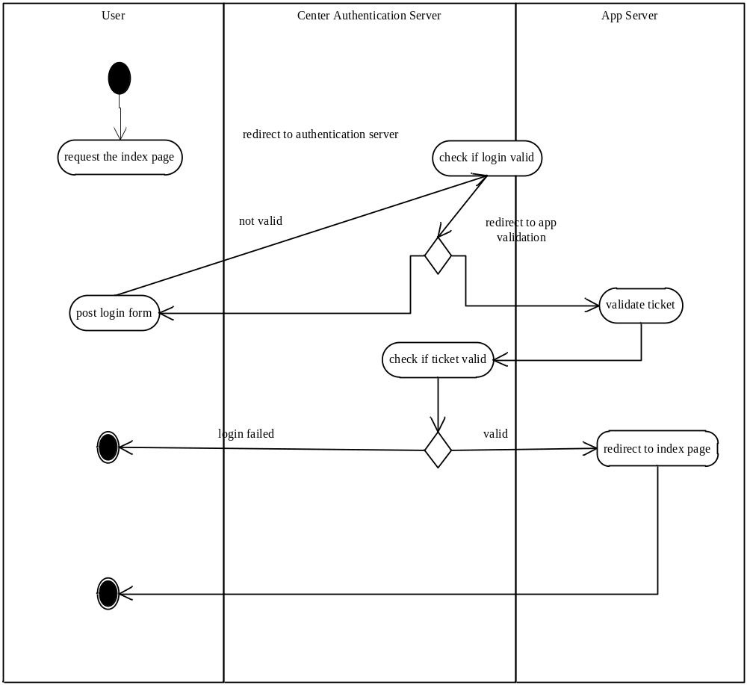
Figure 3.9 activity diagram of SSO process
Secondly, because there are many data types like trading data, TA data, settlement data, third-party data, off-site data which will be used in custody business system, but these data have different formats causing it’s hard to manage and analyze, we need a data importer to format these data into our data schema, the process of data importer is shown in figure 3.5.
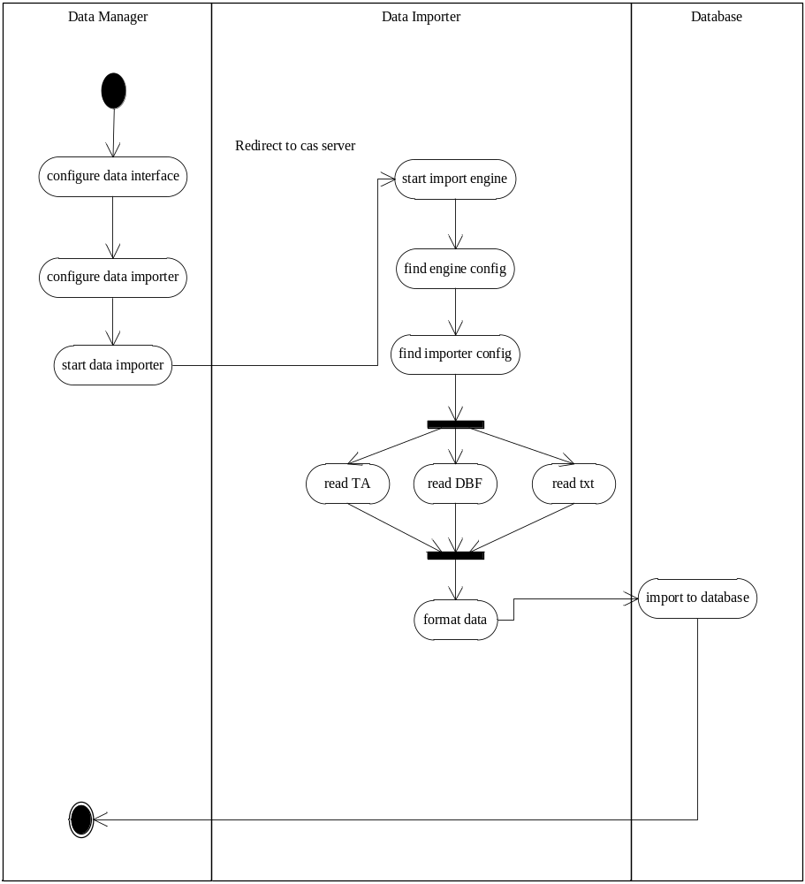
Figure 3.10 activity diagram of data management
Thirdly, it’s common for operator in bank to view the financial data reports at work, there are many electronic reports in different dimension, about 20 reports in clearing system and 20 reports in accounting reports.
At last, asynchronous queue is necessary for some time-consuming task, for example, the message-sending don’t need to response in real-time and it spends a lot of time, what’s more, we have another requirement that manage user’s session in the server side, because we need full control of session which will be exposed to user if stored in client side. We find out that lists structure in Redis can be used as asynchronous queue, while strings can be used as key-value storage, but Redis use a lot of memory, so we have a plan to design a key-value NoSQL using more disk instead, the probable activity design is shown in figure 3.5.
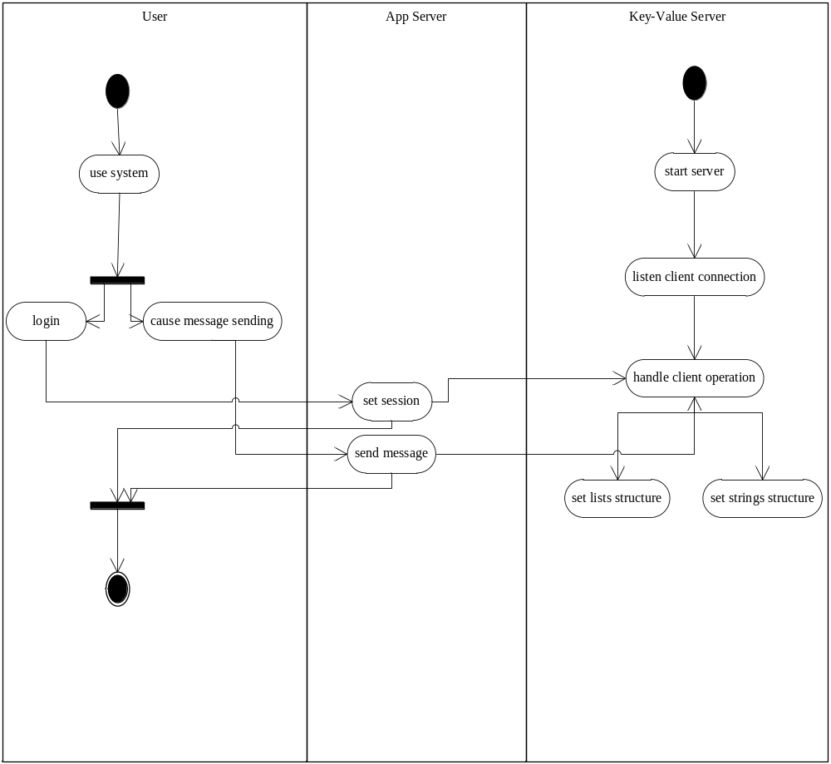
Figure 3.11 activity diagram of using key-value storage
Finally, we illustrate the use-case specification of base service subsystem:
- login the custody business system.
  - brief description: this use case describes how the user login custody business system.
  - Actors.
    - Operators in bank.
    - Data manager
  - Preconditions: actors have credentials of the system.
  - Basic flow of events
    - Actors request for index page of a specific system.
    - App server check session and redirect to center authentication server.
    - Authentication server check if cookie valid
    - Cookie is valid which means user have logon
    - Redirect to app server for validation
    - App server ask authentication server if the ticket valid
    - Ticket is valid and redirect to app index page
    - Display the index page
  - Alternative Flows
    - User have not login before
1.5.1.1 If user have not login before and don’t have cookie in the client.
1.5.12 Authentication server return the login form to client.
1.5.1.3 user fill the form and post asking validation.
    - Credentials is not valid
      - If the username and password is wrong, authentication server return wrong notice.
      - User resubmit the form.
    - Ticket if not valid
      - If authentication server response not valid when app server wants to validate ticket.
      - App server show the error page.

- Logout the custody business system.
  - brief description: this use case describes how the user logout the custody business system.
  - Actors.
    - Operators in bank.
    - Data manager
  - Preconditions: actors have entered a specific subsystem
  - Basic flow of events
    - Actors click the logout button.
    - App server remove all sessions of app server and all cookies set by authenticated server.
    - Request to Authentication for logout
    - Callback for post operation – go to login page.

- Use asynchronous queue.
  - brief description: this use case describes how the user use the asynchronous queue in the custody business system.
  - Actors.
    - Operators who have authorization.
  - Preconditions: user have entered a specific subsystem and have authorization
  - Basic flow of events
    - User do some operation which need send message like updating the manager of assets.
    - App server add the message to asynchronous queue.
    - Add to lists structure in our NoSQL.
    - Consumer use the message in the queue.

- Use storage session
  - brief description: this use case describes how the session is storage in the custody business system.
  - Actors.
    - Operators who have authorization.
  - Preconditions: user have entered a specific subsystem and have authorization
  - Basic flow of events
    - User do some operation which need session storage like login.
    - App server storage session in server side which will use the strings structure.
    - The session will be used when needed.

- View clearing report
  - brief description: this use case describes how user check the clearing reports in the clearing subsystem.
  - Actors.
    - Clearing operators.
  - Preconditions: user have authorization of clearing subsystem.
  - Basic flow of events
    - User login to clearing subsystem.
    - Switch to reports management menu.
    - Fill query criteria and check the result.

- Data Management
  - brief description: this use case describes how user manage the assets data in the whole system.
  - Actors.
    - Data manager.
  - Preconditions: user have authorization.
  - Basic flow of events
    - User login to system management subsystem.
    - Switch to data interface configuration menu.
    - Check and configure the data interface of the whole system.
    - Check and configure the data importer.
    - Start the data importer manually or in deamon.

3.1.2 Non-functional Requirements
(1) Feasibility analyze
The web development technology is very common and have experienced many years, no matter in java or python, while our system use mostly the common and popular frameworks, the data management module and clearing reports module use the spring+springmvc+mybatis, and python-cas module use Flask, we got quite experience about both of them, as for the key-value storage, we have used many different NoSQL and researched on the source code about some of them, and we are quite familiar with the C language, the key-value storage which contains strings and lists data structure is feasible too.
(2) Performance
For the data management module and clearing reports module, we use mybatis as ORM framework quicker than Hibernate, because it uses sql directly and have cache strategy, for spring, we use many singleton instance to improve the efficiency, what’s more, we use earache for java in virtual-machine layer which will save a lot of time. Actually, the another goal of base service subsystem is to improve the performance of whole custody business system, the asynchronous queue is used to handle asynchronous task like sending message, and the key-value storage is used as cache so as to reduce access to database.
Generally speaking, we have investigated the feasibility of base service subsystem, found out it is feasible in technical and performance.

3.3 Development Environment
(1) Hardware condition:
- Macbook air 13
- 120GB ssd
- 4GB RAM
- Intel Core I5 1.6G Hz
(2) Software environment:
- Mac Os x 10.11 EI Captain
- Intellij for java, Vim&Pycharm for Python, Clion for C
- Tomcat for deploying java, gunicorn for deploying python.
We will give an explanation of development environment: our company is free about the environment, so we select what we like, the Intellij is the most efficient IDE for java coding. Vim is most powerful editor no doubt, and it’s fit to write dynamic language code.

Chapter 4 System Design

4.1 Overview of system design
According to the system analysis, there are four parts of base service subsystem, they are: single sign on module, data management module, clearing reports module and asynchronous queue & session storage module. As the components of base service system provide base support for business system separately, and they are independently in functionality, so we will introduce design of these parts in next section, respectively.

4.2 Design of SSO module
The authentication service focus on provide single sign on service, which means user just need one credentials to get access to connected systems. After research, we decide to implement authentication service based on CAS framework, which use a ticked-based protocol exclusively for SSO authentication service.
The SSO involves one or many clients and one server. Clients are embedded in applications whereas the authentication server is a standalone component, the authentication server is responsible for authenticating users and granting accesses to applications, the CAS clients protect the CAS applications and retrieve the identity of the granted users from the CAS server, the sequence diagram of authentication web flow is shown in figure 4.1.
Assuming that we have a CAS server whose domain name is https://cas.com, and two application are http://app1.com and http://app2.com, we can figure out the process by next explanation:
- User request the index page of first application at first time, which play client role in the SSO model, the client detect if the user session exists, may be the assertion in CAS, client redirect to https://cas.com/cas/login?service=http://app1.com for login after finding the assertion session isn’t placed and no ticket parameter in request,
- CAS server generate login ticket and form, after user filling and post login form, server authenticate the credentials, if it’s valid, then generate TGT which is login principal and save it in server side, next, generate TGC which is cookie in client side according to TGT, finally redirect to http://app1.com?ticket=ST-xxx.
- Client finds ticket exists in request, then redirect to service validate URL: http://cas.com/serviceValidate?ticket=ST-xxx&service=http://app1.com.
- Server validate the ticket of validation request and response the xml which contains success string.
- Client redirect to http://app1.com.
- User request the index page of app2, app redirect to server for authentication like what app1 did.
- Server finds the TGT exists, redirect to client.
- Client validate the ticket and get success response.
- Client redirect to index page of app2.
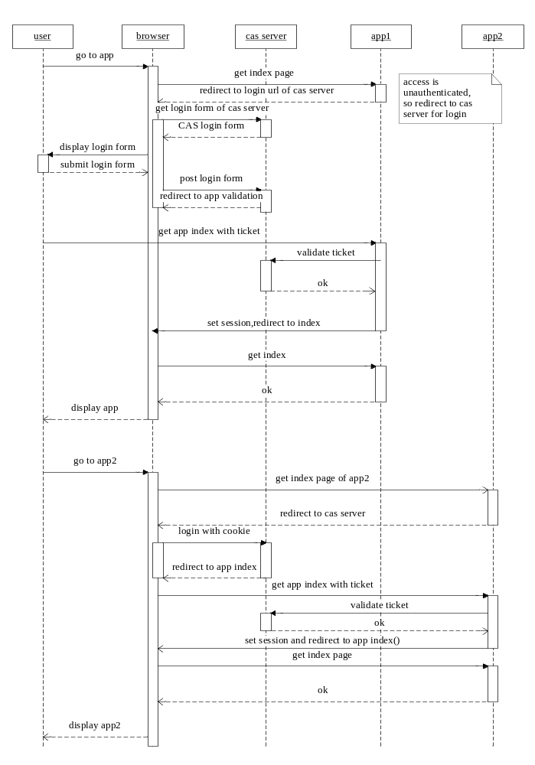
Figure4.1 sequence diagram of SSO process
After knowing the process of SSO process, we will work on the design of server side, it’s obvious to find what server do in the SSO process form figure 4.1, the CAS encapsulate the process and protocol actually, we mainly focus on the authentication strategy, in which we need data source and authentication handler of all subsystems. the class diagram of server is shown in figure 4.2 which ignore the fields and methods of class.
First of all, the SafeDispatcherServlet use DispatcherServlet to configure routing info which is core servlet of SpringMVC, and the DispatcherServlet use the LoginWebFlow class which handler the login process, in the login process, the core one is to authenticate the login form which is charge of AuthenticationViaFormAction class, it uses AuthenticationManager class indirectly, which handle the authentication process by using AuthenticationHandler. What we need to do is to design authentication handler of our system.
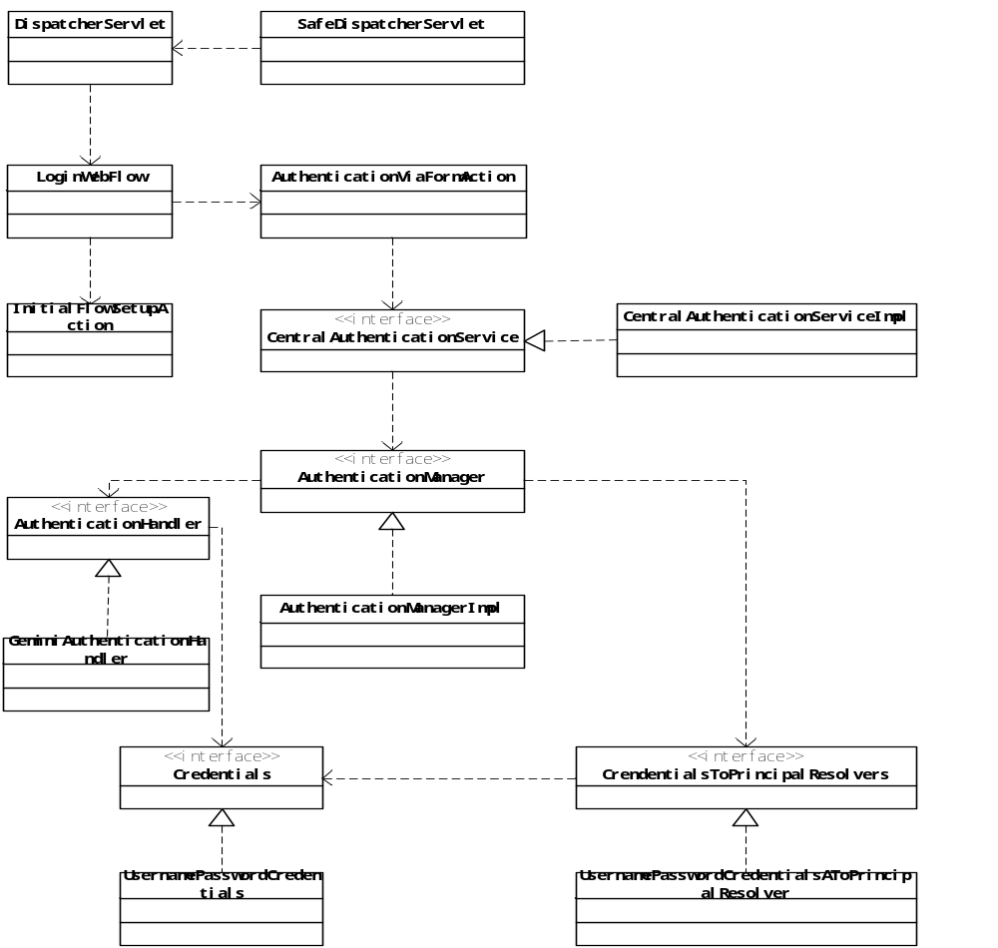Figure4.2 class diagram of CAS server
The client is also very important as the it need to validate the cookie and service tickets, firstly, application client validate the assertion cookie in browser, if there isn’t assertion cookie placed, then send redirect to authentication server, in addition, after authentication server response login successful, the client need to validate the server ticket carried in request parameters since it can be changed, finally, client will show the index page after receiving the successful assertion. That’s the main activity client participates in, so we need to implement the client according the process.

4.3 Design of data management module
Data management module aims to import from raw file storage interface, the local file system and ftp site, what’s more, the configuration and management UI is also need to be provided. Since the configuration web system is simple which just provide atomic operations like adding, deletion, updating, query, we will mainly focus on the system design of data importing process in this chapter.
Firstly, we can figure out the data importing process by looking the sequence diagram which is shown in figure 4.3. In the graph, we start import engine manually or in daemon, then import engine query database for importer configuration which declare how and where to retrieve raw data, next, import engine create ftp scanner according to the importer configuration, then it will start a ftp service if the raw data is in ftp site, the FtpService traverse directory of ftp site according to particular absolute path configured in importer configuration, once a valid file be found, it will download it and then start a specific reader adapting to the file type, different reader implementation have different read strategy, and the characteristics of file is also be configured by data manager, after reading, import engine will start data importer to import the data into relational database, on the path persisting to database, we need to format the data using several suitable formatter, the formatted data will be imported by DbImporter finally.
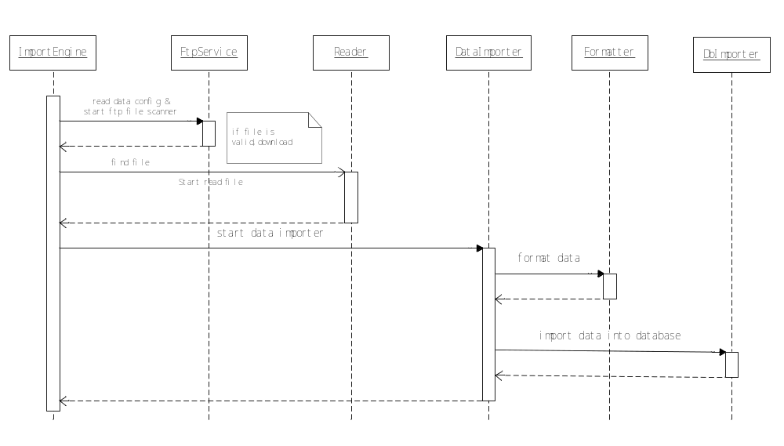
Figure 4.3 sequence diagram of data importing
Finding out the data importing process, we will work on the design of database schema, first of all, the GDM_DAATACONFIG stands for importer configuration which describes where the raw data locates, pattern of file name and some basic info of importer, it uses the GDM_IF entity which means the different data source interface like trading data and third-party data, while the GDM_IF_CATE declare the classification of data interface, what’s more, the importer configuration contains two more parts, you can figure out this situation: what to do with importing if no mapping info between source data and database schema is provided? So it’s necessary to design GDM_MAPFIELD representing database which contains formatters info also, and the GDM_SOURCEMAP indicates the source data mapping. Besides, in the process of importing, we need to record the downloading and importing progress,
They are designed as GDM_IMPORTRECORD and GDM_DOWNLOADRECORD, actually, the GDM_DOWNLOADRECORD also tell whether to download the file or not next time, the ER-diagram of data importing process is shown in figure 4.2.
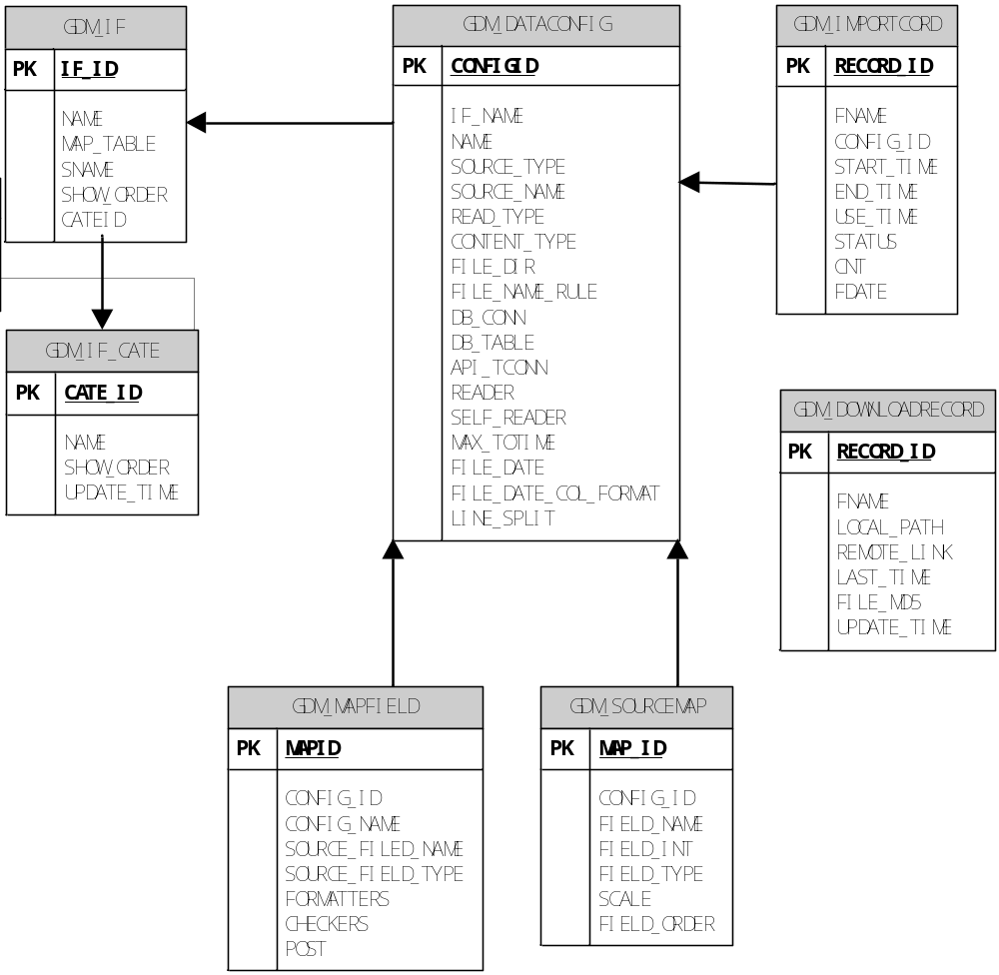
Figure 4.2 ER diagram of data import module

The schemas of some database table in data management module is introduced here, including gdm_dataconfig and gdm_mapfield.
Gdm_dataconfig table describe the structure of importer configuration, it has a primary key CONFIG_ID which will be used by fields mapping, moreover, you can figure out where to retrieve source data referring to FILE_DIR field, what kind of data it is referring to CONTENT_TYPE field, and you can assign split character viewing the LINE_SPLIT.
Gdm_mapfield declare the mapping information between field of source data and database, it has a field called CONFIG_ID refer to gdm_dataconfig, you can choose fit formatters for raw data referring to FORMATTERS, besides, some fields need to be post handled because it need to be formatted based on other fields.
Table 4.1 schema definition of gdm_dataconfig table
Field | Type | PK | Null | Remark
CONFIG_ID | Number(32,0) | Yes | No | ID of importer configuration
IF_NAME | VARCHAR2(32,0) | No | Yes | Name of data interface
NAME | VARCHAR(32,0) | No | Yes | Name of importer
SOURCE_NAME | VARCHAR2(32,0) | No | Yes | Name of source data
CONTENT_TYPE | VARCHAR2(32,0) | No | Yes | Content type if data: DBF, Split, TA
FILE_DIR | VARCHAR2(128,0) | No | Yes | Directory of data
FILE_NAME_RULE | VARCHAR2(32,0) | No | Yes | Rule of file name
READER | VARCHAR2(32,0) | No | Yes | Self-defined reader
FILE_DATE | VARCHAR2(32,0) | No | Yes | Where to get date of file
FILE_ENCODING | VARCHAR2(16,0) | No | Yes | Encoding of file
LINE_SPLIT | VARCHAR2(8,0) | No | Yes | Split character
Table 4.2 schema definition of gdm_mapfield table
Field | Type | PK | Null | Remark
MAP_ID | Number(32,0) | Yes | No | Primary key
CONFIG_ID | Number(32,0) | No | Yes | Refer to gdm_dataconfig
FORMATTERS | VARCHAR(256,0) | No | Yes | Formatters of data
SOURCE_NAME | VARCHAR2(32,0) | No | Yes | Field name of source type
SOURCE_TYPE | VARCHAR2(32,0) | No | Yes | Type of field
POST | Number(4,0) | No | Yes | If post handled

After designing database schema, it’s important to discuss the structure of data importing module in object oriented way, the best way is using class diagram to describe that, the figure 4.3 represents the dependency and association of data importing module. It’s clear to find out the inner connection of all entities by having understood the data importing process, first of all, the core class is ImportEngine, it uses DataScanner to scan the local file system or ftp directory, moreover, DataReaderFactory can be used to handle file reading process, and DataIMproterFactory aims to import data into database, specifically, DataReaderFactory rely on DataReader interaface to read specific file, while there are many different reading strategy, like SplitReader designed for read split file, ByteFileReader used as TA file reader, besides, for importing process, DataImportFactory depends on DataImport interface to import the data once reading is ready, there is a implementation of DataImport, the SimpleDataImporter use other assistant class to complete the importing process, for example, it uses FormatterHelpler to decide appropriate formatters to format the raw data, finally, it uses DbImport interface while has implementation called SimpelDbImporter to handler persistence progress.
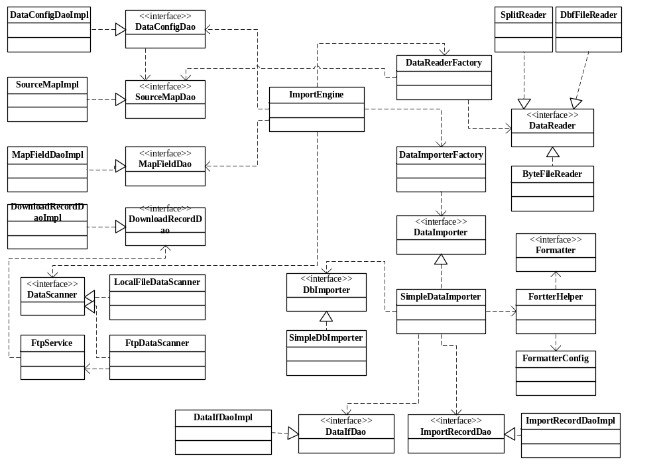
Figure 4.3 class diagram of data importing module

4.4 Design of clearing reports module
The third part of base service subsystem is clearing reports module, it’s designed as backend service handling query electronic reports, first of all, we stress on the requirements again, that is we want to query many kinds of reports having several conditions, so the structured query language will be very complete, but it’s not the core challenge, what trouble most is that we need to deal with 20 more report which need grouping operation, traversing to tree structure and summing operation, if we implement a handler class for every report querying, that will be a ponderous, so we need universal formatter to format raw data.
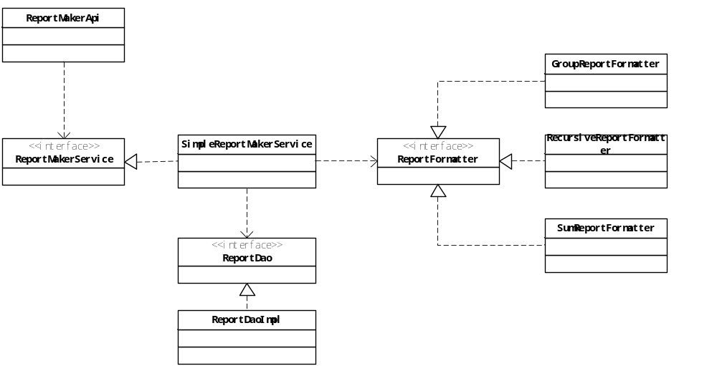
Figure 4.4 class diagram of clearing reports module
So in section, the design of reports querying is illustrated, the core class diagram of clearing reports module is shown in figure 4.4. it’s as common web interaction process for query electronic reports, so ReportMakerApi which using SpringMVC syntax is bring in to handler http requests, it depends on ReportMakerService interface to handler concrete report querying, besides, the implementation of ReportMakerService uses ReportDao query data from database, and format data using ReportFormatter interface whose implementation get involved in reelection to deal with specific report entities. Those entities of reports are not shown in this figure and we don’t introduce the concrete database schema of these reports because it’s too much, actually, what really matter is the formatting process, the query part of this module is also very important because the query is very complicate, but it’s suitable to show the query language here.
In summary, report maker service completes the reports querying process by using data access objects and formatters, data access objects encapsulate the queried data into data transfer object after retrieving appropriate data, while implementation of formatter interface provides consistent interface for different normalization operations.

4.5 Design of asynchronous queue & session storage
Our company have the requirements of sending asynchronous message and storage session in server side, actually we have use Redis cluster to solve these problems, and part of authors’ job to deploy Redis cluster in server, but this solution is not planned to introduce in this thsis.
Redis is fast and completely support all kinds of data structure we use in development, lacking of memory resources, it’s necessary to design a key-value storage server using disk resources for persistence storage, so we provide a program aiming to replace in Redis some scenarios in our company, based on levelDB which is key-value storage libarary, and we call it as GeminiDB
The figure 4.5 show the structure of GeminiDB, it use writing and reading operations provided by levelDB, actually it’s performance is good enough for key-value storage, what we need to do is to design the storage layer, provide strings and lists data structure, moreover, the net layer is essential in which we declare request-response protocol based on socket.
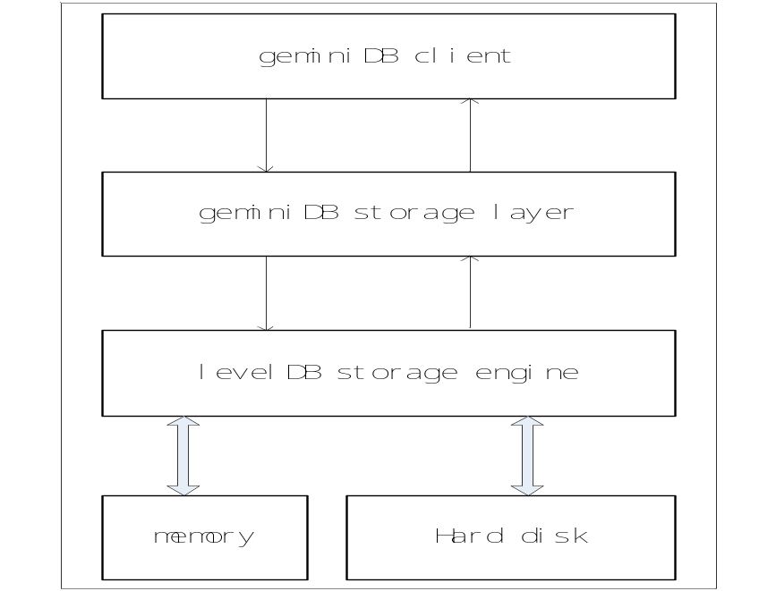
Figure 4.5 structure of Gemini-DB
In detail, the Db mainly cover net layer and commands layer and backend storage layer, net layer is responsible for listening request and response message given by commands layer, so we have designed NetworkServer class in charge of the net layer, it use Link to represent linkage between client and server, and once socket connected, a NetEvent is produced, NetworkServer depends on Request and Response for client request and server response. In another part, BackendServer handle command request by invoking DbServerImpl which implement all operations about strings and lists. As shown in figure 4.5, the MyApplication is the enter point of server, it uses NetworkServer to serve request roundly, moreover, it connect the layer and command layer, specially, by using Options and Config to read configuration, it provide low coupling design allowing you configuring server and levelDB properties.
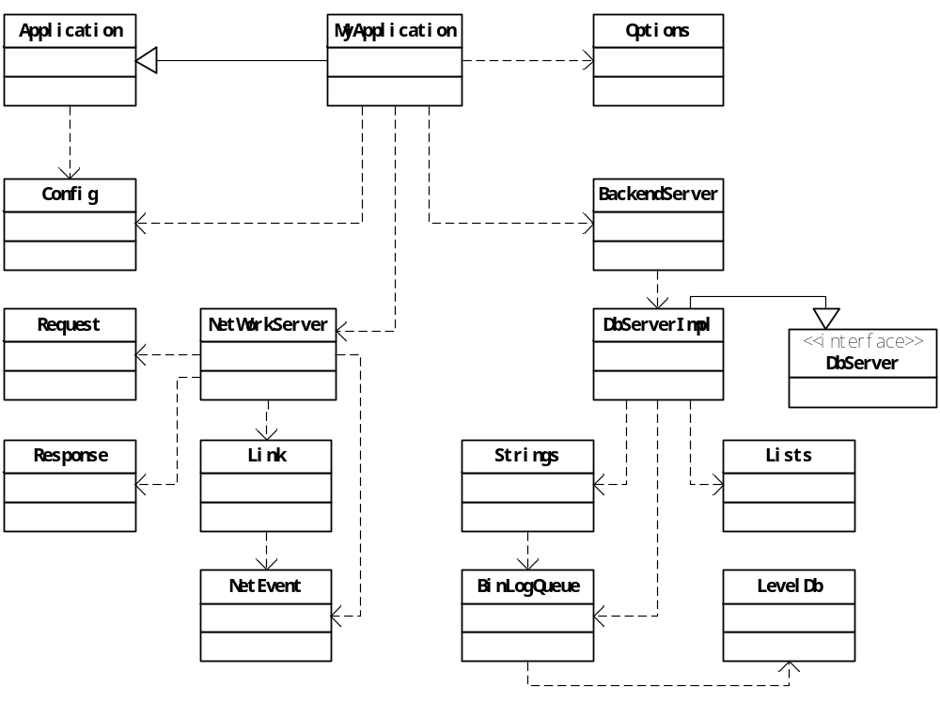
Figure 4.5 class diagram of Gemini-DB

Chapter 5 System Implementation
Former parts have introduced the basic process of four modules of base service subsystem, this chapter illustrate the implementation of every individual module, including program procedure, source core of core parts and user interface.

4.1 Implementation of SSO module

4.1.1 server of single sign on
First of all, we start implementing server part of SSO module, as described in system design section, we mainly focus on providing authentication handler which will be used by authentication manager to verify user credentials.
In detail, the data source need to be configured in db.xml firstly, the data source will be managed by spring core container, address of database, username and password need be provided in db.xml, maxActive indicates max active connections in connection pool, we use dbcp library as data source.
<bean id="dataSource" class="org.apache.commons.dbcp.BasicDataSource"
destroy-method="close">
<property name="driverClassName" value="${gemini.driverClassName}" />
<property name="url" value="${gemini.url}" />
<property name="username" value="${gemini.username}" />
<property name="password" value="${gemini.password}" />
<property name="maxActive" value="8" />
<property name="maxWait" value="2000000" />
<property name="poolPreparedStatements" value="true" />
<property name="defaultAutoCommit" value="true" />
<property name="testWhileIdle" value="true" />
<property name="timeBetweenEvictionRunsMillis" value="20000" />
<property name="numTestsPerEvictionRun" value="10" />
</bean>

Secondly, main spring configuration file deployerConfigContext.xml configure the main class we will use, follow code show how to configure specific authentication handler, main part of it is shown in next.
<property name="authenticationHandlers">
<bean class="com.gemini.cas.GeminiCasAuthenticationHandler">
<property name="dataSource" ref="dataSource"/>
<property name="authenticationQuery" value="select password from tr_user where user_name = ? "/>
<property name="passwordService" ref="passwordService"/>
</bean>
</property>

The GeminiCasAuthenticationHandler class is our custom authentication handler, it uses the query language configured above to query valid credentials of login user, and valid the md5 of password, once it’s correct, it will return true, code is shown next.
UsernamePasswordCredentials user = (UsernamePasswordCredentials) credentials;
Connection conn = null;
PreparedStatement statement = null;
ResultSet resultSet = null;
try {
conn = this.dataSource.getConnection();
statement = conn.prepareStatement("select password from tr_user where user_name = ?");
statement.setString(1, user.getUsername());
resultSet = statement.executeQuery();
if (resultSet.next()) {
String password = resultSet.getString(1);
if (password.equalsIgnoreCase(MD5Util.MD5(user.getPassword())))
return true;
}
} catch (Exception e) {
e.printStackTrace();
} finally {
JdbcUtils.closeResultSet(resultSet);
JdbcUtils.closeStatement(statement);
JdbcUtils.closeConnection(conn);
}
return false;

3.1.2 clients of single sign on
CAS provide java client implementation, so we mainly concentrate on python client, according to what have designed in chapter 4, client mainly do these job:
- Validate if assertion cookie exists at first login.
- Redirect to login port of authentication server if user is not valid.
- Redirect to service validation port after server’s callback.
- Receive response of service validation, and go to after login interface in client if response is ok.
There are mainly two parts python files in our python client, the casConfig.py configure the ip address of cas server, the client interface to receive server’s callback, interface to callback after completing whole login process or logout process, besides, these configurations will be integrated with Flask framework so that we can use it in pycas library.
In pycas directory, we have created three source code files, __init__.py is the enter point of pycas library, login and logout interface is provided in it, they are director in python, just to add @login_required to business interface, it will work, the login_required function is shown next.
def loginre_required(function):
@wraps(function)
def wrap(*args, **kwargs):
if 'CAS_USERNAME' not in flask.session:
flask.session['CAS_AFTER_LOGIN_SESSION_URL'] = flask.request.path
return login()
else:
return function(*args, **kwargs)
return wrap

Once login operation start, login interface will check the assertion cookie in browser, if assertion cookie not exists, it will invoke pycas_login method defined in routing.py to handle redirect process, this method is also be used callback interface for server, the code is shown next.
@blueprint.route('/pycas_login/')
def pycas_login():
redirect_url = create_cas_login_url(
current_app.config['CAS_SERVER'],
current_app.config['CAS_LOGIN_ROUTE'],
current_app.config['CAS_CLIENT']
)
cas_token_session_key = current_app.config['CAS_TOKEN_SESSION_KEY']

if 'ticket' in flask.request.args:
flask.session[cas_token_session_key] = flask.request.args['ticket']
if cas_token_session_key in flask.session:
if validate(flask.session[cas_token_session_key]):
if current_app.config['CAS_AFTER_LOGIN']:
redirect_url=flask.url_for(current_app.config['CAS_AFTER_LOGIN'], _external=True)
else:
del flask.session[cas_token_session_key]
redirect_url = current_app.config['CAS_ERROR_PAGE']
current_app.logger.debug('Redirecting to: {0}'.format(redirect_url))
return flask.redirect(redirect_url)

pycas_login method check if ticket parameter exists, no means it’s first redirect, then it invoke method in cas_urls.py to construct appropriate redirect url, while yes means it’s time redirect for service validation, after last callback of server, pycas_login use validate method in the file to receive and parse response, ok response indicates py_cas can invoke after login interface, then user is permitted into system, the figure below show the client process.
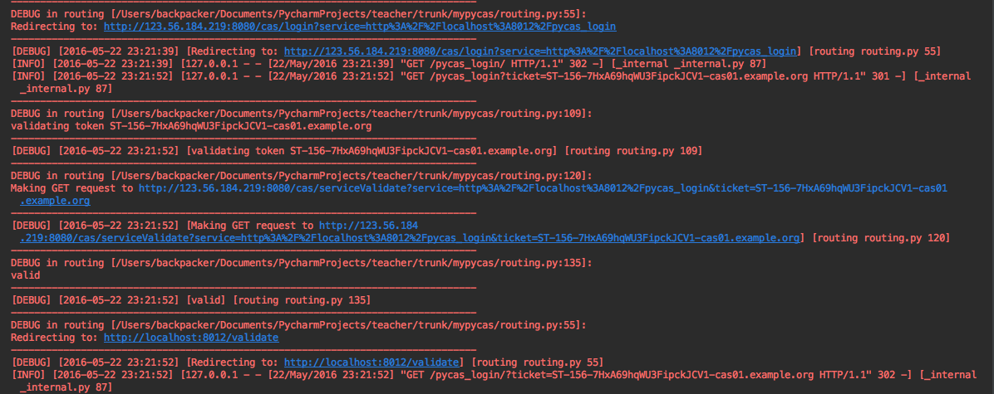
Figure5.1 login process of python client
  - Implementation of data management module
The source code of data management module is referred as gemini-data, whose structure is based on maven project, the configuration interface is introduced firstly because it’s essential part and not that complex, you can find out the DataIfApi is used in order to manage data interface, using SpringMVC, it provide basic operations for data interface management, note it use common multilayer of web development, it’s implementation is not very important for out goals here, so we give the UI directly shown in figure 5.2.
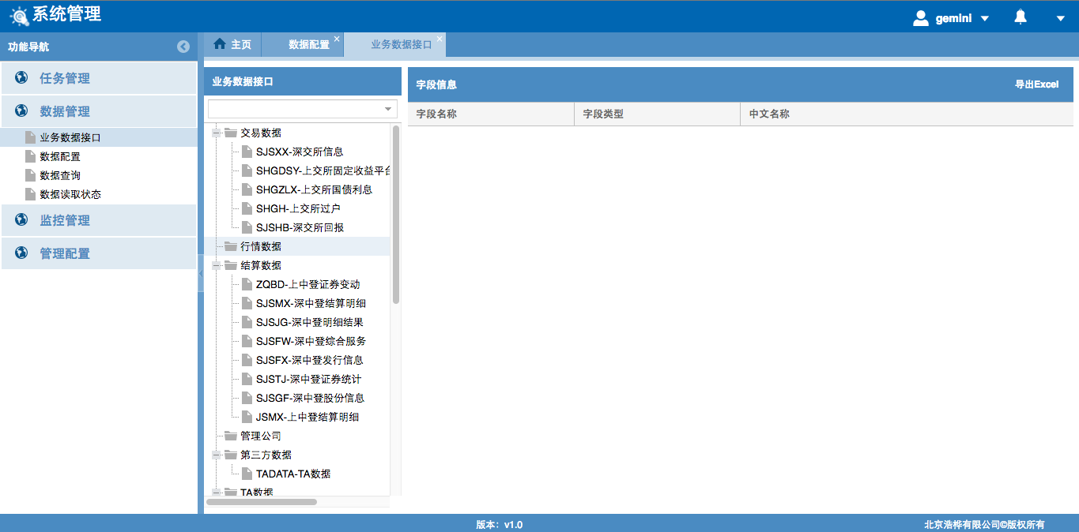
Figure5.2 UI of data interface management
In addition to data interface configuration, we mainly focus on importing process implementation, first of all, some concepts in importing process is introduced:
- Import engine – core components of data importing program, it start scan data interface and assign data reader and importer.
- Reader factory – assign appropriate reader for different data file.
- Importer factory – assign exact importer for reading data.
- Formatter helper – decide correct formatters for formatting every row of data.
Notably source data have different content type, which means fit reading strategy adopted, for example, split file reader, DBF file reader and byte file reader and so forth. There is an important field for every source data file, referred mostly as data of file, because every trading data or market data has date, besides, regex of file name guide import engine to scan and download valid data warehouse, may be local file system or ftp directory, we introduce other important fields in importer:
- Unified name of data, it’s used marking data file so as that retriever can distinguish files.
- File encoding, for assigning fit encoding when open file.
- Data inreface, indicating which database table where the data of this file stored.
The mapping info between source data and database schema is also configurable, there are several content types of file, including excel, csv, json, dbf, byte-file and split-file, dbf file have a specifi data format just like database schema, byte-file is conbined by continus characters, we can configure name and how much bytes used of every field, split file is splited by specifc character like @, : and so forth. UI of importer configuration is shown next.
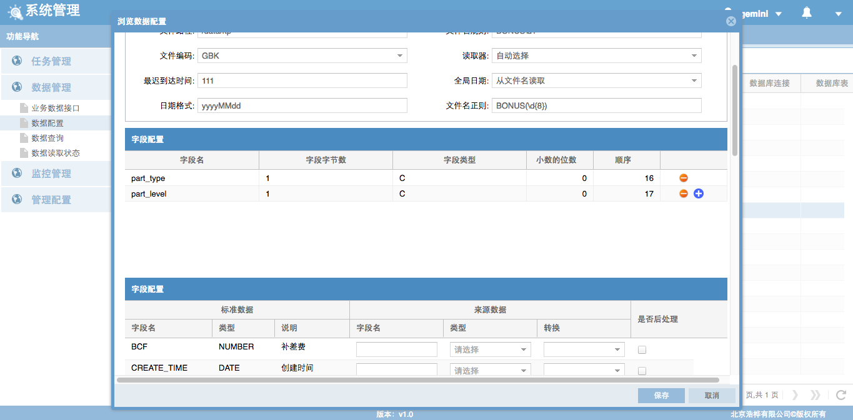
Figure5.3 UI of importer configuration
Import engone read importer configration created by data interface in above way fistly, constuct mapping between directory of warehouse and valid file name pattern, meaning that what kinds of data in a specific directory need to scanned, then start data scanner to scan warehouse, file sacnner complete scanning by using FtpService or LocalFileSystemService, once valid file found, scanner download and invoke doImport method in import engine booting importing process, at same time download records are updated. Next, import engine exucut pre-reading using specific reader choosen by reader factory in order to checking file validation, if file is validated, depending on import factory, real importing process starts from reading data of every column, then package it into map data stucture, besides import config of every file is updated. Most importantly, map stucture need be fomatted by fomatter which hae more than 10 fomat strategy, for example, assigning file name to this field, assigning value of another field, parsing math expression, quering some values using sql and so forth, the fomatters is complex, you can refer fomatter directory in source code folder. finally, importer import map stucture into database depending on db importer.
Finnaly, the core part of foamtter is introduced, there are many fomatters can be configured for a specific column, in the progress of importing reading data, data importer fist check if the field need be post processed, post processed fields will be handled in second loop, the code is shown next.
while(reader.hasNext()){
recordCnt++;
Map<String,Object> sourceRecord= reader.nextRecord(Charset.forName(config.getTrueEncoding()));
Map<String, Object> record = new CaseInsensitiveMap(sourceRecord);
if(null != fileDate)
record.put(Config.DC_FILE_DATE_MAPNAME, fileDate);
Map<String, Object> data = new HashMap<String, Object>();
for(String stdField : stdFields){
MapField mField = fieldMap.get(stdField);
if(Config.YES_INT == mField.getPost())
continue;
String sourceFieldName = mField.getSourceFieldName().trim();
Object srcValue = record.get(sourceFieldName);
Object value = formatHelper.format(mField.getFormatters(), srcValue, record, data);
data.put(stdField, value);
}
for(String stdField : stdFields){
MapField mField = fieldMap.get(stdField);
if(Config.NOT_INT == mField.getPost())
continue;
Object srcValue = record.get(mField.getSourceFieldName());
Object value = formatHelper.format(mField.getFormatters(), srcValue, record, data);
data.put(stdField, value);
}
datas.add(data);
}
The calculating expression formatter is introduced next, it must be configured in a regex, meaning calculation of what fields, formatter parse the configuration into a machine friendly expression and calculate it by javascript engine in java.
@Override
public Object format(Object src, Map<String, Object> conf) {
String srcExp = String.valueOf(conf.get("exp"));
Pattern pattern = Pattern.compile("(F_|D_)(\\w|_)+");
Matcher matcher = pattern.matcher(srcExp);
StringBuffer sb = new StringBuffer();
while (matcher.find()) {
String sub = matcher.group();
String rep = "";
if (sub.startsWith("F_")) {
sub = sub.split("F_")[1];
rep = String.valueOf(record.get(sub));
} else if (sub.startsWith("D_")) {
sub = sub.split("D_")[1];
rep = String.valueOf(data.get(sub));
}
if (rep == null)
rep = "0d";
else {
double repNum = Double.parseDouble(rep);
rep = String.valueOf(repNum) + "d";
}
matcher.appendReplacement(sb, rep);
}
// calculate
Double ret = (Double) MyString.evalExp(sb.toString());
return ret;
}

4.3 Implementation of clearing report module
There are two challenges of clearing report module, first one is about how to query data from database, the mybatis object-relation mapping is used to solve the problem, for every report, the result map information need be configured in report-mapper.xml, indicating which entity be encapsulated after querying, besides, the query language of reports may be very complex, we give a common one next:
<select id="selectAccountOcInfoReport" parameterType="Map"
resultMap="AccountOcInfoReport">
SELECT ga.khsl,ga.XHSL,gpbi.name as bankName,
gpci."NAME" as prodName,gd2.sname as prodCate,gd3.sname as detailCate,gd.sname as opMode,gpci.OP_UNIT as opUnit,gat.name as accountTypeCode
from
(
select nvl(kh.PROD_ID,xh.prod_id) as prod_id,
nvl(kh.ACCOUNT_TYPE_CODE,xh.ACCOUNT_TYPE_CODE),
nvl(kh.khsl,0) as khsl,nvl(xh.XHSL,0) as xhsl,
nvl(kh.OPENBANK,xh.OPENBANK) as openBank
from
(
select count(ga.ACCOUNT_ID) as khsl,ga.PROD_ID,
ga.ACCOUNT_TYPE_CODE,ga.OPEN_BANK_ID as openBank
from GC_ACCOUNT ga
where 1=1
<if test="startDate != null">
and ga.BEGIN_DATE &gt;= #{startDate}
</if>
<if test="endDate != null">
and ga.BEGIN_DATE &lt;= #{endDate}
</if>
group by ga.ACCOUNT_TYPE_CODE,ga.PROD_ID,ga.OPEN_BANK_ID
)kh
full outer join
(
select count(ga.ACCOUNT_ID) as xhsl,ga.PROD_ID,
ga.ACCOUNT_TYPE_CODE,ga.OPEN_BANK_ID as openBank
from GC_ACCOUNT ga
where 1=1
<if test="startDate != null">
and ga.END_DATE &gt;= #{startDate}
</if>
<if test="endDate != null">
and ga.END_DATE &lt;= #{endDate}
</if>
group by ga.ACCOUNT_TYPE_CODE,ga.PROD_ID,ga.OPEN_BANK_ID
)xh
on kh.prod_id=xh.prod_id
) ga
left join GC_PRODUCT_CLEAR_INFO gpci
on ga.PROD_ID = gpci.PROD_ID
left join GP_PRODUCT_INFO gpi
on ga.prod_id = gpi.prod_id
left join GPINFO_BANK_INFO gpbi
on gpbi.bank_id=ga.openBank
</select>
The former select language in mybatis query format show how to query open and closed account information reports, resuleMap declare the entity mapped after querying, this sql join several tables together, as these database tables are dispersed, so we don’t give the structure of them in this thesis.
The clearing reports module is implemented in common java web way, using self-defiend springmvc controller, introduced in system design chapter, ReportMakerApi is a controller responsible for generating all electronic reports, we have refactored it quite a lot, source code folder contains tens of service interface and implementation class before, now they are integrated to one interface called Report ReportMakerService, depending on data access layer, implementation class if ReportMakerService get access to report entities, ReportMaker interface is responsible for reformatting report entities, it mainly has three strategies, grouping, summing and treeing which traverse the entities to form tree structure.
The most significant part is how to abstract formatter interface and implement formatter strategies, we have implemented specific strategies for account rate report, based on it, we have refactored it into reflection way,

4.4 Implementation of GeminiDB

Chapter 6 System Testing
In a SE, the good performance is very important. The performance is mostly shown in the query speed. The function of the index is to provide an efficient So we design some different kind of testing data to check the performance of the index subsystem. After that, we introduce a model of the performance.

6.1 Overall Analyze
el of the performance.

Chapter 7 Conclusion
This system is a part of the study of the whole Chinese search engine. This article presents how to design and implement an index subsystem including the data structure of index and the index-building and other algorithms. The system is based on an original web page library. It builds up inverted indexes of key words for every web page in the library. These indexes can be used in the query subsystem to make the operation of query more efficient.
There are some good characteristics of this system: the author uses inverted index as index data structure, which is the most popular and widely used in modern search engine. It’s simple, easy to implement and very efficient; the author uses C++ STL a lot to ensure the performance, quality and safety of the code; the author uses flexible segmentation algorithms to analyze the web page and users’ queries, the weight of words in dictionary can be adjusted to make the segmentation suitable for the concrete circumstances and different applications.
There are also some shortcomings of the system. First, it’s all based upon library of Tianwang format, so is not expandable if the author wants to use other format. Second, all the indexes are internal data so they can’t be used in other system. Third, it’s a study project without accepting the test driven by mass-data. The whole subsystem is also internal module without user interface. So if no interfaces are provided, the whole system can’t be used as a data production.
The next step of the study can be explored from these two directions:
First, the author have put forward a solution when the indexes are too large to be read into the RAM together (in truth, it happens usually in the modern business SE), that is the author can divide the whole index into small blocks that can be put into RAM and build hierarchical indexes using B+ tree as external sorting data structure.
Second, the author can improve the data structure of index. In the resent years, the mixed index is often used. It is based on the inverted index technique. Furthermore, it scans the original library more than one time and mixes the different kinds of indexes. But it’s still a naive technique and need to be studied more.
Third, the author can use clustering algorithms of data mining to preprocess the original web page library. So when a retrieve is performed, the author can get a better accuracy according the classification result.

Reference
- 李晓明，闫宏飞，王继民．搜索引擎－原理技术与系统[M]，北京：科学出版社，2005，2-18，41-54．
- Page Lawrence, Brin Sergey, Motwani Rajeev. The PageRank Citation Ranking: Bringing Order to the Web. Stanford digital library Technologies Project [J]. 1998, 11: 17
- A.Rungsawang, N.Angkawattanawit. Learnable topic-specific web crawler. Journal of Network and Computer Applications[J].2005,28(2):4-5.
- Justin Zobel, Alistair Moffat. Inverted file for search engines. ACM Computing Serveys[J]. 2006,38(2): 2-3, 5-8
- 昝红英. 2004. 基于实体属性的中文网页检索研究. 北京大学,硕士论文.
- http://sewm.pku.edu.cn/src/ [EB/OL]. 2008.03.05
- 刘开瑛．中文文本自动分词和标注[M]，北京：商务印书馆，2000，1-17．
- http://www.stlchina.org/twiki/bin/view.pl/Main/STLDetailHashMap [EB/OL]. 2008.04.05
- http://www.sgi.com/tech/stl/ [EB/OL]. 2008.04.05
- http://msdn.microsoft.com/zh-cn/default.aspx [EB/OL]. 2008.04.05
- Meng Tao, Yan Hong Fei, Li Xiaoming. An evaluation model on information coverage of search engines. ACTA Electionica Sinaca[J]. 2003, 8(31):1168-1172.
- George Karypis, Eui-Hong (Sam) Han, Vipin Kumar. CHAMELEON: A hierarchical clustering algorithm using dynamic modeling. IEEE Computer[J]. 1999, 32: 68-75.

Acknowledgements
First and foremost, I want to express my heartfelt thankfulness and appreciation to Ms. Chunyan Han who is my supervisor in Northeastern University. It is her guidance that makes my poor paper a beautiful and normative one. I really can’t imagine how many difficulties I would have encountered without her help. Besides, I’m also impressed by her religious and earnest style of study. I think I will be influenced by her for a very long time.
Second, I sincerely thank Professor Chunping Li who is my advisor in Tsinghua University. He helped me so much while I was in Beijing doing research in his library. He will be my advisor in the future for another two or three years when I study in Tsinghua University for my master degree. I’m looking for the days when I’ll be there study from him again.
Besides, I give my everlasting gratefulness to my parents, especially for my mother. She spares nothing to do everything for me. She is the person who loves me the most in the world!
At last, I give my appreciation to all my good friends and my girl friend, for their company and encouragement during these four years in Northeastern University. I want to let all of you know that I appreciate it and won’t forget it forever and never.

