The story Citadel – The Murderer in the House

**Creating the adventure**

1. The initial idea:

To begin with, the creation, I listed a set of items that narrow down the topic and develop ideas:

1. It is a mysterious adventure involving a murder.
2. Apply the pattern of Agatha Christie (And Then There Were None) that involves multiple characters stay in the same isolated space and one of the characters is the murder.
3. No internet, no cell phones, no computer, no magic.
4. The story itself is a puzzle, but try to put in a real puzzle.

2. Collect reference and inspirations:

Below collects the list of references information for inspiration.

1. About Dungeons and dragons:
   1. Core mechanics: roll 20-dice for any actions that can fail:
      1. Attacks roll: A roll to determine if the character succeeds at attacking a monster or other opponent.
      2. Skill checks: A roll to determine if the character uses a skill successfully.
      3. Ability checks: A roll to determine if the character succeeds at attempting to do something to which no specific skill really applies.
   2. Character features:
      1. Name
      2. Race
      3. Class
      4. Level and experience
      5. Ability scores
      6. Special abilities
      7. Key statistics
      8. Feat
      9. Skills
      10. Gear
      11. Spell
   3. The players take a big part in storytelling. The whole gameplay is making a new story.
   4. DM responds to the player’s actions during the round. S/he should also control the pace of the story and pointed out the incidences that do not fit the setting. (The characters does not know that).
2. Write a gripping mystery adventure in four steps (<https://rpgathenaeum.wordpress.com/2011/07/09/write-a-gripping-mystery-adventure-in-four-steps/>)
   1. Step 1: Detail the crime
   2. Step 2: List the clues
   3. Step 3: Add the Red Herrings
   4. Step 4: Start Feeding the Heroes Clues
3. Seven Deadly sins: Pride, Greed, Lust, Envy, Gluttony, Wrath and Sloth
4. Aspects of a crime: (<https://en.wikipedia.org/wiki/Means,_motive,_and_opportunity>)
   1. Means
   2. Motives
   3. opportunity
5. Plan structure of Chinese siheyuan: (<https://zh.wikipedia.org/wiki/%E5%9B%9B%E5%90%88%E9%99%A2>)

Such space structure, gives explicitly definition of public, semipublic and private spaces, which is applicable for organizing the murder.

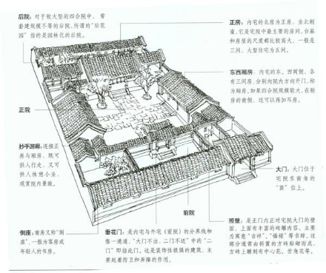

3. Start with characters:

A. the number of the characters.

Stories in this style often involve a given number of characters, which set an enclosed society. In our RPG, game setting the number of the characters can also set the scope of the story, which influence the playtime. In the assignment, it is required to have three players’ characters. If the murder is not one of the player characters, the case should bear enough complexity so that the players will not easily identify the murder easily. With that in mind. Adding another three characters to balance the player characters seems a good strategy. Also identify the murder within three characters seems giving a decent level of complexity. Adding the victim character. It will be seven characters in total.

B. the character settings.

When the number seven comes out it immediate related the statement of seven deadly sins. In addition, in order to create enough sense of mysterious and challenge for finding the murder, some misleading would be necessary. In such case, giving every character the motivation to kill the victim may be a good method. As a result, I decided to use the seven deadly sins as inspiration for the roles personality and the motivation of murdering the victim.

c. Character stats and skills

Based on Role-play 101, three type of skills was defined. They are constitution (the physical power), intelligence (the mental power) and Charisma (the social power). A set of skills were defined based on the needs of detective activities and associated them with the value of the three properties. There are three type of skills. One is environment oriented, that is to achieve information from the environment; one is people orientated, that is to achieve information from a character; and the last one is defense skills, that is protect the information from people oriented skills. Considering the natural of detective stories, observation skill is added as a basic skill for every character and it associate with observation property.

I think it is still important to maintain the freedom of creating the characters as the player wanted. A rule was set for the players to organize their stats values and come up with their own skill set. Each player will have 25 points to distribute among their properties. When certain properties reach a key value, the player will achieve one skill. The key values was set, so that the player can only have two skills at the same time.

A default set of skills was assigned to each character according to their personality.

D. the character relationship.

To organize the story, a table showing the characters’ opinions toward the other characters was created. Some character is more familiar or friendly with other character, some are not. After several iterations of the stories and rules. A familiarity system as added. A table rating how the characters are familiar with each other was created.

1. the story.

The story was created following the steps mentioned in the blog post “Write a gripping mystery adventure in four steps”

Step 1: detail the crime.

The crime was not very complicate or innovated: the lord of a big property was killed by a dagger in his room. It is a bit cliché, but in this way, it made the world easy to understand. There was some thought of making the method of murder very hard to solve, such as creating a “impossible murder” in a concealed room. This thought later was dropped, considering the players’ imagination may be going so far that may be very hard to keep in the single track.

The game map is also created at this stage to provide opportunities for the murder.

Step 2: list the clues:

For the clues, I started with important ones that pointing to the murderer. The clues were defined to prove the means, motive and opportunities. There is also a key clue that directly prove which character is the murder.

Step 3: Add red herrings.

Again, to make the case more complicated, it was planned to make each character a suspect, which is give them the motive and opportunities to commit the murder. Following the same methods of listing clues for the real murder, the clues related to other characters was created. In total, around 30 clues was created including the key clues relating to the murderer. This number was arbitrary determined considering the level of complexity and the scope of the work.

Step 4: Organizing the clues.

At this stage, I realized that the characters was actually created in a balanced way, the player characters can potentially be anyone(including the murder) and potentially this game can serve 6 people play together. It was not intended, but when I realized it, I decided to go further in this direction. Then it organizing the clues in a logic way become important. The major points to consider for the organization are:

1. Who knows the clue initially?
2. Which place can the clue be found?
3. How can one achieve the clue?
4. What is the Prerequisites to find the clue?

Answering the above questions, the clues was categorized and coded based on the characters and places. An events list is also created to show how the clues can be found and which clue should be found first to reveal the other one.

At this point, I realized that this system will be different from the regular D&D that the players should not see all the information at the same time. Secret is what make this game interesting. So, I think of a way to give out clues without informing all the characters. I created cards for the clues. Each clue was written in three cards for the three players. It was planned that in the game if the player achieve one clue, he/she will be given a clue card. In this way, only the player with the clue card will know the clue. Also if the character knows a clue initially, the clue card will be handed initially with the character sheet.

1. Iteration and prepare the materials.

After written down the first draft, multiple iterations were made to refine the clues organization, the skills, the character stories, the game map.

Also I would like to thank Nayeon Kim who are very kind to help create the avatars for the characters.

**Notes and materials for the adventure**

This chapter listed all the materials created to run and track the game play. All the information was organized in an excel file with multiple spread sheets.

1. The game map:

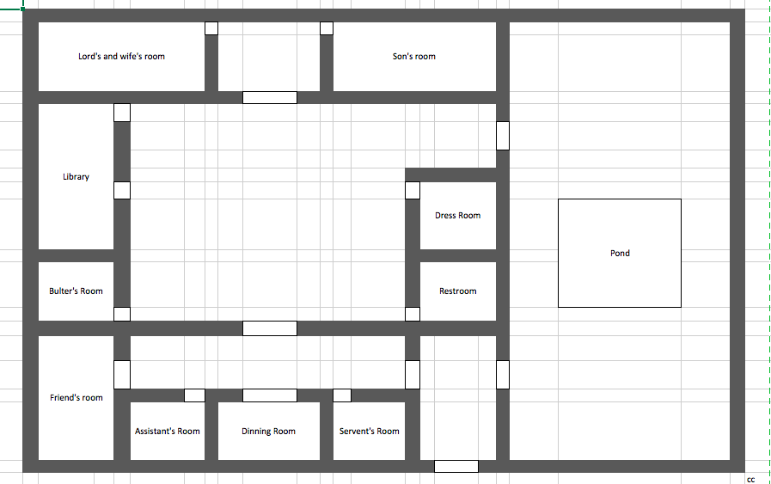

1. Character
   1. Character settings. The list of basic character setting can be found in the table below. As mentioned before the character roles and personality, was created based on the seven deadly sins. After a few iterations the final back story of the character may not completely fit the sins.

|  |  |  |  |  |  |  |  |
| --- | --- | --- | --- | --- | --- | --- | --- |
| Roles | Lord (victim) | Butler | Wife | Son | Accountant | Maid | Friend |
| The Sins | Pride | Wrath | Lust | Sloth | gluttony | Greed | Jealous |
| Age | 55 | 45 | 26 | 25 | 40 | 24 | 50 |
| Background | Love to manipulate people and makes everyone hate him | Being bullied by the lord. | Having affairs with the son. | What to take control over the property. | Gambling all the time and steal money form the lord’s account | Kill for money | Property was taken by the lord and envy his life in this house. |

* 1. Character abilities/stats: Each character will have 4 abilities. The total points of abilities is 25 points. The four abilities are listed below:
     1. Constitution (C): physical power
     2. Intelligence (I): mental power
     3. Charisma (K): social power
     4. Observation(O): observation skill
  2. Character skills: Below listed the skills of the characters with the related abilities. Only when the point of the ability reach the value listed can the player achieve on skill.

|  |  |  |  |  |
| --- | --- | --- | --- | --- |
| Skills | Skill Type | Major ability | Secondary Ability | Descriptions |
| Break | Environment | C: 14 | N/A | Remove or beak a barrier |
| Command | People | K: 14 | N/A | Ask another character to do an action or use the character's skill. |
| Challenge | Defense | I: 14 | N/A | When being targeted by a player's skill, one can challenge this player. Once successes, one can use the same skill on the player without skill check. |
| Investigation | Environment | C: 9 | I: 4 | Find a hidden clue |
| Seduce | People | C:9 | K: 4 | Give out a clue to exchange for another clue |
| Sneaking | Environment | I: 9 | C: 4 | Enter the room someone's room without requiring permission. |
| Redirect | Defense | I: 9 | K: 4 | Redirect a people oriented skill used on this player to a different player. |
| Pretend | People | K: 9 | I: 4 | Pretend to be a different character to acquire clues from other characters. |
| Turn Down | Defense | K: 9 | C: 4 | Refuse the people oriented skill from a character |
| Observation | Basic | O:1 | N/A | Gain information from the environment. |

* 1. Default skill set and stats: The table below listed the default setting of the characters, including their names, abilities, skills and the description of the background and the narrative of what they did in night of the murder.

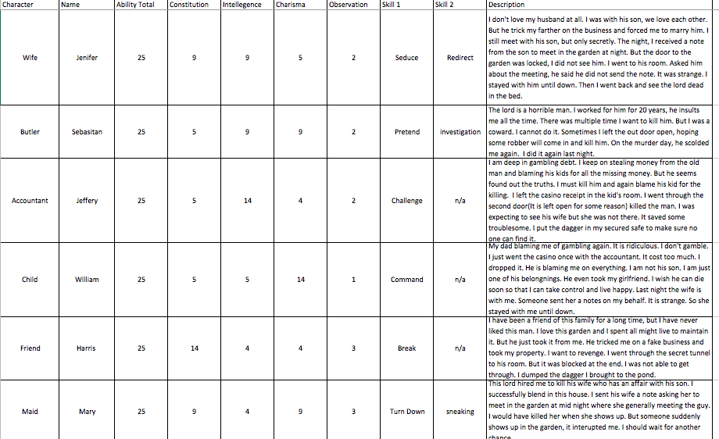

* 1. The character relationship:
     1. Below listed how each character thinks of the other characters

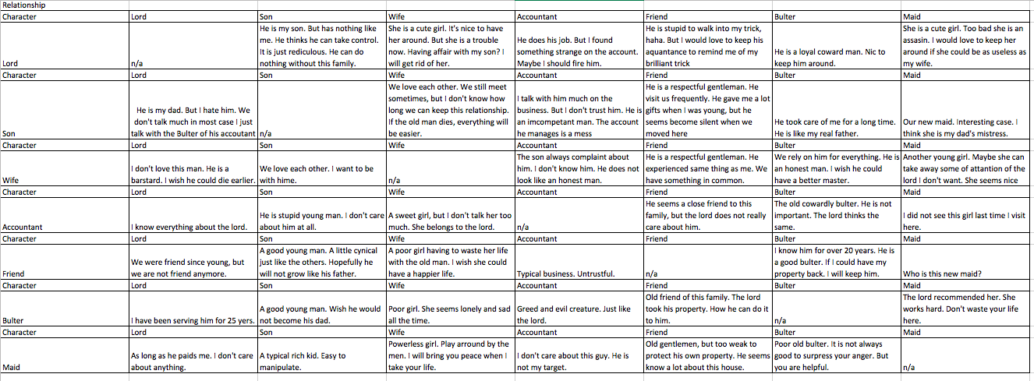

* + 1. Below listed the familiarity points of each character(Column) towards the other character(Row), 3 mean very familiar.

|  |  |  |  |  |  |  |  |
| --- | --- | --- | --- | --- | --- | --- | --- |
| familiarity:1-3 | |  |  |  |  |  |  |
| Character | Lord | Son | Wife | Accountant | Friend | Bulter | Maid |
| Lord | n/a | 1 | 1 | 2 | 1 | 3 | 1 |
| Character | Lord | Son | Wife | Accountant | Friend | Bulter | Maid |
| Son | 1 | n/a | 3 | 0 | 1 | 3 | 0 |
| Character | Lord | Son | Wife | Accountant | Friend | Bulter | Maid |
| Wife | 2 | 3 | n/a | 1 | 2 | 3 | 1 |
| Character | Lord | Son | Wife | Accountant | Friend | Bulter | Maid |
| Accountant | 3 | 2 | 1 | n/a | 1 | 2 | 0 |
| Character | Lord | Son | Wife | Accountant | Friend | Bulter | Maid |
| Friend | 2 | 2 | 2 | 1 | n/a | 3 | 0 |
| Character | Lord | Son | Wife | Accountant | Friend | Bulter | Maid |
| Bulter | 3 | 3 | 2 | 1 | 2 | n/a | 2 |
| Character | Lord | Son | Wife | Accountant | Friend | Bulter | Maid |
| Maid | 1 | 1 | 2 | 0 | 2 | 2 | n/a |

* 1. The character sheet: a character sheet was created for each character for the players to organize their stats and ability, as well as read the back story of their own character. They are listed below:

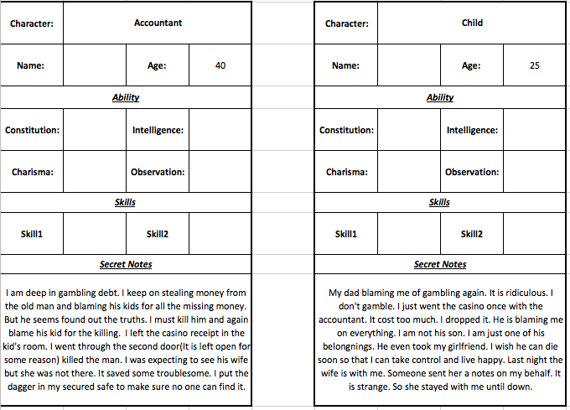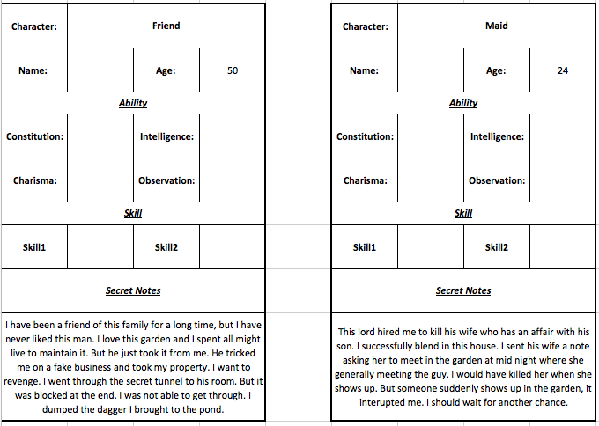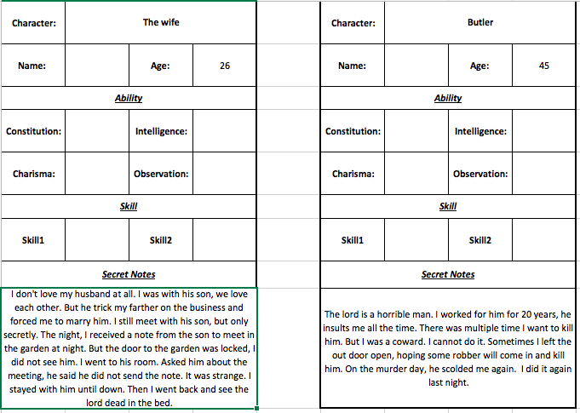

* 1. The avatar image: Again thanks Nayeon Kim for creating the avatars for all the characters.

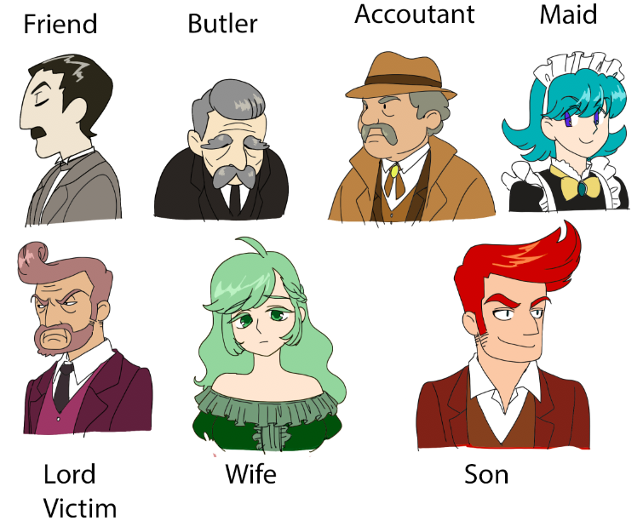

1. The story: Here list the writings created before running the game. Other content about the stories was relied on the players’ imagination.
   1. The beginning: It is nice and sunny morning, but the people living in the Hunt’s house was not have a relaxing time. Lord Hunt was found murdered in his bed. Stabbed to death by a dagger, judging from the shape of the wound. But the dagger was missing.
   2. Narrative of each character background and what they did in the night of the murder:

|  |  |
| --- | --- |
| Character | Description |
| Wife | I don't love my husband at all. I was with his son, we love each other. But he trick my farther on the business and forced me to marry him. I still meet with his son, but only secretly. The night, I received a note from the son to meet in the garden at night. But the door to the garden was locked, I did not see him. I went to his room. Asked him about the meeting, he said he did not send the note. It was strange. I stayed with him until down. Then I went back and see the lord dead in the bed. |
| Butler | The lord is a horrible man. I worked for him for 20 years, he insults me all the time. There was multiple time I want to kill him. But I was a coward. I cannot do it. Sometimes I left the out door open, hoping some robber will come in and kill him. On the murder day, he scolded me again. I did it again last night. |
| Accountant | I am deep in gambling debt. I keep on stealing money from the old man and blaming his kids for all the missing money. But he seems found out the truths. I must kill him and again blame his kid for the killing. I left the casino receipt in the kid's room. I went through the second door(It is left open for some reason) killed the man. I was expecting to see his wife but she was not there. It saved some troublesome. I put the dagger in my secured safe to make sure no one can find it. |
| Child | My dad blaming me of gambling again. It is ridiculous. I don't gamble. I just went the casino once with the accountant. It cost too much. I dropped it. He is blaming me on everything. I am not his son. I am just one of his belongnings. He even took my girlfriend. I wish he can die soon so that I can take control and live happy. Last night the wife is with me. Someone sent her a notes on my behalf. It is strange. So she stayed with me until down. |
| Friend | I have been a friend of this family for a long time, but I have never liked this man. I love this garden and I spent all might live to maintain it. But he just took it from me. He tricked me on a fake business and took my property. I want to revenge. I went through the secret tunnel to his room. But it was blocked at the end. I was not able to get through. I dumped the dagger I brought to the pond. |
| Maid | This lord hired me to kill his wife who has an affair with his son. I successfully blend in this house. I sent his wife a note asking her to meet in the garden at mid night where she generally meeting the guy. I would have killed her when she shows up. But someone suddenly shows up in the garden, it interupted me. I should wait for another chance. |

1. The clues and events: here list the planned events and soocisated clues.

|  |  |  |  |  |
| --- | --- | --- | --- | --- |
| **Line Code** | **Envirionment** | **People** | **Events** | **Clues** |
| 1 |  |  | **#Opening** |  |
| 2 | Lord's Room | everyone | *The will | Some of you must have killed me. Whoever find the murder gets all my possesion |
| 3 | Lord's Room | everyone | *How was killed | The lord keep the dagger in his room and it is missing |
| 4 |  |  |  |  |
| 5 |  |  | **#Untrustful Accountant** |  |
| 6 | Library | N/a | **Search the library(Not accountant) | The accounting books with several pages ripped off |
| 7 | N/a | Child | **Ask The child about the Accountant | The accountant is untrustful. |
| 8 | child | accountant | **Search the child's room | A receipt from a Casino for $10000.00 is in the child's room |
| 9 | N/a | accountant | **Ask the accountant about the child | The lord's child is so lazy and gambling all the time. |
| 10 | N/a | Child/Wife/Friend | ***Ask Child about Gambling | The accountant is untrustful. |
| 11 | accountant | Accountant | ***Search the room of the Accountant | The ripped off pages with made up numbers. |
| 12 | N/a | accountant | ****Ask the accoutant | I am stealing money from the lord's account. |
| 13 | N/a | accountant | *****Search for his personal belongings | The lords' dagger in his suitcase |
| 14 |  |  |  |  |
| 15 |  |  | **#The affair of the wife** |  |
| 16 | N/a | everyone | *Ask the Anyone about the the lord | The lord likes to manipulate people and he enjoyed it. |
| 17 | N/a | maid | **Ask the maid about the wife | She has a lover |
| 18 | Dining Room | wife | **Search the dinning room(Butler, Friends, Accountant) | In the dinning room, there is a piece of paper asking for an meeting at mid-night. Half burnt. |
| 19 | N/a | buter | **Ask Bulter about the wife | I know the lord's wife does not love the lord. |
| 20 | Wife's Room | wife | ***search the wife's room | A love letter from some one |
| 21 | N/a | wife | ****Ask the wife/child/Bultler about the love letter | I drugged the lord to meet the child |
| 22 | N/a | wife | ****Ask the wife about the night | The garden Door is locked at night |
| 23 | Lord's Room | N/a | **Search the lord's room | There is a bottle of sleeping pills. |
| 24 | N/a | butler & wife | ***Ask Butler/Wife about the sleeping pill | The lord's wife takes sleeping pills. |
| 25 |  |  |  |  |
| 26 |  |  | **#The Friend** |  |
| 27 | N/a | maid | **Ask maid about the night | I saw someone at night arround the garden area. |
| 28 | Garden | N/a | **Search the garden | handkerchief with the Friend's Initial. |
| 29 | Garden | N/a | ***Search the door | Hidden entrance to the Lord's room |
| 30 | N/a | friend | ****Ask the the friend about the handkerchief | I went to the lords's room at night to kill him. But I was not successful |
| 31 | Friend's room | friend | **Search the Friend's room | A photo of a family in the gardern one of them looks like the Lords' friend |
| 32 | N/a | Friend/Butler | ***Ask the the about the photo | The lord used some way to take this property from his friend. |
| 33 | N/a | friend | *****Ask the friend about the hiden cave | There is a hidden passway in this property. Connecting the lord's room and the garden. |
| 34 | Passway | friend | *****Check the passway/Acuse firend as murder | The Passway was block at the end. However hard to knock it, It does not open |
| 35 |  |  |  |  |
| 36 |  |  | **#The assassin** |  |
| 37 | Pond | n/a | **Search the pond | A dagger was sunk in the pond |
| 38 | Maid's room | maid | ***Search the maid's room(Butler/sneaking skill) | An ID with the picture of the servant but under a different name. |
| 39 | N/a | maid | ****Ask the maid about the id | I am an Assassin. The lord hired me to kill his wife |
| 40 | N/a | maid | **Ask maid about the night | I saw someone at night arround the garden area. |
| 41 | N/a | Child/Wife/Friend | **Ask Son/wife/Friends About the doors | The door between the main area and outer place is generally locked at night. |
| 42 | N/a | wife | ****Ask the wife about the night | The garden Door is locked at night |
| 43 |  |  |  |  |
| 44 |  |  | **#Bulter** |  |
| 45 | N/a | maid | **Ask the maid about the bulter | I heard the butler cursing the lord secretly |
| 46 | N/a | Maid/Butler | **Ask about the doors (not accountant) | The door between the main area and outer place is generally locked at night. |
| 47 | N/a | accountant | **Ask the accountant about the doors | The door between the main area and outer place was remaind unlocked last night. |
| 48 | N/a | butler | ***Asked about the accountant statement about the door to Butler | I left the main door open at the night |

1. The rule set
   1. The success roll of a skill is above 15 points.
   2. When roll for observation. The dice value should add the observation point to get the value for judgement.
   3. For Sneaking/breaking, the player should enter the place first and conduct further actions in the next round.
   4. Players can create stats for the characters they created, but the total ability point should not exceed 25 points.
   5. When achieving clues from a character, the dice roll should add the familiarity point of the targeted character towards the rolling character.
2. The puzzle: Here show the puzzle for the final clue that opens the accountant’s suit case. The answer was TRUE with is formed by the only duplicated letters in the picture.

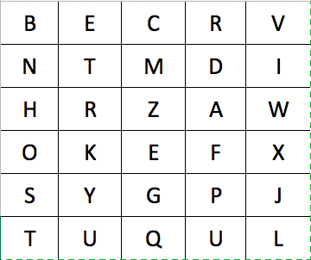

**Running the game**

Here lists the detailed process of how the game progress and what the player did during the process. As it is mentioned before, I realized that this design may potentially support more than three players to play together. So, I had four players. They are:

* Christopher Weidya: played Butler
* Matthew Bofenkamp: played Friend
* Rony Kahana: played Maid
* Candice Li: played Son

|  |  |  |  |
| --- | --- | --- | --- |
| Order | Notes | Events | Clue |
| 1 | Beginning of the story-an old man was killed by a dagger. | #Opening |  |
| 2 | The will | *The will | Some of you must have killed me. Whoever find the murder gets all my possesion |
| 3 | How the old man was killed | *How was killed | The lord keep the dagger in his room and it is missing |
| 4 | Friend searched the pond | **Search the pond | A dagger was sunk in the pond |
| 5 | Maid search for the garden | **Search the garden | handkerchief with the Friend's Initial. |
| 6 | Butler Failed |  |  |
| 7 | Son meet the butler they talk |  |  |
| 8 | Butler Failed Knock the head |  |  |
| 9 | Maid Failed again on accountant "Go Away!" |  |  |
| 10 | Butler |  |  |
| 11 | Friend Failed "A lot of books!" |  |  |
| 12 | Son nothing important | **Search the garden | handkerchief with the Friend's Initial. |
| 13 | Maid Search the butler's room |  |  |
| 14 | Bulter Failed Again |  |  |
| 15 | Friend Ask for the handkerchief and maid returned it |  |  |
| 16 | Son command the Butler to open his door but failed |  |  |
| 17 | Maid Sneak in the friend's room but failed |  |  |
| 18 | Bulter Sneak into the Maid's room Failed again |  |  |
| 19 | Friend Investigate own room failed |  |  |
| 20 | Son command to get in the friend's room and failed |  |  |
| 21 | Maid Open the door for the Butler, Butler investigated but failed |  |  |
| 22 | Friend investigate the blank room and failed |  |  |
| 23 | Son command to get in the maid's room but failed |  |  |
| 24 | Maid get in the Butler's room (exited |  |  |
| 25 | Butler investigate the maid's room and failed |  |  |
| 26 | Friend investigate the blank room and failed again |  |  |
| 27 | Butler ask the son |  |  |
| 28 | Son investigate restroom |  |  |
| 29 | Maid investigate the butler's room |  |  |
| 30 | Butler investigate the maid's room and failed |  |  |
| 31 | Friend investigate the lord's room | **Search the lord's room | There is a bottle of sleeping pills. |
| 32 | Son investigate restroom |  |  |
| 33 | Add new rules |  |  |
| 34 | Maid revealed her clues and acuse the Friend being the wife's lovers |  |  |
| 35 | Bulter invesigate the maid's room again and failed again |  |  |
| 36 | Add new rules: dice roll + familariy and get an honest answer |  |  |
| 37 | Maid ask the wife how she would think if her husband want to kill her. |  |  |
| 38 | Bulter invesigate the maid's room again and failed again |  |  |
| 39 | Son revealed his clue about accountant. | ****Ask the maid about the id | I am an Assassin. The lord hired me to kill his wife |
| 40 | Friend invesigate the restroom (cross out the restroom) |  |  |
| 41 | Son Command to get in to the accountant's room but failed |  |  |
| 42 | Maid Sneaking in the accountant room but failed |  |  |
| 43 | Butler investigate the maid's room and failed. |  |  |
| 44 | Maid revealed her clues about assassin | ****Ask the maid about the id | I am an Assassin. The lord hired me to kill his wife |
| 45 | Friend Ask the butler a question but failed |  |  |
| 46 | Son Ask the accountant to open the door again | ***Search the room of the Accountant | The ripped off pages with made up numbers. |
| 47 | Maid ask if the son killed the lord but failed |  |  |
| 48 | Butler investigate the maid's room | ***Search the maid's room(Butler/sneaking skill) | An ID with the picture of the servant but under a different name. |
| 49 | Friend call the police. The police just refuse to come immediately |  |  |
| 50 | Son ask maid about anything she knows. But failed |  |  |
| 51 | The maid want to kill the wife ( it is not in the rule) |  |  |
| 52 | Maid sneak in the accountant's room but failed |  |  |
| 53 | Butler sneak in the accountant's room but failed |  |  |
| 54 | Break in the accoutant's room but failed |  |  |
| 55 | Son command and get in the accountant's room | ***Search the room of the Accountant | The ripped off pages with made up numbers. |
| 56 | Maid asked accoutant about the dagger. (it is an unexpected question, the final clue should not reveal for now) |  |  |
| 57 | Son refused to let the butler into the accoutant's room so the butler choose to sneak in but failed |  |  |
| 58 | Friend break in the accantant's room but failed |  |  |
| 59 | Son investigate the accoutant's room and get a clue | ***Search the room of the Accountant | The ripped off pages with made up numbers. |
| 60 | Maid asked accoutant if he is in the garden but fail |  |  |
| 61 | Butler investigate the lord's room and fail |  |  |
| 62 | Friend break into the accoutant's room and success |  |  |
| 63 | Son ask Friend why he stay in the room?(Money is all mine!) But failed |  |  |
| 64 | Maid investigate dress room |  |  |
| 65 | Butler investigate the lord's room and fail |  |  |
| 66 | Friend investigate the accountant's room and get a clue | ***Search the room of the Accountant | The ripped off pages with made up numbers. |
| 67 | Change the rule: reveal a clue when other people successful |  |  |
| 68 | Son ask Friend again: why he is here. | ***Ask the the about the photo | The lord used some way to take this property from his friend. |
| 69 | Maid ask for a clue from accoutant(everyone knows the murder at this point) |  |  |
| 70 | Butler failed a investigate again. |  |  |
| 71 | Friend ask for a clue from the maid and failed |  |  |
| 72 | Son ask for a clue from the accoutantant | **Search the child's room | A receipt from a Casino for $10000.00 is in the child's room |
| 73 | Maid ask for a clue from the wife | ***Ask Butler/Wife about the sleeping pill | The lord's wife takes sleeping pills. |
| 74 | Butler failed investigation on the lord's room |  |  |
| 75 | Friend Ask for secret from Butler but failed. |  |  |
| 76 | Son ask for secret from the accoutant | ***Search the room of the Accountant | The ripped off pages with made up numbers. |
| 77 | Maid dug the pond | ***Search the door | Hidden entrance to the Lord's room |
| 78 | Butler ask the wife for a clue and failed |  |  |
| 79 | Friend ask the accoutant for a clue and failed |  |  |
| 80 | Son ask the wife a clue and failed |  |  |
| 81 | Maid ask if the accountant was in the garden at mid-night, but failed |  |  |
| 82 | Butler ask if the accountant was in the garden at mid-night, but failed |  |  |
| 83 | Friend plant more trees. |  |  |
| 84 | Son ask if the accountant was in the garden at mid-night, but failed |  |  |
| 85 | Maid reveal the clue there is a secret passway in the garden | ***Search the door | Hidden entrance to the Lord's room |
| 86 | Maid try to undress the friend |  |  |
| 87 | Butler ask the accoutant if he used the secret passway. |  |  |
| 88 | Maid try to undress everyone |  |  |
| 89 | Friend investigate the passway | *****Check the passway/Acuse firend as murder | The Passway was block at the end. However hard to knock it, It does not open |
| 90 | Son undress the accoutant ask for more secret and revealed all the clues about the accoutant | ****Ask the accoutant | I am stealing money from the lord's account. |
| 91 | Maid undress the wife and | ****Ask the wife/child/Bultler about the love letter | I drugged the lord to meet the child |
| 92 | Butler ask for the recent clue the maid got but fail, the maid revealed the clue | ****Ask the wife/child/Bultler about the love letter | I drugged the lord to meet the child |
| 93 | Friend undress the son but failed |  |  |
| 94 | Son undress the friend but failed |  |  |
| 95 | Maid undress the friend. The friend reveal the clues about the dragger. | **Search the pond | A dagger was sunk in the pond |
| 96 | Maid ask for secret from butler | ***Ask the the about the photo | The lord used some way to take this property from his friend. |
| 97 | Maid summarize the clue |  |  |
| 98 | Butler sneaked in the friend's room |  |  |
| 99 | Friend undress the son and son reveal all his secret |  |  |
| 100 | Son ask what the friend did at night. |  |  |
| 101 | Butler investigate the friend's room but failed. |  |  |
| 102 | Friend undress the maid but the failed |  |  |
| 103 | Son command to butler to undress and butler revealed all the clues | ***Asked about the accountant statement about the door to Butler | I left the main door open at the night |
| 104 | Maid acuse the butler for the murder and butler defensed himself |  |  |
| 105 | Butler investigate the Friend's room | **Search the Friend's room | A photo of a family in the gardern one of them looks like the Lords' friend |
| 106 | Friend undress the Maid and Maid revealed all the secret she knows. |  |  |
| 107 | Son ask the friend if he killed the lord but failed. |  |  |
| 108 | Maid ask friend and failed |  |  |
| 109 | Friend investigate the end of the secret passway but failed. |  |  |
| 110 | Acuse the friend but failed. |  |  |
| 111 | Maid accuse the accoutant of murder and got his suitcase and reveals a puzzle to open the suit case |  |  |
| 112 | Solved the puzzle and find the open the suit case | *****Search for his personal belongings | The lords' dagger in his suitcase |
| 113 | The end |  |  |

**Analysis:**

1. General Thoughts:

This is my first time to write and run a role play table top game. It was a very interesting experience. I started to create the adventure before I could experience one made by the other players. After experience one created by one of our team member, I realized that the on I have being creating was quite different. The ones created by the team member generally put all the players in a team, they are collaborating with each other to go through the task in the games, but mine was more leaning to the mechanics that players challenge each other. Although, in the real game, none of the player picked the murderer character and they end up having some form of collaboration, the foundation of my adventure game is still based on the players trying to achieve clues from the other players.

Furthermore, I think I did not do a good job to lead or guide the whole adventure. Some of the planned strategy was not conducted well and when the players asked some random questions or do something unexpected, I was not able to give a reasonable responds that fit the story setting. Even though, I can feel that the core fun part of this type of the game is the unexpected part. It was a fun experience that some of the player really played their character, for example, the butler player was offering “teas” throughout the process. When he failed a skill check or not sure how to proceed, he offered “teas” and the Friend character actually respond to it. I think that is the fun that existing in group face to face game that a video game cannot offer so far.

1. Interest curves.

Here present the interest curve I planned. The game was organized in an non-linear manner, so it was not easy to predict an exact curve, as it is not possible to anticipate when the player can find certain clues or proceed on certain storyline. This curve as planned based on the modules of the games. Each character has a deep secret. A peak point is anticipated when one of the secret was found. As a result there are 3 big peak point for the wife’s and son’s secret (they are associated), the Friend’s secret( the center point) and the accountant’s(the murderer) secret. The accountant was the murder, so his secret was at the end and was anticipated to have the most impact. The friend is the most important suspect so his secret impacted medium. The wife’s and son’s secret was not so important so they were in the from and gives limited impact. The other two character also have secret by they will serve as the little spice to make the process more interesting.

The planned curve:



The after curve was made based on the rating of the engagement on each activities. It does not really match the planned curve. As not all, the clues were found. The peak time occurs when the one of the player figured out how to use her skill to achieve clues and the time when one of the players said, I will just undress the other character. It was not related to the game itself, but it triggered some excitement. There is another excitement point occurs when one of the player tried 20 times and finally achieved his goal.

The after curve:



The interest curve from Matthew seems matching his familiarity with the group. He is also the only in the group who have more experience for this type of game. He was actually playing his character, trying to hide and get rid of his suspect and find the murder. At first he was not sure. But when later get familiar with the group, he start to act more actively and interact with the other players more.

From Matthew (Played Friend)



Chris may be the one who is trying really hard to win the game. So he used the strategy trying to cover the whole area and find as many clues as he could. His interest curve matches his actions to find the clues. He actually failed the most case, so when he achieved one clue, he was excited. Later on, when he got failed all the time he seems lost the interest. He was also the one solved the final puzzle.

From Chris (Played Butler)



Rony in the most time was asking random questions and not quite on the track. She picked. She probably was not very interested in such type of game.

From Rony (Played Maid)



Candice was really enjoyed to play as an ignorant son, and she was the only one used her command skill and successes. Later on, during the process, players are making up different stories themselves, and she was really excited to respond based on her character setting. I think she enjoy the story more than the others.

From Candice( Played the son)



1. The player’s comments:

Here listed the comments of the players.

* 1. Fifteen is too high to success.
  2. Skill does not really matter. Investigation does not really matter.
  3. Challenging the people is more interesting.
  4. Supper detailed. Backstory is not too long.
  5. A move to accuse someone would be nice.
  6. Start to undress everyone seemed make things getting excited.
  7. Can have some hint for the puzzling in the room to search.
  8. Condition to win can be someone kill someone.
  9. The puzzle was a bit out of place.
  10. It is nice to have different player know different things.

1. Flaws and what did not work.

It was very excited to see that in most cases the players are enjoyed the process, and there was a lot laugh and joking around which made the who process really entertaining. For myself, it is also a really fun play. One of my own experience as DM was that, the players failed too much on achieving clues. It was a bit frustrating, but I changed the rule in the middle to change the situation. Here are some design ideas that was not eventually worked out.

1. Allow the players to make up their own skill set was not working well. All the players picked the environment oriented skill rather than people oriented. It break the whole point of the game and make achieving the clues hard. I had to change the rules to give everyone a skill to achieve clue from people to fix this. From the feedback, it is also true that challenging the players is the fun part.
2. Use card to give clues was not working so well. It was planned to give a card to a play when this player achieved a clue to avoid telling the clue to everyone. Trying to find the clue card was really slow and break the experience.
3. The skill did not play an important role. One of the reason is that no people oriented skill was picked in the first place. Some skill, like investigation was duplicate with observation.
4. Everyone just forget about the system of familiarity. It is my problem of not reinforced it.
5. The npc character including the murderer was forgotten at first. It may be better to have 6 players too play, to trigger more interaction.
6. 15 was really hard to achieved. I did not anticipate it.
7. Possible updates for the next version.

May be make a digital system to help track and give out the clues would help to make it more interesting and make the gameplay more fluently