Farm Battle Project Proposal TP3

**\*\*Changes for TP3 are the texts in Blue**

**Description:**

1. Name: Farm Battle
2. Genre: multiplayer grid-based PVP
3. Game Play:
   1. Two Parties controlled by multiple players
   2. The farmer:
      1. Knock the moles when they show up
      2. Support multiple farmers
   3. The moles:
      1. Player click on the fields to make a mole pop up
      2. Stay x seconds before disappearing (x related to the level of difficulty)
      3. If being hit, dazzle for y seconds and disappear (y related to the level of difficulty)
      4. Each mole player can control multiple moles or Us game AI to play supplement
   4. Battle:
4. 2 minutes campaign
5. Scoring:
6. When farmer hit a mole, farmer score + 1, hit on dazzle moles gains no scores
7. When mole waits for x seconds and disappear without being hit, mole score + 1
8. Map: randomly generated mix of field tiles and grass tiles (Moles only shows on the field tiles)
9. Both the farmer ant the moles shows on the game map

**Competitive Analysis:**

Whac-a-Mole is a popular arcade game. It was invented in 1976 and evolve through times until now. The core game mechanics remains the same. The moles pop out in the game map and the player hit the moles when they pop up to earn scores. When the game gets harder, the mole will remain up for shorter time, which requires the player move faster. There is multiplayer version, when multiple players play together and compete on the number of moles they hit.

Farm Battle is inspirited by Whac-a-Mole, but different in three points:

1. The player can choose to play the farmer or the moles. The competition would happen among the farmer players and the mole players.
2. Cooperation mechanics. The game would support multiple farmers vs multiple moles. Players in the same party should work together to fight against the other party
3. It made us of the network so that the players can play on their individual machines.

**Structural Plan:**

1. Four new classes:
   1. gameMap:
      1. Data:
         1. the dictionary recording the tiles of the map
         2. positions of the UI elements
         3. Scores
         4. game states
         5. size of the map
         6. origin of the map
         7. current time
         8. color and fonts of the map
         9. Dictionary of all the mole data
      2. method:
         1. Randomly generate the map
         2. Convert the mouse position to fit in the tile
         3. Check if the tile is valid for male spawning
         4. Transfer the time to the string of “minutes: seconds” format
         5. Transfer the map to a 2d list, in with the first element is a list of all tile coordinates
   2. Moles
      1. Data:
         1. Number of the moles a client can handle
         2. List of the position of all the moles
         3. The time showing up for each mole
         4. Sprites of the moles
      2. method:
         1. Check the viability of the clicks
         2. Check the hit
   3. OpeningScene:
      1. Data:
         1. Options/buttons
      2. Method:
         1. Load different mode based on the players’ selection
   4. EndingScene:
      1. Data:
         1. Scores
         2. Winning state
      2. Check and visualize the winning state
   5. Farmer:
      1. Data:
         1. The position of the farmer
         2. The target the farmer is going
         3. A List of position tuple representing the route which the farmer goes
      2. Method:
         1. Generate the route based on the current position and the target position
         2. Move the farmer
2. Other Functions:
   1. Functions to handle synchronizations
   2. Functions to draw the UI elements
   3. Game AIs plays as the mole or the farmer when all the players are standing at the same side

**Algorithmic Plan:**

See the image below or FarmBattle_AlgrithemPlan.pdf in the same folder:

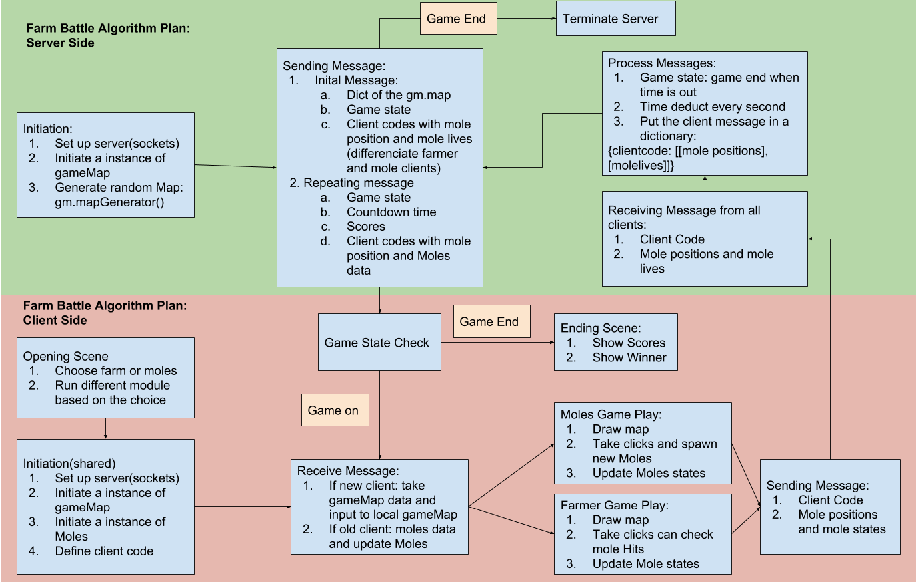

**Timeline Plan:**

1. Spend 2-4 hours every day to implement
2. Start from the core feature than extend to other feature

**Version Control Plan**

1. Use Github Desktop to back up the code
2. Make commit every day after finishing the work:
3. Github link: https://github.com/youlingsi/FarmBattle

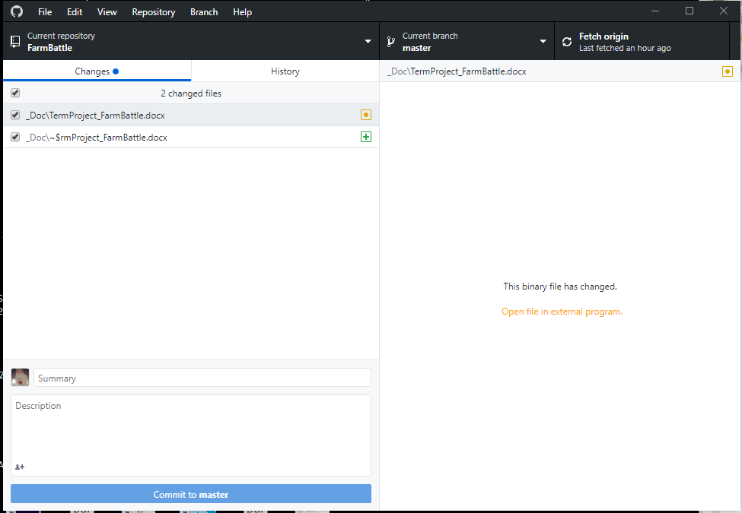

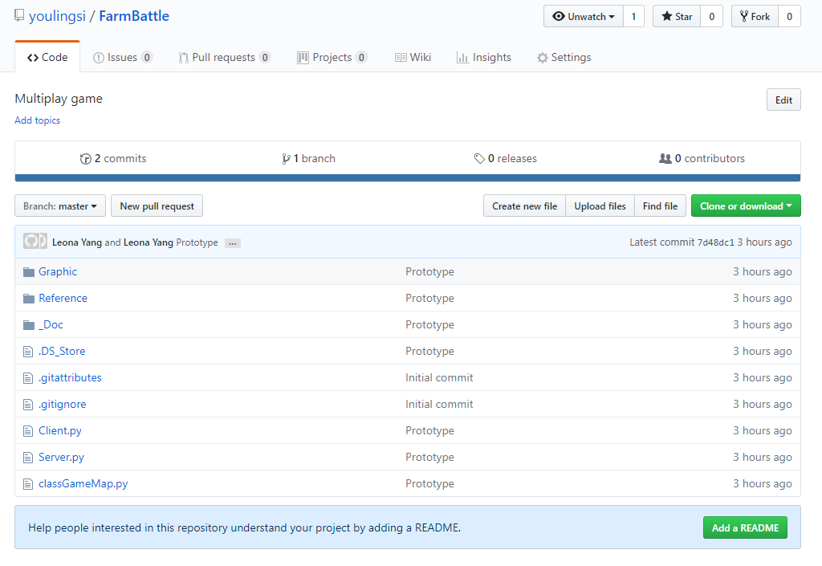

**Module List:**

1. Pygame
2. Socket

**Storyboard:**

