Farm Battle

Genre: multiplayer grid-based PVP

Game Play:

1. Two Parties (two players):
   1. The farmer



* + 1. Plant carrots in the field: take 0.5 to plant a carrot
    2. Defense the carrots against: hit the moles to get the carrots back
  1. The moles

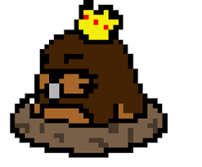

* + 1. Player controls multiple (3) moles
    2. Steal the carrots from the field
    3. Takes 1-2 seconds for each mole to finish stealing

1. Battle:
   1. 2 minutes campaign
   2. The one has more carrots wins the game
      1. Farmer: calculate the carrots that are planted in the field
      2. Moles: the carrots that are stolen

Map:

1. 9X9 grid

Technology:

1. Pygame

Tech Demo:

* 1. Build the farm scene
  2. Load the farm scene to different screen
  3. Mole characters moving on different screen