Dear Eng Sandra and Eng Abdelrahman;

We realized the screenshot was not clear, so here is another one

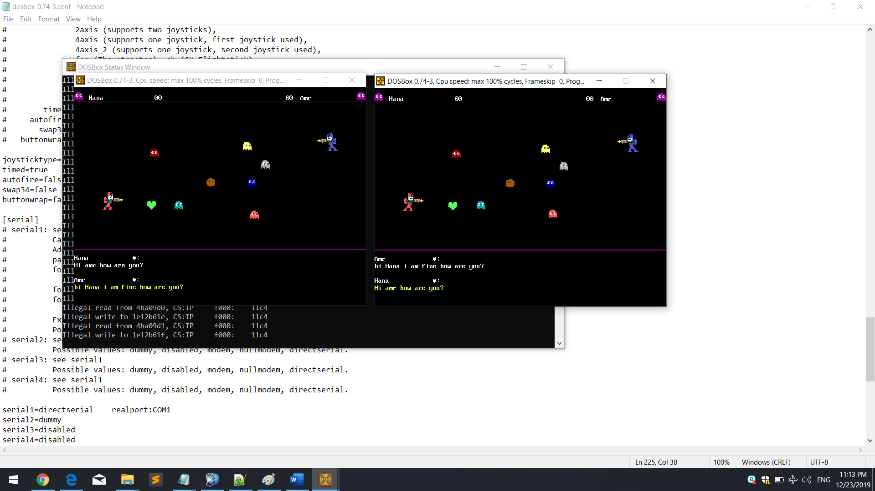Thank you…