|  |
| --- |
|  |
| The Specification |
| [Type the document subtitle] |
|  |
| **[Your Name]** |
| **[Pick the date]** |

[Type the abstract of the document here. The abstract is typically a short summary of the contents of the document. Type the abstract of the document here. The abstract is typically a short summary of the contents of the document.]

Table of Contents

[To update the table of contents, right click the message below and select Update Field (F9 on PC, ⌥⌘U on Mac).]

1. Pages
   1. Page Tree

Home  
 地震计实时数据展示汇总  
 某一个地震计健康状态  
 设置界面  
 阀值健康设置

* 1. Home
  2. 地震计实时数据展示汇总

点击某一个地震计条目 跳转到 “某一个地震计健康状态” 页面

* + 1. User Interface



* + 1. Widget Table

| Footnote | Interactions |
| --- | --- |
| 1 | OnClick:  Case 1:  Open 某一个地震计健康状态 in Current Window |

* + 1. Unnamed
       1. State1
       2. User Interface
  1. 某一个地震计健康状态
     1. User Interface

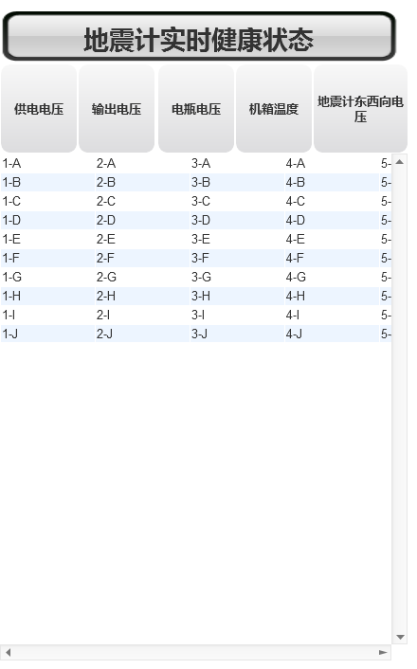

* + 1. Unnamed
       1. State1
       2. User Interface
  1. 设置界面
     1. User Interface

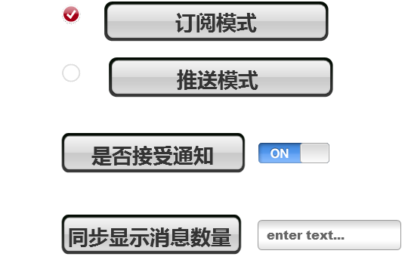

* + 1. 20
       1. 未选择编辑
       2. User Interface
       3. Widget Table

| Footnote | Interactions |
| --- | --- |
| 1 | OnClick:  Case 1:  Set 20 to 选择编辑 |

* + - 1. 选择编辑
      2. User Interface
      3. Widget Table

| Footnote | Interactions |
| --- | --- |
| 1 | OnClick:  Case 1:  Set 20 to 未选择编辑 |

* 1. 阀值健康设置
     1. User Interface

