Internet Technology Assignments

Submitted by: Younesh KC

Roll No: 24071156

# Task 1

## Link: [Task1-Introduction to Moqup](https://app.moqups.com/6QKqsK9tDUAWZyRA4MBOZt1IKL4w9JmC/view/page/a9b9a339d)

## 

# Task2

## Link:[Task2-Wireframing](https://app.moqups.com/6QKqsK9tDUAWZyRA4MBOZt1IKL4w9JmC/view/page/a6473062b)

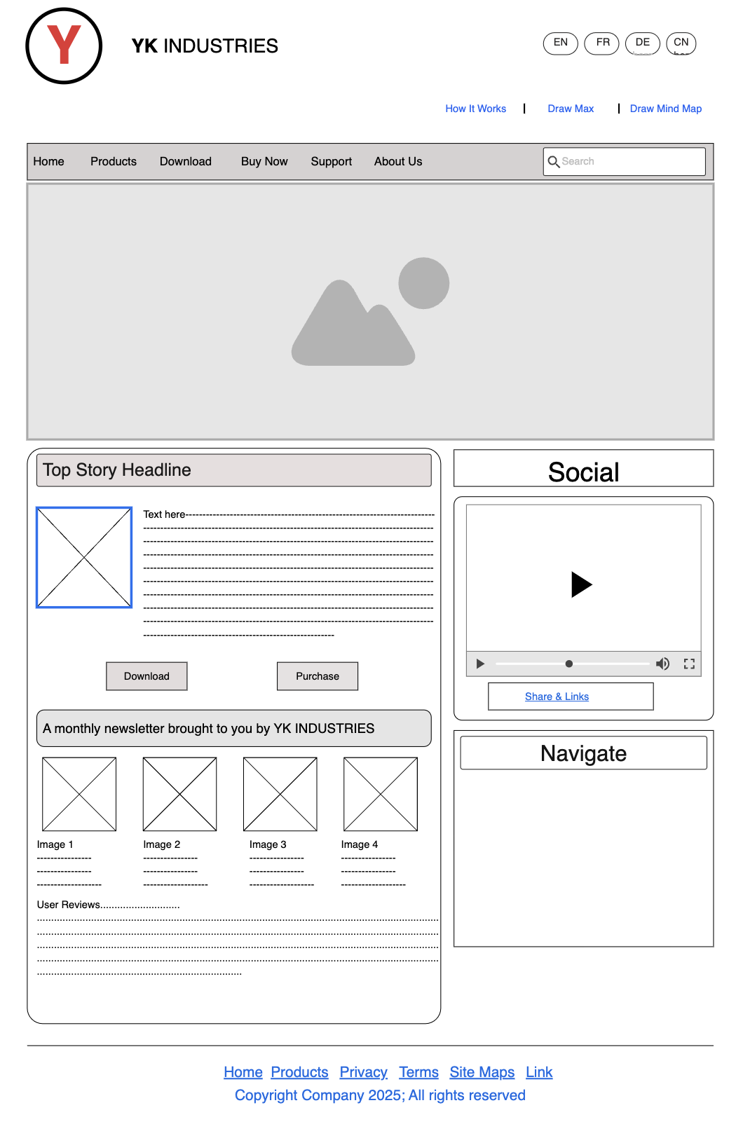

# Task3

## Link:[Mockup of The British College](https://app.moqups.com/6QKqsK9tDUAWZyRA4MBOZt1IKL4w9JmC/view/page/ad93311ae)

