



Innhold

Scenarios 3

Sender 3

1. Select CRM Record 4

2. Start Signing Process 4

3. Signing Information & Document(s) 4

4. Review status on signing processes 8

Signatory 10

1. Receive Email 10

2. Signing process 11

The Word Add-in 15

Prerequisites for Word Add-in 16

Signicat for Dynamics365 - User Guide

Hi,

Thank you for using Signicat for Dynamics365, this guide will help you to send documents for digital signing right away.

This tool will help you send single or multiple documents to a single or multiple recipients for digital signing. Once a document is signed, the result document and status will immediately be updated in CRM. The result will be in PDF format.

# **Scenarios**

1. You want to send one document to one person for signing.
2. You want to send multiple documents to one person for signing.
3. You want to send one document for multiple persons.
4. You want to send multiple documents to multiple persons.
5. You want to send one or multiple documents to multiple person but you want the signed documents separated not merged. For this you need to create a document signing for each person.

# **Sender**

Here we explain the system interactions from the sender of the signing process.

## Select CRM Record

The Signing Tool is available on the following CRM entities:

1. Account
2. Contact
3. Order
4. Quote
5. Case
6. Contract

The document signing record will be connected to the originating record.

Before starting the process:

1. The entity record must be created.
2. The logged-on user must be able to send emails from CRM.
3. Start Signing Process

To start the process, navigate to a specific record and on the ribbon, click on the 3 dots then click the button “Electronically signing”:

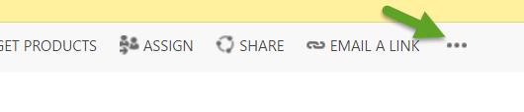

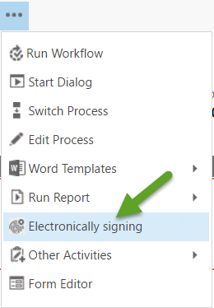

## Signing Information & Document(s)

This will pop up the following window:

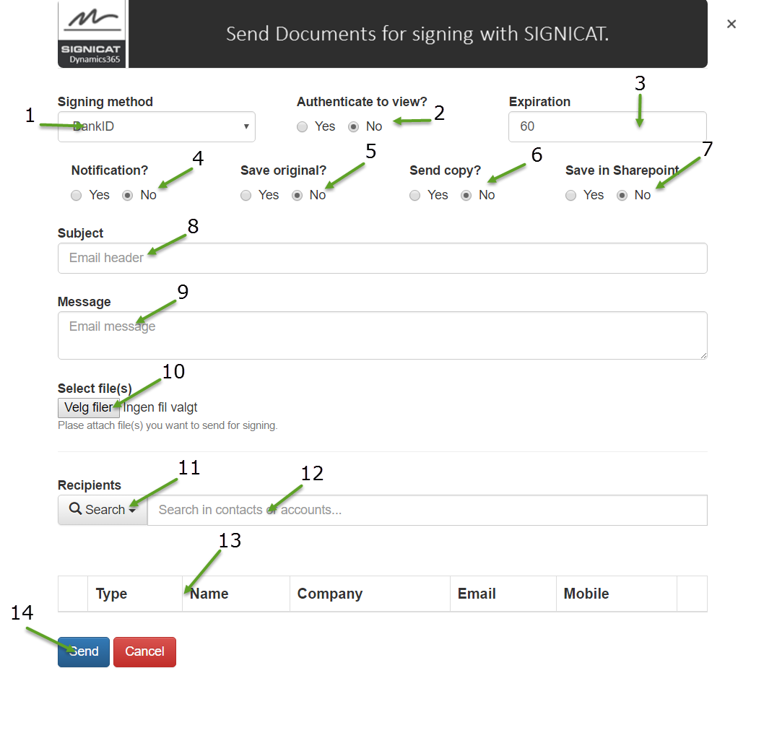

1. **Signing** **Method**: Chose the signing method, the methods that are supported “BankId, Mobile BankID, Social and SMS/Email OTP”
   1. BankID and Mobile BankID: Norwegian BankID is offered and issued by the banks in Norway.
   2. Social: use social media id’s for signing (Facebook, LinkedIn, Google and Window Live are supported).
   3. SMS/Email OTP: Use pin code received in SMS or mail.
2. **Authenticate to view**: The authentication method applies if you want an authentication before the signatory can look at the document that is to be signed. If you chose this option, the signatory will still only need to authenticate once.
3. **Expiration**: The number of days after today’s date the document will be available for signing, after this number, the signer will not be able to sign the document. Default is 60 days. The signatory will be reminded per mail 2 days prior to the expiration date.
4. **Notification**: The sender will receive an email notification when a document is signed.
5. **Save** **Original**: The original file sent to the receiver will be stored as a note in the document signing record in CRM.

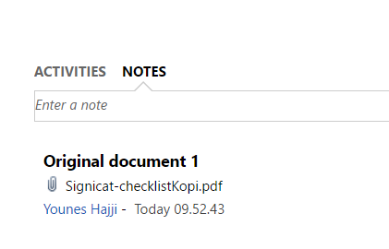

1. **Send** **Copy**: A copy of the signed document will be sent to all signatories. If **Save only merged** is “yes” then only the merged signed document will be sent. (Recommended, default is Yes)
2. **Save** **in** **SharePoint**: The signed document will be stored in the SharePoint document location of the originating record. If the originating record doesn’t have a document location, then this option is not available. (Contact your CRM system administrator if this occurs)
3. **Subject**: The email subject you want to appear in the emails to the signatories (Mandatory).
4. **Message**: The email body you want to appear in the emails to the signatories (Mandatory).
5. **Select file(s)**: Select one or more files that are to be signed. Only PDF files are supported. There is no limitation to the file size. (Mandatory)
6. **Recipients**: Chose a catalog to search in, either Contacts or Accounts. (Mandatory)

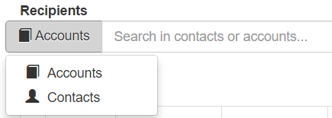

1. **Search box**: Add signers. Either from the Account entity or the Contact entity. Minimum 3 characters must be entered in the search box. The search engine searches in Contact or Account emails, parent accounts, names and phone numbers. The result will be listed in a list. Select a Contact/Account and hit enter. The record you chose will be added to the list below. You may repeat this procedure to select several recipients. If you don’t find the recipient’s email in CRM, you will need to update the CRM records before you start the signing process.

**Save only merged**: If more than one recipient is added, everybody will receive a copy of the document for signing at the same time. The option for saving only the merged signed document will show up, by choosing YES (recommended), only the merged result will be saved in CRM. If NO is chosen, both the merged and each single separated signed document by each person will be saved separately.

This requires some further explanation: Signicat will store a copy of each signed document, from each of the signatories (ex. 2 documents sent 2 signatories = 4 signed copies). Signicat will also in addition store a copy of each document with all the signatures merged into each document (ex. 2 documents sent to 2 signatories = 2 merged signed copies). 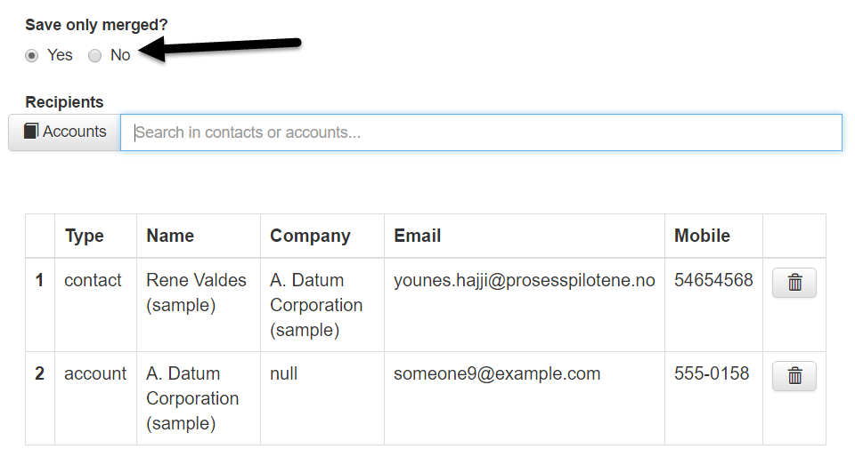

1. **Recipient list**: The list of the receivers of the documents. Records in the list can also be removed by hitting the button to right of the row.
2. **Send**: Hit Send to start the process. A document Signing record will be created in CRM under the originating record. A request is sent to Signicat. And emails are generated in CRM and sent to the recipients automatically.



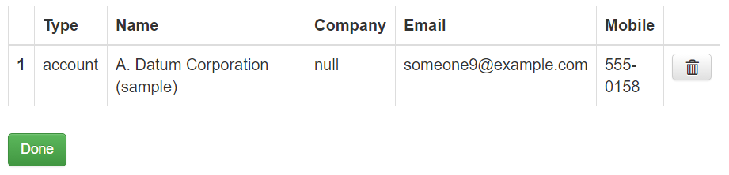

**IMPORTANT**: The logged-on user must be able to send emails from the designated CRM mailbox. If your mail box is not activated in CRM, please contact your CRM system administrator.

## Review status on signing processes

To see the result and status of the documents for a specific record, navigate to the entity record, click “Document Signings”

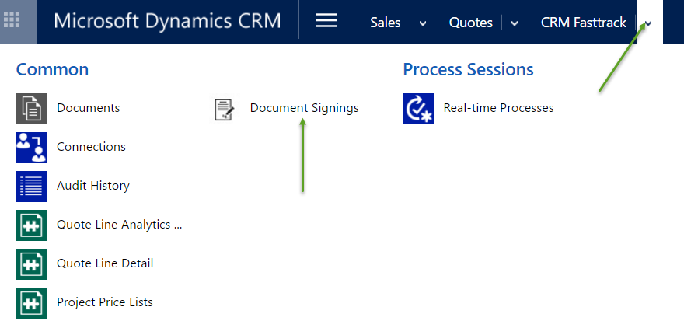

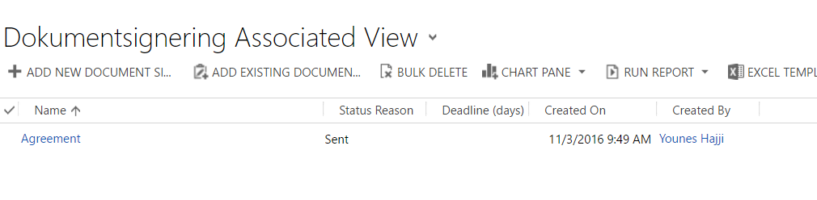

If the status is sent, then none or not all the documents has been signed:

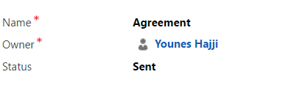

A task is created for each recipient, the status for each one could be viewed:

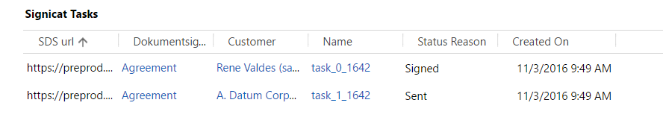

When all the tasks has changed status to Signed, the document signing will change status to signed, the merged document will be saved in CRM Notes and uploaded to SharePoint if requested.

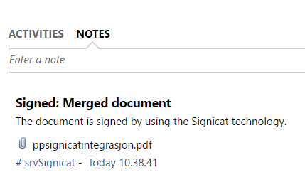

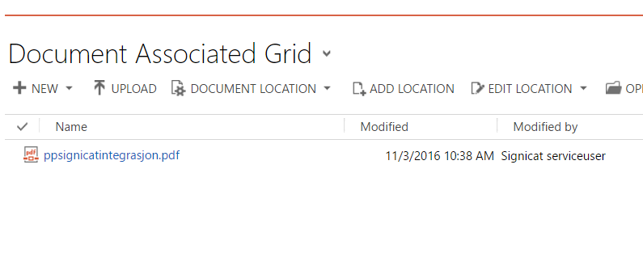

# **Signatory**

Here we explain the system interactions from the signatories.

## Receive Email

Each signatory will receive an email from the sender (see figure below). The email contains a button “Click here to review and sign with SIGNICAT”. By clicking this button, the signatory is forwarded to the Signicat signing form, your message will be placed in the email body as the figure below shows, the signature on this email will be the first name and the last name of the user that was logged-on while creating a document signing.

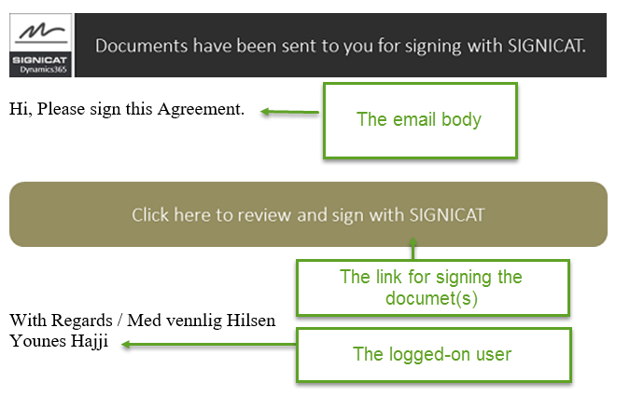

## Signing process

After clicking the button, the following frame will show up, if you have chosen authentication before view, the signatory will have to logon before viewing the document:

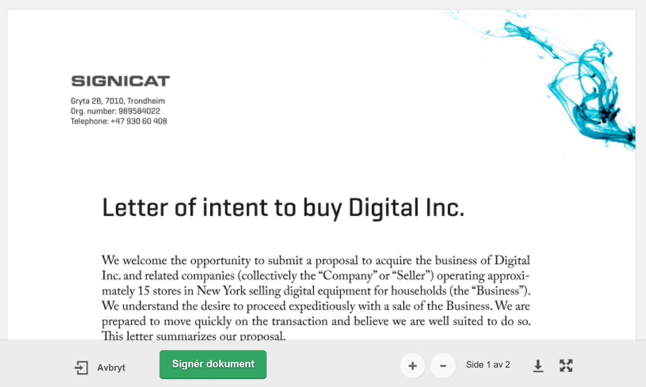

* 1. Sign using the Norwegian BankID/Mobile BankID.

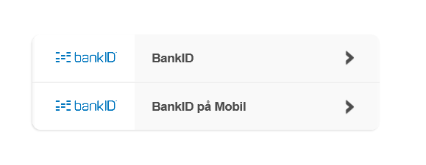

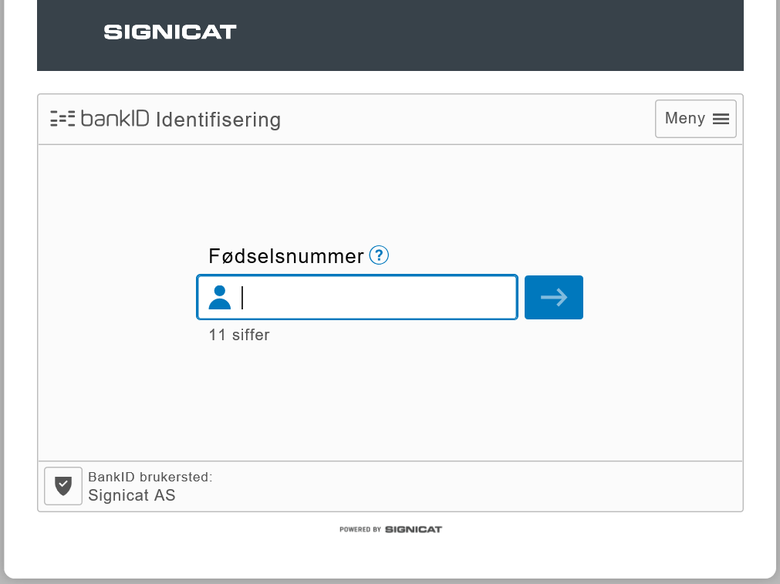

* 1. Sign using either SMS/E-mail OTP.

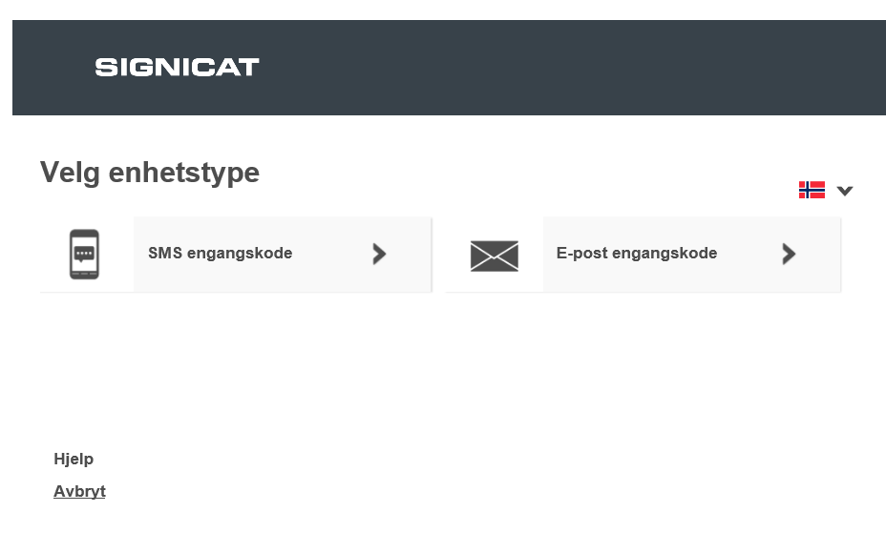

* 1. Sign using a social medium (Facebook, LinkedIn, Windows Live ID or Google):

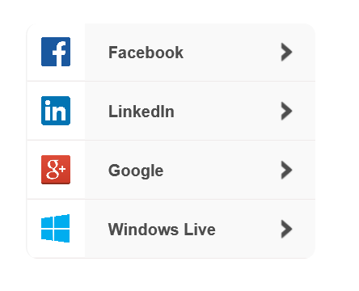

The first page of the signed document will look like this (The document is signed by using BankID in this example):

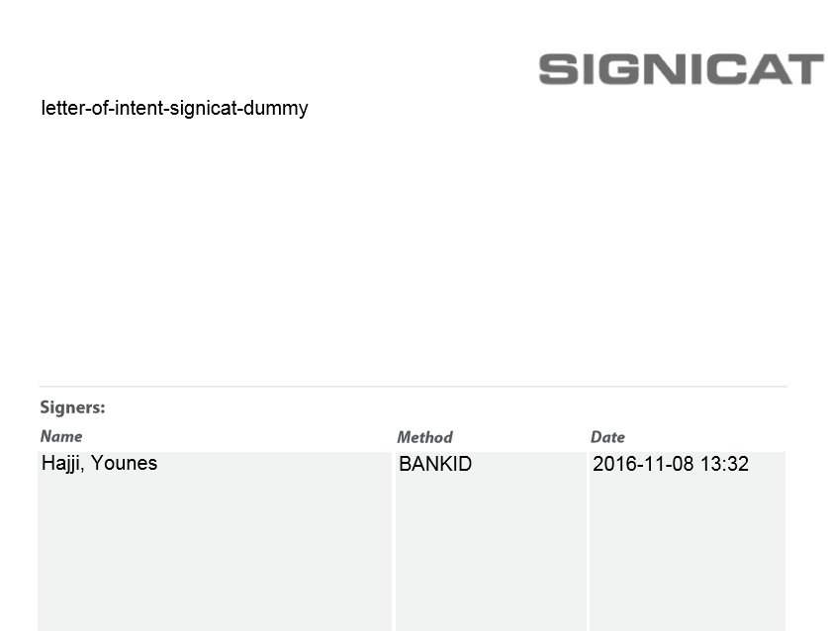

The last page of signed document will contain the secure Signicat provided identification description. The legal certificate will also be included in the PDF file

.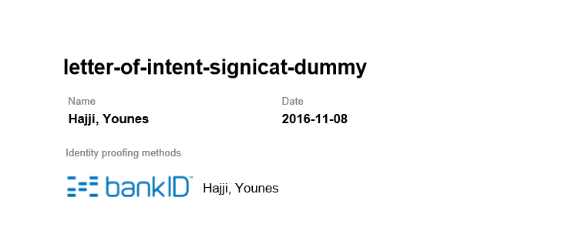

# **The Word Add-in**

The Signicat for Dynamics365 has an alternative way for initiating signing processes through Word Templates. This is useful if you like your CRM system to create your document and start the signing process in one sweep. The instructions below explain how it looks like for the end user when this feature is implemented in your CRM system. For explanation on how to implement the feature, please refer to the Signicat implementation guide.

To send documents directly from word for signing, generate a word template for your entity record, navigate to the “Signicat” pane in the Word document and click the button “Sign”:

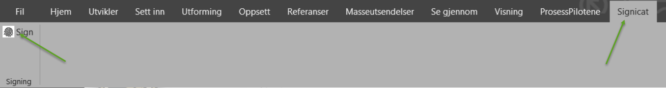

After hitting the Sign button, a message will pop up after a couple of seconds:

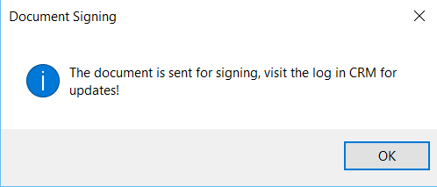

You can navigate to CRM to find the document singing:

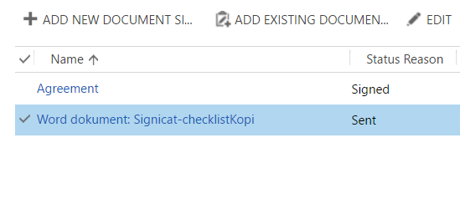

## Prerequisites for Word Add-in

1. The Word template must have the record number, the record number database field name, and the recipient mail address, otherwise the template may contain whatever information that is relevant:

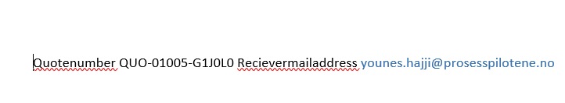

**Note**: These properties may be invisible in the template for the reader if this is more suitable.

1. The email to the signatory will not be sent from the logged-on user’s mailbox. It will be sent from a preconfigured user. Please refer to the Signicat implementation guide.
2. The word add-in needs to be installed on the user’s computer. Please refer to the Signicat implementation guide.