



*Implementation Guide*

This guide will help the CRM administrator/implementation responsible for making Signicat tools available for end users.

*CRM*

1. Install the ProsessPiloteneJscriptKit & ProsessPiloteneSettingKeys by importing the provided ZIP file into CRM solutions.
   1. Navigate to Customizations 🡪 Customize the system 🡪 Entities 🡪 SettingKey, under Areas that display this entity, check Settings.
2. Install the Signicat for Dynamics365 CRM solution.
3. Add the following values to the settingkey entity, navigate to Settings 🡪 SettingKeys, click New and add these values (Create a new group “Signicat”):
   1. Key: entitylogicalnames. Value: pp_accountid,pp_quoteid,pp_opportunityid,pp_salesorderid,pp_incidentid,pp_contractid
   2. Key: webapiurl. Value: <https://prosesspilotenesignicatwebapi.azurewebsites.net/>
   3. If you are using the Signicat Word Add-In, add: Key: wordsignuser. Value: {the guid of the systemuser that will send the emails to the signer}.

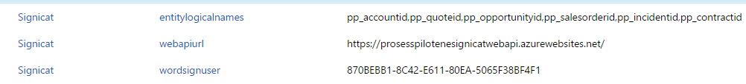

1. If you have SharePoint and want the signed documents to be saved in the SharePoint Document Location, add the following values in the SettingKeys (Create a new group called “Signicat SharePoint”):
   1. Key: wordsaveinsp. Value: yes (Add only if you are using the Word Add-in).
   2. Key: sppassword. Value: {The password of the SharePoint user}, if the logged-on user has access to SharePoint, this is not needed.
   3. Key: spuser. Value: {The user login email address for SharePoint}, if the logged-on user has access to SharePoint, this is not needed.
2. If you are using the Word Add-In, distribute the installation files to the users for installation, please find the installation files and the User Guide under the installed solution “ProsessPilotene DocumentSign” 🡪 Configuration.