



## C:\Users\YounesHadjji\AppData\Local\Microsoft\Windows\INetCacheContent.Word\SignicatMailLogo.png

*Signicat for Dynamics365 - User Guide*

Hi,

Thank you for using Signicat for Dynamics365, this guide will help get started with sending documents for digital signing right away.

This tool (SDC) will help you send single or multiple documents to a single or multiple recipients for digital signing. Once a document is signed, the result document and status will immediately be updated in CRM. The result will be in PDF format.

*Scenarios*

1. You want to send one document to one person for signing.
2. You want to send multiple documents to one person for signing, for this you only need to create one document signing request.
3. You want to send one document for multiple persons, for this you need to create only one document signing.
4. You want to send multiple documents to multiple persons, for this you to create only one document signing.
5. You want to send one or multiple documents to multiple person but you want the signed documents separated not merged. For this you need to create a document signing for each person.

*Process flow*

The SDC is available on the following CRM entities:

1. Account
2. Contact
3. Order
4. Quote
5. Case
6. Contract

Before starting the process:

1. The entity record must be created.
2. The logged-on user must be able to send emails from CRM.

To start the process, navigate to a specific record and on the ribbon, click on the 3 dots:

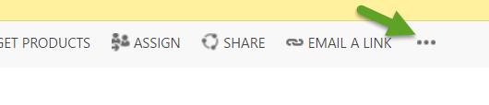

Click the button “Electronically signing”:

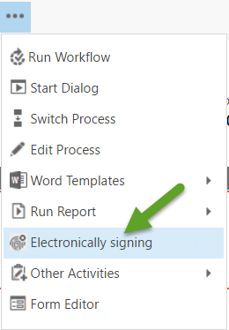

The following window will popup:

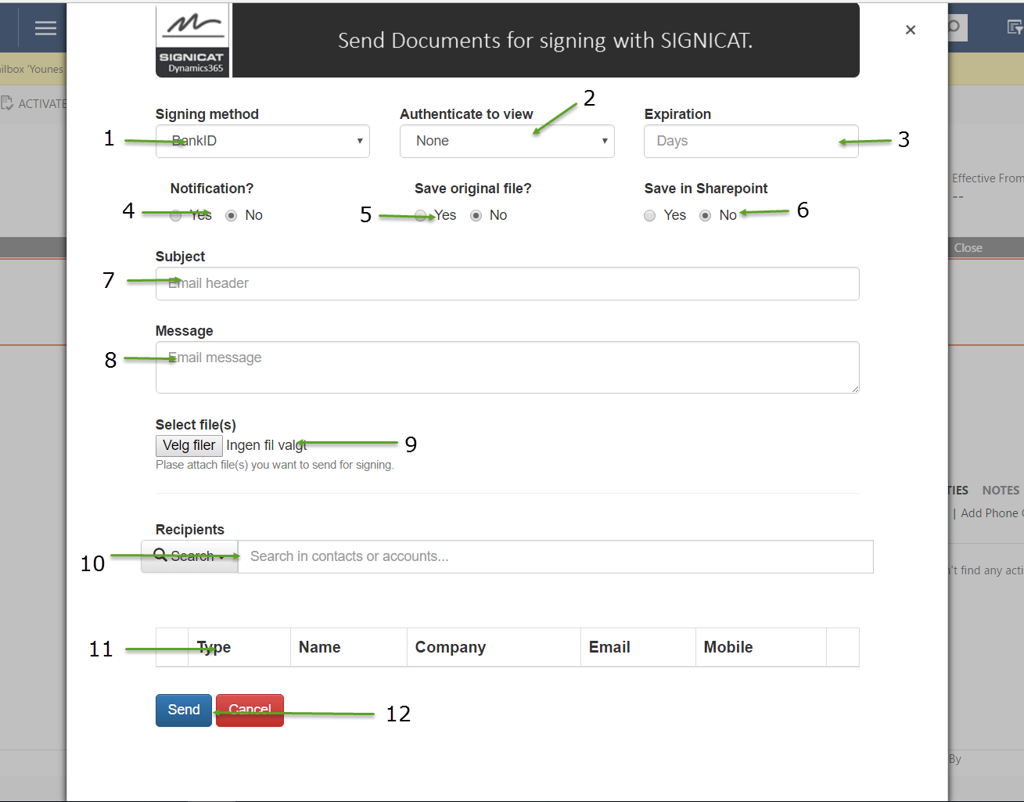

1. Chose the signing method, the methods that are supported “BankId and EsaySign”
   1. BankID: Norwegian BankID is offered and issued by the banks in Norway.

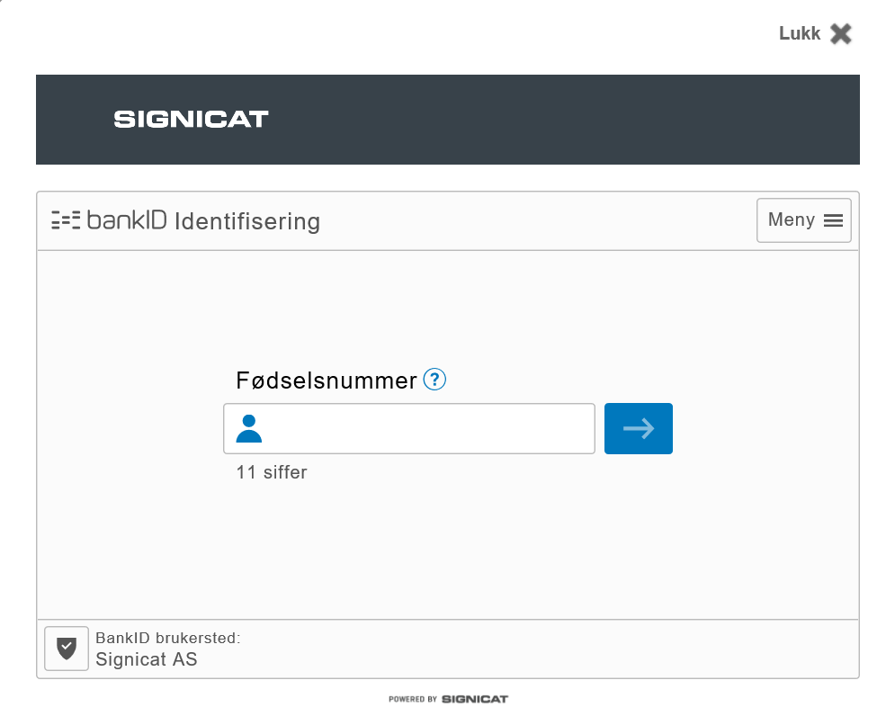

* 1. Signicat EasySign captures the essence of real world ink signatures by collecting information and data about the user's name, place and date of signature in addition to a hand-written signature. Optionally, photographic documentation (in terms of driver's license or passport) and proof-of-possession of phone numbers may be included in the signed document as well.

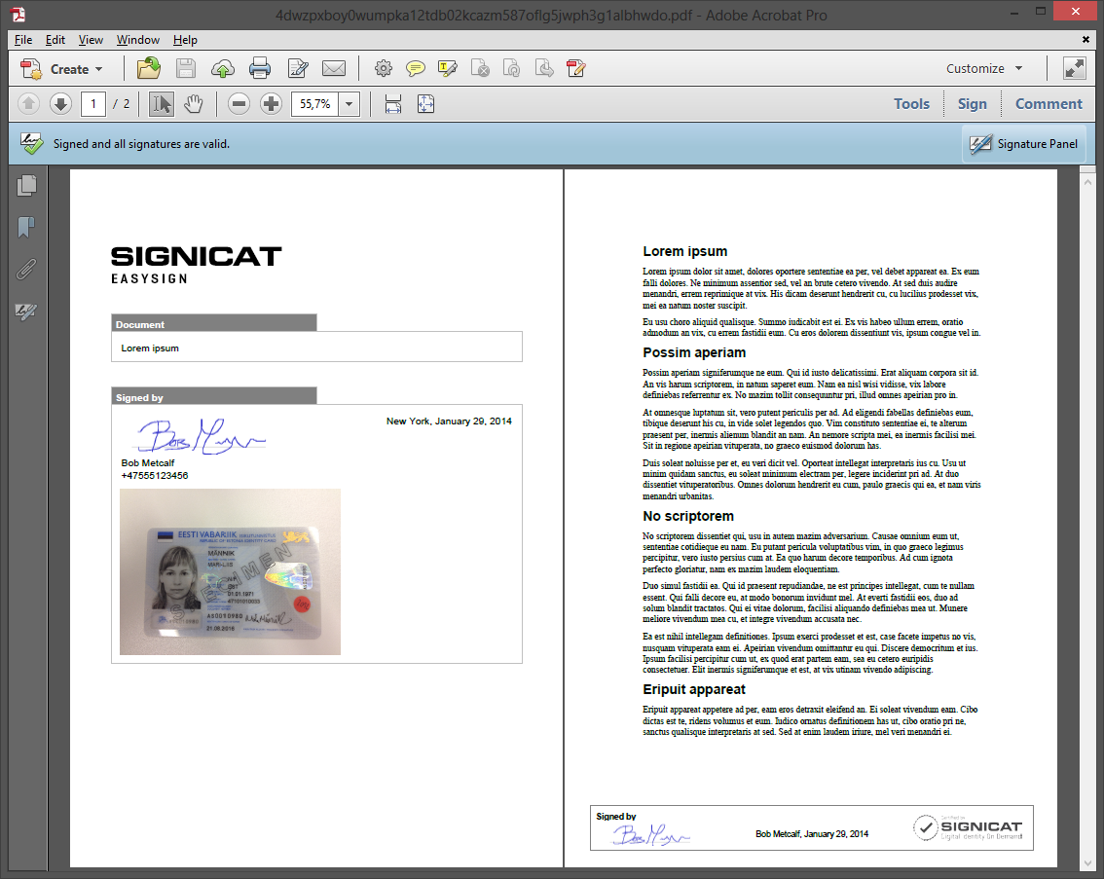

1. The authentication method available is “BankID”, if the signing method is BankID and the authentication method is chosen then the signer will not see the document until he logs on. The signer will not need to log on twice to sign the document.
2. The number of days after today’s date the document will be available for signing, after this number, the signer will not be able to sign the document. Default is 60 days.
3. The sender will receive an email when a document is signed.
4. The file sent to the receiver will be stored as a note in the document signing in CRM.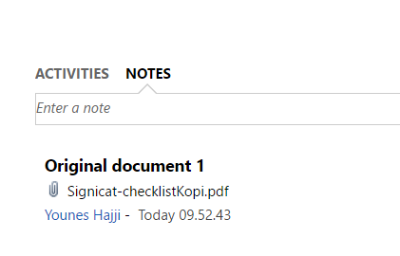
5. The signed document will be stored in the SharePoint document location of the originating record. If the originating record doesn’t have a document location, then this option is not available.
6. The email subject (Mandatory).
7. The email body (Mandatory).
8. Select one or more files at once (Mandatory). Only PDF files are supported. There is no limitation to the file size.
9. Add signers. Either from the Account entity or the Contact entity. Minimum 3 characters must be entered in the search box. The search engine searches in Contact or Account emails, parent accounts, names and phone numbers. The result will be listed in a list. Select a Contact/Account and hit enter. The record will be added to the table below.

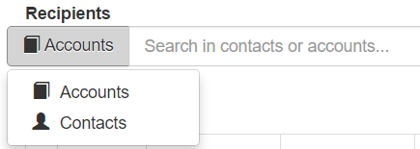

If more than one recipient is added, the option for saving only the merged signed document will show up, by choosing YES, only the merged result will be saved in CRM if NO is chosen, the merged and the single separated signed documents by each person will be saved separately.

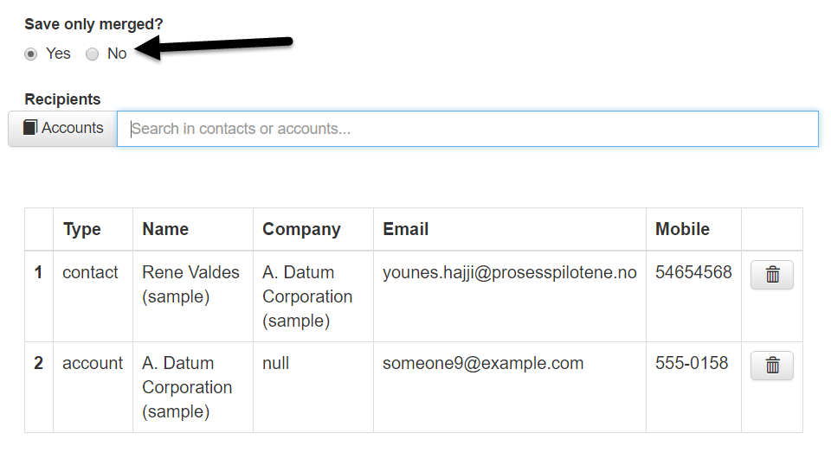

1. The list of the receivers of the documents. Records in the list can also be removed by hiting the button to right of the row.
2. Hit Send to start the process. A document Signing record will be created in CRM under the originating record. A request is sent to Signicat. And emails are generated in CRM and sent to the recipients.



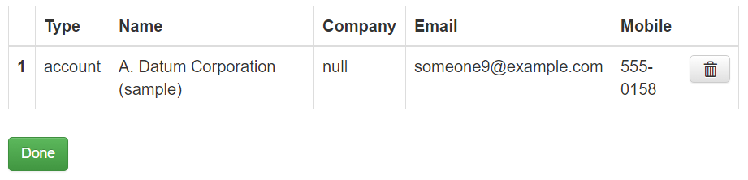

IMPORTANT: The logged-on user must be able to send emails from its mailbox.

The email that is sent to the recipients: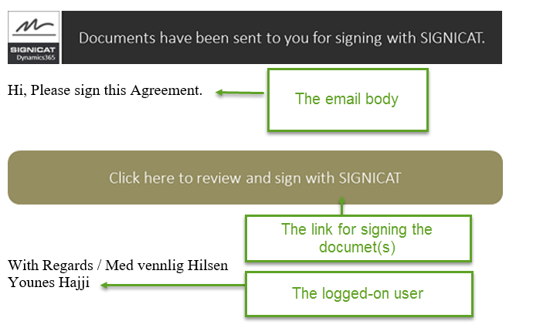

*CRM: Document signing*

In order to see the result and status of the documents for a specific record, navigate to the entity record, click “Document Signings”

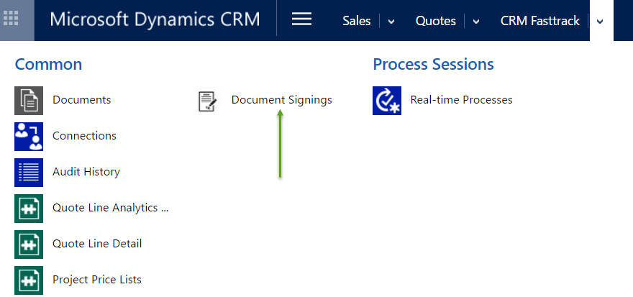

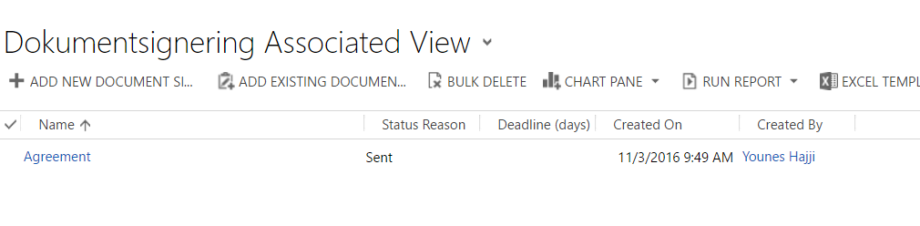

If the status is sent, then none or not all the documents has been signed:

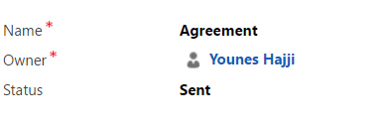

A task is created for each recipient, the status for each one could be viewed:

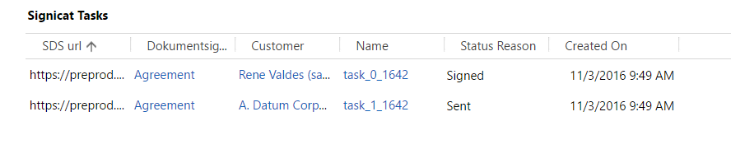

When all the task has changed status to Signed, the document signing will change status to signed, the merged document will be saved in Notes and uploaded to SharePoint if requested.

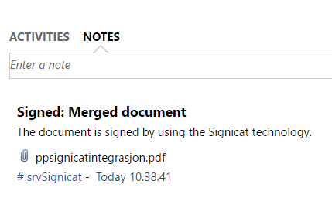

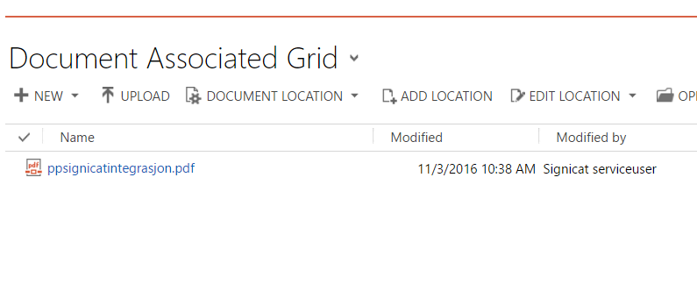

*The Word Add-in*

In order to send documents directly from word for signing, generate a word template for your entity record, navigate to the “Signicat” pane in the Word document and click the button “Sign”:

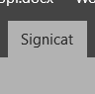 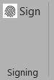

After hitting the Sign button, a message will pop up after a couple of seconds:

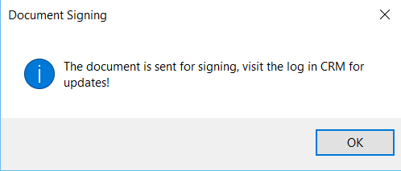

You can navigate to CRM to find the document singing:

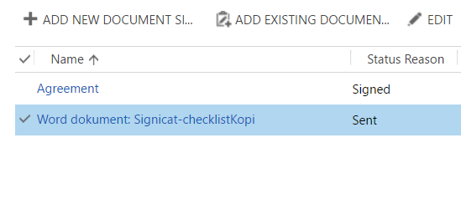

*Prerequisites for Word Add-in*

1. The Word template must have the record number, the record number filed name and the recipient mail address:

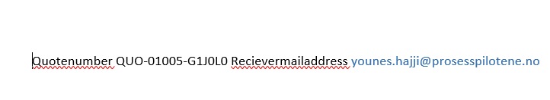

1. The email to the signer will not be sent from the logged-on user’s mailbox. It will be signed from preconfigured user.