



*Implementation Guide*

This guide will help the CRM administrator/implementation responsible for making Signicat tools available for end users.

*Dynamics 365*

1. Install the Signicat for Dynamics365 CRM solution.
2. Go to Settings -> Customizations -> Customize the system and add the Document signings and Signicat config to the settings sitemap.

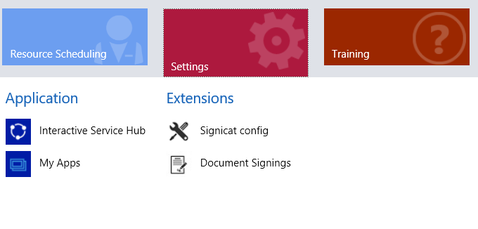

1. Navigate to Signicat Config and add a new record, you can call it whatever you want, only one entry can be created, and this entry applies to all CRM users:

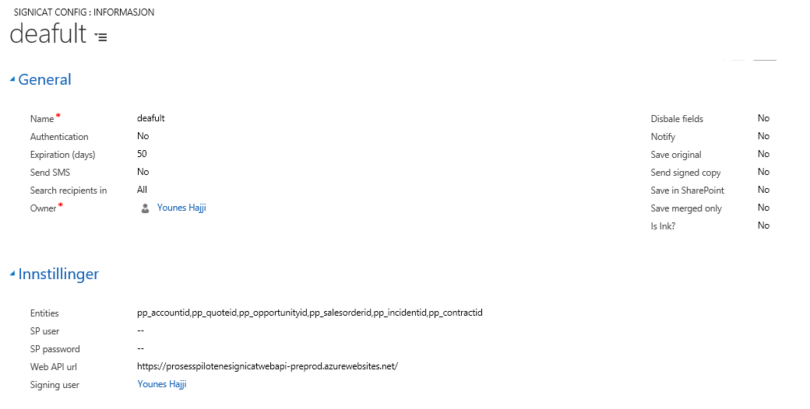

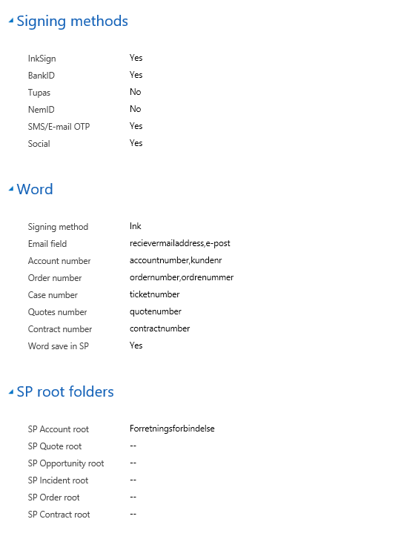

* Click yes on the Signing methods you to be available for the users.
* If you click yes on Disable fields, all the option fields will be inactive, then it is important to pick a search option if all fields are disabled, either Account or Contact:



|  |  |
| --- | --- |
| Entities | Use standard: pp_accountid,pp_quoteid,pp_opportunityid,pp_salesorderid,pp_incidentid,pp_contractid |
| Web Api Url | Url for the Sginicat Api |
| Signing user | The service account user that will run different CRM processes. |
| SP User, Password | If you want to use a specific user for SharePoint saving. |
| Word | Chose a singing method and the name of the Word template tags on the different entities. |
| Word save in SP | Click yes if the signed document should be saved in SharePoint. |
| SP Root folders | Root folder name for the different entities. Eks. if Account is the root folder for all, fill inn the account folder name in SharePoint on the field SP Account root. |