idées.

1-les box:

allô maman bobo

2- Vêtements: vêtements personnalisés sans stockage

1ntik

3-

Etapes.

site: quora.com

Well doing so is quite simple. Just follow these steps.

1. Get a wampp or xampp server installed on your computer to create a local server.

2. Use html, css or any other tool for building the front end of your website.

3. Make a database using MySQL provided by the local server which you just installed.

4. Connect to the database using php script.

Write the required php function and link your files accordingly.

5. Prefer keeping all your files with .php extension.

6. Refer http://www.php.net, http://www.mysql.com, http://www.tutorialspoint.com, http://www.w3schools.com for your syntax relates queries.

Bigcommerce.com

Ideas for ecommerce

Thinking about launching an ecommerce business, but don’t know where to start? Well, an [*ecommerce business idea*](https://www.rewardcamp.com/rewardcamp-retailer-builds-a-million-dollar-e-commerce-business-in-the-toilet-accessories-niche/) would be helpful.

Of course, that’s just for starters.

While you can peruse books and guides on how exactly to start a successful, long-term online store –– every entrepreneur everywhere has to start at the exact same place.

And that place requires you to answer this 1 question:

*What are you going to sell?*

From there, you’ll then launch into competitive reviews and building your online store –– just 2 more steps on the way to building a long-term, successful venture.

But it all starts with what your product is. And, some even argue, the ultimate success of your business is also all about your product.

Marketing, social media reviews, customer lifetime loyalty –– all of those are easier when your product speaks for itself.

So, while some of us are lucky enough to have online store ideas find us, others of us –– well, we have to search.

Top 16 Ecommerce Business Ideas of 2019

To help save you time and energy, we picked the brains of some of the industry’s most trusted and successful entrepreneurs, marketers and researchers to get their thoughts on business opportunities with huge growth potential. Dive on in and learn more about their favorite ecommerce business ideas for 2019.

1. [Niche fashion communities build fast and sell well](https://www.bigcommerce.com/blog/ecommerce-business-ideas/#idea-1).
2. [Online digital health services are on the rise](https://www.bigcommerce.com/blog/ecommerce-business-ideas/#idea-2).
3. [Sell Industrial b2b products for high margins with little competition](https://www.bigcommerce.com/blog/ecommerce-business-ideas/#idea-3).
4. [Identify super niche products (think gluten-free)](https://www.bigcommerce.com/blog/ecommerce-business-ideas/#idea-4).
5. [Planners have a massive following](https://www.bigcommerce.com/blog/ecommerce-business-ideas/#idea-5).
6. [Target tech savvy retirees (who shop online)](https://www.bigcommerce.com/blog/ecommerce-business-ideas/#idea-6).
7. [Appeal to people’s ideologies](https://www.bigcommerce.com/blog/ecommerce-business-ideas/#idea-7).
8. [The education industry is getting big investor bucks](https://www.bigcommerce.com/blog/ecommerce-business-ideas/#idea-8).
9. [Do things Amazon can’t](https://www.bigcommerce.com/blog/ecommerce-business-ideas/#idea-9).
10. [Find confusing products (and provide useful instructions)](https://www.bigcommerce.com/blog/ecommerce-business-ideas/#idea-10).
11. [Passion is the most important part](https://www.bigcommerce.com/blog/ecommerce-business-ideas/#idea-11)!
12. [Remove the middlemen to win big](https://www.bigcommerce.com/blog/ecommerce-business-ideas/#idea-12).
13. [Deep knowledge has the most power](https://www.bigcommerce.com/blog/ecommerce-business-ideas/#idea-13).
14. [Solve your own problem](https://www.bigcommerce.com/blog/ecommerce-business-ideas/#idea-14).
15. [Use KickStarter for research](https://www.bigcommerce.com/blog/ecommerce-business-ideas/#idea-15).
16. [Sell something cool](https://www.bigcommerce.com/blog/ecommerce-business-ideas/#idea-16).

Ecommerceceo.com

[Ecommerce CEO](https://www.ecommerceceo.com/)

* [Courses](https://mba.ecommerceceo.com)
* [Startup Guide](https://www.ecommerceceo.com/start-ecommerce-business/)
* [Platforms](https://www.ecommerceceo.com/ecommerce-platforms/)
* [My Library](https://mba.ecommerceceo.com/library)

# 15 Niche Ecommerce Business Ideas You Can Bank On



* [Darren DeMatas](https://www.ecommerceceo.com/author/darren/)
* May 18, 2019
* [18 Comments](https://www.ecommerceceo.com/ecommerce-business-ideas/#comments)

**1.2KSHARES**

Your dream of sitting on the beach and running a ecommerce business starts with a profitable ecommerce business idea.

I’m dreaming. Are you?

If you’re planning on diving into ecommerce (like I am), the first step is to research and decide what niche to attack. Then figure out the specific products and validate your [business plan](https://www.ecommerceceo.com/ecommerce-business-plan/).

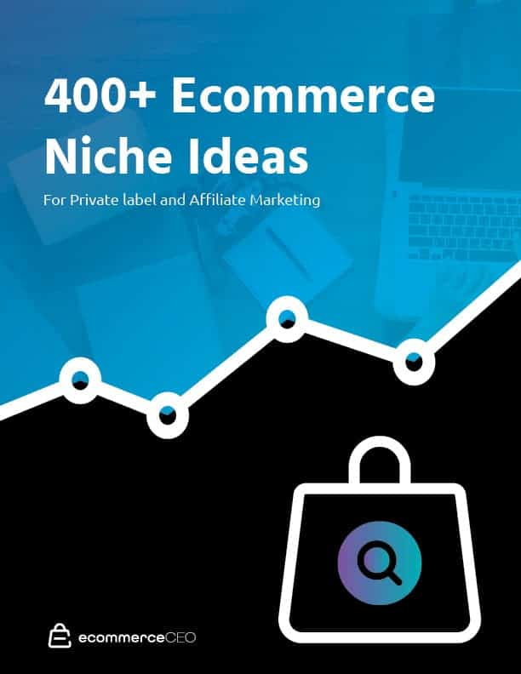

##### Get 400+ Ecommerce Niche Ideas

Learn the key criteria for a successful product niche. Get Amazon and Google search monthly volume  for 400+ private label product and affiliate marketing ideas.

[Yes! Send Me Ecommerce Niche Ideas](https://www.ecommerceceo.com/400-ecommerce-niche-ideas-ebook/)

If you want to compete in today’s competitive ecommerce world, you need to build a sustainable brand.

Churn and burn [ecommerce business models](https://www.ecommerceceo.com/types-of-ecommerce-business-models/)fail.

You can make money selling products with drop shipping, affiliate marketing, or [private label.](https://www.ecommerceceo.com/private-label-products/)

With a million products to sell on Amazon, there are too many small ecommerce business ideas out there. We conducted our own analysis, analyzed many niches to narrow down to the hundreds of ideas on this site.

For this post, we are highlighting the best business ideas but you can reference the articles below for more ideas to start selling:

1. [29 Private Label Product Ideas](https://www.ecommerceceo.com/private-label-products/)
2. [14 Print On Demand Ideas](https://www.ecommerceceo.com/print-on-demand-products/)
3. [7 Digital Product Ideas](https://www.ecommerceceo.com/sell-digital-products/)
4. [21 Trending And Evergreen Niche Product Ideas](https://www.ecommerceceo.com/what-to-sell-online/)
5. [100+ Things To Make And Sell](https://www.ecommerceceo.com/things-to-make-and-sell-online/)

If you are looking towards specific product ideas, be it digital, consumables, or crafts, we have other updated articles on those as well as free courses.

These products also work for brick and mortar businesses, if that’s what you are into, or you want to combine your [ecommerce store](https://www.ecommerceceo.com/start-ecommerce-business/) with a brick and mortar store. We have tested these selling products for their niche market and profitable business model.

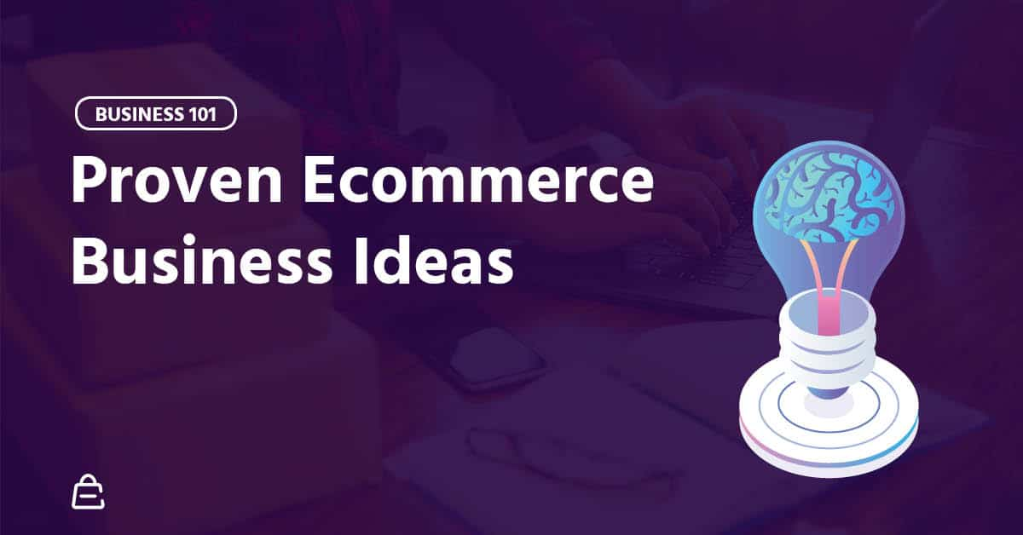

## 1: Double Dip With Affiliate Marketing And Private Label Products

Don’t get stuck on the actual products, instead, capitalize on a [niche market](https://www.adweek.com/digital/how-one-niche-online-wholesaler-is-carving-out-space-in-a-crowded-ecommerce-market/) and grow your popularity and customer trust.

Combining physical products with affiliate marketing is [my #1 ecommerce business idea](https://www.ecommerceceo.com/amazon-affiliate-store/).

To run an affiliate store, you need to be passionate about the ecommerce niche you choose and have enough knowledge to guide people who visit your site.

[Having a deep understanding of your niche helps you produce products and experiences that delight your target audience.**Click to Tweet**](https://twitter.com/intent/tweet?text=Having%20a%20deep%20understanding%20of%20your%20niche%20helps%20you%20produce%20products%20and%20experiences%20that%20delight%20your%20target%20audience.&url=https%3A%2F%2Fwww.ecommerceceo.com%2Fecommerce-business-ideas%2F)

If you can’t give them a sufficient guide, they’ll bounce. If you aren’t passionate, you may give up before actual income comes in.

It’s easier to build affiliate marketing income if you already have a website with some traction. If you don’t have one already, building it takes time.

Get a feel of the market and see what your target market is willing to buy. You can choose popular software, apparel, or consumable goods. To start, get registered as an [affiliate on Amazon](https://www.ecommerceceo.com/amazon-affiliate-store/), or on a manufacturer’s website.

After a while, you can use your affiliate store to catapult your brand. This is where you bring in your private label product. That is, something relevant to the niche of your affiliate store.

Both models together is a strong startup idea that can catapult your brand.

Dr. Axe is one example of a health niche site double dipping with affiliate marketing and branded products.

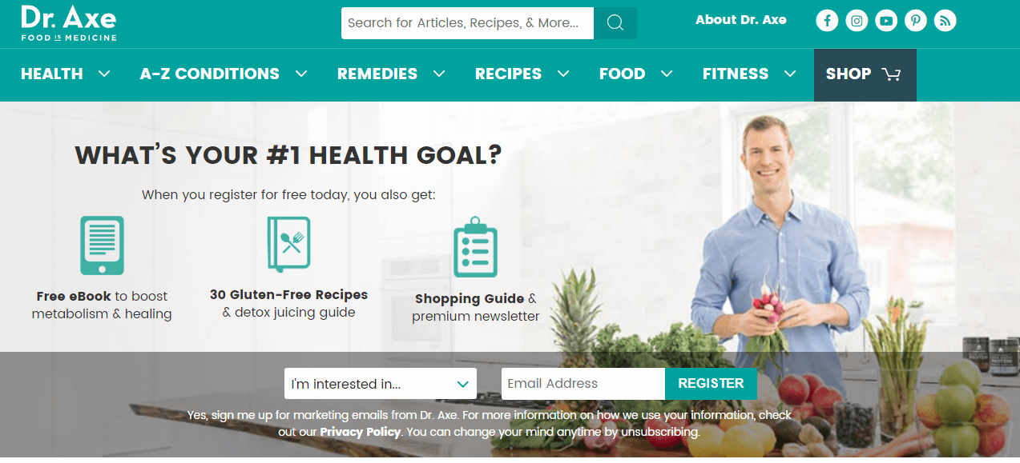

## 2. Private Label Natural Skincare Products For Women

Organic skincare is on the rise.

People are moving away from chemical-filled skincare products as they become more aware of how some chemicals affect the skin and the environment. Their preferred option is natural products.

This is a top ecommerce niche; the margins are great and stats look good. The organic skincare products market is expected to ring in at $22 billion by 2024. The year on year growth rate is a [10%.](https://blog.marketresearch.com/global-skincare-market-to-reach-135-billion-by-2021) This shows steady growth.

Trending products in this market include facial oil, body scrub, mineral sunscreen, and facial cleanser. The good thing is, you can sell any of them for the long term.

Unless you have the time, knowledge, and resources, the most logical way to ensure your products are truly organic is private label. Regardless of the products you choose there are [private label manufacturers](https://www.ecommerceceo.com/private-label-manufacturers/) that can make them for you.

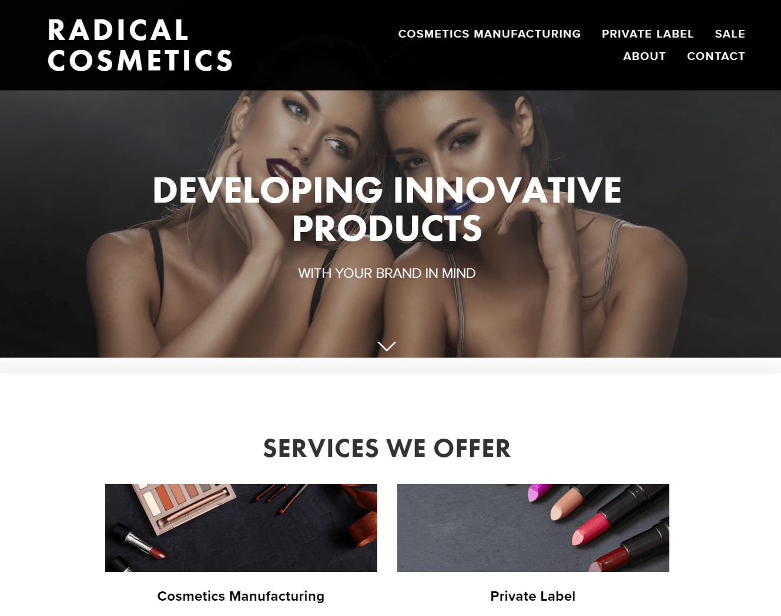

Radical Cosmetics is one. You can also use Alibaba and manufacturer directories to get more. While you are at it, you’ll see other ecommerce niche ideas that you can try.

[It’s not enough to have a good ecommerce business idea, you need a unique selling proposition.**Click to Tweet**](https://twitter.com/intent/tweet?text=It%E2%80%99s%20not%20enough%20to%20have%20a%20good%20ecommerce%20business%20idea%2C%20you%20need%20a%20unique%20selling%20proposition.&url=https%3A%2F%2Fwww.ecommerceceo.com%2Fecommerce-business-ideas%2F)

Women love beauty products and natural ones are even better, but that doesn’t mean that you’ll easily sell immediately you drop down into the ecommerce world. There are businesses already doing the same thing you’re about to do, nothing is new. Choose a unique selling proposition

## 3. Sell Handmade Treats To Pet Owners

There is an increase in pet ownership. Cats are not only owned by old weird ladies, nor dogs owned by a family of four.

One thing that increased with all of that is the tendency to treat pets as members of the family. Good news for us though because pet owners are spending more and more on homemade pet food products.

If you already make treats for your pets or have some healthy recipes, make them and sell online.

The market grows at a [steady rate](https://www.ibisworld.com/industry-trends/specialized-market-research-reports/consumer-goods-services/pet-care/pet-food-production.html), and there are opportunities to maximize customer lifetime value. You can offer subscription boxes for treat supplies, cross-sell with white label pet food or kennels.

## 4. Wholesale Baby Toiletries For Eco-Friendly Parents

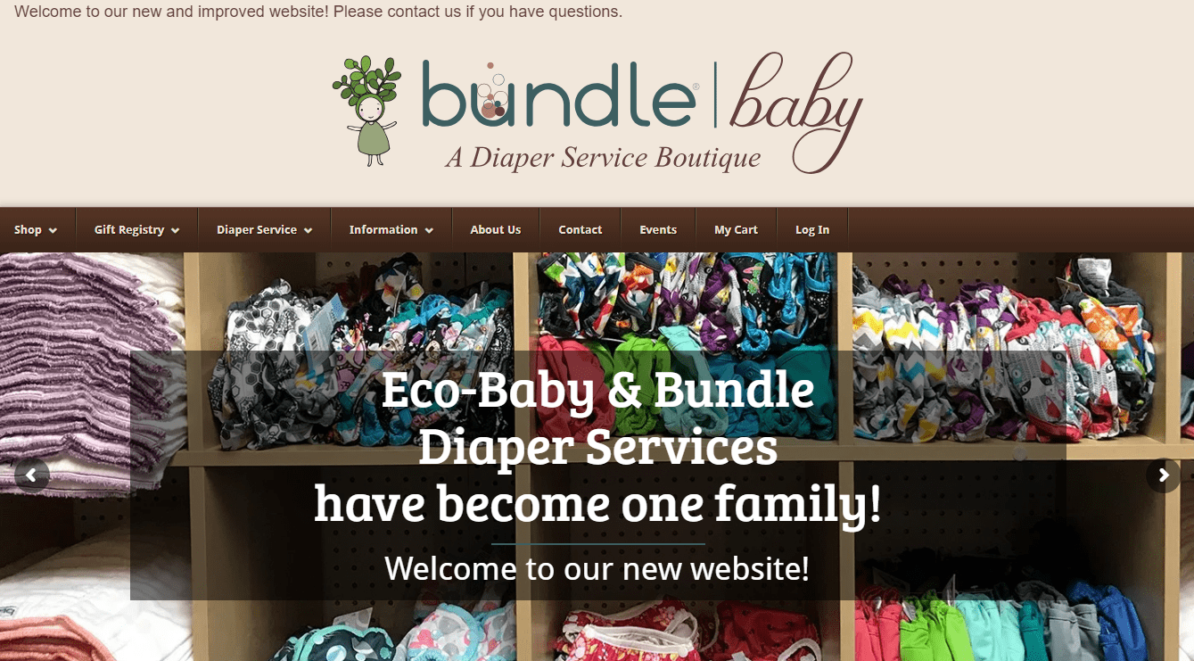

By 2020, there will be 80 million babies in the US, accounting for 24% of our entire population.

As long as the earth is fine, this growth is good for ecommerce entrepreneurs.

Today, about 20% of baby products sales take place online—more than any other consumer packaged goods category – [Scott Siders, Researcher and Writer at BigCommerce.](https://www.bigcommerce.com/blog/baby-kids-ecommerce-design/)

Kids influence up to [$500 billion](https://www.commercialfreechildhood.org/resource/marketing-children-overview) in household spending in the US every year. One big part of that is toiletries.

Disposable diapers end up in landfills where they stay for about 500 years emitting methane. They don’t degrade well and are not as cost effective as their more eco-friendly alternatives – cloth diapers or hybrid diapers.

With the rise in everything eco-friendly, biodegradable diapers and wipes are types of products you should use to start a business.

Why?

Eco-friendly diapers have become a point of passion for many parents; they save money and save the environment while at it.

You can buy high quality biodegradable products in bulk and either sell online to retailers or consumers. There are many upsell, cross-sell opportunities, subscription service, and chances to expand your shop products as you go.

## 5. Print On Demand Lifestyle Apparel

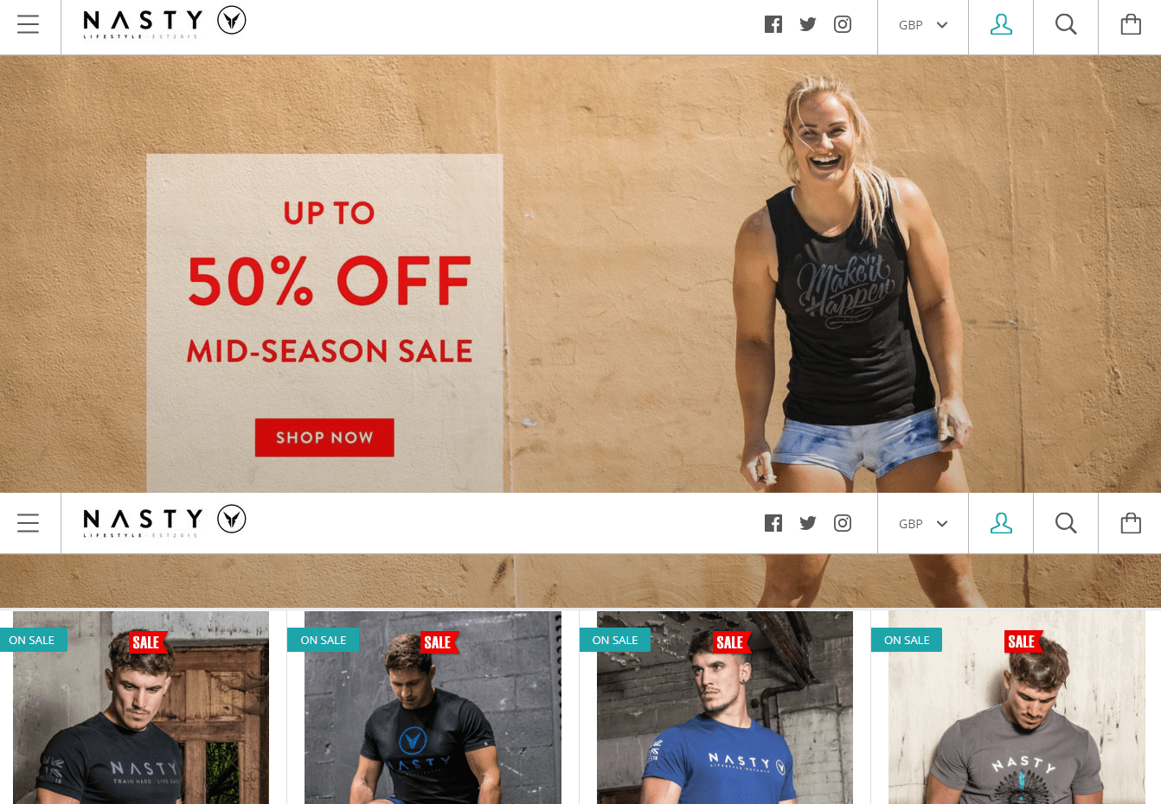

T-shirts are easily the first clothing item you’ll think of for print on demand. No wonder plain t-shirts are harder to see these days with the variety of design-printed shirts everywhere.

Since the t-shirt market is saturated, you’ll have more chances of selling when you have a niche [target market](https://www.ama.org/resources/Best-Practices/Pages/How-Accurate-is-Targeted-Marketing-if-You-Can%E2%80%99t-See-Your-Target-The-CMO-Mission-Data-Driven-Segmentation.aspx).

Lifestyle products make up one of the top ecommerce niches. With print on demand lifestyle apparel, you can easily piggyback on a community or trend that already exists. We have:

* Pets
* Animals
* Music
* Maps
* Fitness
* Food

These are broad category niches that you can look into for a micro niche. Say, designs for nurses who CrossFit, highly detailed city maps on shirts, or look into the dog or cat community for inspiration.

“A micro niche makes this [standing out in a crowd] possible and leads to an increase in business growth”…Jackie Nagel, President of synnovatia

There are many other [categories and products](https://www.ecommerceceo.com/print-on-demand-products/) that you work your ecommerce idea around. As long as there is a passionate audience, you are set for the road.

## 6. Dropship HIIT Equipment And Sell Training Programs To Beginners

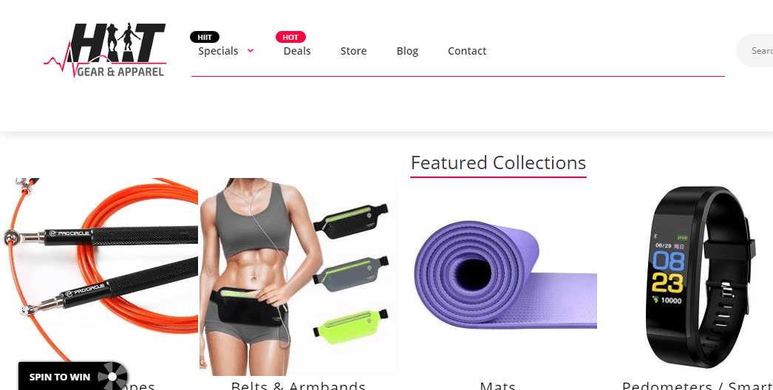

The fitness niche is one of the top ecommerce niches. It is evergreen, stable and profitable for the most savvy ecommerce entrepreneurs. HIIT workouts keep rising in popularity; you’ll hit a home run with this niche if you choose to start an online business selling HIIT equipment.

You can dropship armbands, jump ropes, medicine balls, and other smaller items with less shipping cost. This is a great idea for a small business startup.

This ecommerce business idea has been trending upwards for a while now. Start your online marketing first by analyzing the competitive space.

Workout equipment (generally) is a competitive keyword but ranking for HIIT equipment is not as competitive. You have high demand, ad success potential with video marketing, and a lot of cross-sell opportunities.

Better still, add training programs for beginners to this startup idea, be it videos, lists, or both. They also do well as lead magnets. Work all of that with excellent customer service and good marketing.

## 7. Launch A Beauty Subscription Box For Men

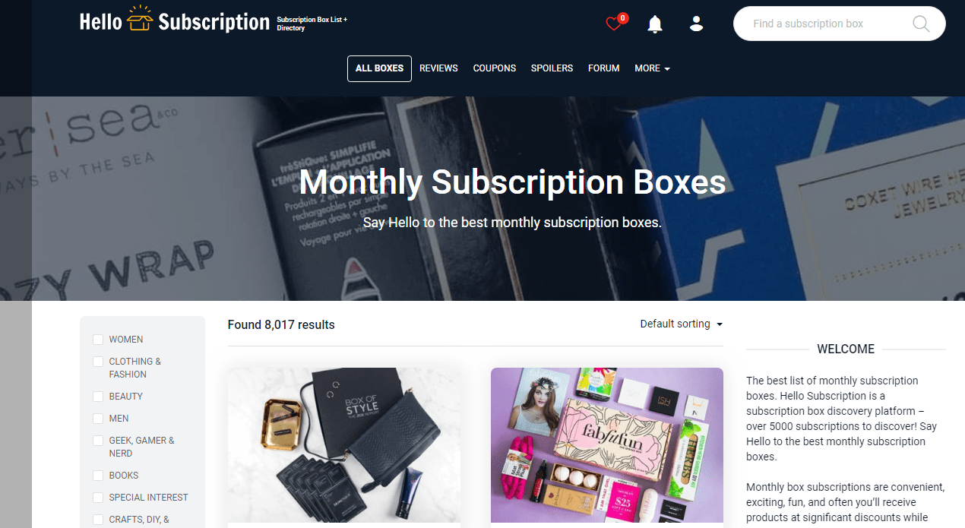

There’s a lot of hype around subscription and [subscription boxes](https://boxes.hellosubscription.com/). This shows in the industry’s growth which is about [200% since 2011](https://hbr.org/2017/12/subscription-businesses-are-booming-heres-how-to-value-them).

I won’t deny that business-to-customer subscription services are sprouting up everywhere. Nevertheless, there’s growth potential for new entrants.

You just have to find either trending products, hard-to-find personalized products, or products people regularly need that you can group in a niche market.

Choose a targeted audience; in this case, men are a good option. There are subscriptions for women everywhere already.

Beauty product for men is not only the one-in-four shower gel. Considering that we often shave or groom beards, certain products are necessary. You can get products like post shave balm, beard oil, acne wash, face wash, facial moisturizer, and cologne.

One good thing about subscriptions is recurring monthly income, which contributes to customer lifetime value.

## 8. Rent High-End Fashion To Budget Minded Fashionistas

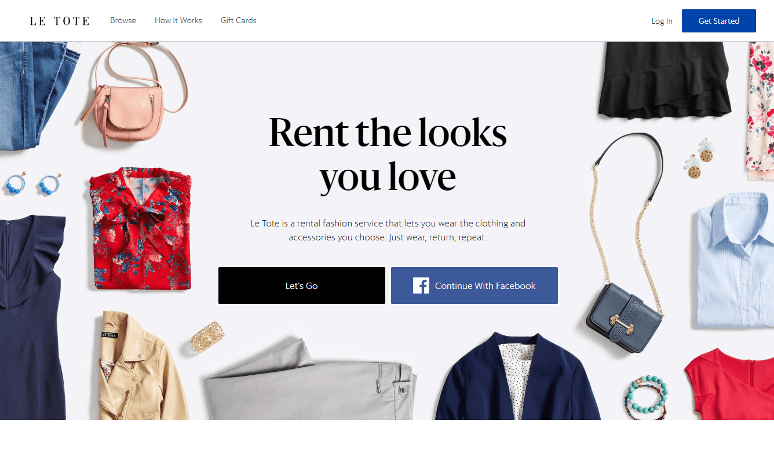

Give people the chance to rent high-end fashion from brands like Kate Space and Nicole Miller at a retail price.

My wife is loving [Rent the Runway](https://www.renttherunway.com/), and there are others who love apparel from the runway and the collection of high-end brands.

The idea of renting out dresses online may seem odd at first, but the success of rental platforms like Rent the Runway and Le Tote have proven the potential of this ecommerce business idea. They are hot topics in the fashion industry.

There are many [online marketing](https://www.searchenginejournal.com/compete-with-big-ecommerce-brands/219783/) opportunities in this niche. Social media marketing is effective. You can also add a subscription service, say $100 a month for a certain number of dresses and accessories. Also, you can cross-rent with a ‘complete the look’ section for accessories on your online store.

As much as this great idea is profitable, it’s also very demanding to run. Preparing your strategy and organizing a good business plan will help you. Also make sure you know your [break-even point.](https://www.ecommerceceo.com/break-even-point-calculator/)

## 9. Deliver Organic Food On Demand To Clean-Eating Enthusiasts

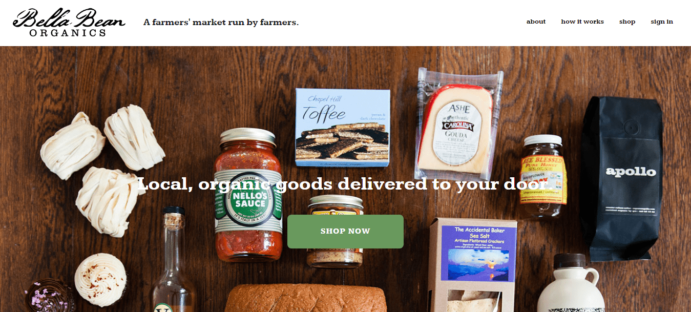  
The US online grocery sales have brought in about[$17.5 billion](https://www.statista.com/statistics/293707/us-online-grocery-sales/) this year. By 2021, that amount is expected to rise to nearly $30 billion. That’s a lot of money. And still, online grocery in the US is not even as good as that in the UK.

This is a great idea for anyone interested in selling food and beverage.

The market is wide, so specializing in an organic grocery store is one profitable way to niche and cash in on this market in the long term.

The profit potential is good; you can get about 20 – 40% from sales if you build alliances with people who grow organic food.

Another place to get supplies would be your local grocery stores, but that might not be as profitable. When that step is ticked, you can go marketing aggressively. Let people know what you deliver.

To increase customer lifetime value, you can add in monthly subscriptions as part of your package.

If you choose this business idea, you should know that you’re limited to locations that you can sell to. You can’t deliver much farther than your state or country, unlike a clothing store for example.

## 10. Create Online Courses For Computer-Savvy Students

Do you have an expert or enough knowledge about a subject, industry, or a new way to do/achieve certain things? Then make a course around it.

With expected sales at [$286.62 billion](https://www.businesswire.com/news/home/20180226006458/en/Global-Online-Education-Market-2018-2023-Type-Technology) in 2023, a whopping 80% growth from the figure recorded in 2017, this is a good product to build an online business on.

Although, there many online courses, the market cannot be saturated. Even if a platform like Udemy, or other online stores have millions of courses, there will still be unmet needs.

People would buy as long as it’s relevant and they know it exists.

However, you have more chances of selling if you’re known as an expert of some sorts. You can prove that through social media or showing up on search engine results – your website and interviews elsewhere.

Digital products are a good source of passive income. If you don’t fancy online courses, [see these 7 other digital product ideas](https://www.ecommerceceo.com/sell-digital-products/).

## 11. White Label Prepackaged Gluten-Free Food

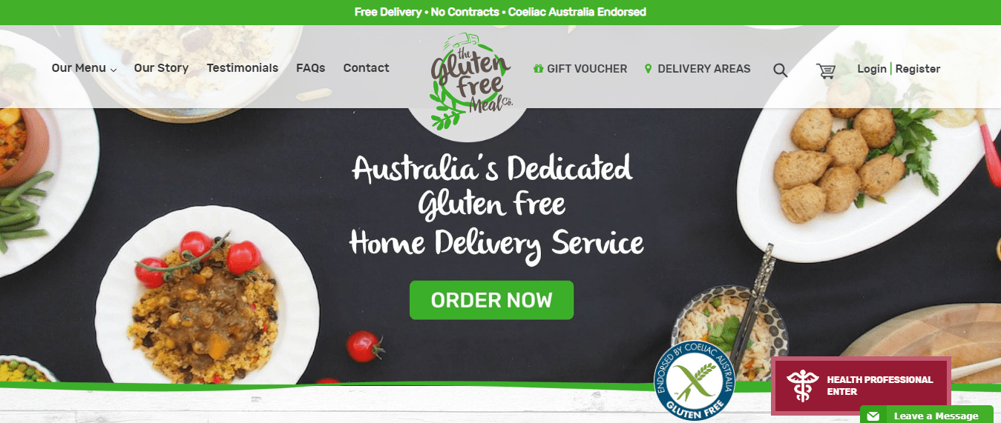

Gluten-free food is not new, but there’s an increased growing craze for it. The celebrities talking about it are increasing interest as well.

Gluten-free enthusiasts are hardcore about their diet and are careful to buy only food and snacks that carry the “gluten-free” tag on it. Since a lot of prepackaged food and snack contain gluten, you have a good chance. Sell to one customer and your name gets out there fast.

The easiest way to sell gluten-free food is white label. You could make them, but that requires more funds and personnel.

## 12. Dropship Handmade Jewelry To Women

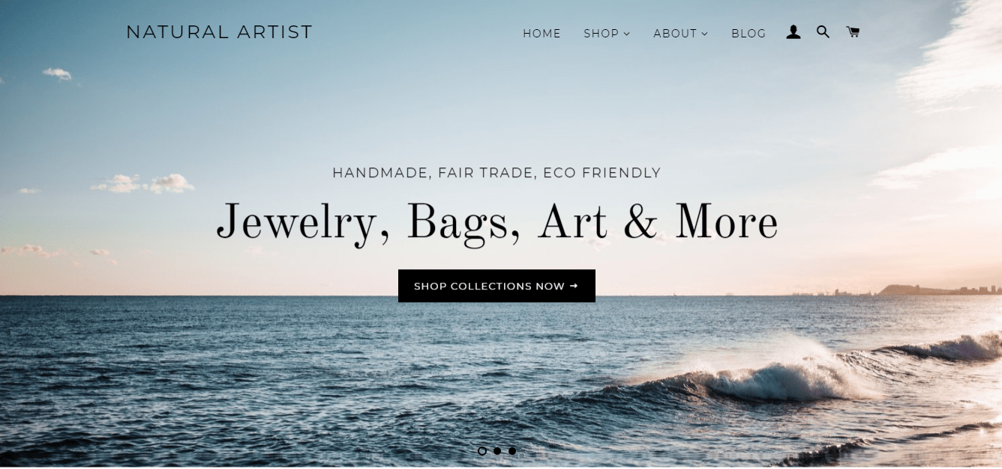

You have more chances of differentiating as a dropshipper when you sell unique products.

[Customers want unique products and unique experiences.**Click to Tweet**](https://twitter.com/intent/tweet?text=Customers%20want%20unique%20products%20and%20unique%20experiences.&url=https%3A%2F%2Fwww.ecommerceceo.com%2Fecommerce-business-ideas%2F)

Unique = handmade, custom, antique.

Also, the price of handmade jewelry is hard to guess easily so you can set a reasonable price and have a good margin. Selling on your online store also puts you in more control than marketplaces.

Concerning supplies, you have better chances when you don’t use AliExpress. Many sellers are already dropshipping the tons of jewelry on AliExpress; competition is fierce.

Go directly to the craft maker’s website and ask if you can retail the product. While this isn’t entirely necessary, if they know that you are dropshipping, you could get a discount especially if you are bringing in many sales.

Handmade jewelry is not the only craft you can dropship, make, or wholesale. Check out these selling 100+ handmade product ideas that we’ve brought together in this article. They have good enough search volume and a stable trend.

## 13. Private Label Bamboo Toothbrushes

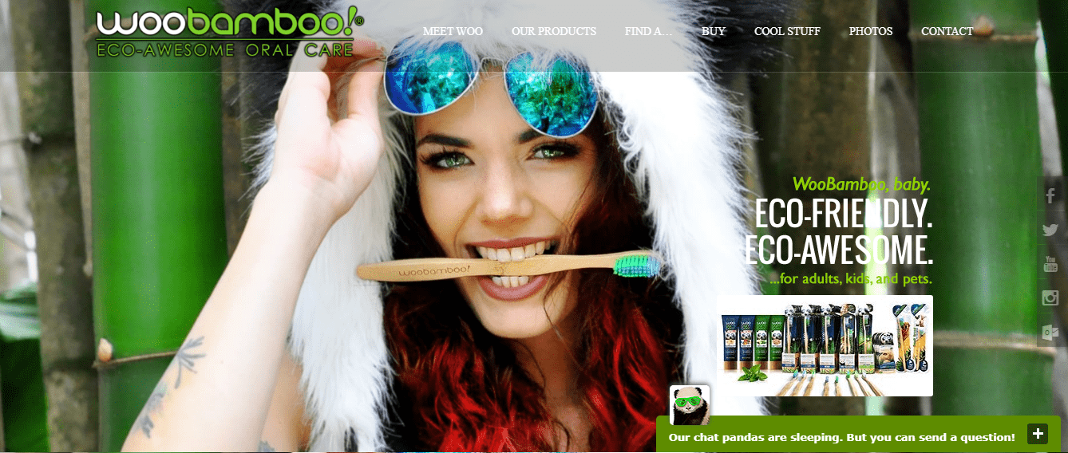

If you are still unsure of the products to sell, bamboo toothbrushes are a good choice for a small business.

The interest in all things eco-friendly and minimalism turned bamboo toothbrushes into a trendy product. This is a good ecommerce business idea that you shouldn’t ignore.

The only way you can be sure that you differentiate and your products are unique and genuinely eco-friendly is private label.

There’s one mistake some sellers of this product make, and that is plastic packaging. That misses the whole point of sustainability, and you can leverage on that. Some manufacturers deliver in sustainable packages, but the market hasn’t reached the apex yet, so there’s much space for you to cash in.

After a while, you can add other [niche products](https://www.tandfonline.com/doi/abs/10.2753/MIS0742-1222270204) like toothpaste, storage containers, and dental floss. You can white label those.

Do your market research to find any other product you want to cross-sell in your online store. Look out for low competition, high volume, stable trend, and good future projections. [Google trends](https://trends.google.com/trends/), search, Ahrefs, and Junglescount are relevant to that.

## 14. Dropship High-End Camera Drones

There is a lot of interest in drones and more units will take off in the coming years. The whole industry is expected to be worth [$127 billion](https://dronelife.com/2016/07/19/8-incredible-drone-industry-stats/) by 2020.



There are different level of users and different types of drones. For an ecommerce business idea, camera drones are products you can scale with.

People use camera drones in agriculture and wedding. They also use them to record aerial shots of cities. Target your customers on social media with high quality videos and images that represent your brand. You can go with serious, funky, or fun.

## 15. Private Label Men’s Bags

The female bag niche is saturated. It’s possible to sell, but a better opportunity is in the men’s bag niche.

This is a viable niche because you have a diverse selection and styles of bags you could bring into the market.

When you start, choose an audience. You have students, employees, and retirees to target. This will help you in choosing exact products to fill your online store. You could start with laptop bags and add in regular backpacks.

[Add a customization to your product that isn’t on the market.**Click to Tweet**](https://twitter.com/intent/tweet?text=Add%20a%20customization%20to%20your%20product%20that%20isn%E2%80%99t%20on%20the%20market.&url=https%3A%2F%2Fwww.ecommerceceo.com%2Fecommerce-business-ideas%2F)

There are backpacks and other styles of men’s bags already on the market. You don’t want to look like every other store. Think. Things like anti-theft or charging ports that are on flowing in. Or go lower with tech by choosing a shoe compartment.

As you grow, you can add in other styles of bags like drawstrings, purses and sling bags.

Market on social media and use blogger and influencer marketing.

## So… What’s Your Ecommerce Business Idea?

You’re not limited to these ecommerce business ideas. We also have tons of other selling ideas. If you go through all them as well, you’ll have more than 100 validated business ideas that you can use to kickstart a profitable ecommerce brand:

* [29 Private Label Product Ideas](https://www.ecommerceceo.com/private-label-products/)
* [14 Print On Demand Ideas](https://www.ecommerceceo.com/print-on-demand-products/)
* [Digital Product Ideas](https://www.ecommerceceo.com/sell-digital-products/)
* [21 Trending And Evergreen Niche Product Ideas](https://www.ecommerceceo.com/what-to-sell-online/)

If you see an ecommerce niche idea that you are passionate about that’s not on our list, do your market research and be sure that there is growth potential.

**The best ecommerce niches have:**

* market & sales growth
* growth on Google trends
* strong Amazon sales
* bloggers and influencers
* a clear niche type
* an identifiable niche audience on Facebook

Another thing that is important for any product you sell online is your marketing. People are not going to whip out their credit card if you have a generic brand.

You can start online marketing before you make or get products from your suppliers. As you deliver, focus on product quality and customer service. If you give out crappy products or talk rudely, your customers will bounce.

You’d be surprised how many new brands don’t respond to customers online.

If you have any questions, send them in and I’ll answer as soon as possible.



#### Darren DeMatas

Darren has an MBA in Internet Marketing and 10+ years of experience marketing retail, manufacturing and Internet marketing corporations, 7-figure brands and startups online. Follow him on [Twitter](https://twitter.com/ecommerceCEO), [LinkedIn](https://www.linkedin.com/in/internetmarketingmba) to [learn ecommerce](https://www.ecommerceceo.com/).

### **18 Thoughts On “15 Niche Ecommerce Business Ideas You Can Bank On”**

1. /var/folders/xy/3l_l3kms10l29p7tbk13cxgh0000gn/T/com.microsoft.Word/WebArchiveCopyPasteTempFiles/8ebce9333e64eea288f8caac2634758c?s=50&d=mm&r=g

[**SHABBIR**](http://bootstrappingecommerce.com)

[SEPTEMBER 29, 2015 AT 10:47 AM](https://www.ecommerceceo.com/ecommerce-business-ideas/#comment-354)

Wow, this is a really epic list! I’m honored to be a part of it

[Reply](https://www.ecommerceceo.com/ecommerce-business-ideas/#comment-354)

* 1. /var/folders/xy/3l_l3kms10l29p7tbk13cxgh0000gn/T/com.microsoft.Word/WebArchiveCopyPasteTempFiles/dfd07e39a66fa6e1981d1db93fe9c9f4?s=50&d=mm&r=g

**DARREN DEMATAS**

[SEPTEMBER 29, 2015 AT 10:59 AM](https://www.ecommerceceo.com/ecommerce-business-ideas/#comment-355)

Thanks Shabbir! The fact that you’re a seasoned pro added a ton of value to the post:)

[Reply](https://www.ecommerceceo.com/ecommerce-business-ideas/#comment-355)

1. /var/folders/xy/3l_l3kms10l29p7tbk13cxgh0000gn/T/com.microsoft.Word/WebArchiveCopyPasteTempFiles/fc6d3c47531973a9c8f94c2dfcd789db?s=50&d=mm&r=g

[**CHRIS MAKARA**](http://chrismakara.com)

[SEPTEMBER 30, 2015 AT 7:51 AM](https://www.ecommerceceo.com/ecommerce-business-ideas/#comment-358)

Darren – this is a very well done list, nice job! So many great people participated and shared some excellent insight.

[Reply](https://www.ecommerceceo.com/ecommerce-business-ideas/#comment-358)

* 1. /var/folders/xy/3l_l3kms10l29p7tbk13cxgh0000gn/T/com.microsoft.Word/WebArchiveCopyPasteTempFiles/dfd07e39a66fa6e1981d1db93fe9c9f4?s=50&d=mm&r=g

**DARREN DEMATAS**

[SEPTEMBER 30, 2015 AT 4:01 PM](https://www.ecommerceceo.com/ecommerce-business-ideas/#comment-364)

thanks for dropping by, Chris

[Reply](https://www.ecommerceceo.com/ecommerce-business-ideas/#comment-364)

1. /var/folders/xy/3l_l3kms10l29p7tbk13cxgh0000gn/T/com.microsoft.Word/WebArchiveCopyPasteTempFiles/88d1541e0c14c89306f6b9d9ebea3d09?s=50&d=mm&r=g

[**DENNIS**](http://www.storegrowers.com)

[SEPTEMBER 30, 2015 AT 11:06 AM](https://www.ecommerceceo.com/ecommerce-business-ideas/#comment-360)

Impressive post Darren, thanks for putting this together. I’m happy to be in such good company!

I love how everyone answers the same question from a slightly different perspective. So if you’re considering a new niche, taking all of this advice will not only put you on a more profitable path, you’ll also be growing more easily.

[Reply](https://www.ecommerceceo.com/ecommerce-business-ideas/#comment-360)

* 1. /var/folders/xy/3l_l3kms10l29p7tbk13cxgh0000gn/T/com.microsoft.Word/WebArchiveCopyPasteTempFiles/dfd07e39a66fa6e1981d1db93fe9c9f4?s=50&d=mm&r=g

**DARREN DEMATAS**

[SEPTEMBER 30, 2015 AT 4:00 PM](https://www.ecommerceceo.com/ecommerce-business-ideas/#comment-363)

Starting is often the hardest part. Some people over analyze and never start, while others jump in with pockets blazing. Hopefully this advice will help at least one person

[Reply](https://www.ecommerceceo.com/ecommerce-business-ideas/#comment-363)

1. /var/folders/xy/3l_l3kms10l29p7tbk13cxgh0000gn/T/com.microsoft.Word/WebArchiveCopyPasteTempFiles/f8d69258525dec38624a29eb3d570d8c?s=50&d=mm&r=g

[**ANN SMARTY**](http://myblogu.com/blog/)

[SEPTEMBER 30, 2015 AT 2:28 PM](https://www.ecommerceceo.com/ecommerce-business-ideas/#comment-361)

Wow this turned out to be a great article: Lots of wisdom! Thanks for having me: I am honored!

[Reply](https://www.ecommerceceo.com/ecommerce-business-ideas/#comment-361)

* 1. /var/folders/xy/3l_l3kms10l29p7tbk13cxgh0000gn/T/com.microsoft.Word/WebArchiveCopyPasteTempFiles/dfd07e39a66fa6e1981d1db93fe9c9f4?s=50&d=mm&r=g

**DARREN DEMATAS**

[SEPTEMBER 30, 2015 AT 3:59 PM](https://www.ecommerceceo.com/ecommerce-business-ideas/#comment-362)

Thanks, Ann! As Dennis said, each person brought some interesting perspectives, so thanks for contributing. We did the best we could to summarizethe common themes at the end of the article.

Cheers

[Reply](https://www.ecommerceceo.com/ecommerce-business-ideas/#comment-362)

1. /var/folders/xy/3l_l3kms10l29p7tbk13cxgh0000gn/T/com.microsoft.Word/WebArchiveCopyPasteTempFiles/392615cb11bf2d612818f22a40983947?s=50&d=mm&r=g

**JASON**

[NOVEMBER 7, 2015 AT 11:50 PM](https://www.ecommerceceo.com/ecommerce-business-ideas/#comment-390)

Great post Darrin!  
Most of the advice seems geared towards ranking in Google. Larry Kim proposed testing with Facebook and Adwords first. What is the advice if I want to build an ecommerce store and only use smart PPC campaigns to drive traffic? That makes the website a little more Google algo proof and a lot less stressful to launch (not worrying about ranking).

Richard Lazazzera suggests creating a mock store or landing page to test conversions. It is a good idea but how do you sell “fake items” to people or what is the content of the landing page? Just to get an email address?

[Reply](https://www.ecommerceceo.com/ecommerce-business-ideas/#comment-390)

* 1. /var/folders/xy/3l_l3kms10l29p7tbk13cxgh0000gn/T/com.microsoft.Word/WebArchiveCopyPasteTempFiles/dfd07e39a66fa6e1981d1db93fe9c9f4?s=50&d=mm&r=g

**DARREN DEMATAS**

[NOVEMBER 10, 2015 AT 8:42 AM](https://www.ecommerceceo.com/ecommerce-business-ideas/#comment-393)

Some seriously good questions, Jason. I think using PPC to help launch a site is good, but I still wouldnt rely solely on it. What works today, might not work tomorrow. As evidenced in the many PPC campaigns I ran, paused and unpaused.

If your strategy is solely based on competition for that last click before purchase (transactional keywords) – you’re missing out on top funnel sales and brand awareness. Like if you are selling outdoor backpacks, you could have a ton of great content about hiking to help build your brand and top funnel.

This might be a good topic to ask Richard about. He said he would do an interview with me, maybe we can ask him there. Anything else you want me to ask Richard?

[Reply](https://www.ecommerceceo.com/ecommerce-business-ideas/#comment-393)

1. /var/folders/xy/3l_l3kms10l29p7tbk13cxgh0000gn/T/com.microsoft.Word/WebArchiveCopyPasteTempFiles/89f732060e2b36fa22b29c58f007dd52?s=50&d=mm&r=g

[**CAROLINE**](http://hitasoft.com/products/)

[MARCH 10, 2016 AT 2:57 AM](https://www.ecommerceceo.com/ecommerce-business-ideas/#comment-478)

Thanks for sharing the informative insights of those expertise. Worthwhile to read to research and get into depth with ecommerce values

[Reply](https://www.ecommerceceo.com/ecommerce-business-ideas/#comment-478)

1. /var/folders/xy/3l_l3kms10l29p7tbk13cxgh0000gn/T/com.microsoft.Word/WebArchiveCopyPasteTempFiles/e363614c5ed278c8b35b40dfa3666009?s=50&d=mm&r=g

[**ECO-FRIENDLY**](http://ecofriendlywoman.com)

[MAY 25, 2016 AT 5:46 PM](https://www.ecommerceceo.com/ecommerce-business-ideas/#comment-580)

Thanks for this post! You’ve given people great tips especially those who have not decided yet which e-commerce business to venture in.

[Reply](https://www.ecommerceceo.com/ecommerce-business-ideas/#comment-580)

1. /var/folders/xy/3l_l3kms10l29p7tbk13cxgh0000gn/T/com.microsoft.Word/WebArchiveCopyPasteTempFiles/6ab7d0188db5a7b1679ee242657cf55e?s=50&d=mm&r=g

[**JASON SANTIAGO**](http://www.spi-global.com/content-solutions/our-services/content-distribution)

[JUNE 7, 2016 AT 11:05 PM](https://www.ecommerceceo.com/ecommerce-business-ideas/#comment-592)

A lot of advice from different experts here. It actually takes a lot of time and research before finding the proper niche. The most successful venture I’ve pushed here in our country is designer cakes and ever since the surge of foodie reality shows, competition suddenly became tight. Anyway, thanks for this article! Much appreciated.

[Reply](https://www.ecommerceceo.com/ecommerce-business-ideas/#comment-592)

1. /var/folders/xy/3l_l3kms10l29p7tbk13cxgh0000gn/T/com.microsoft.Word/WebArchiveCopyPasteTempFiles/d3e90acd196e88bf8c7555e2a1300713?s=50&d=mm&r=g

[**ALI KHAN**](https://pk.linkedin.com/in/p2palikhan)

[MARCH 28, 2017 AT 1:00 AM](https://www.ecommerceceo.com/ecommerce-business-ideas/#comment-907)

Great ideas & inspirations, unique selling point & focusing on specific niche is very important. Well, thanks for sharing great piece of content ever seen..

[Reply](https://www.ecommerceceo.com/ecommerce-business-ideas/#comment-907)

1. /var/folders/xy/3l_l3kms10l29p7tbk13cxgh0000gn/T/com.microsoft.Word/WebArchiveCopyPasteTempFiles/ff9d3ba2ee785e93dfbb63557d64b104?s=50&d=mm&r=g

[**DAVID CBRADIOS**](https://carcbradios.com)

[FEBRUARY 4, 2018 AT 9:50 PM](https://www.ecommerceceo.com/ecommerce-business-ideas/#comment-1274)

I’m just running a shopify website for dropshipping. I will appreciate your help on this journey. Thanks

[Reply](https://www.ecommerceceo.com/ecommerce-business-ideas/#comment-1274)

1. /var/folders/xy/3l_l3kms10l29p7tbk13cxgh0000gn/T/com.microsoft.Word/WebArchiveCopyPasteTempFiles/a902b9c7b6fed2c70d840724b0b89b6b?s=50&d=mm&r=g

**PARIYA**

[MAY 8, 2018 AT 10:28 PM](https://www.ecommerceceo.com/ecommerce-business-ideas/#comment-1482)

… we have virtually on our doorstep here in Thailand so many physical factory stores of enviormentally friendly, reclaimed hardwood Teak furniture. We even have three beds, and several other pieces of Teak furniture ourselves due to its hardwearkng, and solid built to last nature, with its aesthetic beauty also.  
All furniture is handmade, and made to order, some can be bespoke for customer size dimensions.  
Our main concern is customer confidence in having to wait maybe at least 6-9 weeks from ordering, should our individual suppliers have a busy period, times could be even longer, and should a customer need several furniture items time scales will increase further.  
We’ve done some research and most high SEO Teak furniture being sold is for mainly garden pool,so much being of the factory mass produced kind, low quality, not enviomently friendly such as Indonesian Teak which on a positive they have bought pre-made bulk and shipped for their shipping times being so quick as no making by hand to be done, and no international shipping.  
Our products would also have a slightly higher price due to the handmade, bespoke USP.

How can customer confidence be made with such waiting times, on such high ticket furniture.

[Reply](https://www.ecommerceceo.com/ecommerce-business-ideas/#comment-1482)

1. /var/folders/xy/3l_l3kms10l29p7tbk13cxgh0000gn/T/com.microsoft.Word/WebArchiveCopyPasteTempFiles/2d0f8ee5cd6e98e143cc1d8a7db1f495?s=50&d=mm&r=g

[**THOMAS**](https://www.thomas-it.pl/)

[NOVEMBER 8, 2018 AT 6:36 AM](https://www.ecommerceceo.com/ecommerce-business-ideas/#comment-7001927)

Such a great and motivational post! Bravo!

[Reply](https://www.ecommerceceo.com/ecommerce-business-ideas/#comment-7001927)

1. /var/folders/xy/3l_l3kms10l29p7tbk13cxgh0000gn/T/com.microsoft.Word/WebArchiveCopyPasteTempFiles/df74f10cf1573cd27f8234a0b51ae680?s=50&d=mm&r=g

[**SCOTT LINDSAY**](https://www.vettedopps.com)

[NOVEMBER 27, 2018 AT 7:59 PM](https://www.ecommerceceo.com/ecommerce-business-ideas/#comment-7001988)

This is an amazing list! I especially learned a lot from Kurt Elster’s statement about going too broad and too big. That’s so true. You must niche down so you can target your message to the right people.

[Reply](https://www.ecommerceceo.com/ecommerce-business-ideas/#comment-7001988)

### Leave A Comment

Haut du formulaire

**Your email address will not be published. Required fields are marked \***

### Type here..

**Name\***

**Email\***

**Website**

Bas du formulaire

### Guides

* [**How To Start an Ecommerce Business**](https://www.ecommerceceo.com/start-ecommerce-business/)
* [**Ecommerce Startup Checklist**](https://www.ecommerceceo.com/ecommerce-startup-checklist/)
* [**Ecommerce Business Models**](https://www.ecommerceceo.com/types-of-ecommerce-business-models/)
* [**400+ Ecommerce Niche Ideas**](https://www.ecommerceceo.com/400-ecommerce-niche-ideas-ebook/)
* [**What To Sell On Amazon**](https://www.ecommerceceo.com/what-to-sell-on-amazon/)
* [**Break Even Point Calculator**](https://www.ecommerceceo.com/break-even-point-calculator/)
* [**Best Ecommerce Platforms**](https://www.ecommerceceo.com/ecommerce-platforms/)
* [**Product Profitability Calculator**](https://www.ecommerceceo.com/product-profitability-analysis/)
* [**Ecommerce Toolkit**](https://www.ecommerceceo.com/ecommerce-tools/)

### [/var/folders/xy/3l_l3kms10l29p7tbk13cxgh0000gn/T/com.microsoft.Word/WebArchiveCopyPasteTempFiles/Get-Free-Guide-Niche.jpg](https://www.ecommerceceo.com/400-ecommerce-niche-ideas-ebook/)

### Copyright © 2019 Ecommerce CEO

### Scroll to Top

Cahier des charges

1.Les pages, les articles, modification des infos du client, ce que doit faire le client lorsqu’il arrive sur le site (règles de gestion pour chaque écran, fonctionnalités)

**1.Cadre du projet** : résumé, contexte de l’entreprise, enjeux et objectifs, livrables, présentation de l’équipe, planning prévissionel. **Nawal**

**2. Benchmark 3.considérations marketing :** cibles, international, référencement, charte éditoriale. **Youness**

**4. Conception graphique :** Brief créatif, charte graphique. **Emilie**

**5. Spécifications fonctionnelles :** périmètre fonctionnel :front office, back office. Arborescence, aperçu des contenus, page (nom de la page), cinématique (nom de la fonctionnalité). **Cédric.**

**6. Spécifications techniques.** Présentation de la solution : choix technologiques, bases de données. Domaine et hébergement : nom de domaine, hébergement, email. Accessibilité : compatibilité navigateurs, types d’appareils, service tiers, sécurité, maintenance et évolutions.

**7. Budget**