LUME

System Design Review

STATUS  Proposed |  | OWNER  LUME Product & Engineering |  | LAST UPDATED  July 18, 2026

Authors | Codex architecture review
Reviewers | Product, platform, security, and operations owners
Related docs | CLAUDE.md; docs/vision/product-vision.md; docs/scalability/monorepo-foundation.md
Scope | A review of LUME's current public web, admin/API, tenant-data, media, and deployment architecture, with a recommended stabilization path.

1. Abstract
LUME is evolving into a multi-tenant dealership platform with two deliberately different surfaces: a performance-sensitive public Vite site and a data-heavy Next.js admin/API application. Shared packages, Supabase with tenant-scoped RLS, Cloudflare R2, and Vercel form a credible foundation. The recommended direction is to preserve this split while making public API ownership, generated database contracts, and operational evidence more explicit.
The system must serve public inventory and pages quickly, isolate tenant data, support visitor accounts and admin operations, and allow design/content configuration without exposing secrets. This review does not propose a framework rewrite, a new datastore, or microservices. It assumes Supabase remains the transactional source of truth and R2 remains the media store.

2. Goals and Non-Goals
Goals | Non-goals
Keep every public and administrative data path tenant-scoped by construction and verifiable in tests. | Do not split the product into microservices or replace Supabase/R2 in the next phase.
Make the public inventory path consistently bounded: one paginated request before optional metadata and media work. | Do not move the root Vite app to apps/web until its documented trigger and a dedicated migration window.
Make migrations, public API contracts, and environment identity auditable through CI and staging parity. | Do not allow arbitrary CSS, JavaScript, storage keys, or cross-tenant asset references in tenant configuration.
Continue staging-first releases with production isolation checks and additive, reversible migrations. | Do not promise zero-latency public experiences; optimize the critical path while retaining correct fallbacks.

3. Background and Problem Statement
The codebase has moved beyond a cinematic prototype: it now has tenant-aware inventory, visitor state, Customer 360, website design revisions, background jobs, email/integration hooks, and public/admin deployments. The main architectural risk is not missing primitives; it is ambiguity at the seams. The Vite public app remains at the repository root, public APIs live mainly in the admin Next.js app while root Vercel functions must remain self-contained, and the hand-written Database type claims to mirror an early migration despite a much larger current migration history. If left unresolved, deployment drift and schema/API drift will become the dominant source of regressions.
Treat the public site as an untrusted, performance-oriented client; treat Next.js route handlers and cron routes as the trusted application boundary; use Supabase RLS as the final tenant isolation boundary; and use R2 only for tenant-owned or product-owned objects addressed by validated keys. Every request must resolve a tenant once, carry it through explicit filters or claims, and never derive authority from a browser-supplied identifier alone.

4. Proposed Architecture

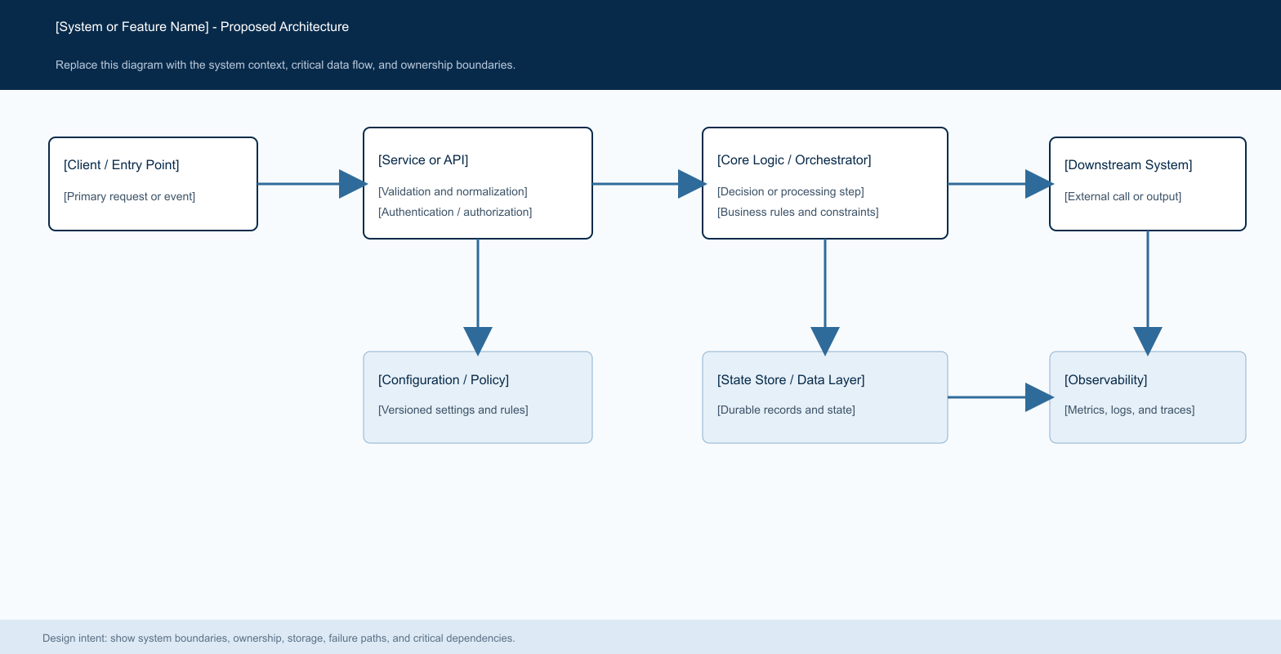
Figure 1. LUME architecture: Public Vite site -> tenant-scoped API boundary -> Supabase/R2; Admin Next.js -> trusted operations -> the same tenant-scoped stores.

Core components

Component | Responsibility | Primary storage | Failure behavior
Public Vite application | Renders public pages, inventory, visitor UI, and the visual experience. Sends bounded tenant-scoped API requests. | Vercel static delivery; R2 public media; public API | Show a localized UI error or safe media fallback; never fall back to another tenant's data.
Next.js admin and API application | Authenticates staff, resolves tenant context, validates input, owns protected writes and public API reads. | Supabase Auth, tenant_members, tenant settings/design, environment allowlists | Fail closed for identity, membership, write authorization, and unsafe configuration; degrade reads safely when optional services are unavailable.
Supabase data plane | Stores tenants, vehicles, pages, visitors, operational events, revisions, quotas, and integrations under RLS. | Postgres, Auth, Storage metadata, pgvector RPCs, RLS policies | Public reads return bounded errors; trusted mutations use idempotent RPC/transaction patterns when state and history must change together.
Cloudflare R2 and asset pipeline | Stores public media and tenant uploads; database rows retain validated keys and ownership metadata. | R2 public bucket plus tenant asset records and upload validation | Uploads fail without creating misleading references; published revisions retain old asset references for rollback.
Delivery and observability | Vercel deployment checks, analytics/speed insights, error capture, staging parity, and route-level health/readiness. | Vercel telemetry plus tenant-scoped operational/analytics ledgers | Current checks are strong at build and migration time; add explicit latency/error SLOs and synthetic tenant journeys before larger rollout.

5. Request Lifecycle
- A visitor request carries a resolved tenant via validated host, query, or header; an admin request carries an authenticated Supabase session and tenant route context.
- Normalize tenant once, origin-check public writes, validate typed payloads, resolve visitor sessions server-side, and require member role checks for admin actions.
- Load only the tenant record, role/session state, active design/configuration, and request-specific rows with explicit tenant filters.
- Read paths return small public projections; write paths apply a tenant-scoped state transition and return a typed result.
- Persist operational state and append-only history before noncritical emails, webhooks, analytics, or background delivery.
- External integrations are env-guarded and no-op safely when unprovisioned; retry only idempotent deliveries with bounded attempts and recorded outcomes.
- Return a minimal response, record trusted operational events where required, and emit error/usage signals outside the visitor-critical path.

6. API and Data Contracts

Primary data contract

Field | Type | Required | Description
field_name_1 | string | Yes | tenant_slug: canonical tenant routing identity; validate against the resolved active tenant.
field_name_2 | enum | Yes | actor_kind: visitor, authenticated member, or trusted system route; never trust a client-supplied privilege.
field_name_3 | UUID | Yes | schema_version: normalizes legacy tenant themes/designs to the Luxury template compatibility layer.
field_name_4 | UUID | Yes | tenant_id: mandatory relation on every tenant-owned record and explicit query filter.
field_name_5 | JSON document | No | design/event payload: retain only needed operational fields; do not load password hashes or session tokens into UI projections.
field_name_6 | asset key | No | asset_key: finite allowlisted slot with tenant ownership validation; resolve to a URL only at trusted display boundaries.
field_name_7 | idempotency key | No | idempotency_key: identifies a retryable external delivery or state transition and suppresses duplicate side effects.

Contract guarantees

- Tenant resolution and authorization precede every data access; operational state is durable before optional side effects.
- Use database-generated IDs and timestamps; state transitions that need history use a trusted transaction/RPC and return whether a change occurred.
- Record tenant_id, actor, action category, source record ID, design/template version, and delivery idempotency key when applicable.
- Current-state tables are the source of truth for present UI; append-only operational events describe history; consent-gated browser analytics is not operational truth.
The versioned schema or interface definition is published at
packages/db/src/schema.ts and the ordered supabase/migrations ledger; replace the hand-written mirror with generated types under a controlled workflow.

7. Consistency, Idempotency, and Replay

LUME should make current state and trusted history consistent for customer-impacting mutations, while allowing analytics, email, and webhooks to be eventually consistent. The visitor saved-vehicle history pattern is the model: repeated requests are harmless, cross-tenant/visitor attempts fail, and one successful state transition produces at most one operational event.
Scenario | Expected behavior | Reasoning
Repeated save/unsave or webhook delivery | Return the stable current state; create no duplicate current row or operational event. | Use unique constraints, transaction/RPC return flags, and delivery idempotency keys.
Database mutation or asset ownership validation fails | Return a typed failure; do not emit trusted history or downstream effects for an uncommitted mutation. | Prevents false Customer 360 history and leaves a route-level error signal for operators.
Email, CRM, domain, or webhook target fails | Keep core request success independent; record pending/failed delivery and retry through bounded workers when configured. | The primary transaction remains authoritative; delivery outcomes are separate, timestamped records.
Tenant design, bot, plan, or domain configuration changes | Use the resolved active revision/configuration for the request; publish creates a durable previous revision for restore. | Validate and persist a versioned document server-side; do not compose authority from mutable client state.

8. Security and Privacy Considerations

- Supabase Auth plus tenant_members roles gate admin access; public endpoints resolve an active tenant and use explicit projections; RLS is the backstop.
- Public and Customer 360 projections exclude password hashes, session tokens, and unrelated metadata. Browser bundles never receive service-role or LLM credentials.
- Server-only environment variables live in the admin/Vercel environment; public VITE variables contain only browser-safe configuration; R2 write credentials stay server-only.
- Migrations are additive and applied first to staging; production identity checks prevent cross-environment deploy/migration mistakes; unprovisioned integrations no-op safely.
- Tenant-scoped exports/deletion routes must remain authorized and auditable; design revisions and operational events need explicit retention policy before enterprise scale.

9. Operational Readiness
Signal | SLO or alert | Owner | Launch gate
Public API availability | Define a 99.9% monthly success target for list/detail/visitor-session reads. | Platform | Required
Inventory first-card path | Track p75 first cards and API TTFB by tenant; alert on sustained regression against staging baseline. | Public web | Required
Trusted mutation and external-delivery failures | Alert on mutation errors immediately; separate external delivery retry debt from visitor-facing errors. | Platform | Required
Environment/migration parity | Block promotion when deployment identity, migration ledger, or required flags do not match the target environment. | Release engineering | Required
Tenant-state reconciliation | Run a staging synthetic journey for public inventory, visitor save/unsave, admin asset update, and design publish/restore before promotion. | Platform | Recommended
Roll out tenant-sensitive changes through staging, keep default-off flags for risky routing/integrations, validate with a real demo tenant, and retain a rollback commit plus database revision restore path before main promotion.

10. Alternatives Considered

Alternative | Why it was considered | Why it was not selected
Merge public and admin into one Next.js application now | One framework and routing/deployment surface. | High-risk rewrite of a working cinematic/WebGL client; defer until the documented apps/web trigger.
Keep all business logic in the browser | Fast iteration for purely visual experiences. | Cannot safely hold secrets, enforce tenant writes, or provide durable operational audit.
Split each domain into a separate service | Independent scaling and isolated deploys in theory. | Adds distributed consistency, observability, and release complexity before the product needs it.
Use browser analytics as the Customer 360 source of truth | Simple event collection and reporting. | Consent, ad blockers, retries, and spoofing make analytics unsuitable for trusted customer history.

11. Open Questions
- What is the canonical public API deployment model after the next public-app move: proxy to admin Next.js, or a dedicated public API service? Document one contract and ownership model.
- When do tenant design revisions, visitor data, delivery events, and raw imports expire or become exportable/deletable? Define retention by plan and jurisdiction.
- What tenant and catalog scale triggers generated Supabase types, a durable shared cache, and the apps/web migration? Set explicit thresholds rather than reacting after drift.
- Who owns contract compatibility across migrations, packages/db, root Vercel functions, and the public client? Assign an API/schema steward.

12. Decision and Next Steps
Keep the current Vite + Next + Supabase + R2 architecture. Do not rewrite it. Tighten contracts and observability first, then perform the public-app move only when its trigger is met. The first rollout audience should remain the staging demo tenant; broaden only after schema/API parity, synthetic journeys, and rollback evidence are recorded.
Milestone | Deliverable | Exit criteria
M1 | Contract baseline | Publish canonical public API and tenant-resolution contracts; add generated-schema or CI drift check.
M2 | Operational evidence | Add tenant-aware SLO dashboards and staging synthetic journeys for public/admin critical flows.
M3 | Contract rollout | Ship contract hardening to selected tenants; observe zero cross-tenant findings and no critical-path regression for one release cycle.
M4 | Scale trigger | Move the public app only when second-tenant/custom-domain scale requires it and the migration checklist has passed.

Use footnotes for definitions, assumptions, or terms that need precision without interrupting the main narrative.

