- Location of WRF meteorological output

/E/dwen/model/output/original/china_lat-5.01lon81.43_lat33.23lon174.14-2013-feb

For example: WRF output for a period from 6:00AM Jan. 3 to 5:00AM Jan. 4, 2013

-- wrfout_d01_2013-02-03_06-04_05_new (output for domain 1)
-- wrfout_d02_2013-02-03_06-04_05_new (output for domain 2)
-- wrfout_d03_2013-02-03_06-04_05_new (output for domain 3)
-- wrfout_d04_2013-02-03_06-04_05_new (output for domain 4)

Each file contains 5 2-d variables, 55 3-d variables, 9 4-d variables and 48 times. Time interval is 30 minutes.

- Process WRF output
- Plot wind field at a specific height

Command:

ncl dm=1 'dir="/E/dwen/model/output/original/china_lat-5.01lon81.43_lat33.23lon174.14-2013-feb/"' ht=200.5 'dt="2013-02-04_12:30:00"' extract_wind_stream_field_h.ncl
ncl dm=1 'dir="/E/dwen/model/output/original/china_lat-5.01lon81.43_lat33.23lon174.14-2013-feb"' ht=200 'dt="2013-02-04_12:30:00"' extract_wind_stream_field_h.ncl

Parameters in the above command line

“dm” ----- specify which domain output will be used
"dir" ----- specify the location of meteorological data
“ht” ----- specify which height (m) output will be plotted
"dt" ----- specify the date and time where meteorological data will be processed and plotted
“extract_plot_wind_field_h.ncl” --- script file used to process and plot wind field

The plot generated is named like
"windfield2013-02-04_12:30:00_dm1-200.5m.png”
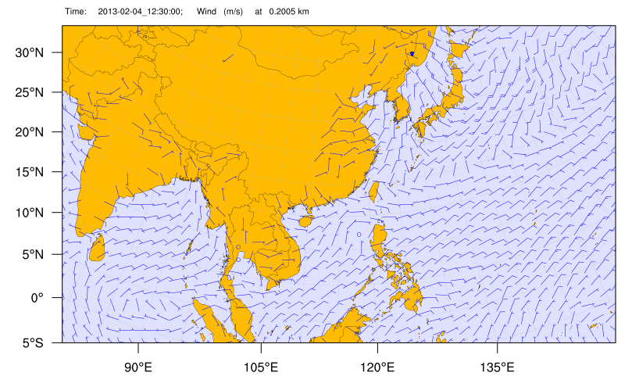

2) Extract wind speed at a specific point

Command:

ncl dm=1 'dir="/E/dwen/model/output/original/china_lat-5.01lon81.43_lat33.23lon174.14-2013-feb/"' agh=68.5 lat=25.294600 lon=121.580935 'st="2013-02-04_12:30:00"' 'et="2013-02-07_01:00:00"' extract_point_wind_timeseries.ncl

Parameters in this command line

“dm” ----- specify which domain output will be used
"dir" ----- specify the location of meteorological data
“agh” ----- specify above ground height (m) of the point to be processed
“lat” ----- specify latitude of the point (degree)
“lon” --- specify longitude of the point (degree)
"st" ----- specify the starting date and time of a duration where meteorological data will be processed and plotted
"et" ----- specify the end date and time of a duration where meteorological data will be processed and plotted
“extract_point_wind_timeseries.ncl” --- script used to process wind speed

The output file is name like “windspeed_dm1lat25.29lon121.58h68.50m2013-02-04_12:30:00-2013-02-07_01:00:00.txt”
A time series plot is also generated “windspeed_dm1lat25.29lon121.58h68.50m2013-02-04_12:30:00-2013-02-07_01:00:00.png”
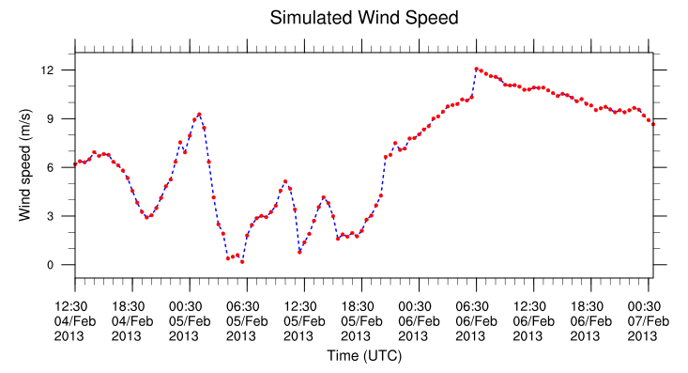

3) Plot WRF simulation domain

Command:

ncl 'dir="/E/dwen/model/output/original/china_lat-5.01lon81.43_lat33.23lon174.14-2013-feb/"' dm=1 wrf_map.ncl

Parameters in this command line

“dm” ----- specify which domain will be plotted
"dir" ----- specify the location of meteorological data
“wrf_map.ncl” --- script used to plot WRF domain

The map generated is named like
“WRF_map_dm1.png”

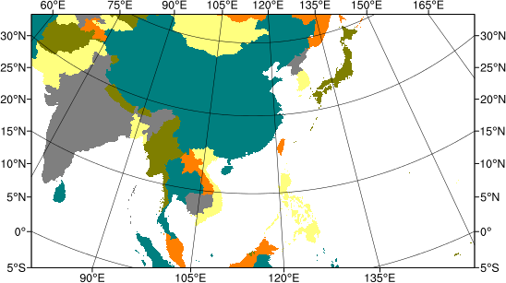

WRF domains setup

