1.The phishing sample I have used:

<https://caniphish.com/email-phishing-simulator?email=X-Copyright-Infringement#emailTitle>

2. spoofed email - [x@webnotifications[.]net](mailto:x@webnotifications[.]net)

The threat actor used X to make the victim trust them

3. the sample that I used doesn’t have an option to see the header, so I used one of my emails to use the online header analyzer.

<https://mxtoolbox.com/Public/Tools/EmailHeaders.aspx?huid=5ffd9922-6577-4dbf-9474-1aeae8e20584>

4.

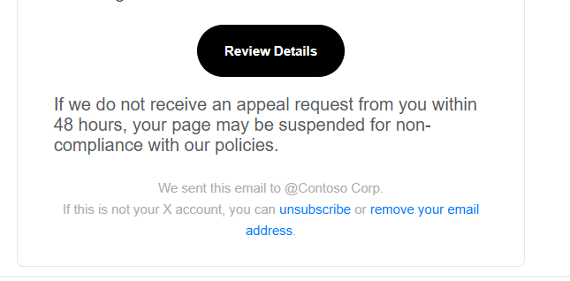

5.

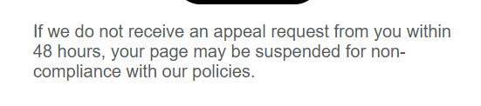

6. javascript:;window.parent.$(‘#webModal’).modal(‘show’);

7. grammatical error: “the reported material infringes on copyright laws”

8. Summary:

1. weird email

2. an urgent language

3. improper hyperlinks

4. grammatical errors