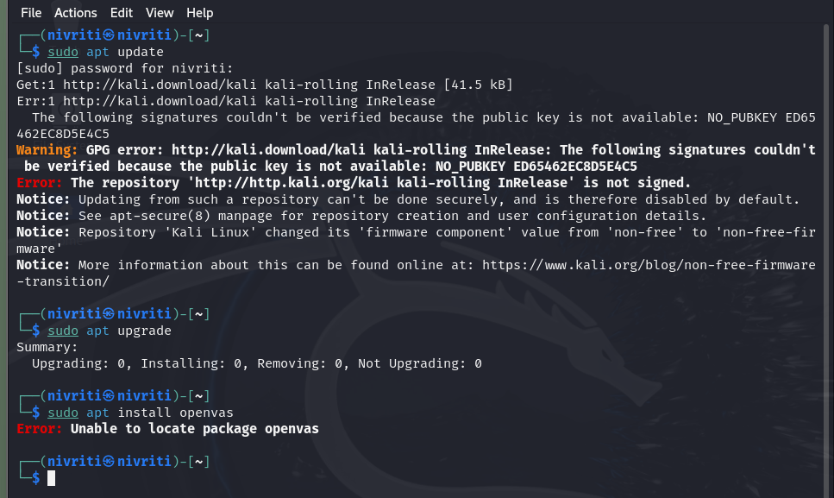

I was not able to install either of them but I have understood the process of scanning for the vulnerability.