TASK 4

Firewalls

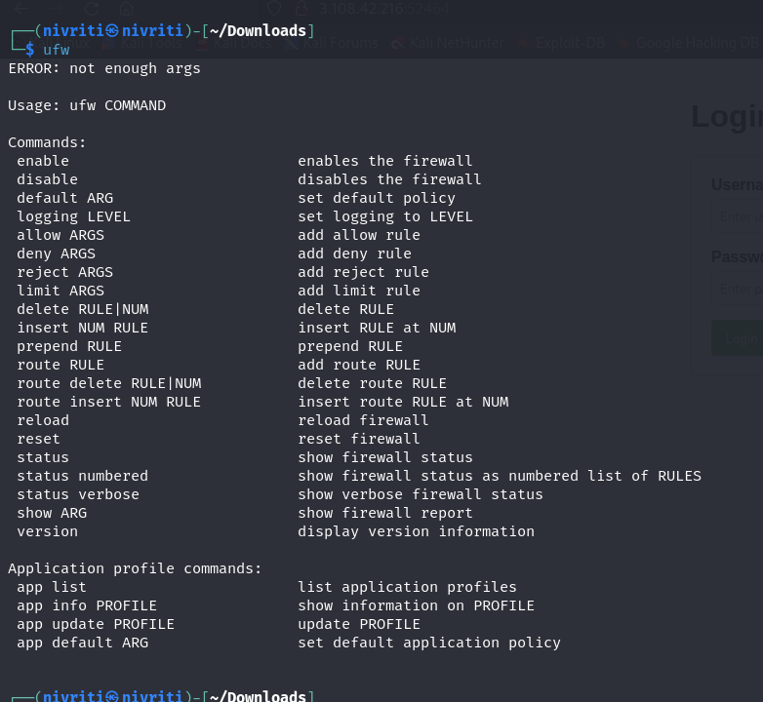

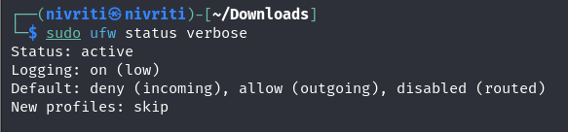

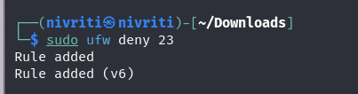

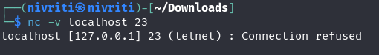

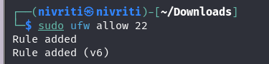

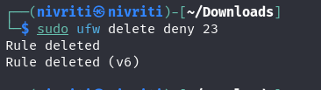

* A firewall filters network traffic by examining packets and comparing them against a set of rules. It allows or blocks traffic based on these rules.