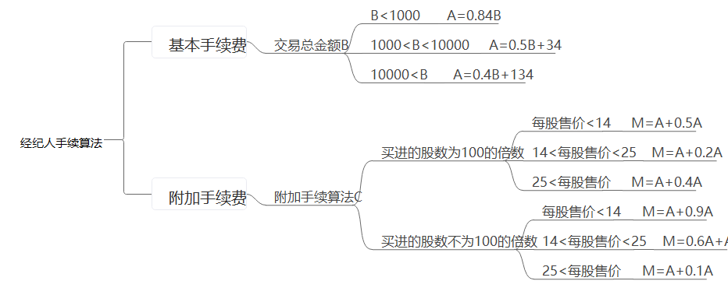

1：LOOP:DO WHILE Z>0
2: A=B+1
3: IF A>10
4: IF Y<5
5: THEN GOTO LOOP
6: ELSE C=3
7: G=H+R
8: END DO
9: IF F>0
10: STOP

