第6題:

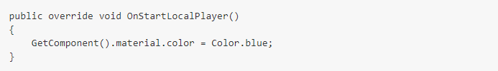

加入方法：OnStartLocalPlayer

輸入程式碼 GetComponent().material.color = Color.red [\\變紅色](file:///\\變紅色)

<https://github.com/young75715200/F410616637>