# 00_Windows_Subsystem_install

## 点击开始设置

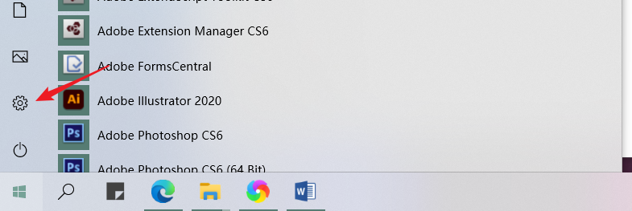

## 点击更新和安全

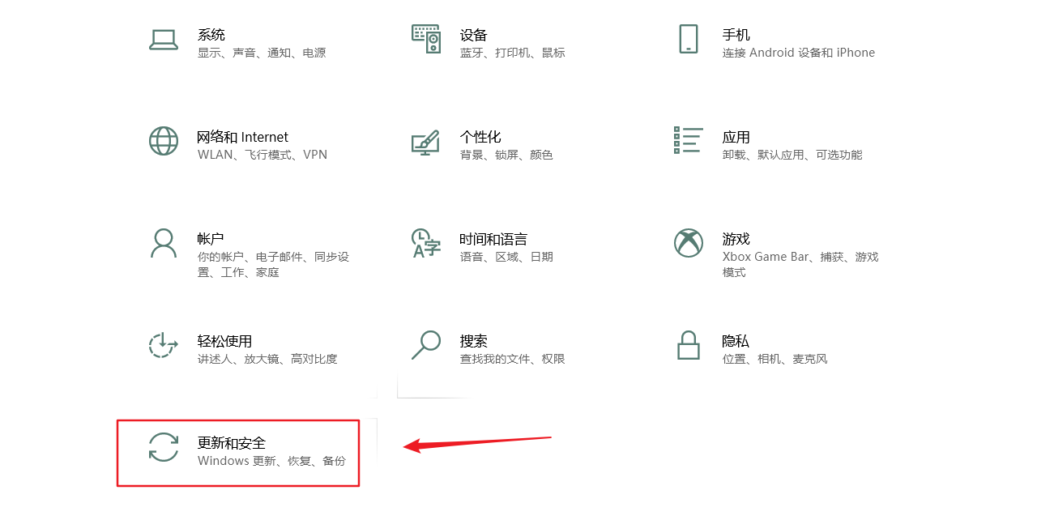

## 点击开发者选项，打开开发人员模式，弹出框中点击“是”

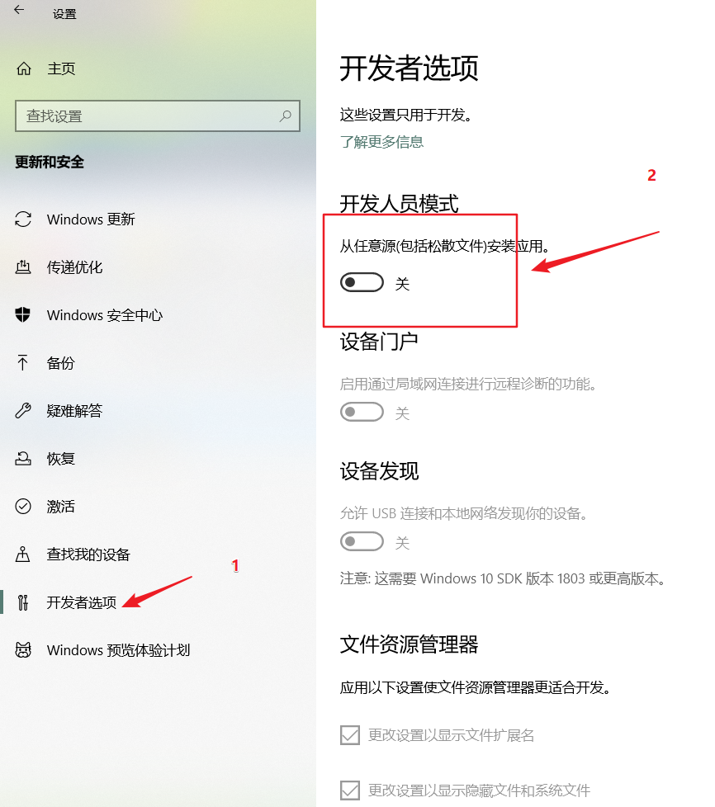

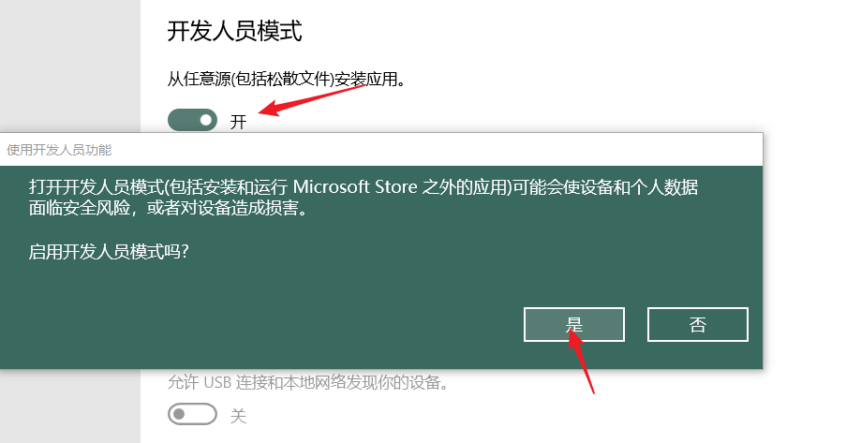

## 然后返回，点击应用

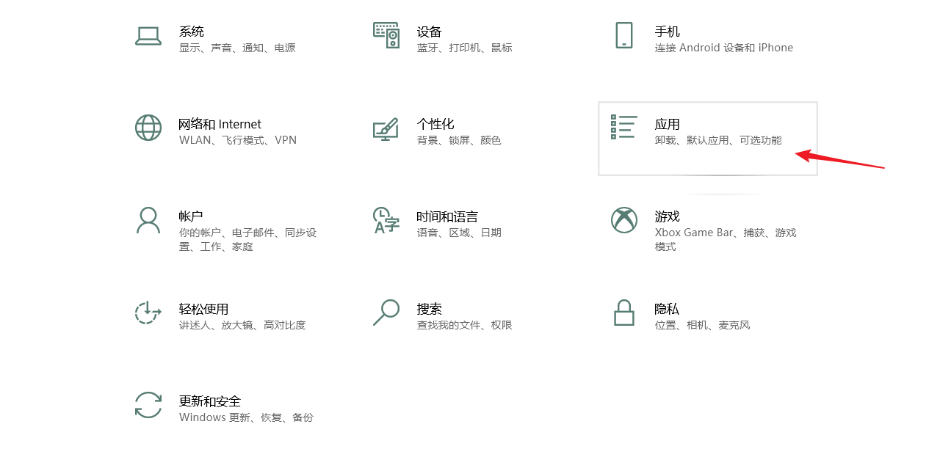

## 在应用和功能界面，选择程序和功能

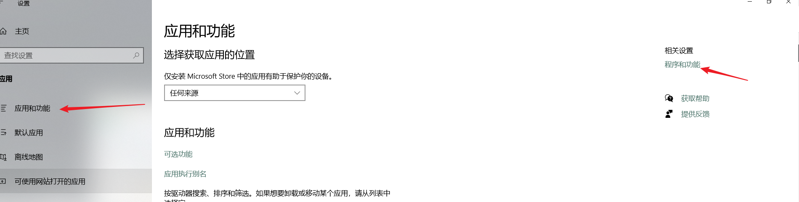

## 点击启用或关闭windows功能，弹出的窗口中拉到最下面，勾选上适用于Linux的Windows子系统

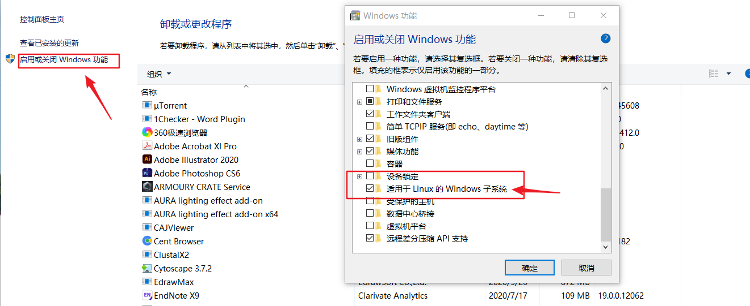

## 然后会自动安装所需要的库

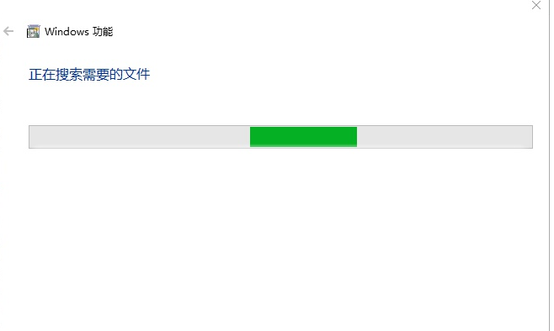

## 安装完毕后需要重启电脑，.重启电脑后并没有安装linux系统，还需要输入lxrun /install /y来进行系统的下载

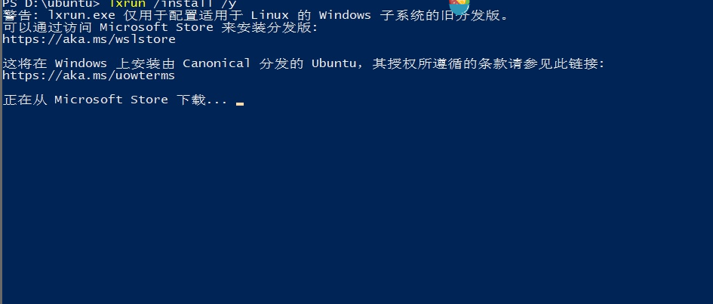

## 可以看到屏幕中显示可以通过访问windows应用商店来安装分发版，下面是一个url。在windows搜索框中输入该网址https://aka.ms/wslstore，然后回车。

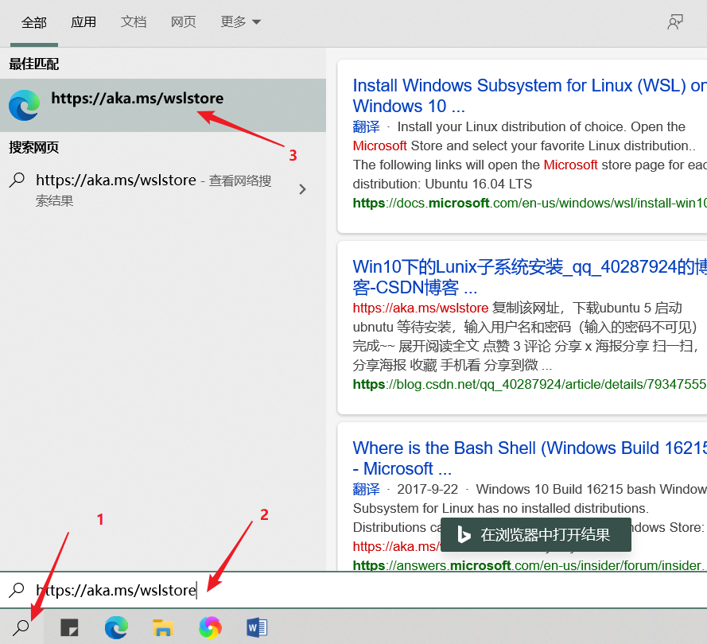

## 之后会先打开edge浏览器，然后自动跳转到win10应用商店

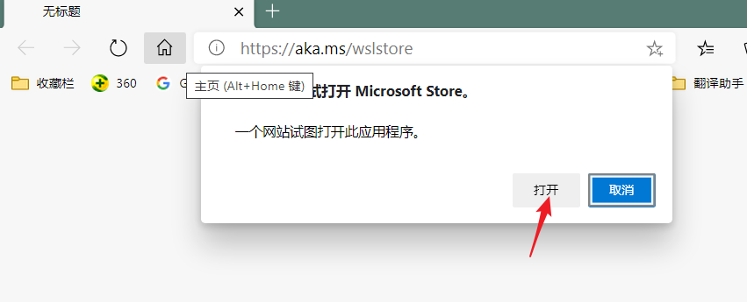

## 然后选择自己喜欢的linux版本，一般下载ubuntu

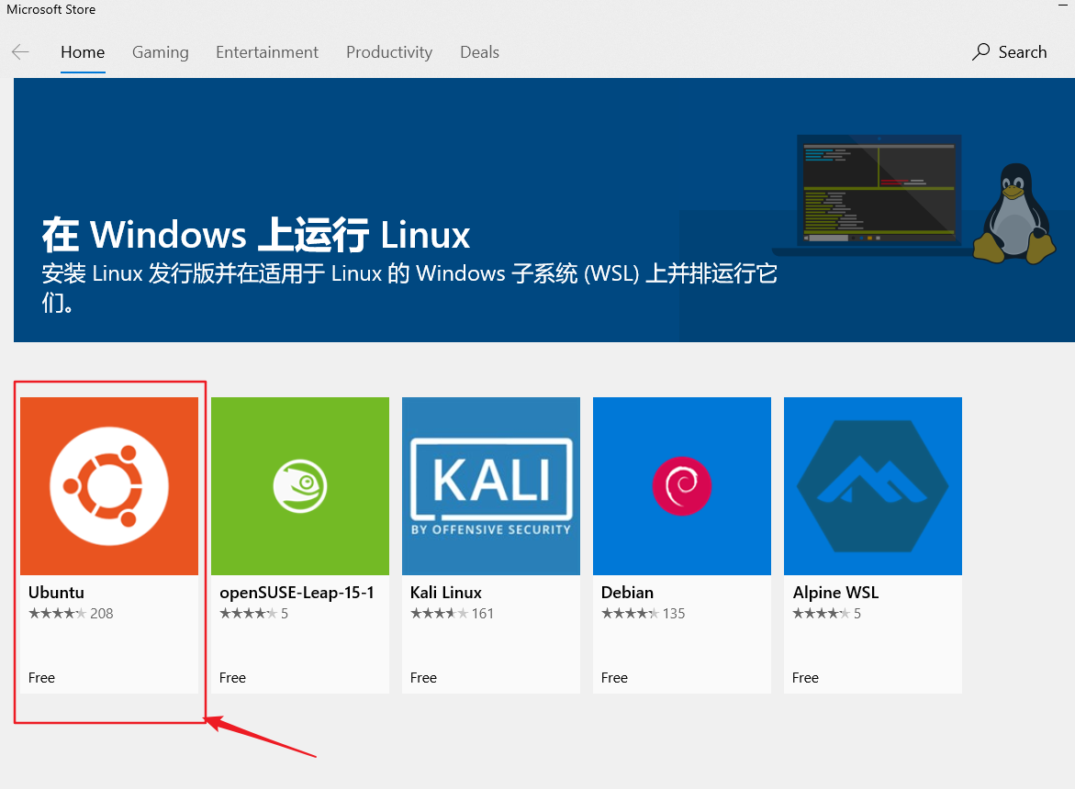

## 点击Iinstall 开始安装

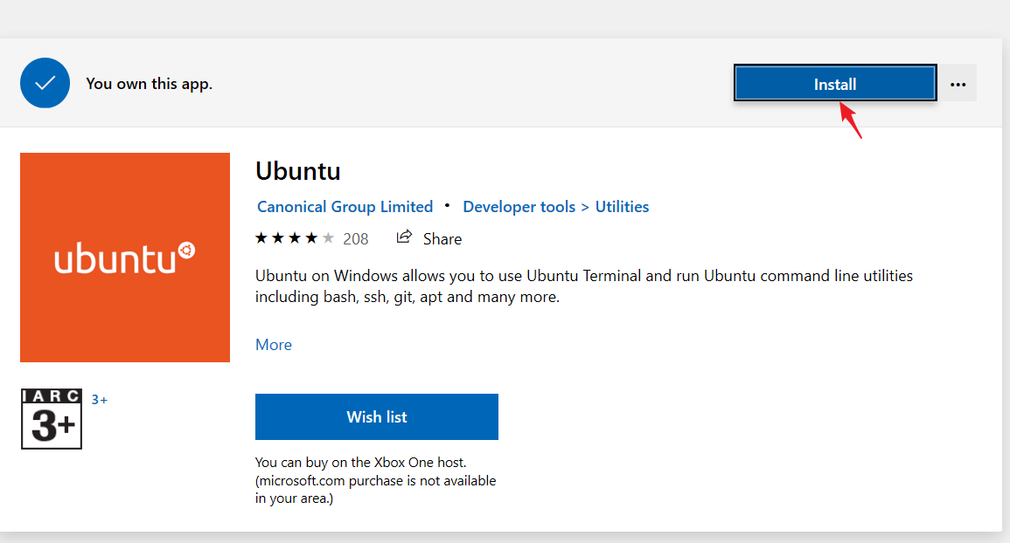

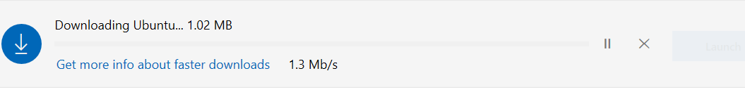

## 安装完毕点击launch打开ubuntu



## 出现安装页面需要几分钟时间等待一下

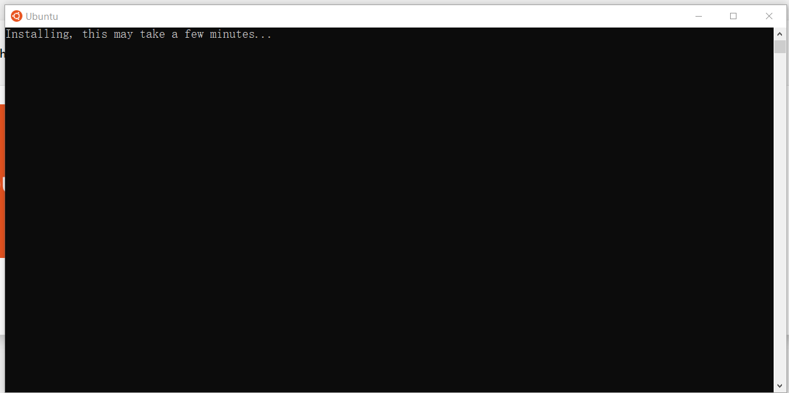

## 输入用户名，及密码 （重复密码）。

我输入的用户名是biotest

密码是123456

注意linux输入密码时不会显示字符

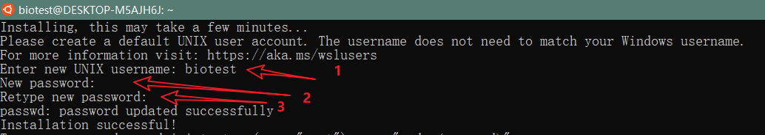

## 换源

### 查看Linux版本

lsb_release -a

### 备份数据源

sudo cp /etc/apt/sources.list /etc/apt/sources-backup.list

### 更换sources.list内容：

#阿里源

deb http://mirrors.aliyun.com/ubuntu/ bionic main restricted universe multiverse

deb http://mirrors.aliyun.com/ubuntu/ bionic-security main restricted universe multiverse

deb http://mirrors.aliyun.com/ubuntu/ bionic-updates main restricted universe multiverse

deb http://mirrors.aliyun.com/ubuntu/ bionic-proposed main restricted universe multiverse

deb http://mirrors.aliyun.com/ubuntu/ bionic-backports main restricted universe multiverse

deb-src http://mirrors.aliyun.com/ubuntu/ bionic main restricted universe multiverse

deb-src http://mirrors.aliyun.com/ubuntu/ bionic-security main restricted universe multiverse

deb-src http://mirrors.aliyun.com/ubuntu/ bionic-updates main restricted universe multiverse

deb-src http://mirrors.aliyun.com/ubuntu/ bionic-proposed main restricted universe multiverse

deb-src http://mirrors.aliyun.com/ubuntu/ bionic-backports main restricted universe multiverse

#163源

deb http://mirrors.163.com/ubuntu/ bionic main restricted universe multiverse

deb http://mirrors.163.com/ubuntu/ bionic-security main restricted universe multiverse

deb http://mirrors.163.com/ubuntu/ bionic-updates main restricted universe multiverse

deb http://mirrors.163.com/ubuntu/ bionic-proposed main restricted universe multiverse

deb http://mirrors.163.com/ubuntu/ bionic-backports main restricted universe multiverse

deb-src http://mirrors.163.com/ubuntu/ bionic main restricted universe multiverse

deb-src http://mirrors.163.com/ubuntu/ bionic-security main restricted universe multiverse

deb-src http://mirrors.163.com/ubuntu/ bionic-updates main restricted universe multiverse

deb-src http://mirrors.163.com/ubuntu/ bionic-proposed main restricted universe multiverse

deb-src http://mirrors.163.com/ubuntu/ bionic-backports main restricted universe multiverse

#中科大源

deb https://mirrors.ustc.edu.cn/ubuntu/ bionic main restricted universe multiverse

deb-src https://mirrors.ustc.edu.cn/ubuntu/ bionic main restricted universe multiverse

deb https://mirrors.ustc.edu.cn/ubuntu/ bionic-updates main restricted universe multiverse

deb-src https://mirrors.ustc.edu.cn/ubuntu/ bionic-updates main restricted universe multiverse

deb https://mirrors.ustc.edu.cn/ubuntu/ bionic-backports main restricted universe multiverse

deb-src https://mirrors.ustc.edu.cn/ubuntu/ bionic-backports main restricted universe multiverse

deb https://mirrors.ustc.edu.cn/ubuntu/ bionic-security main restricted universe multiverse

deb-src https://mirrors.ustc.edu.cn/ubuntu/ bionic-security main restricted universe multiverse

deb https://mirrors.ustc.edu.cn/ubuntu/ bionic-proposed main restricted universe multiverse

### 更新源

sudo apt-get update

sudo apt-get upgrade