# Homework7

Name Yu Yang Student ID 892449550

# 14.1

Each node in access lists represents an object’s domains and access rights.

While each node in capability lists represents a domain’s allowed access operations associated with objects.

# 14.10

Even the capability list is associated with a domain, but it is never directly

accessible to a process executing in that domain. Rather, the capability list is itself a protected object, maintained by the operating system and accessed by the user only indirectly.

# 14.15

The strength is the access rights is with the object itself, set we could remove or add access rights in the list conveniently.

The weakness is to check a domain’s access rights on the object, we need to iterate the whole list (in worst case), which is very expensive but need to be done every time we access the object.

# 14. 16

The strength is whenever an object is accessed, the system only needs to check the capabilities matches what are in the domain’s capabilities, this is much faster than the one associated with objects. And capability could be copy to other domains easily.

The weakness is the lack of control: it is more difficult when we want to remove or change the capabilities.

# 15.3

Salt is a random number which is generated by system and added to the password. The “salted” password is encrypted and stored with salt in a password file.

When system performs password check, the password provided by user is append with salt and encrypted, then compare with the stored one. Hacker couldn’t use a single password to compare with all the passwords encrypted simultaneously because salt are different for different users.

# 15.6

The COPS itself could be hacked and disabled.

Or itself could have security issues that could not be scanned.

To solve it, we could tighten the access to COPS, only system manager above certain level could get the COPS, and we could encrypt the COPS before store it on media.

# 15.9

Physical sites where computer systems are stored: human and physical

Network breach: human, OS and physical

Modem breach: human and physical

Malicious log in: OS and human

Backup media protection: human and physical

Programmers for the system: human

# 15.14

a. Use private key of the sender to encode message

b. Use public key of the receiver to encode message

c. Using both keys mention of a & b in encryption.

# VM

## Screenshot

### Fork bomb

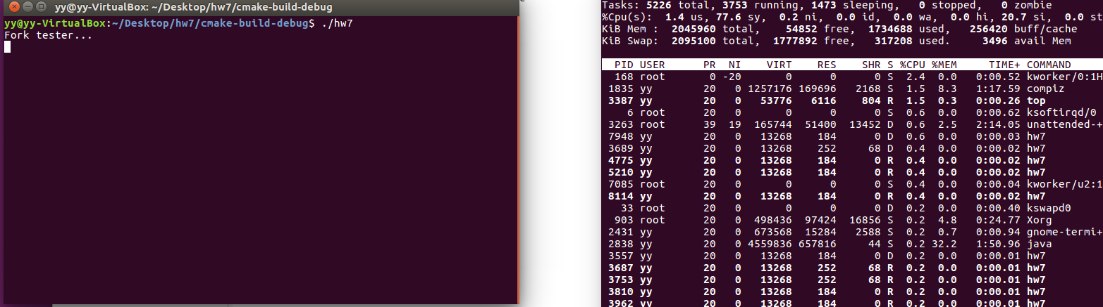

### Memory limit

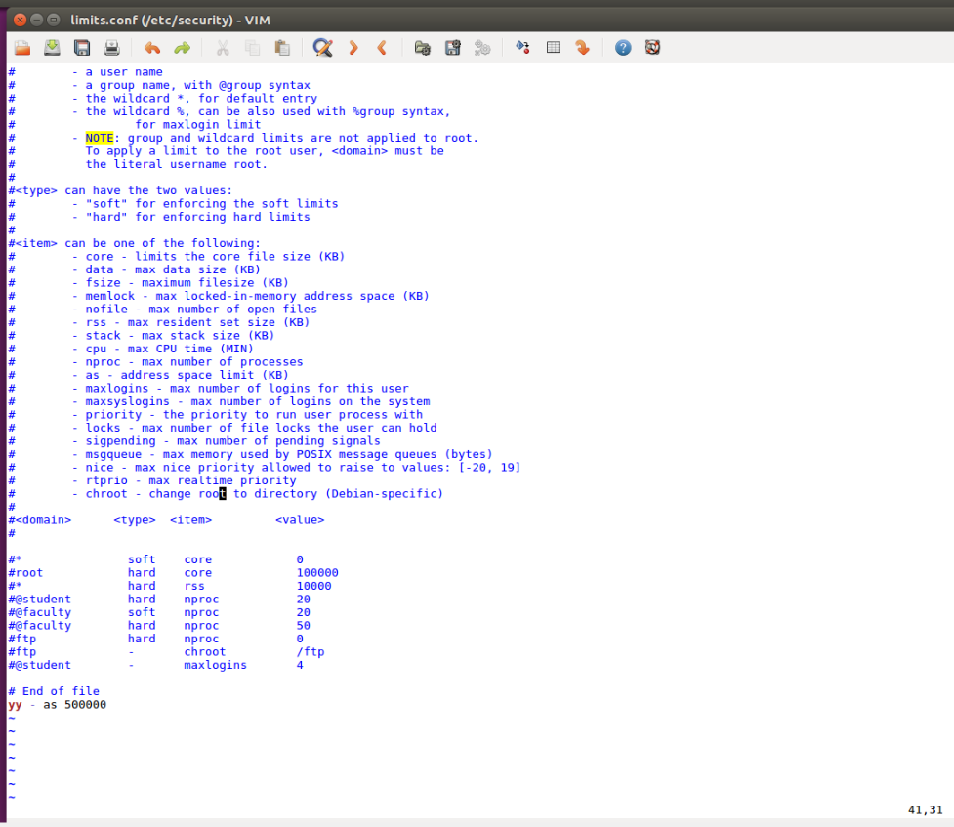

## Questions

### 1.

-p

Use pipe() instead of socketpair() for inter-process communication

-t

Use multi thread instead of multi process

-g

Specify the number of groups

### 2.

Without p, socketpair is used and test time increased.

Reason: pipes reger to buffering between virtual files, they don’t use packets which sockets ue. And sockets is based on IPv4 and IPv6. So sockets are more time-consuming.

### 3.

Without t, multi processes are used instead of threads and test time increased.

Reason: because a thread is only an entity in a thread and thread is light-weighted than process.