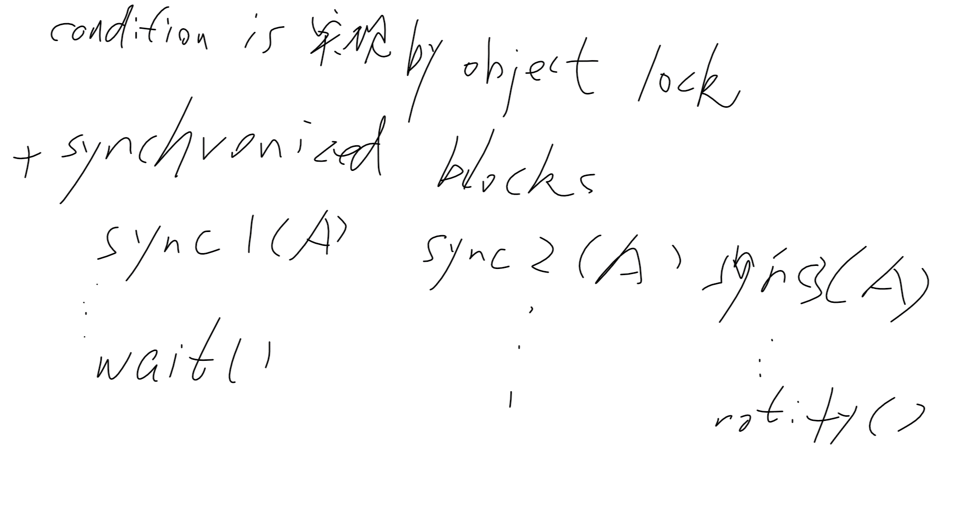

And code examples, sharedQueue.java

Notify = thos.notify()

When we need 2nd , q.wait(), q.notify()

Solution for deadlock in shared.java

For program2:

2 separate queue for consumer and producers, deque or enque notify another queue

How many condition room

Sync block

Waiting and notifying

For drd:

Package test;

Test/foo.java

Drd start guide read and use