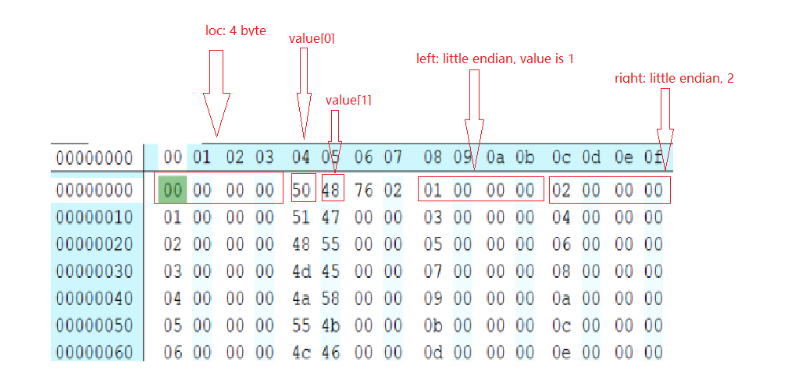

As the screenshot shows, C is using LSB. So the left child index of the first node: 01000000, is 00000001 in Big endian. Every node is padded into 16 bytes.