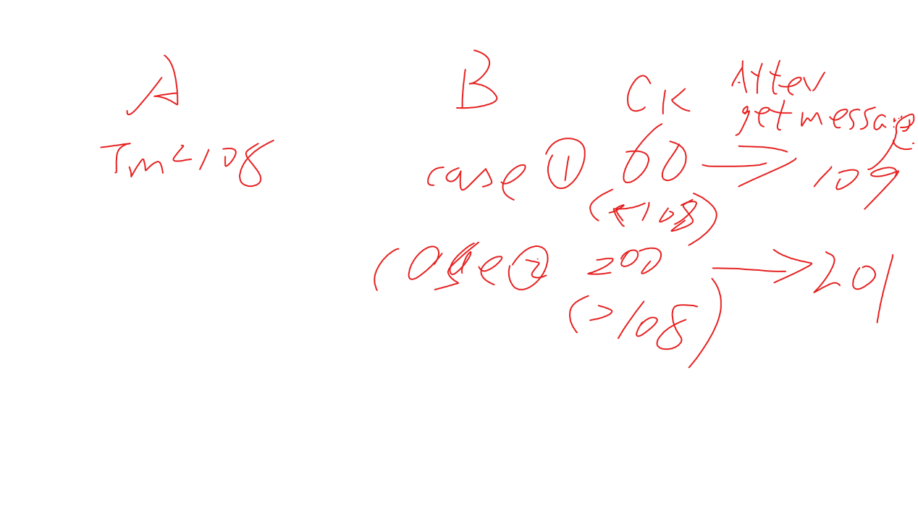

Every time receving message, advance clock even it will create holes