Capstone Models and Results Guide
A plain language walkthrough of the three slides, the A B C model roles, the queue aware approach, and the evidence we can claim
This guide starts from the database problem and works toward the slides. The main takeaway is careful: one older SF1 comparison favors simple latency baselines over the learned candidates, while the larger research question—whether a queue aware controller can improve the timing of Iceberg maintenance—still needs an accepted, matched evaluation.

The three points to keep in mind
1. Compaction can make later queries cheaper by changing the table layout, but the rewrite itself consumes resources and can interfere with current work.
2. Models A, B, and C answer different prediction questions. Their predictions are inputs to a decision rule; they do not make the schedule decision by themselves.
3. The current results do not establish that machine learning or the queue policy wins. They identify what the next valid experiment must measure.

A short explanation you can say aloud
“Our project studies when an Iceberg table should be compacted. Compaction can improve the layout for future queries, but it also uses resources while queries may already be waiting. We are building an external controller that considers both future query arrivals and the work already in the queue. The A/B models estimate query service time under observed maintenance states, and C forecasts future arrivals. We must also measure rewrite duration and layout change separately. The SF1 results show that simple query and layout medians slightly beat the learned latency candidates. That is a negative result for the current model comparison, not proof that scheduling cannot help. Our next step is to establish a repeatable timing effect on matched layouts, then compare queue aware decisions against strong simple policies.”
For a review process, first learn the queue and metric definitions, then rehearse the slide explanations. Use the final section to practice likely professor questions.

1 The project from scratch
Apache Iceberg stores a table as data files plus metadata that points to the files and their snapshots. As data is written over time, a table can end up with many small files or a layout that is less convenient for the queries being run. Compaction rewrites data into a different set of files and publishes a new table snapshot. A better layout can reduce the work needed by later scans, but creating it takes compute, I/O, and time.
That creates a timing problem. If a rewrite starts while queries are active, it may compete for resources. If it waits for a quieter period, it may avoid some interference—but the server may still have a backlog, and the rewrite may take longer than the quiet period. A forecast of fewer future arrivals does not by itself prove that the queue will drain.

The end to end pipeline
1. Observe the workload before the decision: when requests arrive, how much work is already waiting, what the table layout looks like, and what host resources are currently measured.
2. Estimate consequences: predict query service time under the observed maintenance condition, forecast future arrivals from past-only information, and measure rewrite duration and layout transition separately.
3. Compare a small set of actions: start a rewrite now, wait for a later decision point, or do no rewrite during the horizon.
4. Replay the full workload and audit every request, query result, maintenance task, snapshot, and telemetry record. Keep failed, refused, queued, and unattempted work visible.
5. Evaluate the complete outcome: time from arrival to result, work completed, waiting and service components, maintenance work, and the queue and layout left at the end.
A schedule is useful only if it improves the whole workload under a stated objective. A lower query prediction error alone is not evidence that the controller made a better decision.

What data represents
The project uses Snowset workload timing records to study arrivals. The original Snowset SQL mix and ingestion history are not available in the form needed here, so the physical query workload uses a custom set of six TPC H derived query templates. That benchmark mix is assigned by the experiment; it is not recovered from Snowset. TPC H scale factor 1 and 10 describe the size of the benchmark tables, not production clusters.
This distinction matters in a presentation: say “real arrival timing with a controlled TPC H derived query mix,” rather than saying that we replay the original Snowset SQL workload.

2 What models A B and C do
The letters refer to three candidate components in the current model plan. They are not three competing algorithms that all predict the same thing. A and B predict query service time in two observed client states. C predicts how many requests may arrive in a future interval.
Component | Question it answers | Prediction target and unit | What it does not establish
A | How long may a query take when the maintenance client has a request pending? | Query service time in milliseconds. | A pending request is not proof that Spark was actively rewriting at that exact moment, and the estimate is not a causal slowdown by itself.
B | How long may a query take when no maintenance request is pending, given the observed layout? | Query service time in milliseconds. | It is not a counterfactual for A unless layouts, queries, host state, and source blocks are comparable.
C | How many requests may arrive over a future interval, using past-only observations? | Arrival count per fixed time bin or forecast horizon. | Counts are not CPU utilization, service demand, or the original Snowset SQL mix.

The A/B distinction is an observed client condition. It does not mean A is “compaction on” and B is “compaction off” in a fully causal sense. Their predictions describe measured service times under available support. The design compares separate A/B estimators with a shared estimator that receives the observed maintenance state; either structure could be better, so it must be evaluated on held out whole episodes.
A separate estimate is needed for rewrite duration and the resulting layout change. We cannot infer the cost of compaction by subtracting A from B. Those targets have different meaning and units, and the query observations may not be matched.

Inputs the query models may use
Feature group | Examples from the registered SF10 candidate | Why it is available
Query structure | Query template ID and pre execution plan counts such as scans, joins, aggregates, exchanges, sorts, filters, and windows. | Known before that query runs; describes the work requested.
Table layout | File count, row count, and total data bytes for the relevant table. | Describes the state the optimizer or controller observes.
Decision and queue state | Whether the maintenance client has a request pending and the measured dispatch queue depth. | Represents current scheduling context.
Recent host state | CPU busy fraction, memory use, read rate, and write rate over 60 and 300 second windows. | Summarizes measurements that exist before the prediction decision.

3 The queue aware approach
Queue awareness is the part that turns prediction into a scheduling decision. A forecast only describes new requests expected to arrive. The current queue contains work that has already arrived and has not finished. A controller has to reason about both.

Follow one request through the system
Stage | Plain language meaning | Clock or quantity
Offered arrival | The workload makes a request available to the system. | Original arrival time.
Dispatch wait | The request waits behind earlier work before execution begins. | Dispatch time minus arrival time.
Service | The query executes and returns its result. | Execution/fetch completion minus dispatch or start, according to the recorded client boundary.
End to end response | The user waits from request arrival until the result is available. | Arrival to result; it includes queue waiting and query service.
Maintenance | A rewrite is submitted, runs, and changes the table’s physical layout. | Actual start, completion, resource observations, and before/after table state.

This is why a service time model can miss the scheduler’s largest opportunity. The controller may reduce waiting by changing which work starts when, even if each query’s service time hardly changes. The evaluation must measure both waiting and service, then total response time.

How the controller compares actions
1. It starts with only information available at that decision time: past arrivals, the live FIFO queue, measured host state, and the current table layout.
2. For each allowed action—start now, wait to a later opportunity, or no maintenance—it estimates how the queue may evolve as new requests arrive and completed queries leave.
3. It includes the rewrite’s own duration and resource use, and estimates how the post rewrite layout may affect later queries. These effects require evidence; the controller must not invent them.
4. It compares whole horizon outcomes and retains unfinished queue work and the final table state. A policy cannot appear better merely by pushing work past the measurement boundary.
The queue aware prototype includes FIFO request accounting, decision policies, recorded state replay, and physical episode auditing. It is a working research implementation, not an accepted finding that the policy improves performance. The queue package and the A/B/C model package are separate research tracks; the model package does not yet supply an accepted fitted scheduler bundle.

The registered policy outcome
The registered outcome sums arrival to result times for the full offered cohort. We also report waiting, service, completions, drain time, rewrite work, failures, residual queue, and final layout separately, avoiding arbitrary weights across incompatible units.

4 The metrics and how to read them

Mean absolute error for A and B
Prediction leakage: do not use the same query’s realized runtime, actual bytes scanned, or output cardinality as predictors; they are known only after the decision. With six fixed query templates, plan counts may simply identify the template, so a complexity claim needs richer SQL variation and held out query families.
Mean absolute error, or MAE, averages the absolute gap between a predicted query service time and the measured service time. Its unit is the same as the target: milliseconds here. Lower MAE means the predictions were closer on average in that evaluated sample. An MAE of 20 milliseconds does not mean the query ran in 20 milliseconds; it means the average prediction miss was 20 milliseconds.
The slide says “equal episode mean absolute error.” The evaluation first scores each episode, then gives every episode equal weight in the final mean. This avoids letting a longer episode dominate just because it contains more query rows. It does not make dependent episodes independent, and one reserved source family is still a narrow test.

Count error for C
For an arrival forecast, MAE and root mean squared error (RMSE) are measured in requests per forecast bin. MAE is the average absolute count miss. RMSE penalizes occasional large misses more strongly because it squares errors before averaging. Neither metric directly measures CPU, I/O, query service, or policy benefit.
Target | Useful model checks | What a small error cannot prove
A/B query service time | Equal episode MAE in ms, error by query/layout/state, and prediction coverage on supported contexts. | That compaction caused the latency difference, or that the scheduler reduced end to end response time.
C offered arrivals | Count MAE/RMSE by horizon, against persistence and seasonal baselines; coverage if intervals are used. | That the server will be quiet, that the queue will drain, or that compaction should start.
Rewrite consequence | Measured rewrite duration, actual work/resources, and verified before/after layout. | A general rewrite cost model if there are only a few layouts or one source family.
Queue policy | Whole cohort response time, waiting and service, completions, drain time, unfinished queue, maintenance debt, and final layout. | A robust policy win from prediction MAE alone or from dropping unfinished requests.

Prediction accuracy is not a policy score
A model can predict service time well but still recommend the wrong action. The scheduler must use predictions to compare actions over time. Conversely, a simple median or fixed rule can make a good decision even if a learned prediction looks sophisticated. That is why the project compares learned models with simple baselines and judges the final controller on full workload outcomes.

5 Slide one results so far
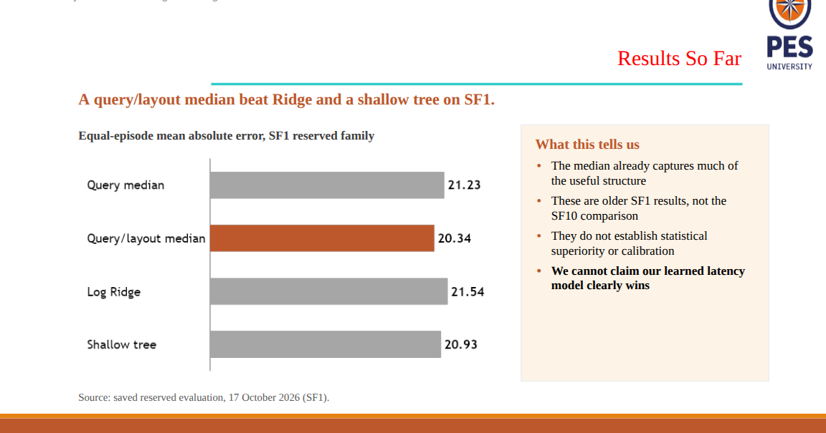
Original slide 1 SF1 reserved evaluation dated 17 October 2026
The chart compares four ways to predict query service time on one reserved SF1 evaluation family. The horizontal bars show equal episode MAE in milliseconds. Shorter is better because it means a smaller average miss between the model prediction and the measured service time.
Method on the slide | MAE | How to explain it
Query median | 21.23 ms | For each query identity, use its historical median service time as the prediction.
Query/layout median | 20.34 ms | Use a median for the query and its observed layout condition. This is the lowest error in this result.
Log Ridge | 21.54 ms | A regularized linear model trained on a logarithmic service time target. Its error is higher than both median baselines here.
Shallow tree | 20.93 ms | A small decision tree that can split into simple groups. It is also slightly less accurate than the query/layout median here.

The query/layout median misses by about 1.20 ms less than Log Ridge and 0.59 ms less than the shallow tree in this comparison. It also misses by about 0.89 ms less than the query median. These are differences in prediction error, not query speedups.
What this result supports: on this older reserved SF1 family, the query/layout median was the strongest of the four listed predictors. The simple baseline already captures much of the structure available in this sample.
What it does not support: a claim of statistical superiority, calibration, better compaction timing, better queue outcomes, or a learned latency model winning. The saved result is explicitly uncalibrated, model acceptance is false, and scheduler authorization is false. It is not the SF10 comparison.

6 Slide two why the learned models show no edge yet
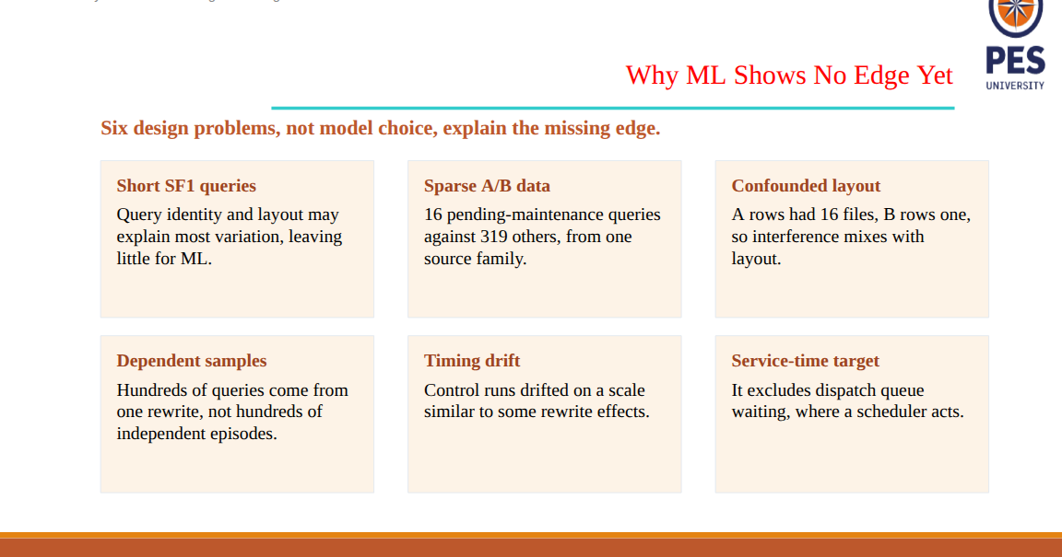
Original slide 2 six design limits in the earlier SF1 comparison
This slide is explaining why the current dataset and experiment design make a learned advantage hard to demonstrate. These are limits of the evidence, not proof that machine learning can never help.
Issue | In plain language | Why it matters and what a stronger study needs
Short SF1 queries | The early benchmark queries finish quickly, so there may be little extra timing signal beyond which query ran and what layout it scanned. | The model may have little stable variation to learn. Use richer query work and enough independent episodes before claiming generalization.
Sparse A/B observations | The earlier candidate set had 16 queries with pending maintenance and 319 without, all from one source family. | The A condition has very little support. More rows from the same family do not replace independent source blocks.
Confounded layout | The earlier A rows used a 16 file layout while B rows used one file. | Maintenance state and layout change together, so a latency difference cannot be attributed to maintenance. Compare matched layouts or a controlled layout matrix.
Dependent samples | Many query rows came from the same rewrite episode. | Queries from one rewrite share the same host, cache, layout, and timing conditions. Split and reason at the independent episode or source family level.
Timing drift | Control timing changed by an amount comparable to some rewrite contrasts. | Cache warming, background work, or machine drift can look like a maintenance effect. Use matched time blocks, counterbalanced order, and real control observations.
Service time target | The query models start measuring after dispatch; they exclude time waiting in the scheduler queue. | A scheduler may mostly help by reducing waiting. Evaluate arrival to result and report wait and service separately.

7 Slide three revised research status and next gate
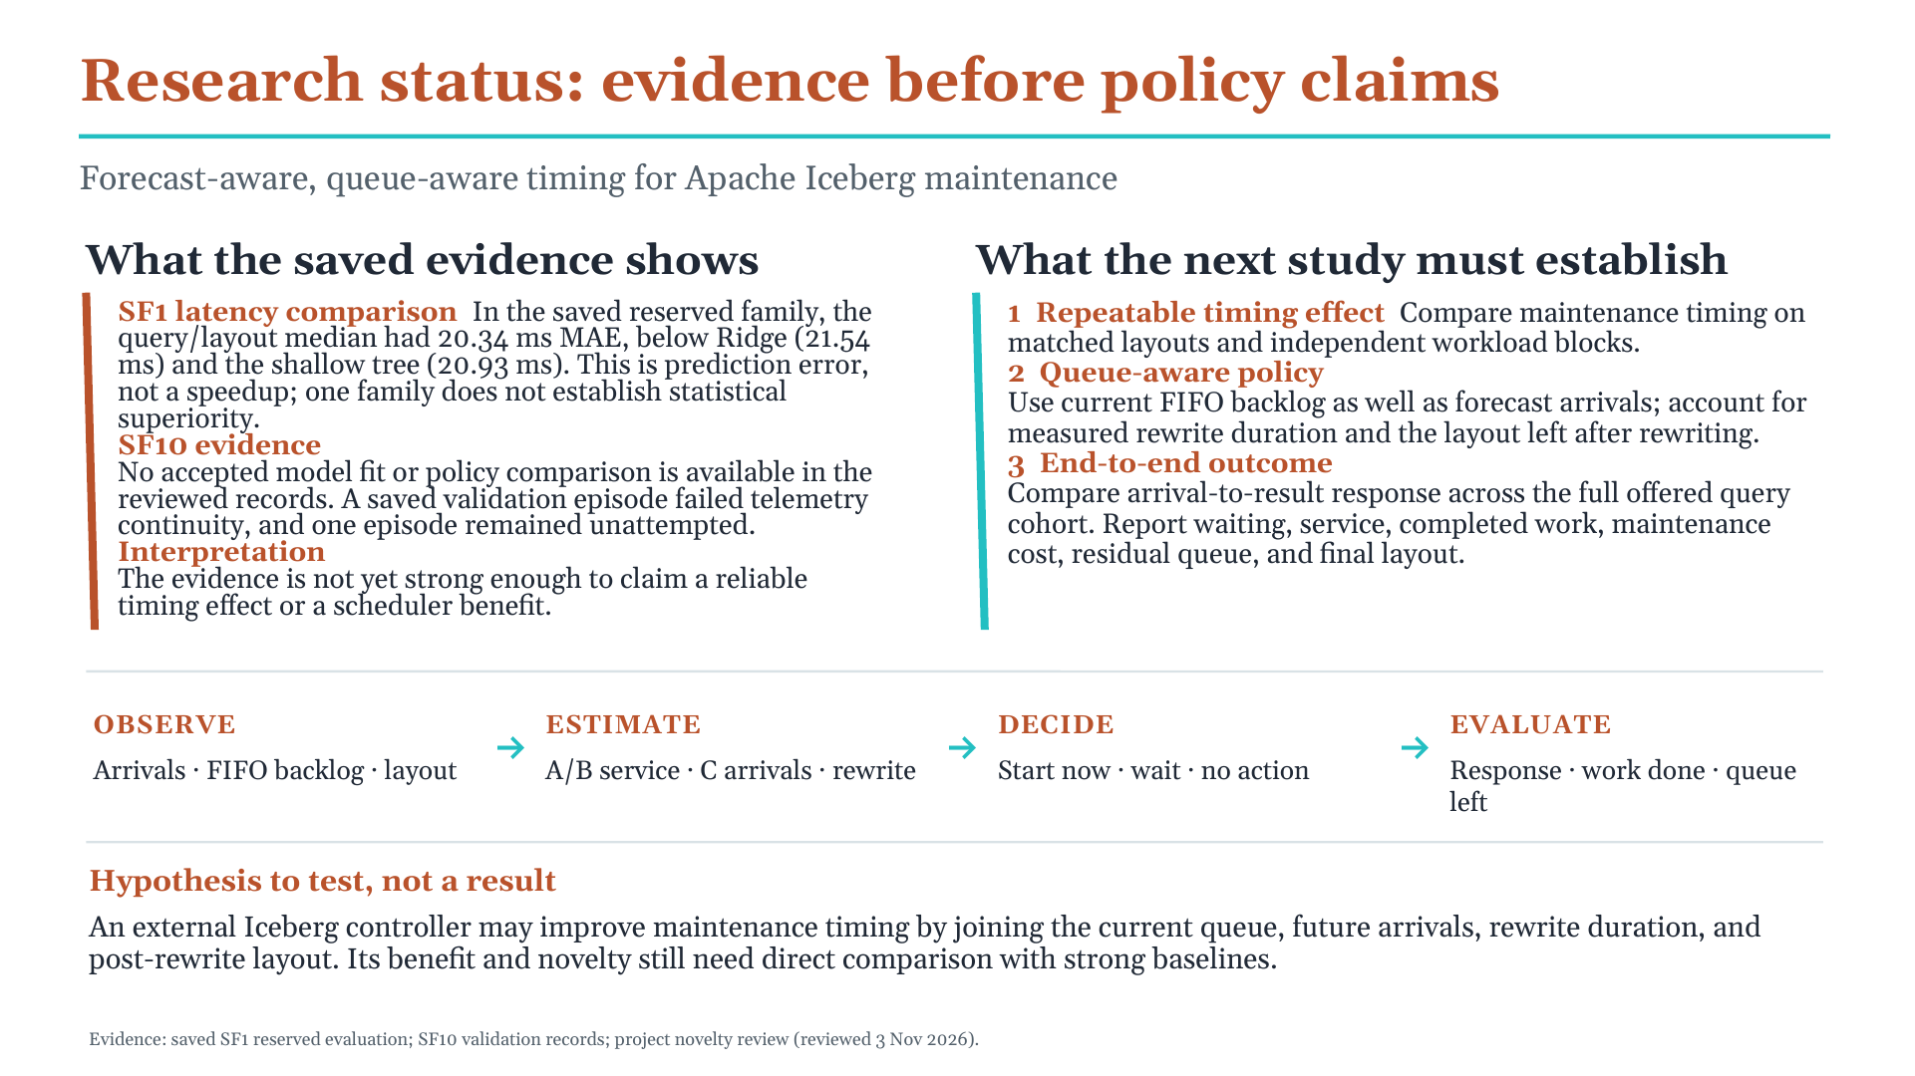
Revised research status slide editable PowerPoint supplied separately
Slide element | What it communicates
Measure the present | Use past arrival history, the live dispatch backlog, actual table layout, and observed host state. A forecast is not a substitute for queue state.
Estimate consequences | A and B predict query service time by observed client maintenance state. C forecasts arrival counts. Rewrite duration and post rewrite layout change are separate measured quantities.
Compare actions | Compare starting now, waiting, or doing no maintenance. Count waiting plus service and rewrite work, then retain the queue and table layout left at the horizon.
Evidence reviewed | The SF1 result favors the query/layout median over the listed learned latency candidates. No accepted SF10 model or policy comparison is supported by the saved evidence reviewed for the slide.
Next research gate | Repeat timing comparisons on matched layouts and independent source blocks. Then compare a queue aware policy with strong simple rules using full workload outcomes.
Potential contribution | Test whether an external Iceberg controller that combines backlog, rewrite duration, and post rewrite layout improves timing. This is a hypothesis, not a novelty claim.

8 The earlier arrival forecast diagnostic
The first slide does not show Model C, but an earlier diagnostic compared a past only Poisson count forecaster with a daily seasonal baseline on one selected warehouse trace. Its errors are request counts per bin, not milliseconds and not CPU percentages.
Forecast horizon | Poisson count MAE | Daily baseline MAE | Meaning
1 minute | 7.01 requests | 8.52 requests | Across held out 1 minute bins, the forecast missed the count by about seven requests on average.
5 minutes | 18.18 requests | 24.38 requests | Across held out 5 minute bins, its mean absolute count miss was about eighteen requests.
10 minutes | 30.55 requests | 40.44 requests | Across held out 10 minute bins, its mean absolute count miss was about thirty requests.

Within that diagnostic, the Poisson point forecast had lower MAE than the daily baseline at each listed horizon. The scope was one warehouse, three reserved test days, and overlapping forecast horizons. The result does not establish uncertainty calibration, broad trace generalization, server load prediction, an accepted Model C, or scheduling benefit. The A/B query latency comparison and the C count forecast answer different questions and their MAE numbers cannot be compared to each other.

9 Research direction and what must be proven
The goal is not simply to place three models on a diagram. The scientific question is whether information about future demand and current queue state can help choose when an Iceberg rewrite should start, after measuring its duration, resource use, and resulting layout.

Why the novelty claim must stay narrow
The project novelty review found that quiet time scheduling, forecast driven planning, interference aware optimization, and dynamic compaction already appear in prior systems. AutoComp discusses scheduling compactions in predictable off peak periods. NoisePage and SOPHIA combine forecasts with cost or interference models and planning. ArceKV studies workload dependent compaction across time. Therefore “we forecast the next quiet period,” “we use three models,” or “we are queue aware” is not enough by itself to establish an A star contribution.
A possible direction to test is an external Iceberg controller whose decision explicitly joins live FIFO backlog, measured rewrite duration, and the query consequences of the post rewrite layout, using a complete arrival to result objective and preserving terminal queue debt. This is a candidate distinction, not a verified literature gap or proven algorithmic contribution. It needs a direct baseline comparison and a complete literature review.

Next research gates
1. Close the SF10 evidence audit using the saved raw receipts. Preserve all failed and unattempted counts. Do not fit from a partial or telemetry invalid episode.
2. Freeze the whole horizon objective and the comparison policies before inspecting new outcomes. Include no maintenance, a simple current queue rule, a quiet window rule, and an honestly described forecast plus planning baseline.
3. First test whether timing creates repeatable headroom at all. Compare registered start times on matched layouts and independent source blocks, with natural arrivals and full queue completion accounting.
4. If headroom exists, evaluate the queue aware policy on untouched workload blocks. Report model accuracy and coverage, queue wait, service time, complete response, completed work, remaining debt, rewrite cost, and failures.
5. Use ablations to show whether future arrivals, current backlog, rewrite estimates, or post rewrite layout add value. Keep future information as an oracle diagnostic only, never a runtime input.
6. Update the novelty review against primary sources. If no reproducible timing advantage or distinctive mechanism survives, narrow the claim rather than tuning toward the desired conclusion.
The project’s high venue aspiration should make these gates stricter, not encourage overclaiming. A publication worthy contribution must show a clear mechanism, a defensible comparison, independent evidence, and a result that matters to actual workload outcomes.

10 Professor questions you can answer clearly
What exactly does compaction do?
It rewrites table files and publishes a new layout snapshot. This may help later scans, but the rewrite consumes resources and can interfere with work already running.
Why use three models?
A and B estimate query service time in two observed maintenance states; C forecasts future arrival counts. They cover separate inputs to a possible decision. The three model split is a candidate design, not the contribution itself.
Does A minus B prove compaction slows queries?
No. A and B observations can differ in layout, timing, query mix, and host state. A causal statement needs matched, controlled physical episodes and complete evidence.
Did machine learning beat the baselines?
Not in the saved SF1 reserved family shown. The query/layout median had 20.34 ms MAE, below Ridge at 21.54 ms and the shallow tree at 20.93 ms. The sample is limited and does not establish a universal result.
Does Model C predict load?
It predicts request counts. It does not directly predict CPU or whether the server will be free, because existing backlog and query service demands also matter.
What does queue aware mean here?
The controller accounts for requests already waiting as well as future arrivals. It compares start now, wait, or no maintenance while measuring arrival to result time and retaining unfinished work at the horizon.
What is the strongest current limitation?
We do not yet have an accepted, independent SF10 policy comparison. The current saved SF10 validation evidence includes a telemetry continuity failure, so no model was fitted from that episode.
What could make this novel?
A measured, Iceberg specific start time decision that combines backlog, rewrite duration and the post rewrite layout, and improves whole workload outcomes beyond strong baselines. That benefit and novelty still need proof.

What we can claim today
- The SF1 reserved family shows lower query service time prediction MAE for the query/layout median than for the listed Ridge and shallow tree candidates.
- An earlier arrival count diagnostic had lower point forecast MAE than a daily baseline on one warehouse, but it did not test server load or scheduling value.
- The project has a queue aware implementation and audited evaluation code, but the code does not establish performance benefit, independent generalization, or novelty.
- A telemetry invalid SF10 attempt is preserved as a failure and is not model training evidence. The accepted evidence set still needs a complete SF10 comparison.

Evidence references
This guide separates slide content from the project records used to interpret it. Saved artifact evidence was reviewed locally; this document does not claim a live run or accepted remote status.
- Original slide screenshots supplied with the request: SF1 results, ML limitations, and October 27 project status.
- `results/consistent_reserved_evaluation_20261017/result.json` and its registration: one reserved SF1 family, uncalibrated status, primary query/layout median, model acceptance false, scheduler authorization false.
- `docs/novelty_comparison_2026-10-17.md`: prior art review, candidate research hypothesis, and minimum evidence gates.
- `three_model_maintenance/README.md` and `docs/learned_cost_model_implementation_plan.md`: A/B/C definitions, candidate status, training and validation requirements.
- `docs/arrival_forecast_diagnostic_review_2026-10-14.json`: historical arrival count MAE values and diagnostic limitations for C-like forecasting.
- `queue_aware_maintenance/README.md`, `queue_aware_maintenance/docs/guides/IMPLEMENTATION_WALKTHROUGH_2026-10-21.md`, and `queue_aware_maintenance/docs/plans/STUDY_PLAN.md`: controller flow, FIFO accounting, end to end response objective, and study limits.
- `results/sf10_archive_validation_20261101_02/result.json`, `progress.json`, and the corresponding no maintenance log: 0 passed, 1 failed, 1 unattempted; no model fit; telemetry sampling gap.

