Name: Shashank Keshava Murthy
SRN: PES1UG24CS434
SEC: 5 H
problem Statement: #6

1. CREATED bug report project
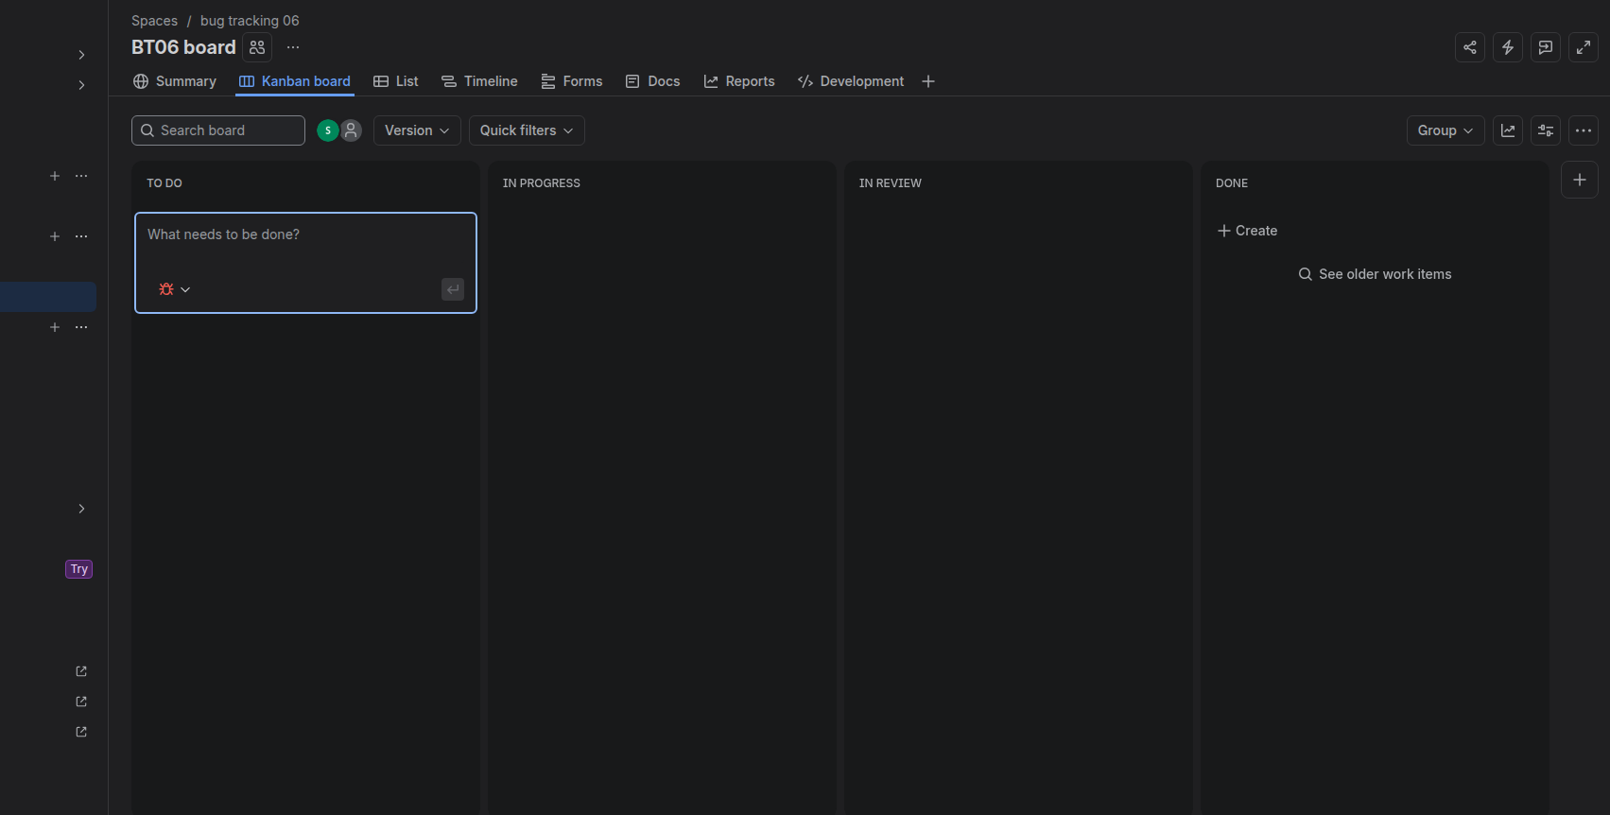
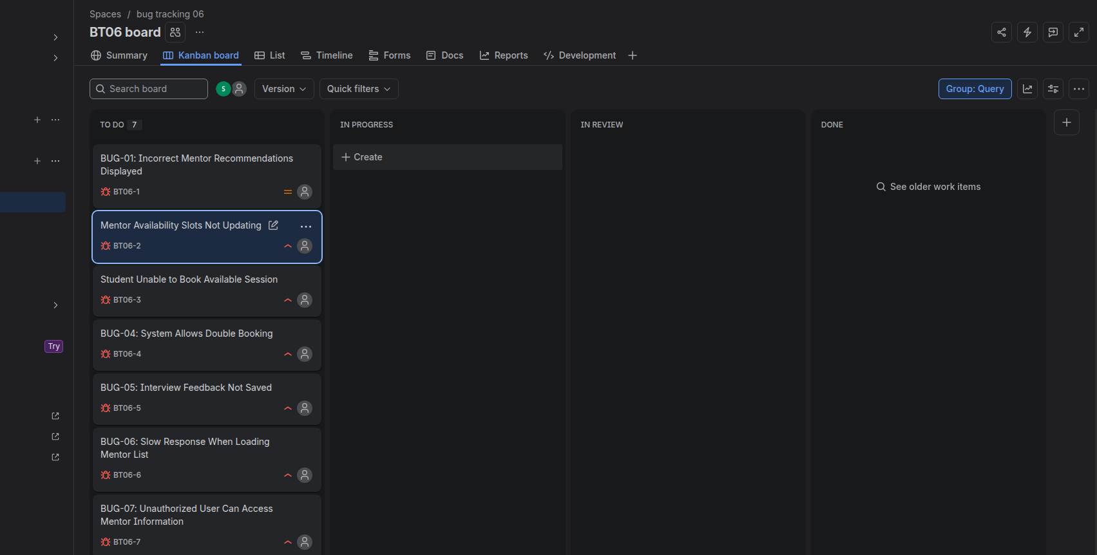
2. Created Bugs

Bug ID | Bug Summary | Description
BUG-01 | Incorrect Mentor Recommendations Displayed | The system displays incorrect or unsuitable mentor recommendations to students. The recommended mentors may not match the student's requirements, interests, or selected criteria.
BUG-02 | Mentor Availability Slots Not Updating | Changes made by a mentor to their available time slots are not properly updated or reflected in the system, causing students to see incorrect availability information.
BUG-03 | Student Unable to Book Available Session | A student is unable to successfully book a mentoring session even when the selected mentor has an available time slot displayed in the system.
BUG-04 | System Allows Double Booking | The system allows more than one student to book the same mentor for the same time slot, resulting in scheduling conflicts and double bookings.
BUG-05 | Interview Feedback Not Saved | Feedback submitted after an interview is not saved correctly in the system, causing the submitted evaluation or feedback information to be lost.
BUG-06 | Slow Response When Loading Mentor List | The system takes an unusually long time to load and display the list of available mentors, negatively affecting system performance and user experience.
BUG-07 | Unauthorized User Can Access Mentor Information | Users without proper authorization are able to access mentor information that should be restricted, creating a privacy and security issue.

