NAME: SHASHANK KESHAVA MURTHY
SRN: PES1UG24CS434
SEC: 5H
problem statement : 6

1. 5 Frs and 2 NFRs
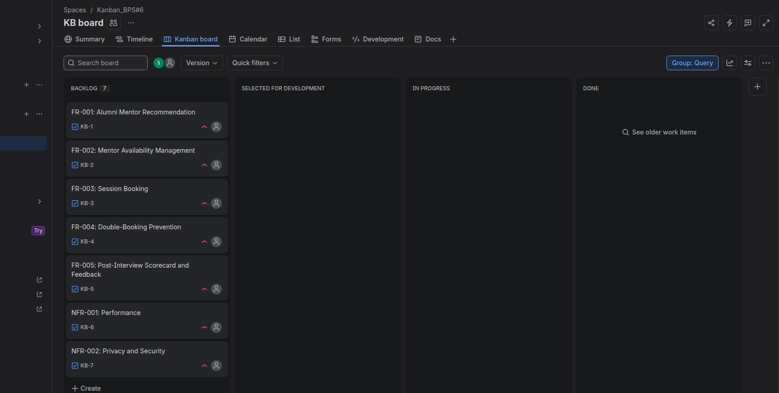
2.Epics created
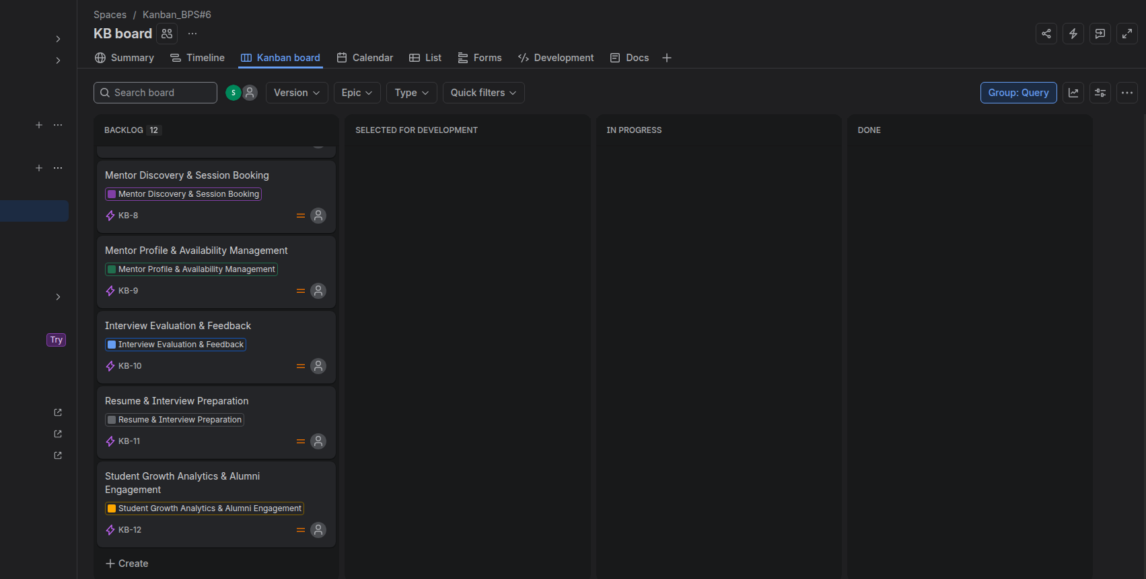
3. Epics mapped
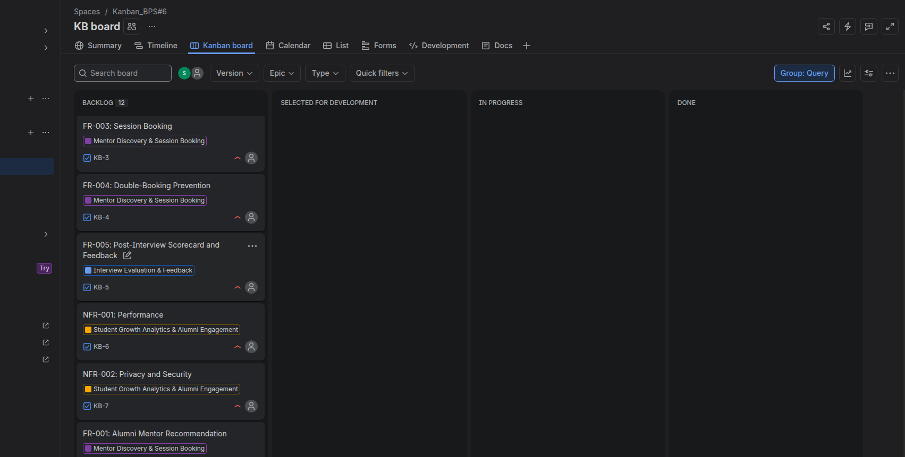
4. Added subtasks
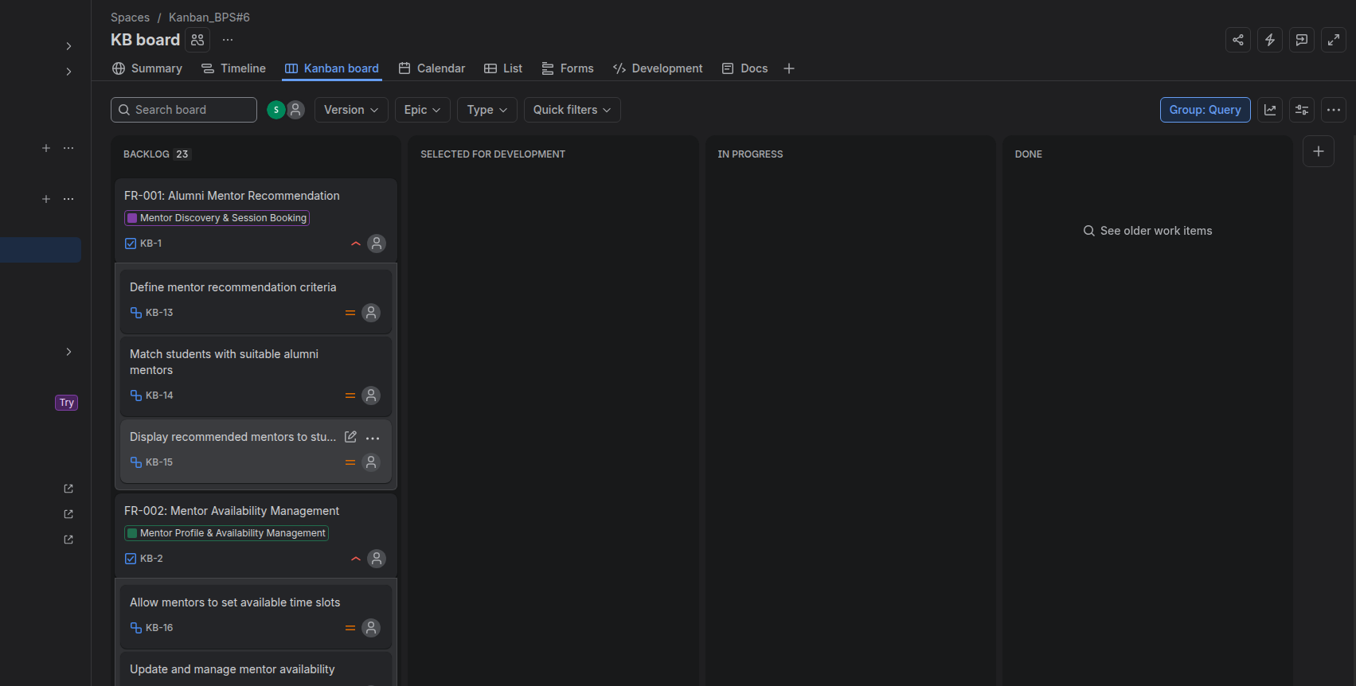
5. Complete backlog
