Name: Shashank Keshava Murthy
SRN: PES1UG24CS434
SEC: 5 H
problem Statement: #6

1. Created Project
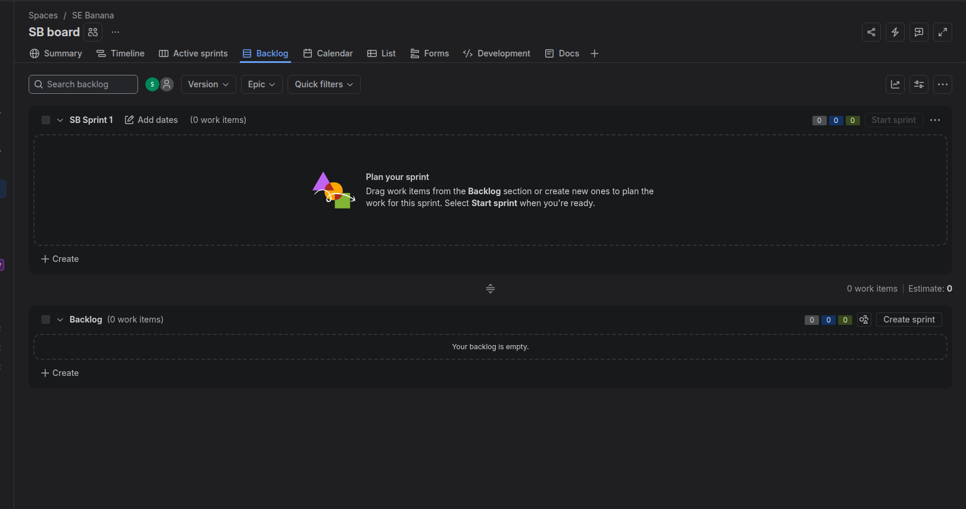

2.Created Epics
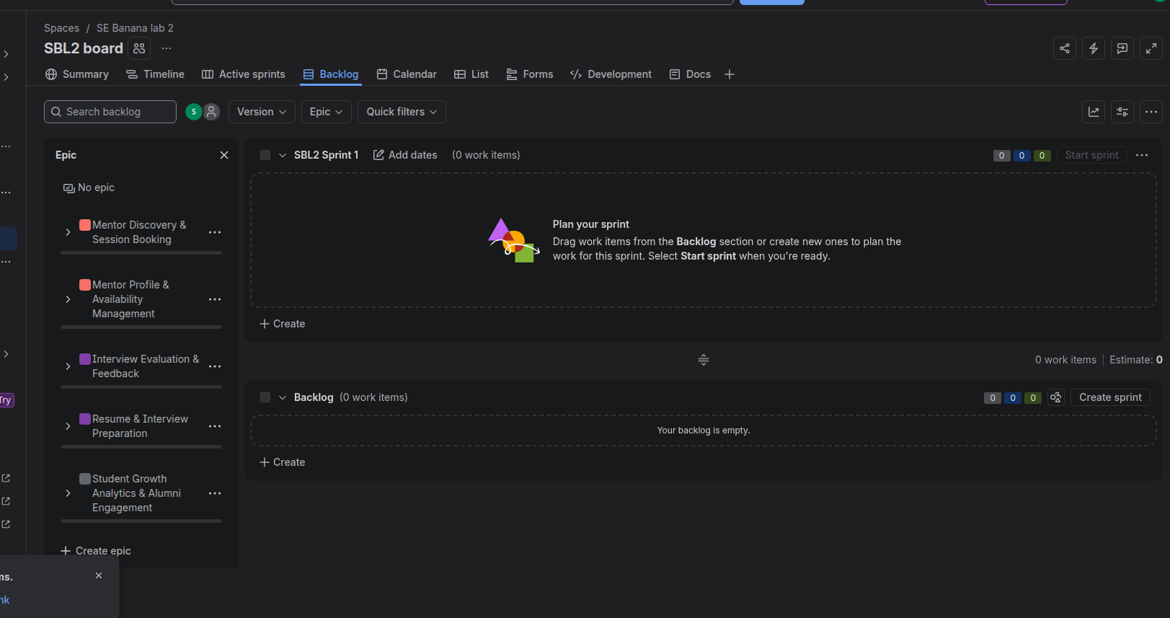
3. User story
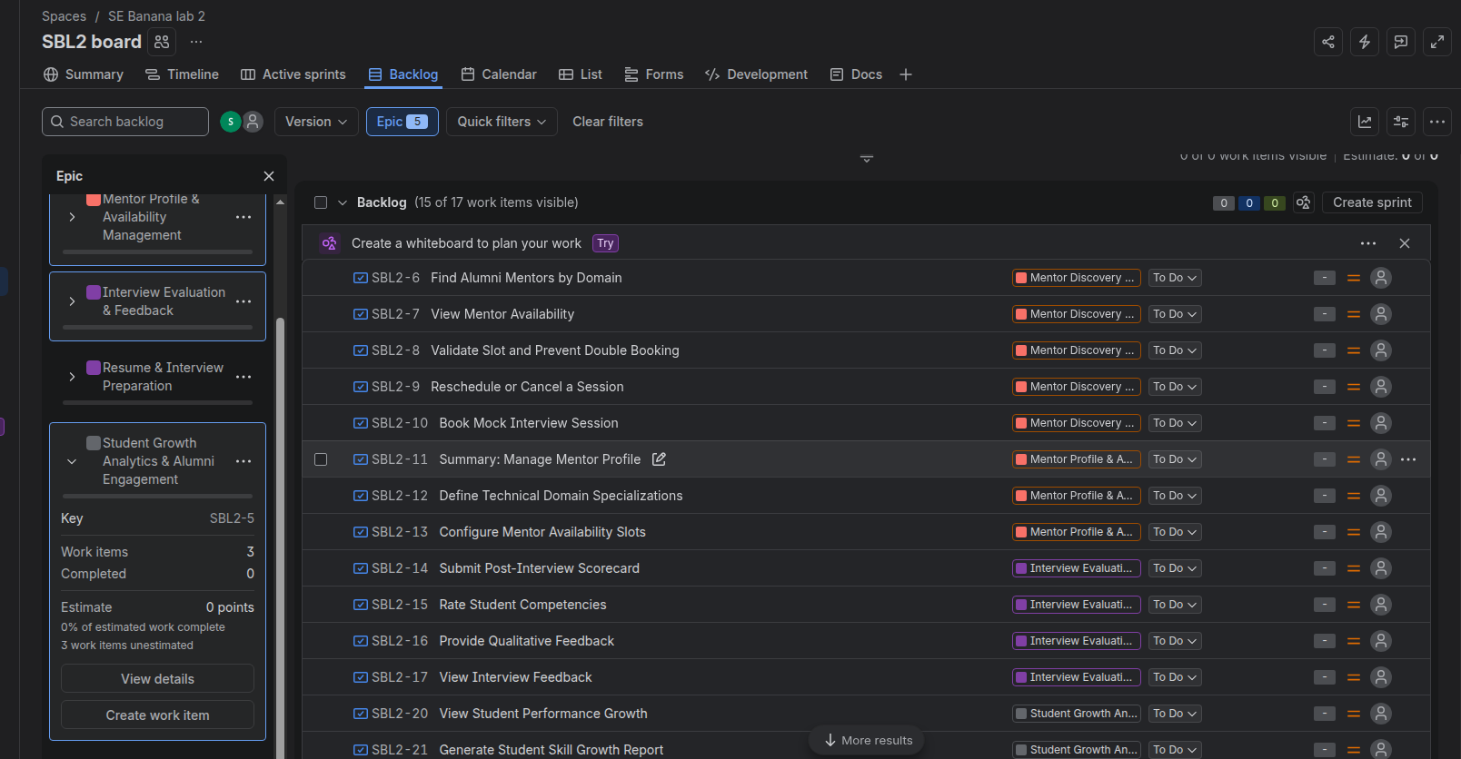

4. priority set
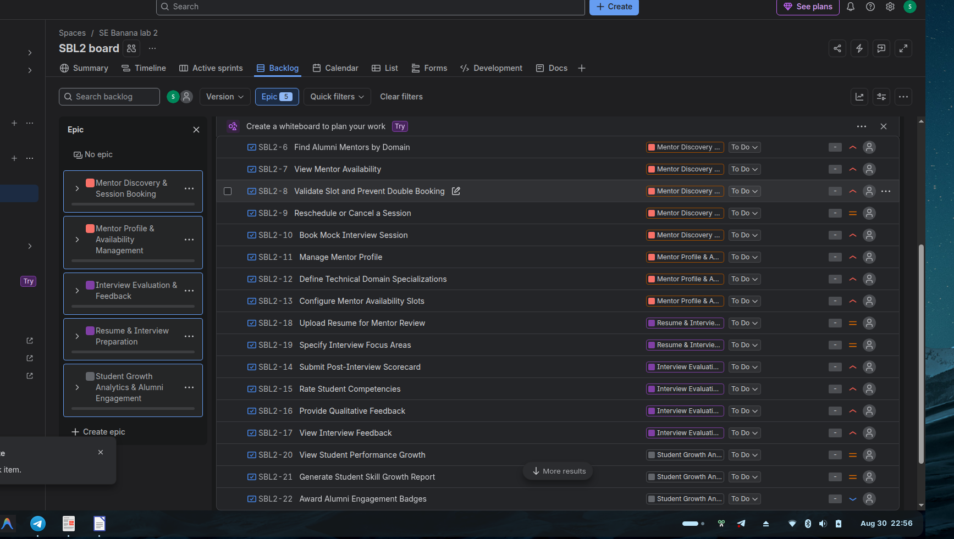
5. fibnacci estimate

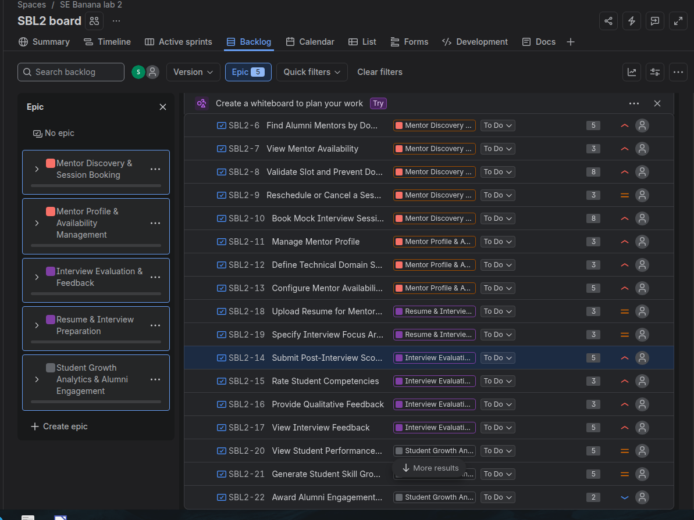
Epic | Story ID | User Story / Work Item | Story Points
🟠 Mentor Discovery & Session Booking | SBL2-6 | Find Alumni Mentors by Domain | 5
 | SBL2-7 | View Mentor Availability | 3
 | SBL2-8 | Validate Slot and Prevent Double Booking | 8
 | SBL2-9 | Reschedule or Cancel a Session | 3
 | SBL2-10 | Book Mock Interview Session | 8
🟠 Mentor Profile & Availability Management | SBL2-11 | Manage Mentor Profile | 3
 | SBL2-12 | Define Technical Domain Specializations | 3
 | SBL2-13 | Configure Mentor Availability Slots | 5
🟣 Interview Evaluation & Feedback | SBL2-14 | Submit Post-Interview Scorecard | 5
 | SBL2-15 | Rate Student Competencies | 3
 | SBL2-16 | Provide Qualitative Feedback | 3
 | SBL2-17 | View Interview Feedback | 5
🟣 Resume & Interview Preparation | SBL2-18 | Upload Resume for Mentor Review | 3
 | SBL2-19 | Specify Interview Focus Areas | 3
⚫ Student Growth Analytics & Alumni Engagement | SBL2-20 | View Student Performance Growth | 5
 | SBL2-21 | Generate Student Skill Growth Report | 5
 | SBL2-22 | Award Alumni Engagement Badges | 2

Summary
Epic | Number of Stories
🟠 Mentor Discovery & Session Booking | 5
🟠 Mentor Profile & Availability Management | 3
🟣 Interview Evaluation & Feedback | 4
🟣 Resume & Interview Preparation | 2
⚫ Student Growth Analytics & Alumni Engagement | 3
Total | 17 Stories
6. sprint 1
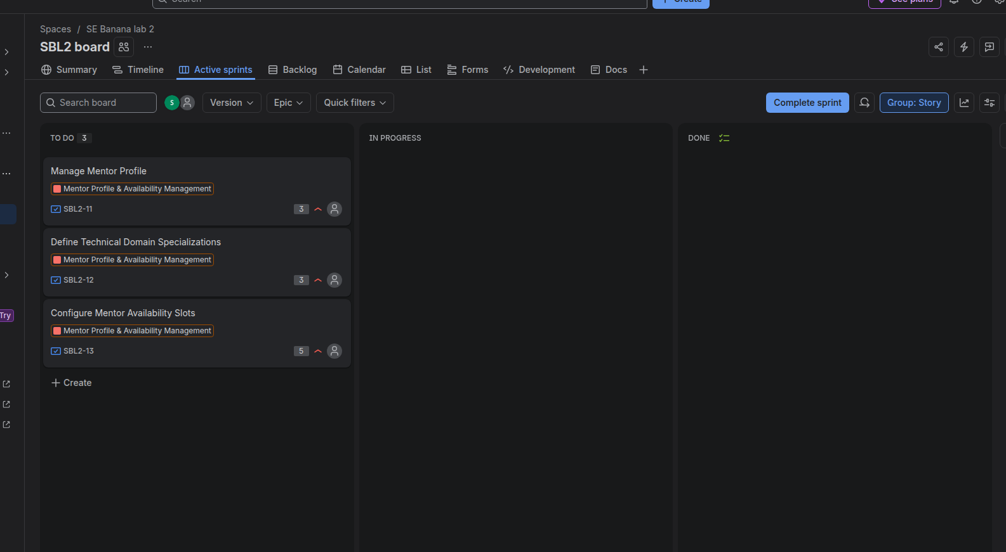

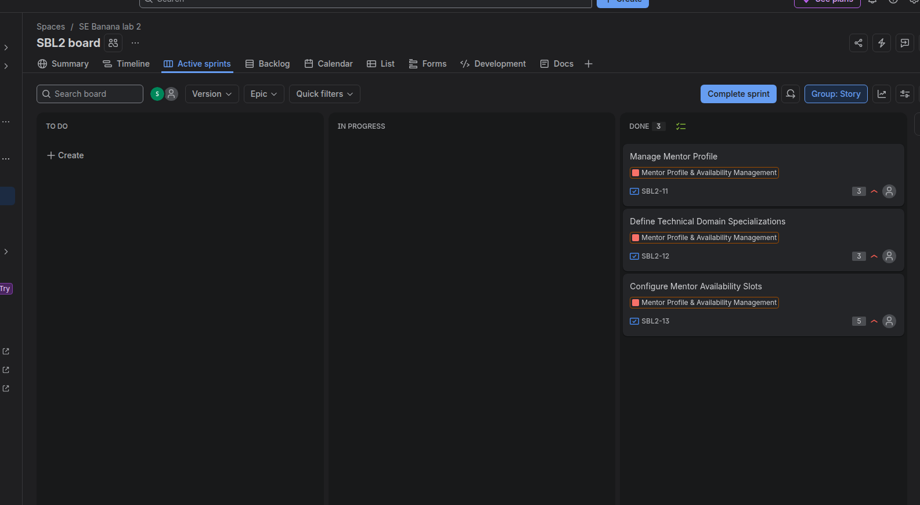
7. sprint 2
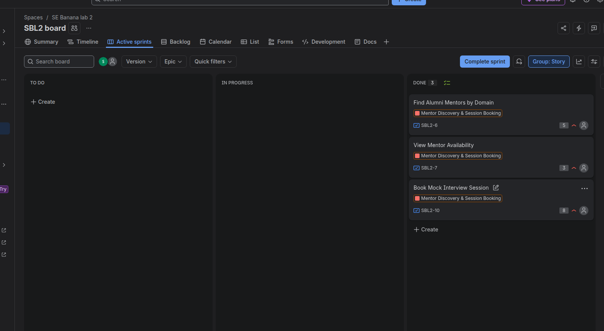
8.
Burndown Chart

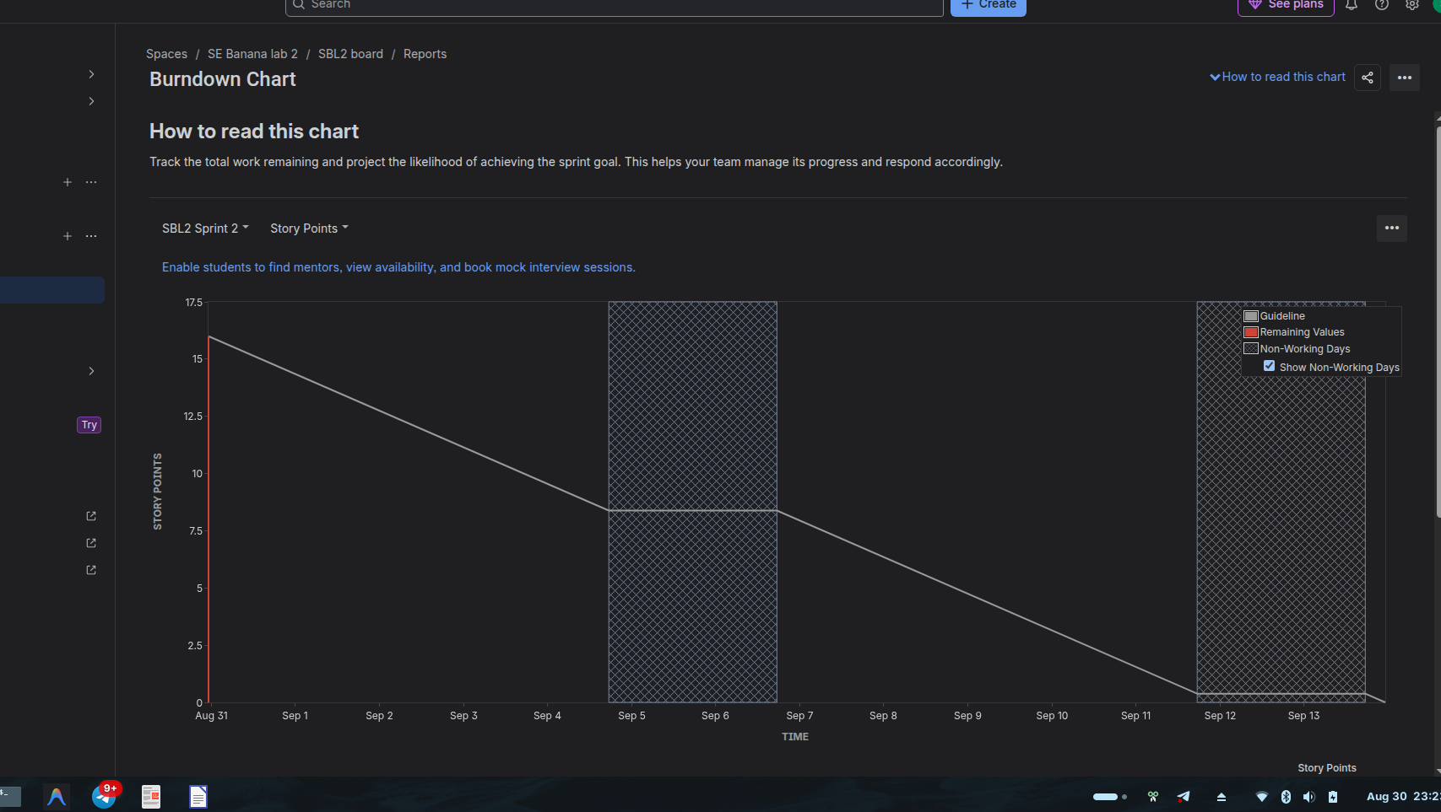
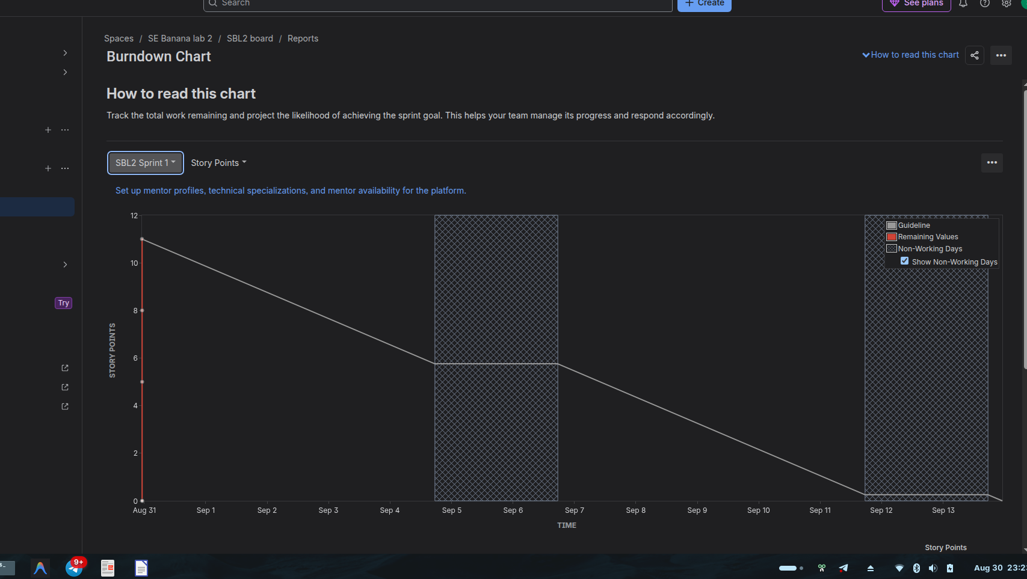
Reflection Questions

1. Did your estimations reflect the actual effort?

Yes, the estimations were reasonably appropriate for this simulated sprint. The selected stories had story point estimates based on their expected complexity and effort. Since this was a simulation rather than actual development work, the estimates represent planned effort rather than measured real-world effort.

2. Was your backlog well-prioritized?

Yes. The backlog was prioritized by placing the foundational mentor-related functionality first. The first sprint focused on Manage Mentor Profile, Define Technical Domain Specializations, and Configure Mentor Availability Slots, which are important features that provide a foundation for later functionality.

3. How did your simulated sprint align with your plan?

The simulated sprint aligned with the original plan. The three selected user stories were included in SBL2 Sprint 1, completed during the simulation, and moved through the workflow to Done. This shows that the sprint execution followed the planned scope and goal.

4. What insights did the burndown chart give about your team’s capacity?

The burndown chart showed the total planned work decreasing from approximately 11 story points toward zero over the two-week sprint. It provides a visual way to understand whether the team is completing work at a pace that allows the sprint goal to be achieved. For this simulated sprint, it represents a team capacity of roughly 11 story points for the selected sprint scope.

