## 2/18/15 (5:35)

**Start time: 6:30 pm**

Setting up <http://d3js.org/> , reviewing javascript

Using this tutorial to learn D3: <http://alignedleft.com/tutorials/d3/making-a-scatterplot>

Covered all available tutorials

Using Mixture/Sass tools for live preview and website layout <http://mixture.io/>

**Break at: 9:13 pm (Cumulative 2:43)**

Currently generated a scatterplot using D3, next is reading on transitions and animations

Stress tested D3 with 33765*3 randomly generated data points, simulating the load of graphing 3 villages

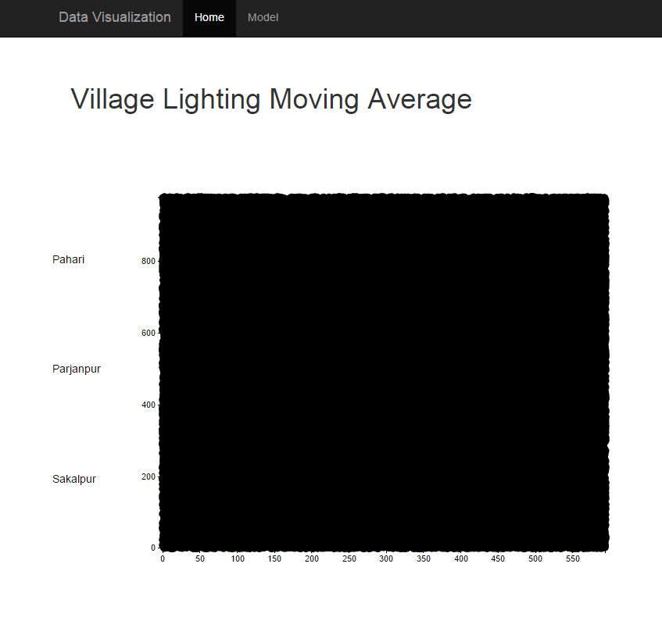  
**Resumed at: 11:13 pm**

Issue: Loading local CSV through Javascript

Resolved: used relative filepath and left the rest to Mixture

**Break at: 12:03 am (Cumulative 3:33)**

**Resumed at: 12:56 am**

CSV loads asynchronously to increase speed, reading about queue.js

Setting graph colors

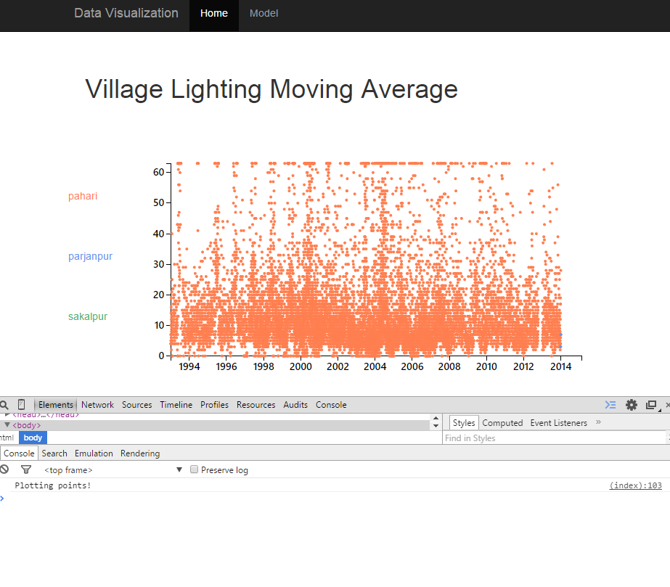

Current issues: when cycling through the three datasets, the last one to be updated overwrites previous data. Overall performance seems very fast with the current amount of data, but performance may change when transitions/interactive features are added.

**Ended at: 2:58 am (Cumulative 5:35)**