# 2/19/2015 (3:00)

**Start time: 4:00 pm**

Fixed overwriting issue, three scatterplots now showing correctly

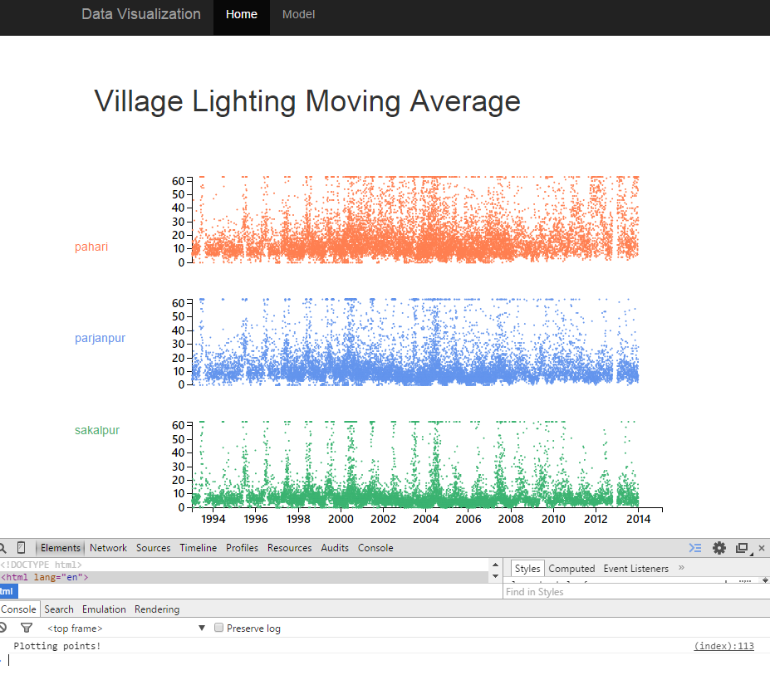

**Break at: 5:00 pm**

**Resumed at: 8:00 pm**

Moving averages added, needs cleaning in the first few data points. Also, some odd things going on in terms of jumps in time. Spent a lot of time troubleshooting why the line was jumping back. Probably need to pre-sort the data before calculating/drawing the moving average.

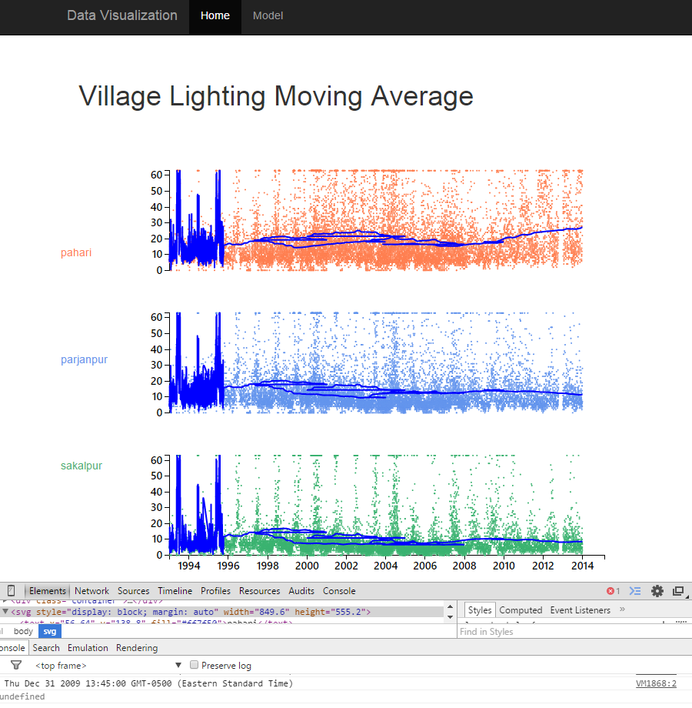

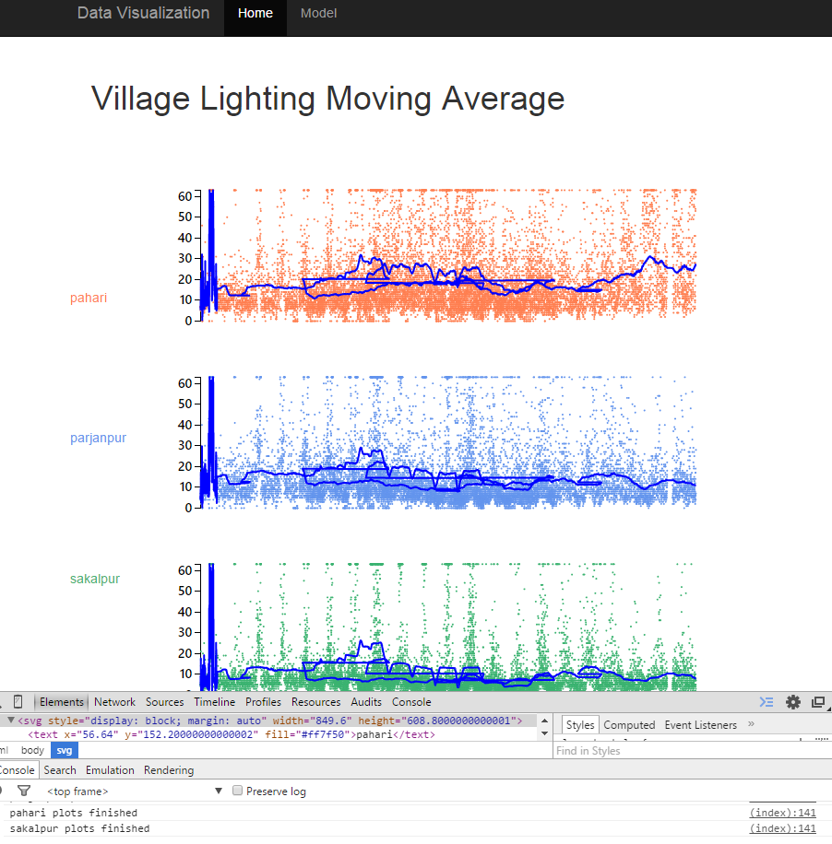

**Finished 10:00 pm**