4:15 pm

Updating github

Learning PIXI

Following tutorial here: <http://www.goodboydigital.com/pixi-js-tutorial-getting-started/>

And example here: <http://www.goodboydigital.com/pixijs/examples/13/>

The goal is to write a js script to render many shapes using pixi, and see if pixi is capable enough to animate all the assemblies/consitituencys in India.

NOTE: Tutorial may be slightly outdated (pixi says it no longer needs a stage. requestAnimFrame is undefined

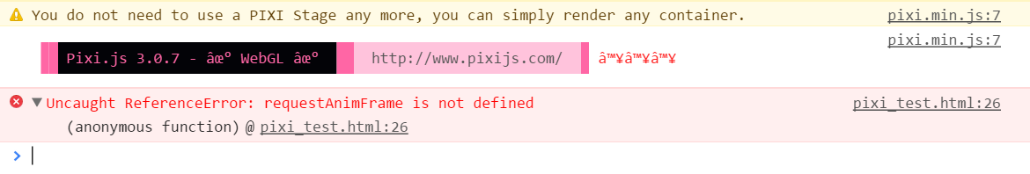

Also cleaning up github, removing the web framework and keeping the important js scripts.

Graph generating scripts moved to /javascript/d3_js/d3_graph.html

Currently doesn’t work (Data for the graph was not set to upload to github, as it exceeded the file limit)

Removed unnecessary files and reorganized the scripts.

6:15 pm finished