Start: 5:30 p.m.

Finally fixed the darn webGL rendering bug!!!

Turns out PIXI had issues drawing corners. Following the advice on this thread: <https://github.com/pixijs/pixi.js/issues/1075>

Specifically using lineTo and moveTo together so that no corners are drawn fixed it.

Next I need to work on the CSV.

Break: 6:30 p.m.

Resume: 10:30 p.m.

New issue! Fill doesn’t work now that lines have been fixed. I’m going to take a look at other technologies, as PIXI js has been very buggy so far. The promise of webGL rendering like canvas but with higher performance has been a big disappointment. I might try previous versions of PIXI, but next up I’m probably going to look at paper.js, especially this demo:

<http://paperjs.org/examples/hit-testing/>

Break: 11:00 p.m.

Resume: 2:00 a.m.

Finally fixed the webGL issue! It turns out the rounding was causing duplicate datapoints, which really threw webGL off. After removing the duplicates, webGL looks just as good as canvas, and runs faster!

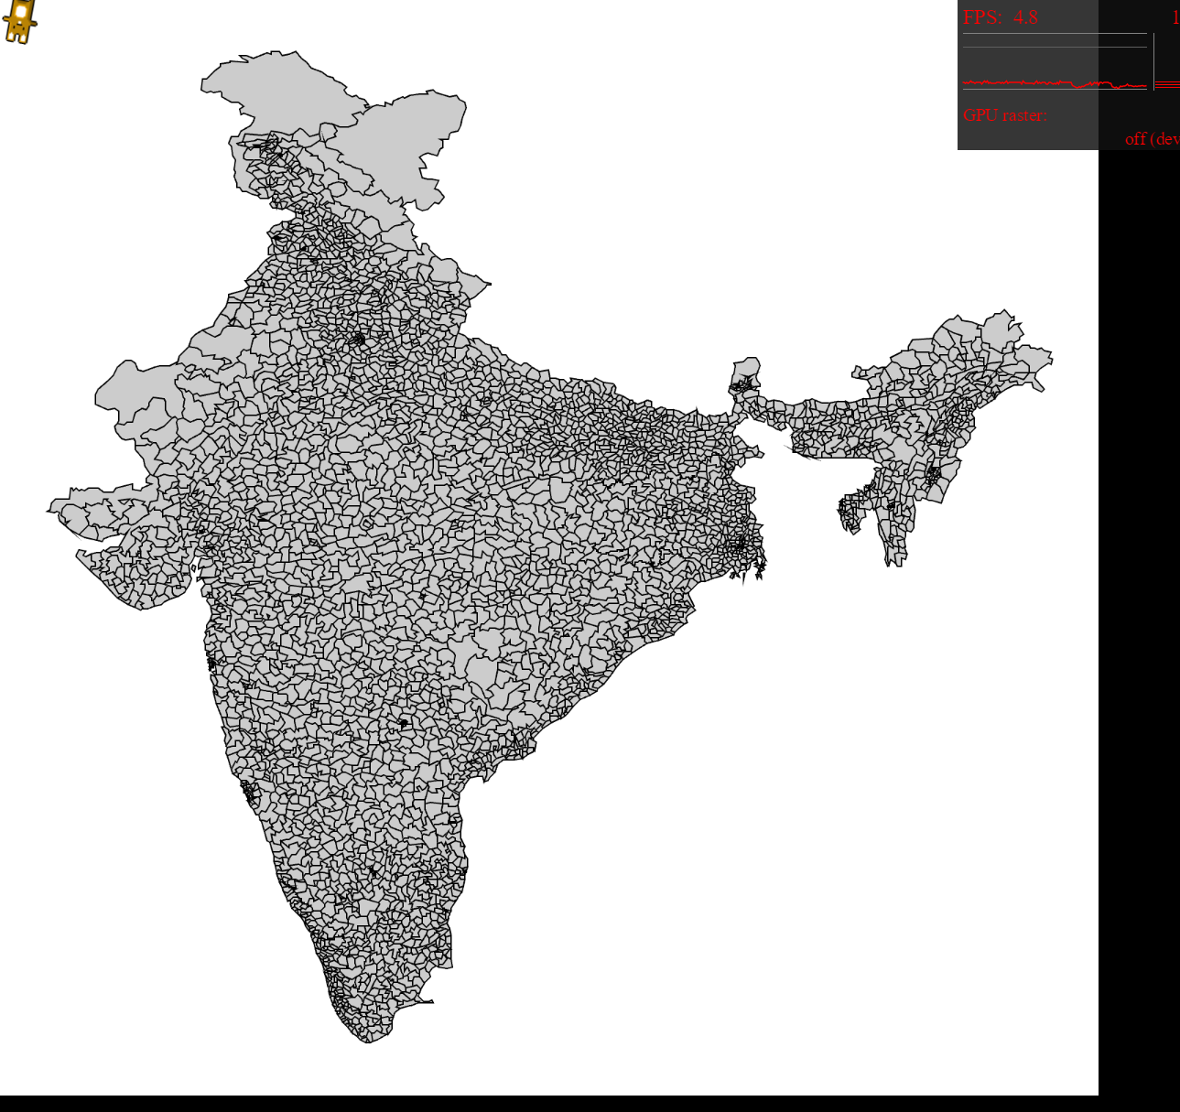

Finish: 2:45 a.m.

Total: 2.25 hours