Start: 3:30 p.m.

Adding data animation now that webGL drawing is working. Going to look at nightlights IO for the color palette. Using chroma.js to interpolate colors and d3.js to read the csv.

CSV reading and color interpolation is working. There seems to be an odd patch where the ac data doesn’t match up with the shapefile.

Animation running (around 10 fps). Part of Karnataka is missing. Really not sure why? It also seems to get tinted grey, which isn’t even on the black-yellow color scale.

Set up the nightlights IO yellow for the scale.

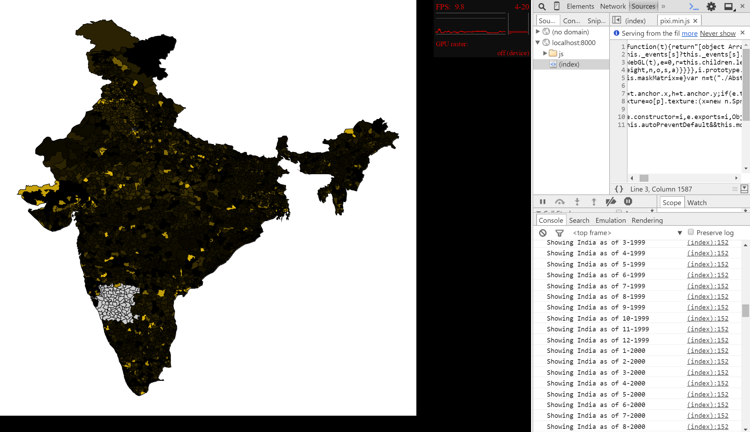

Finish: 6:30 p.m.

Total: 3 hours