Start: 10:30 p.m.

Going to try scaling manually and then converting all floats to integers to fix the webGL rendering issue.

Fixed the fill mismatch issue, but lines do not render well in webGL. Going to continue with canvas for now.

Trying to render all of the assemblies. <https://github.com/mbloch/mapshaper> might be useful if pixi doesn’t pan out.

All AC’s rendered (on top of each other), but FPS dropped to around 1.5 with the canvasrenderer.

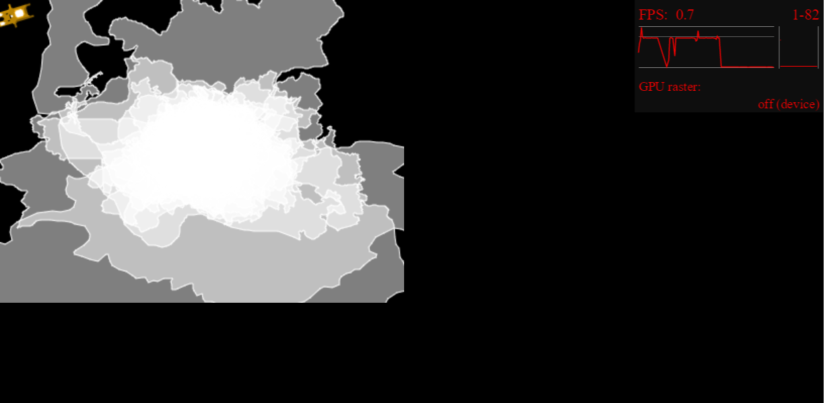

webGL renderer not working either. PIXI isn’t quite working as well as I had hoped. Checking out the mapshaper source files.

I don’t think mouseover interactivity is feasible. There’s just too many AC’s, and even if the map is scaled all the way up they’re very small. The extra performance cost required to add mouseover interaction is probably not worth it.

Finish: 11:30 p.m.

Total: 1 hour