Start: 3:00 p.m.

Working out the bugs with webGL.

Right now canvas renderer is working, map looks like this:

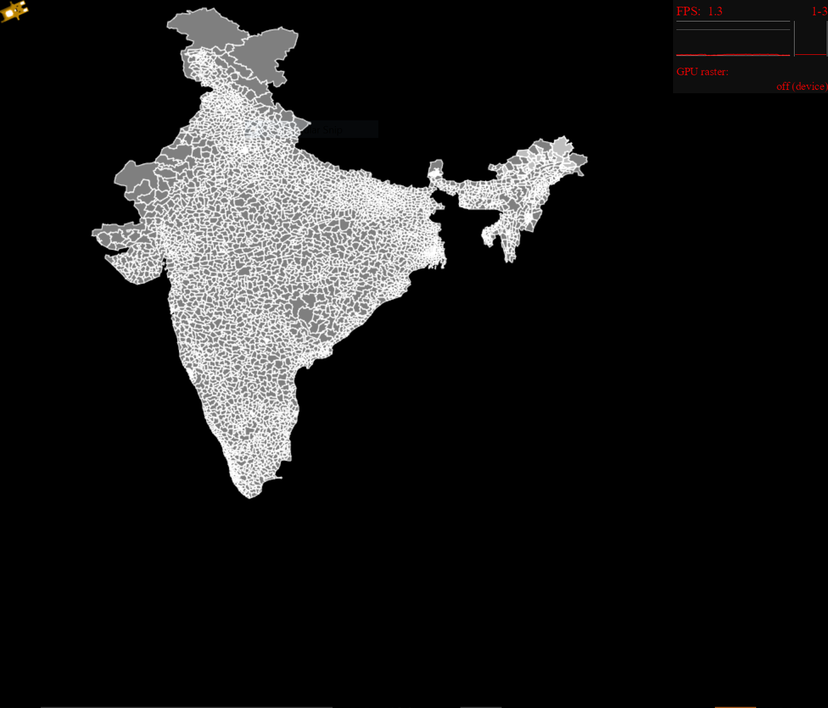

And webGL rendering looks like this:

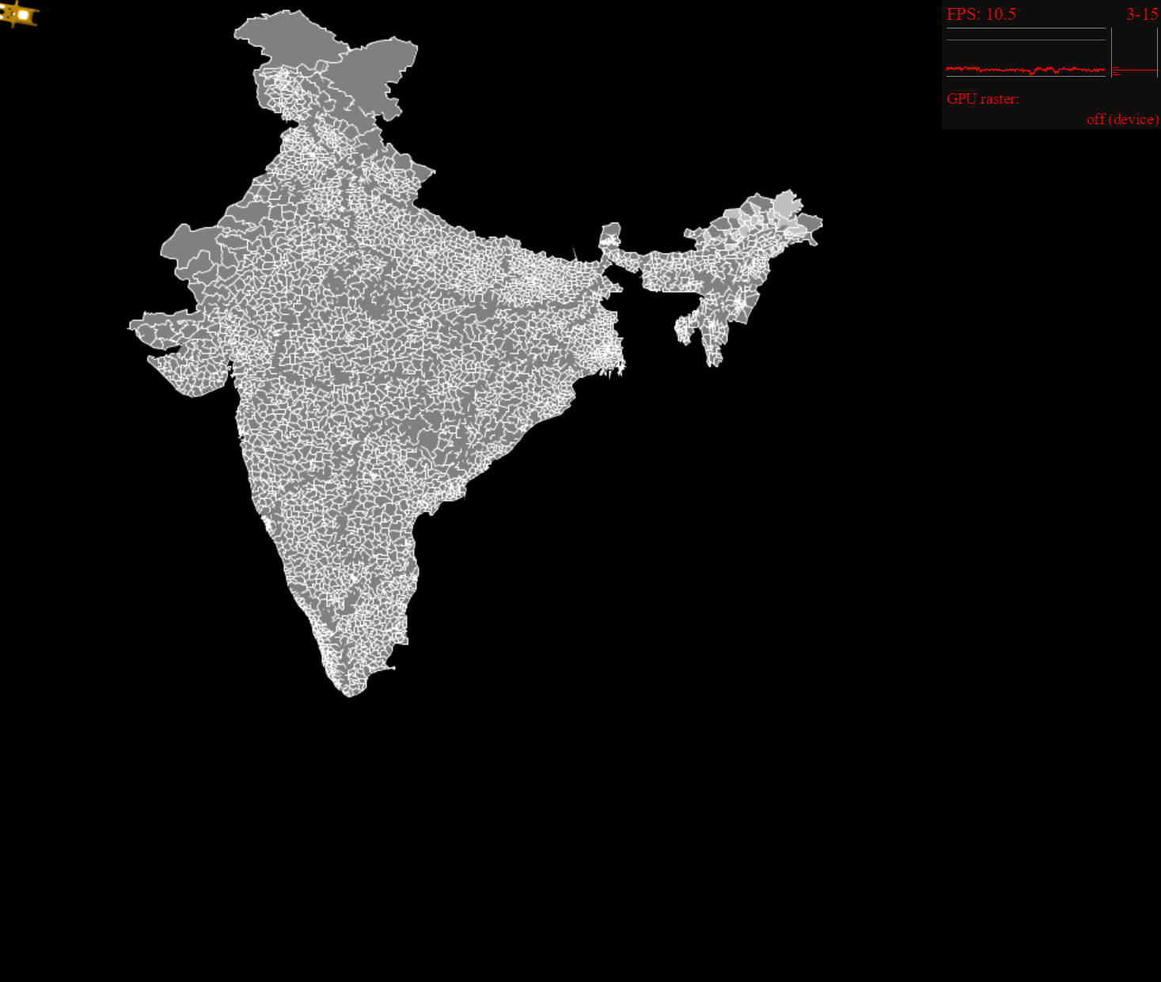

Canvas rendering is significantly smoother, but has lower performance, whereas webGL is faster but some lines aren’t rendering properly.

Working on fixing this issue. Maybe drawPolygon from PIXI.Graphics()

The mapshaper gui is really awesome. Will spend more time trying to read the code and figure out how it renders.

Finish: 4:30 p.m.

Total: 1.5 hours