卫星原始数据解格式和解压缩模拟测试

1、模拟数据制作
- 使用1024*480大小的卫星数据作为模拟数据种子。文件大小158640字节，16位灰度图像
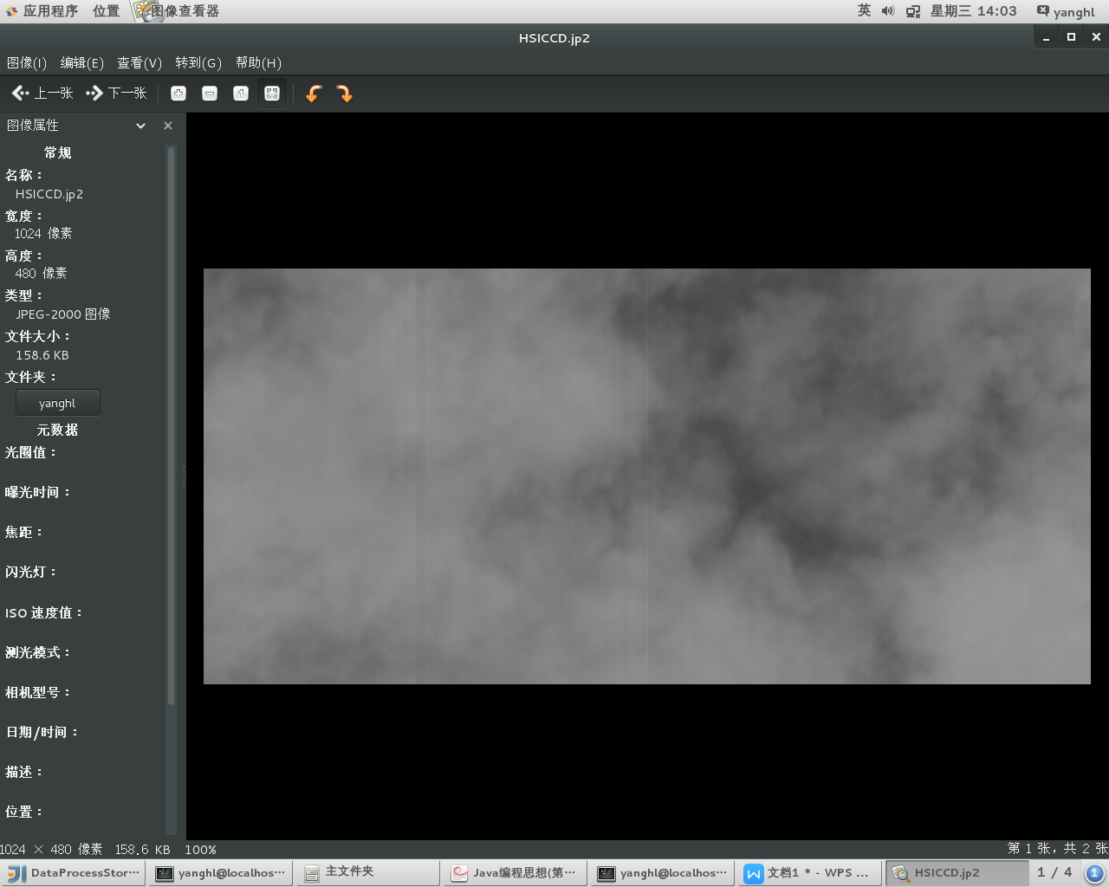
- 采用编程方式对以模拟数据种子图片上添加文字标签，模拟载荷以及帧计数标示。如下图所示。
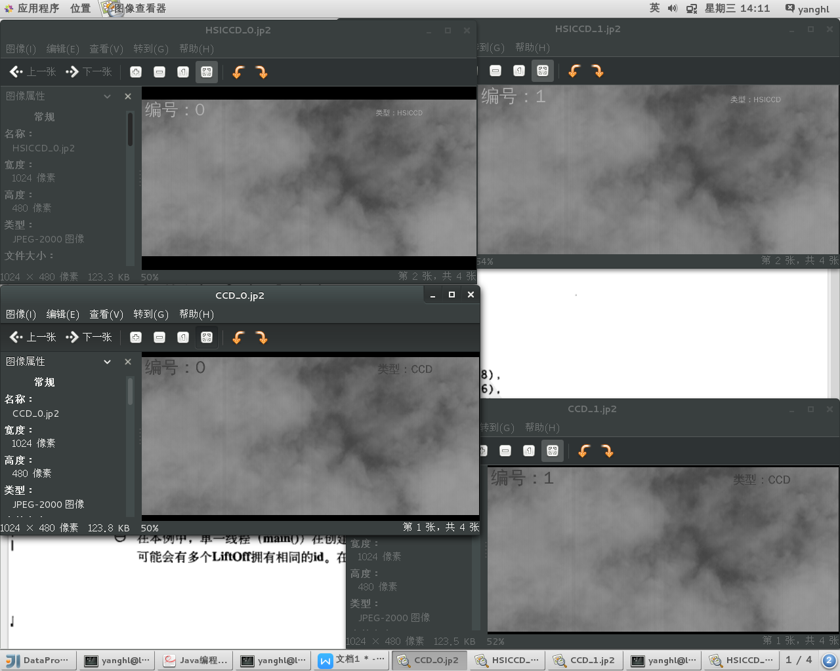
- 共模拟四种载荷，CCD、HSICCD、IRS、HSIIRS，对每种载荷的jp2数据进行gz压缩，然后再将四个gz文件再打包压缩为zip，以模拟一个AOS数据包中包括多虚拟信道的情况。
模拟文件层次如下：
|-- PACK_0.zip
| |-- CCD_0.jp2.gz
| -- CCD_0.jp2
| |-- HSICCD_0.jp2.gz
| -- HSICCD_0.jp2
| |-- HSIIRS_0.jp2.gz
| -- HSIIRS_0.jp2
| |-- IRS_0.jp2.gz
| -- IRS_0.jp2
|-- PACK_1.zip
| |-- CCD_1.jp2.gz
| -- CCD_1.jp2
| |-- HSICCD_1.jp2.gz
| -- HSICCD_0.jp2
| |-- HSIIRS_1.jp2.gz
| -- HSIIRS_1.jp2
| |-- IRS_1.jp2.gz
| -- IRS_1.jp2
|-- PACK_N.zip

如下图所示
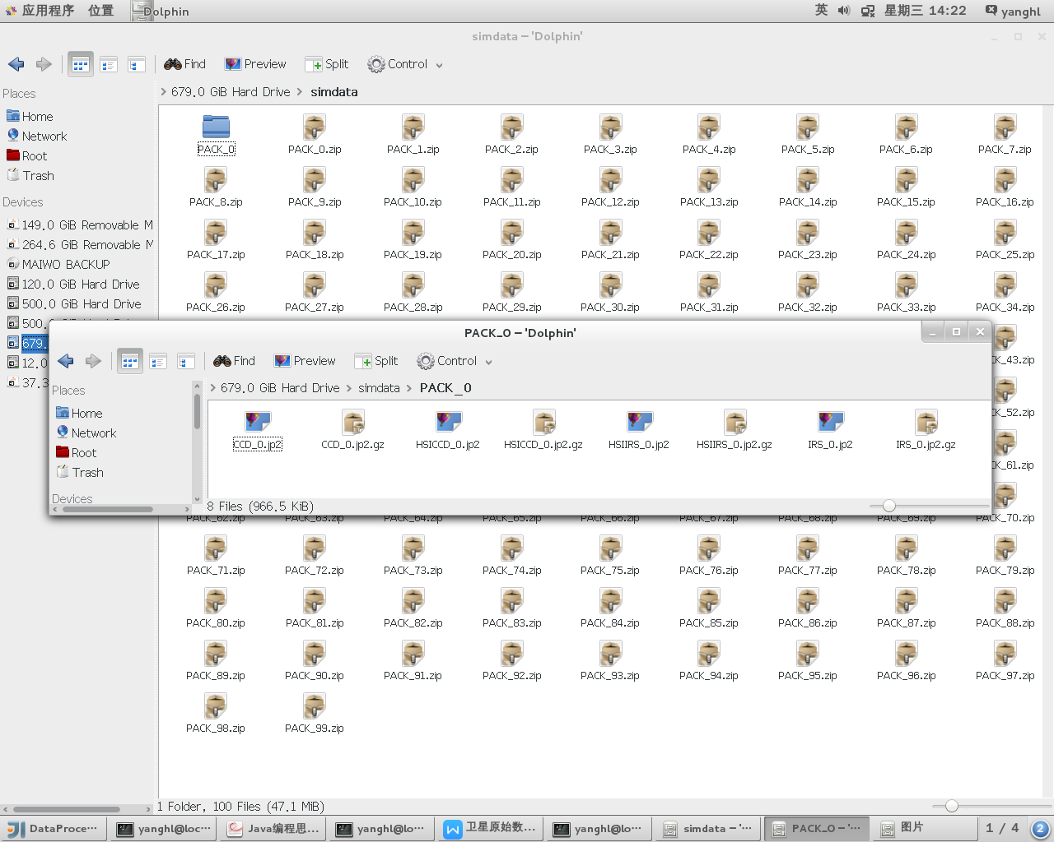

2、数据处理测试流程
- 首先进行串行数据处理机制验证；再验证单机解包和JP2000解压缩性能；待前两项工作完成后，集成REDIS作为数据生产、消费缓冲队列，考察其性能；最后集成为Storm规范的处理形式，进行集群验证。
- 定义包结构封装模拟数据包PACK_N.zip，数据读入内存后在各个处理模块流转。
- 当前实现两个处理模块，以模拟卫星数据接收处理流程。
  - 模块1：Parser，解ZIP和GZIP，其读入PACK_N.zip数据，解出4个jp2文件。使用JDK自带ZIP和GZIP处理库
  - 模块2：decompressor，解jpeg2000，将jp2文件转换处理为RAW格式
经过验证程序已经可以正确的将PACK_N处理为RAW。使用JAI.ImageIO.jpeg2000库进行jpeg2000解压缩。
- 进行解包和解压缩性能验证
  - 单机单进程解包性能如下：
100个PACK包，共包括400个jp2图片。约48MB数据。
CPU使用率，
ZIP和GZIP解包时12-15%
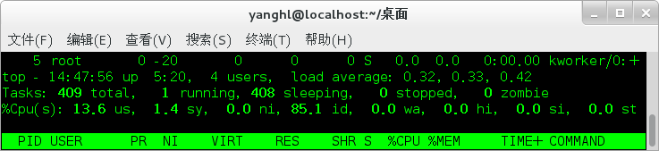
Jp2000解压缩时5-7%
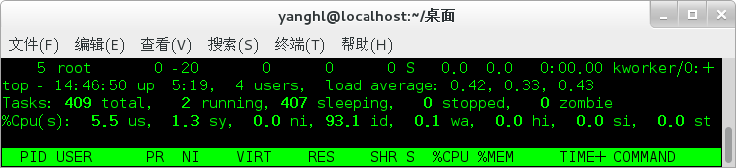
  - 进行单机多线程测试1（12线程），（测试环境2路6核+超线程，共24个可用CPU）12进程，每进程处理20个PACK包。共处理240PACK，数据量约为120MB，解包速率约为每秒766MB/s，jp2000解压缩14MB/s
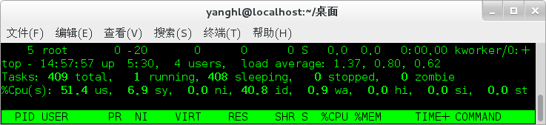
  - 进行单机多线程测试2（24线程），（测试环境2路6核+超线程，共24个可用CPU）24进程，每进程处理20个PACK包。共处理480PACK，数据量约为237MB，解包速率平均约为每秒276MB/s，jp2000解压缩19494KB/s
CPU 使用率约为80%
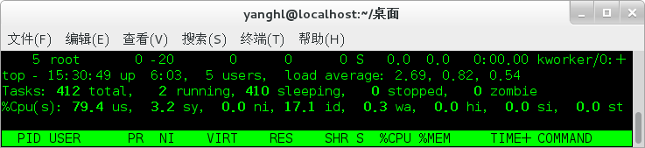
  - 进行单机多线程测试3（48线程），（测试环境2路6核+超线程，共24个可用CPU）24进程，每进程处理20个PACK包。共处理960PACK，数据量约为480MB，解包速率平均约为每秒350MB/s，jp2000解压缩19336.KB/s

关于解包和解压缩的初步结论：当前java版本处理程序，未进行相关优化，解ZIP包等常规数据处理单机即可达到最高700MB/s，Jpeg2000解压缩（默认解压缩参数）单机的处理能力上限约为19MB/s。如果单机处理器提升至四路，预计单机处理能力能提升至35MB左右（即输入速率约300Mb/s），处理900Mb/s的压缩数据量，预计需要4台服务器。处理2000Mb/s的压缩数据量，预计需要6-7台服务器构成的处理集群。

3、关于内存数据库的测试情况REDIS
REDIS内存数据库支持原生String、List、hashmap等数据类型。
作为缓冲区使用，使用List构建一个双向链表，模拟数据队列，数据生产者将数据逐个压入队尾、消费者从队首取出，并加以处理。
Storm可以良好的与REDIS集成，因此使用REDIS作为缓冲区

由数据模拟进程对已经生成号仿真数据PACK_N.zip读取，压入DATA:PACK队列中，将每一个数据的ID压入单独的DATA:PACKID队列中。
数据处理类ProcessFrame中包括了解包和解压缩的处理流程。从队列中将数据包和ID弹出，送入处理流程进行处理。
在运行时实现12个线程并行处理。

在存在20个解包解压缩消费线程的情况下，此时REDIS List 连续压入数据的压入性能约为270MB/s。
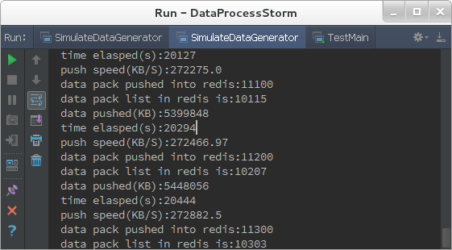

在控制压入速度为24.3MB/s左右时，生产者和消费者的速度基本达到平衡，缓冲队列中可见的最长的堆积包数为20。与单机进行直接内存解包和解压缩性能相似。下图为处理了12GB数据后速率情况，稳定保持在24.3MB/s。
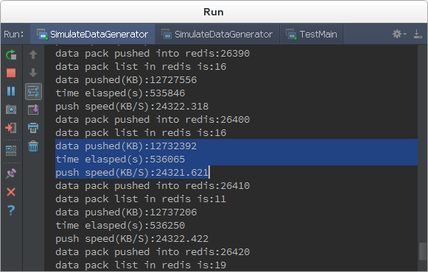
如果输入数据速率超出了单一REDIS的压入速率，则可以考虑进行sharding，分散压到多台REDIS中。
如果不考虑网络传输瓶颈问题，单台数据生产者产生的数据采用10台同类型的计算机可以实时处理完成。

4、与流数据处理平台Storm的集成
完成了模拟处理模块的开发，以及与Storm平台的集成。
构建了两个拓扑（处理流程）
Topology 1:
Simstorm，用于进行数据的解包和解压缩，着重大计算量，实现高度并行化解压缩。

Topology 2：
SortedDataQVAndRecord，有序数据的输出为文件，同时生成快视数据。

仿真数据处理与记录系统处理流程
共包括4个主要组件
- 仿真数据的生成与输出。SimulateDataGenerator。根据种子文件，生成大批量静态仿真数据文件，模拟打包、压缩等过程，在每一帧图片上记录标签。
- 内存数据库，REDIS。其作为组件间的媒介，同时提供双向链表（队列）和有序集和等功能。
3、Topology 1:Simstorm，解格式解压缩，从REDIS中的链表头部获取输入数据，经过处理后，输出结果压入REDIS中的SortedSet
4、Topology 2:SortedDataQVAndRecord，从REDIS中获取有序数据，进行数据快视和记录处理，生成结果文件。
全流程已经跑通，输入为独立的单景仿真数据，输出为排序的连续的解压缩数据和快视数据。如下所示：
输入数据：
经过集群处理后的输出的快视数据，转换为8bit灰度图，PNG格式：
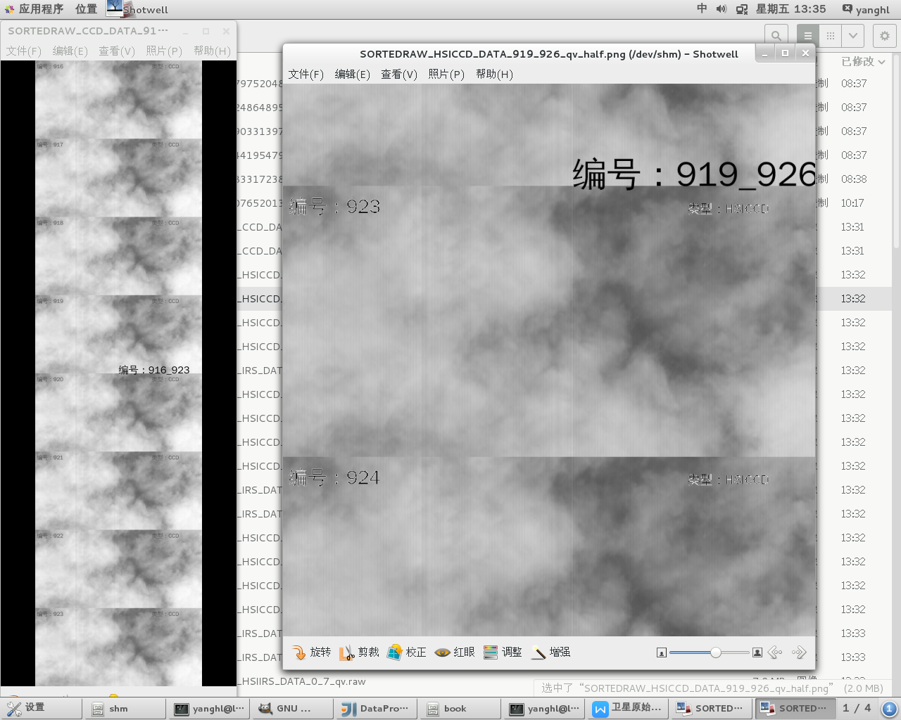
经过集群处理后的输出的原始数据，1024*480单帧16bit灰度图解压缩为960KB，共计发送1000帧，处理生成后每个传感器的合成数据约为1.1GB
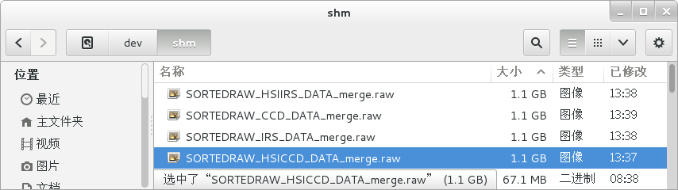

已经验证的主要关键技术
- Java代码Jpeg2000解压缩处理能力，由于主平台为Java平台，因此JAVA实现的程序比较便于集成。使用jai image io的jpeg2000编解码器可以实现对给定真实种子数据的编解码。性能满足要求。
- REDIS作为主要数据交换媒介和缓冲区，其中
  - Linkedlist可用来将已知有序数据，压入，弹出。
  - SortedSet可用来将无序生成的数据存入排序输出，
  - 单机性能在10Gbps量级，满足处理要求
- 当前仿真系统主要处理流程：
SimulateDataGenerator----打包原始仿真数据——>REDIS数据库(linkedlist)——>SimStorm拓扑（解包和解压缩）——REDIS数据库(SortedSet)——>SortedDataQVandRecord——>本地文件，拼接后的条带和快视数据
- Storm中多样化拓扑结构的实现，可以实现自定义数据流，自定义数据流内部结构，根据数据流的名称、关键子段等信息进行数据流分组，定向，进行一对多，等流程模式处理
- Storm的并行处理能力，可以通过定义Slot，实现对主机处理能力的规划，可以通过task\executer对spout、bolt等关键处理组件的并行度定义。
- Storm平台开发的可调式性，集群软件能否实现程序的便捷调式对软件开发和测试有着巨大影响。可以通过localCluster将已经开发完成topology提交至本机模拟的单进程Storm平台，可以设置断点进行开发调式。本机运行通过后，可以将topology提交至正式的remote集群。remote集群可以采用单机便捷的搭建。

5、后续工作
- 进行规模化压力测试，选择4-6台计算机搭建storm集群，进行规模化压力测试。检查压力下，集群输出能力。
- 测试集群容错能力。
- 进行Scheduler的集成，实现topology中的特定处理组件运行在特定计算机的能力。输入和输出两个首尾模块一般需要能受空部署在特定计算机上。
- 设计更好的算法流程，实现并行处理环境下的无序生成数据包，有序输出。
- 实现压测数据的统计及速度测算，最终实现2000Gbps的处理能力。
- 实现Storm环境下，与C的处理模块的集成。
……
N、实现对真实卫星数据的处理，测试处理能力，实现2000Gbps以上的处理能力

当前Storm前端监控UI运行样例
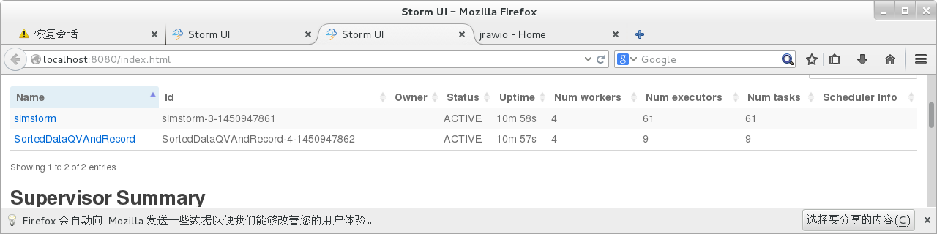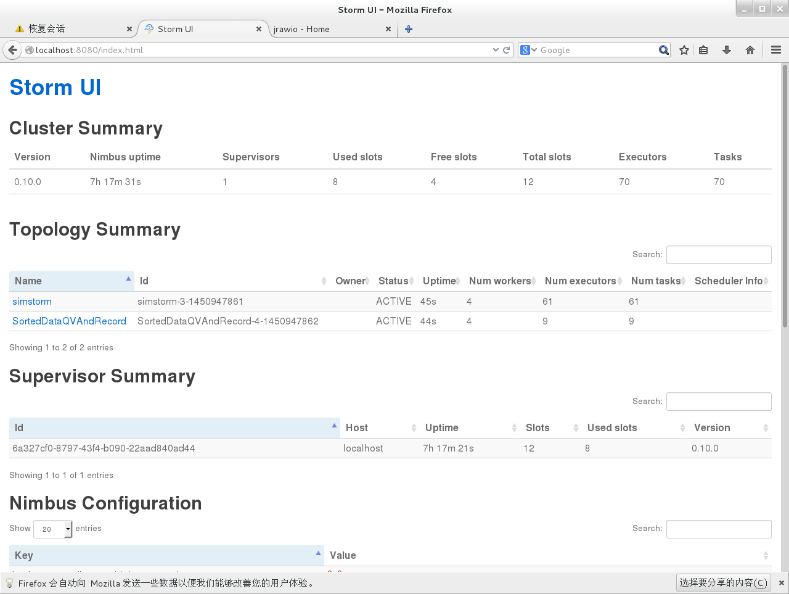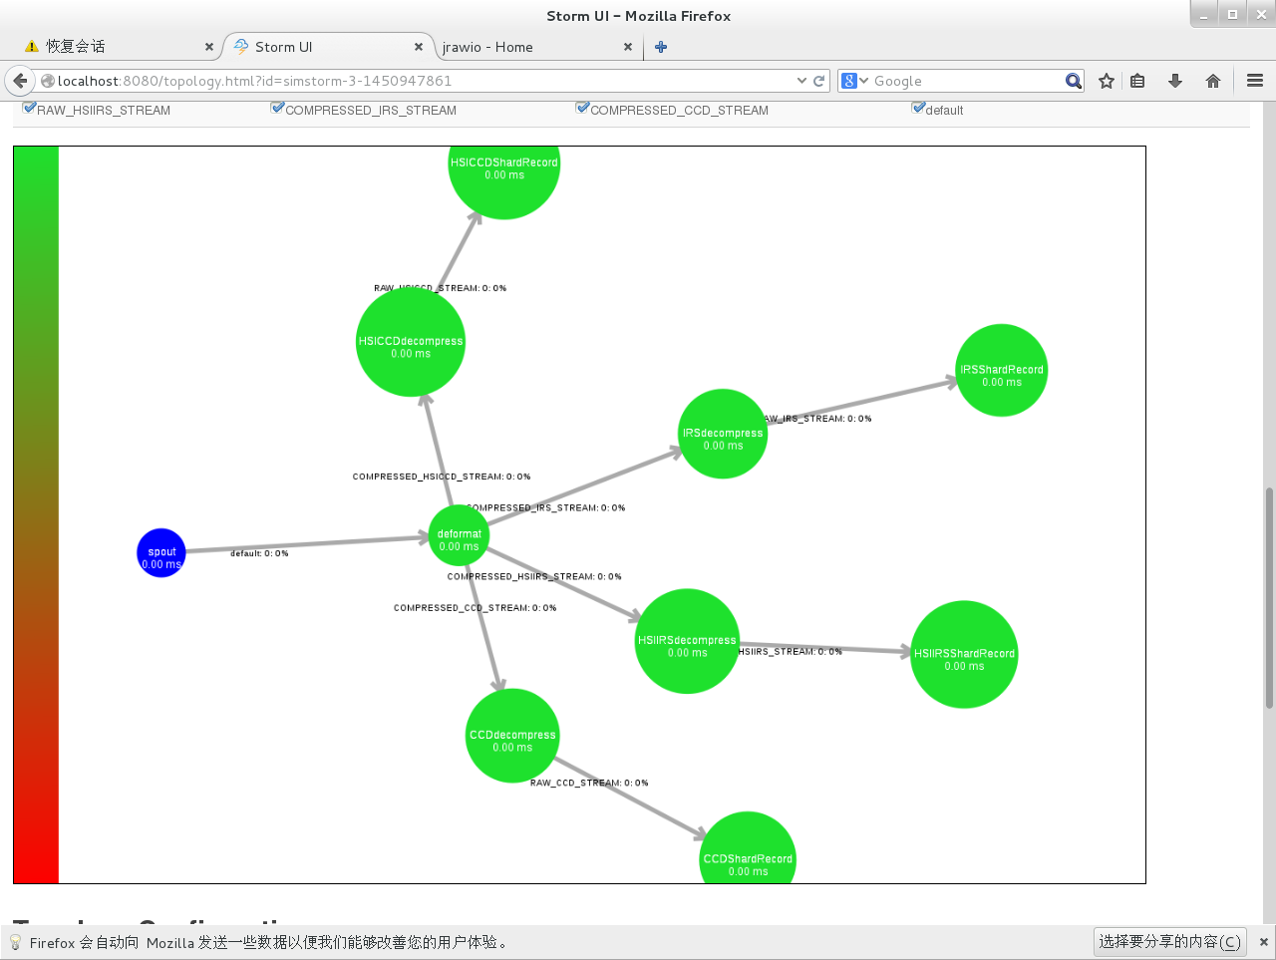

附：

测试系统配置情况
CPU：cpu family : 6
model name : Intel(R) Xeon(R) CPU E5-2630 v2 @ 2.60GHz
cpu MHz : 1200.062
cache size : 15360 KB
内存:32GB

附测试记录：
测试1单机单线程。
Prasing is done.Processed package:100 data(byte):49365614 takes time elasped(ms):355 speed(KB/s):139058.0
Decompressing is done.processed package:400 data size(byte)49278691 takes time elasped(ms):24041 speed(KB/s):2049.0
测试2单机12线程。
Prasing is done.Processed package:20 data(byte):9883380 takes time elasped(ms):222 speed(KB/s):44519.0
Prasing is done.Processed package:20 data(byte):9883380 takes time elasped(ms):227 speed(KB/s):43539.0
Prasing is done.Processed package:20 data(byte):9883380 takes time elasped(ms):229 speed(KB/s):43158.0
Prasing is done.Processed package:20 data(byte):9883380 takes time elasped(ms):239 speed(KB/s):41353.0
Prasing is done.Processed package:20 data(byte):9883380 takes time elasped(ms):240 speed(KB/s):41180.0
Prasing is done.Processed package:20 data(byte):9883380 takes time elasped(ms):243 speed(KB/s):40672.0
Prasing is done.Processed package:20 data(byte):9883380 takes time elasped(ms):244 speed(KB/s):40505.0
Prasing is done.Processed package:20 data(byte):9883380 takes time elasped(ms):246 speed(KB/s):40176.0
Prasing is done.Processed package:20 data(byte):9883380 takes time elasped(ms):249 speed(KB/s):39692.0
Prasing is done.Processed package:20 data(byte):9883380 takes time elasped(ms):252 speed(KB/s):39219.0
Prasing is done.Processed package:20 data(byte):9883380 takes time elasped(ms):258 speed(KB/s):38307.0
Prasing is done.Processed package:20 data(byte):9883380 takes time elasped(ms):257 speed(KB/s):38456.0

Decompressing is done.processed package:80 data size(byte)9866067 takes time elasped(ms):7330 speed(KB/s):1345.0
Decompressing is done.processed package:80 data size(byte)9866067 takes time elasped(ms):7366 speed(KB/s):1339.0
Decompressing is done.processed package:80 data size(byte)9866067 takes time elasped(ms):7397 speed(KB/s):1333.0
Decompressing is done.processed package:80 data size(byte)9866067 takes time elasped(ms):7459 speed(KB/s):1322.0
Decompressing is done.processed package:80 data size(byte)9866067 takes time elasped(ms):7499 speed(KB/s):1315.0
Decompressing is done.processed package:80 data size(byte)9866067 takes time elasped(ms):7512 speed(KB/s):1313.0
Decompressing is done.processed package:80 data size(byte)9866067 takes time elasped(ms):7517 speed(KB/s):1312.0
Decompressing is done.processed package:80 data size(byte)9866067 takes time elasped(ms):7544 speed(KB/s):1307.0
Decompressing is done.processed package:80 data size(byte)9866067 takes time elasped(ms):7591 speed(KB/s):1299.0
Decompressing is done.processed package:80 data size(byte)9866067 takes time elasped(ms):7622 speed(KB/s):1294.0
Decompressing is done.processed package:80 data size(byte)9866067 takes time elasped(ms):8273 speed(KB/s):1192.0
Decompressing is done.processed package:80 data size(byte)9866067 takes time elasped(ms):8310 speed(KB/s):1187.0

测试3单机24线程。

Prasing is done.Processed package:20 data(byte):9883380 takes time elasped(ms):618 speed(KB/s):15992.0
Prasing is done.Processed package:20 data(byte):9883380 takes time elasped(ms):623 speed(KB/s):15864.0
Prasing is done.Processed package:20 data(byte):9883380 takes time elasped(ms):625 speed(KB/s):15813.0
Prasing is done.Processed package:20 data(byte):9883380 takes time elasped(ms):618 speed(KB/s):15992.0
Prasing is done.Processed package:20 data(byte):9883380 takes time elasped(ms):621 speed(KB/s):15915.0
Prasing is done.Processed package:20 data(byte):9883380 takes time elasped(ms):620 speed(KB/s):15940.0
Prasing is done.Processed package:20 data(byte):9883380 takes time elasped(ms):617 speed(KB/s):16018.0
Prasing is done.Processed package:20 data(byte):9883380 takes time elasped(ms):609 speed(KB/s):16228.0
Prasing is done.Processed package:20 data(byte):9883380 takes time elasped(ms):618 speed(KB/s):15992.0
Prasing is done.Processed package:20 data(byte):9883380 takes time elasped(ms):630 speed(KB/s):15687.0
Prasing is done.Processed package:20 data(byte):9883380 takes time elasped(ms):632 speed(KB/s):15638.0
Prasing is done.Processed package:20 data(byte):9883380 takes time elasped(ms):617 speed(KB/s):16018.0
Prasing is done.Processed package:20 data(byte):9883380 takes time elasped(ms):619 speed(KB/s):15966.0
Prasing is done.Processed package:20 data(byte):9883380 takes time elasped(ms):629 speed(KB/s):15712.0
Prasing is done.Processed package:20 data(byte):9883380 takes time elasped(ms):630 speed(KB/s):15687.0
Prasing is done.Processed package:20 data(byte):9883380 takes time elasped(ms):632 speed(KB/s):15638.0
Prasing is done.Processed package:20 data(byte):9883380 takes time elasped(ms):635 speed(KB/s):15564.0
Prasing is done.Processed package:20 data(byte):9883380 takes time elasped(ms):639 speed(KB/s):15466.0
Prasing is done.Processed package:20 data(byte):9883380 takes time elasped(ms):627 speed(KB/s):15762.0
Prasing is done.Processed package:20 data(byte):9883380 takes time elasped(ms):860 speed(KB/s):11492.0
Prasing is done.Processed package:20 data(byte):9883380 takes time elasped(ms):848 speed(KB/s):11654.0
Prasing is done.Processed package:20 data(byte):9883380 takes time elasped(ms):860 speed(KB/s):11492.0
Prasing is done.Processed package:20 data(byte):9883380 takes time elasped(ms):853 speed(KB/s):11586.0
Prasing is done.Processed package:20 data(byte):9883380 takes time elasped(ms):857 speed(KB/s):11532.0

Decompressing is done.processed package:80 data size(byte)9866067 takes time elasped(ms):11631 speed(KB/s):848.0
Decompressing is done.processed package:80 data size(byte)9866067 takes time elasped(ms):11679 speed(KB/s):844.0
Decompressing is done.processed package:80 data size(byte)9866067 takes time elasped(ms):11696 speed(KB/s):843.0
Decompressing is done.processed package:80 data size(byte)9866067 takes time elasped(ms):11736 speed(KB/s):840.0
Decompressing is done.processed package:80 data size(byte)9866067 takes time elasped(ms):11745 speed(KB/s):840.0
Decompressing is done.processed package:80 data size(byte)9866067 takes time elasped(ms):11784 speed(KB/s):837.0
Decompressing is done.processed package:80 data size(byte)9866067 takes time elasped(ms):11800 speed(KB/s):836.0
Decompressing is done.processed package:80 data size(byte)9866067 takes time elasped(ms):11796 speed(KB/s):836.0
Decompressing is done.processed package:80 data size(byte)9866067 takes time elasped(ms):11827 speed(KB/s):834.0
Decompressing is done.processed package:80 data size(byte)9866067 takes time elasped(ms):11833 speed(KB/s):833.0
Decompressing is done.processed package:80 data size(byte)9866067 takes time elasped(ms):11844 speed(KB/s):833.0
Decompressing is done.processed package:80 data size(byte)9866067 takes time elasped(ms):11858 speed(KB/s):832.0
Decompressing is done.processed package:80 data size(byte)9866067 takes time elasped(ms):11868 speed(KB/s):831.0
Decompressing is done.processed package:80 data size(byte)9866067 takes time elasped(ms):11868 speed(KB/s):831.0
Decompressing is done.processed package:80 data size(byte)9866067 takes time elasped(ms):11881 speed(KB/s):830.0
Decompressing is done.processed package:80 data size(byte)9866067 takes time elasped(ms):11888 speed(KB/s):829.0
Decompressing is done.processed package:80 data size(byte)9866067 takes time elasped(ms):11946 speed(KB/s):825.0
Decompressing is done.processed package:80 data size(byte)9866067 takes time elasped(ms):11949 speed(KB/s):825.0
Decompressing is done.processed package:80 data size(byte)9866067 takes time elasped(ms):11972 speed(KB/s):824.0
Decompressing is done.processed package:80 data size(byte)9866067 takes time elasped(ms):12130 speed(KB/s):813.0
Decompressing is done.processed package:80 data size(byte)9866067 takes time elasped(ms):12125 speed(KB/s):813.0
Decompressing is done.processed package:80 data size(byte)9866067 takes time elasped(ms):12133 speed(KB/s):813.0
Decompressing is done.processed package:80 data size(byte)9866067 takes time elasped(ms):12143 speed(KB/s):812.0
Decompressing is done.processed package:80 data size(byte)9866067 takes time elasped(ms):12146 speed(KB/s):812.0

测试4单机48线程。

Prasing is done.Processed package:20 data(byte):9883380 takes time elasped(ms):1578 speed(KB/s):6263.0
Prasing is done.Processed package:20 data(byte):9883380 takes time elasped(ms):1551 speed(KB/s):6372.0
cleaning DataProcessor Modual
Prasing is done.Processed package:20 data(byte):9883380 takes time elasped(ms):1545 speed(KB/s):6397.0
cleaning DataProcessor Modual
Prasing is done.Processed package:20 data(byte):9883380 takes time elasped(ms):1576 speed(KB/s):6271.0
cleaning DataProcessor Modual
Prasing is done.Processed package:20 data(byte):9883380 takes time elasped(ms):1378 speed(KB/s):7172.0
cleaning DataProcessor Modual
cleaning DataProcessor Modual

Prasing is done.Processed package:20 data(byte):9883380 takes time elasped(ms):1582 speed(KB/s):6247.0
cleaning DataProcessor Modual
Creating DataProcessor Modual
Creating DataProcessor Modual
Creating DataProcessor Modual
Creating DataProcessor Modual
Creating DataProcessor Modual
Creating DataProcessor Modual
Creating DataProcessor Modual
Creating DataProcessor Modual
Creating DataProcessor Modual
Creating DataProcessor Modual
Creating DataProcessor Modual
Creating DataProcessor Modual

Prasing is done.Processed package:20 data(byte):9883380 takes time elasped(ms):1566 speed(KB/s):6311.0
cleaning DataProcessor Modual
Creating DataProcessor Modual
Creating DataProcessor Modual
Creating DataProcessor Modual
Creating DataProcessor Modual
Creating DataProcessor Modual
Creating DataProcessor Modual
Creating DataProcessor Modual
Creating DataProcessor Modual
Creating DataProcessor Modual
Creating DataProcessor Modual
Creating DataProcessor Modual
Creating DataProcessor Modual

Prasing is done.Processed package:20 data(byte):9883380 takes time elasped(ms):1591 speed(KB/s):6212.0
cleaning DataProcessor Modual
Creating DataProcessor Modual
Creating DataProcessor Modual
Creating DataProcessor Modual
Creating DataProcessor Modual
Creating DataProcessor Modual
Creating DataProcessor Modual
Creating DataProcessor Modual

Prasing is done.Processed package:20 data(byte):9883380 takes time elasped(ms):1576 speed(KB/s):6271.0
cleaning DataProcessor Modual

Prasing is done.Processed package:20 data(byte):9883380 takes time elasped(ms):1395 speed(KB/s):7084.0
cleaning DataProcessor Modual

Prasing is done.Processed package:20 data(byte):9883380 takes time elasped(ms):1598 speed(KB/s):6184.0
cleaning DataProcessor Modual
Creating DataProcessor Modual
Creating DataProcessor Modual
Creating DataProcessor Modual

Prasing is done.Processed package:20 data(byte):9883380 takes time elasped(ms):1392 speed(KB/s):7100.0
cleaning DataProcessor Modual
Creating DataProcessor Modual
Creating DataProcessor Modual
Creating DataProcessor Modual
Creating DataProcessor Modual
Creating DataProcessor Modual

Prasing is done.Processed package:20 data(byte):9883380 takes time elasped(ms):1378 speed(KB/s):7172.0
cleaning DataProcessor Modual

Prasing is done.Processed package:20 data(byte):9883380 takes time elasped(ms):1578 speed(KB/s):6263.0
cleaning DataProcessor Modual
Creating DataProcessor Modual

Creating DataProcessor Modual
Prasing is done.Processed package:20 data(byte):9883380 takes time elasped(ms):1363 speed(KB/s):7251.0
cleaning DataProcessor Modual
Creating DataProcessor Modual
Creating DataProcessor Modual
Creating DataProcessor Modual
Creating DataProcessor Modual
Creating DataProcessor Modual
Creating DataProcessor Modual
Creating DataProcessor Modual
Creating DataProcessor Modual

Prasing is done.Processed package:20 data(byte):9883380 takes time elasped(ms):1402 speed(KB/s):7049.0
cleaning DataProcessor Modual
Creating DataProcessor Modual

Prasing is done.Processed package:20 data(byte):9883380 takes time elasped(ms):1308 speed(KB/s):7556.0
cleaning DataProcessor Modual

Prasing is done.Processed package:20 data(byte):9883380 takes time elasped(ms):1582 speed(KB/s):6247.0
cleaning DataProcessor Modual
Creating DataProcessor Modual
Creating DataProcessor Modual
Creating DataProcessor Modual
Creating DataProcessor Modual
Creating DataProcessor Modual
Creating DataProcessor Modual
Creating DataProcessor Modual

Prasing is done.Processed package:20 data(byte):9883380 takes time elasped(ms):1585 speed(KB/s):6235.0
cleaning DataProcessor Modual
Creating DataProcessor Modual
Creating DataProcessor Modual
Creating DataProcessor Modual
Creating DataProcessor Modual

Creating DataProcessor Modual
Prasing is done.Processed package:20 data(byte):9883380 takes time elasped(ms):1610 speed(KB/s):6138.0
cleaning DataProcessor Modual
Prasing is done.Processed package:20 data(byte):9883380 takes time elasped(ms):1362 speed(KB/s):7256.0
cleaning DataProcessor Modual
Creating DataProcessor Modual

Prasing is done.Processed package:20 data(byte):9883380 takes time elasped(ms):1592 speed(KB/s):6208.0
cleaning DataProcessor Modual

Prasing is done.Processed package:20 data(byte):9883380 takes time elasped(ms):1568 speed(KB/s):6303.0
cleaning DataProcessor Modual
Prasing is done.Processed package:20 data(byte):9883380 takes time elasped(ms):1413 speed(KB/s):6994.0
cleaning DataProcessor Modual
Creating DataProcessor Modual
Creating DataProcessor Modual
Creating DataProcessor Modual
Creating DataProcessor Modual
Creating DataProcessor Modual

Creating DataProcessor Modual
Prasing is done.Processed package:20 data(byte):9883380 takes time elasped(ms):1617 speed(KB/s):6112.0
cleaning DataProcessor Modual
Creating DataProcessor Modual
Creating DataProcessor Modual
Creating DataProcessor Modual
Creating DataProcessor Modual
Creating DataProcessor Modual
Creating DataProcessor Modual
Creating DataProcessor Modual
Creating DataProcessor Modual
Creating DataProcessor Modual
Creating DataProcessor Modual
Creating DataProcessor Modual

Prasing is done.Processed package:20 data(byte):9883380 takes time elasped(ms):1339 speed(KB/s):7381.0
cleaning DataProcessor Modual
Creating DataProcessor Modual
Creating DataProcessor Modual
Creating DataProcessor Modual
Creating DataProcessor Modual
Creating DataProcessor Modual
Prasing is done.Processed package:20 data(byte):9883380 takes time elasped(ms):1579 speed(KB/s):6259.0
Creating DataProcessor Modual
Prasing is done.Processed package:20 data(byte):9883380 takes time elasped(ms):1602 speed(KB/s):6169.0
cleaning DataProcessor Modual

Creating DataProcessor Modual
Creating DataProcessor Modual
Creating DataProcessor Modual

Prasing is done.Processed package:20 data(byte):9883380 takes time elasped(ms):1430 speed(KB/s):6911.0
cleaning DataProcessor Modual
Creating DataProcessor Modual
Creating DataProcessor Modual
Creating DataProcessor Modual
Creating DataProcessor Modual

Creating DataProcessor Modual
Prasing is done.Processed package:20 data(byte):9883380 takes time elasped(ms):1623 speed(KB/s):6089.0
cleaning DataProcessor Modual
Creating DataProcessor Modual
Creating DataProcessor Modual
Creating DataProcessor Modual
Creating DataProcessor Modual
Creating DataProcessor Modual

Prasing is done.Processed package:20 data(byte):9883380 takes time elasped(ms):1141 speed(KB/s):8662.0
cleaning DataProcessor Modual
Creating DataProcessor Modual
Creating DataProcessor Modual
Prasing is done.Processed package:20 data(byte):9883380 takes time elasped(ms):1610 speed(KB/s):6138.0
cleaning DataProcessor Modual
Creating DataProcessor Modual
Creating DataProcessor Modual
Creating DataProcessor Modual
Creating DataProcessor Modual
Creating DataProcessor Modual
Creating DataProcessor Modual
Creating DataProcessor Modual
Creating DataProcessor Modual

Prasing is done.Processed package:20 data(byte):9883380 takes time elasped(ms):1414 speed(KB/s):6989.0
Creating DataProcessor Modual
Creating DataProcessor Modual

Creating DataProcessor Modual
Creating DataProcessor Modual
Creating DataProcessor Modual

Prasing is done.Processed package:20 data(byte):9883380 takes time elasped(ms):1614 speed(KB/s):6123.0
cleaning DataProcessor Modual
Prasing is done.Processed package:20 data(byte):9883380 takes time elasped(ms):1628 speed(KB/s):6070.0
cleaning DataProcessor Modual

cleaning DataProcessor Modual
Creating DataProcessor Modual
Creating DataProcessor Modual
Creating DataProcessor Modual
Creating DataProcessor Modual
Creating DataProcessor Modual
Creating DataProcessor Modual
Creating DataProcessor Modual
Creating DataProcessor Modual
Creating DataProcessor Modual
Prasing is done.Processed package:20 data(byte):9883380 takes time elasped(ms):1153 speed(KB/s):8571.0
cleaning DataProcessor Modual
Creating DataProcessor Modual
Creating DataProcessor Modual
cleaning DataProcessor Modual
Creating DataProcessor Modual
Creating DataProcessor Modual
Prasing is done.Processed package:20 data(byte):9883380 takes time elasped(ms):1606 speed(KB/s):6154.0
cleaning DataProcessor Modual
Prasing is done.Processed package:20 data(byte):9883380 takes time elasped(ms):1590 speed(KB/s):6215.0
cleaning DataProcessor Modual
Creating DataProcessor Modual
Creating DataProcessor Modual
Creating DataProcessor Modual
Creating DataProcessor Modual
Creating DataProcessor Modual
Creating DataProcessor Modual
Creating DataProcessor Modual

Prasing is done.Processed package:20 data(byte):9883380 takes time elasped(ms):1156 speed(KB/s):8549.0
cleaning DataProcessor Modual
Creating DataProcessor Modual
Creating DataProcessor Modual
Creating DataProcessor Modual
Creating DataProcessor Modual
Creating DataProcessor Modual
Creating DataProcessor Modual
Creating DataProcessor Modual
Creating DataProcessor Modual
Creating DataProcessor Modual
Creating DataProcessor Modual
Creating DataProcessor Modual
Creating DataProcessor Modual
Creating DataProcessor Modual
Creating DataProcessor Modual
Creating DataProcessor Modual
Creating DataProcessor Modual
Creating DataProcessor Modual

Creating DataProcessor Modual
Creating DataProcessor Modual

Creating DataProcessor Modual
Prasing is done.Processed package:20 data(byte):9883380 takes time elasped(ms):1637 speed(KB/s):6037.0
cleaning DataProcessor Modual
Prasing is done.Processed package:20 data(byte):9883380 takes time elasped(ms):1167 speed(KB/s):8469.0
cleaning DataProcessor Modual
Creating DataProcessor Modual
Creating DataProcessor Modual
Creating DataProcessor Modual
Creating DataProcessor Modual
Creating DataProcessor Modual
Creating DataProcessor Modual

Prasing is done.Processed package:20 data(byte):9883380 takes time elasped(ms):1365 speed(KB/s):7240.0
cleaning DataProcessor Modual
Creating DataProcessor Modual

Prasing is done.Processed package:20 data(byte):9883380 takes time elasped(ms):1167 speed(KB/s):8469.0
cleaning DataProcessor Modual

Prasing is done.Processed package:20 data(byte):9883380 takes time elasped(ms):1163 speed(KB/s):8498.0
cleaning DataProcessor Modual
Creating DataProcessor Modual

Prasing is done.Processed package:20 data(byte):9883380 takes time elasped(ms):1164 speed(KB/s):8490.0
cleaning DataProcessor Modual
Creating DataProcessor Modual

Prasing is done.Processed package:20 data(byte):9883380 takes time elasped(ms):1170 speed(KB/s):8447.0
cleaning DataProcessor Modual
Creating DataProcessor Modual
Creating DataProcessor Modual
Creating DataProcessor Modual
Creating DataProcessor Modual
Creating DataProcessor Modual
Creating DataProcessor Modual
Creating DataProcessor Modual

Prasing is done.Processed package:20 data(byte):9883380 takes time elasped(ms):1353 speed(KB/s):7304.0
cleaning DataProcessor Modual
Creating DataProcessor Modual
Creating DataProcessor Modual
Creating DataProcessor Modual
Creating DataProcessor Modual
Creating DataProcessor Modual
Creating DataProcessor Modual
Creating DataProcessor Modual
Creating DataProcessor Modual
Creating DataProcessor Modual
Creating DataProcessor Modual
Creating DataProcessor Modual
Creating DataProcessor Modual
Creating DataProcessor Modual
Creating DataProcessor Modual
Creating DataProcessor Modual
Creating DataProcessor Modual
Creating DataProcessor Modual
Creating DataProcessor Modual

Prasing is done.Processed package:20 data(byte):9883380 takes time elasped(ms):1275 speed(KB/s):7751.0
cleaning DataProcessor Modual
Creating DataProcessor Modual
Creating DataProcessor Modual
Creating DataProcessor Modual
Creating DataProcessor Modual

Decompressing is done.processed package:80 data size(byte)9866067 takes time elasped(ms):20747 speed(KB/s):475.0

Decompressing is done.processed package:80 data size(byte)9866067 takes time elasped(ms):21418 speed(KB/s):460.0

Decompressing is done.processed package:80 data size(byte)9866067 takes time elasped(ms):22071 speed(KB/s):447.0

Decompressing is done.processed package:80 data size(byte)9866067 takes time elasped(ms):22238 speed(KB/s):443.0

Decompressing is done.processed package:80 data size(byte)9866067 takes time elasped(ms):22562 speed(KB/s):437.0

Decompressing is done.processed package:80 data size(byte)9866067 takes time elasped(ms):22544 speed(KB/s):437.0

Decompressing is done.processed package:80 data size(byte)9866067 takes time elasped(ms):22413 speed(KB/s):440.0

Decompressing is done.processed package:80 data size(byte)9866067 takes time elasped(ms):22478 speed(KB/s):438.0

Decompressing is done.processed package:80 data size(byte)9866067 takes time elasped(ms):22712 speed(KB/s):434.0

Decompressing is done.processed package:80 data size(byte)9866067 takes time elasped(ms):23143 speed(KB/s):426.0

Decompressing is done.processed package:80 data size(byte)9866067 takes time elasped(ms):23277 speed(KB/s):423.0

Decompressing is done.processed package:80 data size(byte)9866067 takes time elasped(ms):23011 speed(KB/s):428.0

Decompressing is done.processed package:80 data size(byte)9866067 takes time elasped(ms):23368 speed(KB/s):422.0

Decompressing is done.processed package:80 data size(byte)9866067 takes time elasped(ms):23149 speed(KB/s):426.0

Decompressing is done.processed package:80 data size(byte)9866067 takes time elasped(ms):23628 speed(KB/s):417.0

Decompressing is done.processed package:80 data size(byte)9866067 takes time elasped(ms):23174 speed(KB/s):425.0

Decompressing is done.processed package:80 data size(byte)9866067 takes time elasped(ms):23180 speed(KB/s):425.0

Decompressing is done.processed package:80 data size(byte)9866067 takes time elasped(ms):23705 speed(KB/s):416.0

Decompressing is done.processed package:80 data size(byte)9866067 takes time elasped(ms):23687 speed(KB/s):416.0

Decompressing is done.processed package:80 data size(byte)9866067 takes time elasped(ms):23304 speed(KB/s):423.0

Decompressing is done.processed package:80 data size(byte)9866067 takes time elasped(ms):23759 speed(KB/s):415.0

Decompressing is done.processed package:80 data size(byte)9866067 takes time elasped(ms):23594 speed(KB/s):418.0

Decompressing is done.processed package:80 data size(byte)9866067 takes time elasped(ms):23807 speed(KB/s):414.0

Decompressing is done.processed package:80 data size(byte)9866067 takes time elasped(ms):23815 speed(KB/s):414.0

Decompressing is done.processed package:80 data size(byte)9866067 takes time elasped(ms):23848 speed(KB/s):413.0

Decompressing is done.processed package:80 data size(byte)9866067 takes time elasped(ms):23876 speed(KB/s):413.0

Decompressing is done.processed package:80 data size(byte)9866067 takes time elasped(ms):23877 speed(KB/s):413.0

Decompressing is done.processed package:80 data size(byte)9866067 takes time elasped(ms):23870 speed(KB/s):413.0

Decompressing is done.processed package:80 data size(byte)9866067 takes time elasped(ms):23906 speed(KB/s):412.0

Decompressing is done.processed package:80 data size(byte)9866067 takes time elasped(ms):23887 speed(KB/s):413.0

Decompressing is done.processed package:80 data size(byte)9866067 takes time elasped(ms):23956 speed(KB/s):411.0

Decompressing is done.processed package:80 data size(byte)9866067 takes time elasped(ms):23899 speed(KB/s):412.0

Decompressing is done.processed package:80 data size(byte)9866067 takes time elasped(ms):24009 speed(KB/s):410.0

Decompressing is done.processed package:80 data size(byte)9866067 takes time elasped(ms):23736 speed(KB/s):415.0

Decompressing is done.processed package:80 data size(byte)9866067 takes time elasped(ms):23749 speed(KB/s):415.0

Decompressing is done.processed package:80 data size(byte)9866067 takes time elasped(ms):24263 speed(KB/s):406.0

Decompressing is done.processed package:80 data size(byte)9866067 takes time elasped(ms):23835 speed(KB/s):413.0

Decompressing is done.processed package:80 data size(byte)9866067 takes time elasped(ms):24061 speed(KB/s):410.0

Decompressing is done.processed package:80 data size(byte)9866067 takes time elasped(ms):24354 speed(KB/s):405.0

Decompressing is done.processed package:80 data size(byte)9866067 takes time elasped(ms):24356 speed(KB/s):405.0

Decompressing is done.processed package:80 data size(byte)9866067 takes time elasped(ms):23942 speed(KB/s):412.0

Decompressing is done.processed package:80 data size(byte)9866067 takes time elasped(ms):24242 speed(KB/s):406.0

Decompressing is done.processed package:80 data size(byte)9866067 takes time elasped(ms):24452 speed(KB/s):403.0

Decompressing is done.processed package:80 data size(byte)9866067 takes time elasped(ms):24431 speed(KB/s):403.0

Decompressing is done.processed package:80 data size(byte)9866067 takes time elasped(ms):24455 speed(KB/s):403.0

Decompressing is done.processed package:80 data size(byte)9866067 takes time elasped(ms):24198 speed(KB/s):407.0

Decompressing is done.processed package:80 data size(byte)9866067 takes time elasped(ms):24491 speed(KB/s):402.0

Decompressing is done.processed package:80 data size(byte)9866067 takes time elasped(ms):24311 speed(KB/s):405.0

Process finished with exit code 0

